 | Gary L. Kepley  Mailstop KSOPKJ0502-508  Director – Regulatory Systems  5454 West 110th Street  Overland Park, Kansas 66211  Voice: 913-345-7572  Email: Gary.Kepley@embarq.com

March 17, 2008

Ms. Renee Jenkins, Director of Administration
Public Utilities Commission of Ohio
180 East Broad Street
Columbus, Ohio 43215-3794

Re: United Telephone Company of Ohio d/b/a Embarq
Case No. 08-191-TP-ATA
Case No. 07-464-TP-COI and
Case No. 90-5041-TP-TRF

Dear Ms. Jenkins:

Submitted as an electronic filing are revisions to United Telephone Company of Ohio d/b/a Embarq, P.U.C.O. No. 1 Access Service Tariff. These revisions are filed in compliance with Case No. 07-464-TP-COI.

The following tariff pages are enclosed:

P.U.C.O. No. 1, Access Service Tariff Section 25 Revised Sheets 1-3

On February 29, 2008, Embarq filed revisions to its' P.U.C.O. No. 1 – Access Service Tariff to propose an exception for Expanded Interconnection Service under Section 17. After discussions with staff, Embarq wishes to withdraw the proposed exception filed under Case No. 08-191-TP-ATA and reinstate the language in effect prior to that filing. The minor textual changes that were included in the original filing to renumber paragraphs and references within Section 25 are not withdrawn and should be processed for approval. Revised Exhibits A and B are provided which exclude the tariff page originally filed for Section 17.

Should you have questions or require additional information regarding this filing, please contact Gary Baki at (614) 220-8629.

Sincerely,
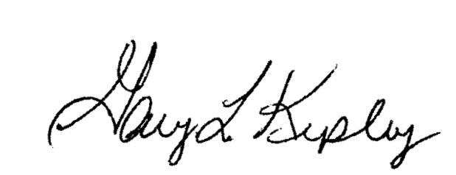

Gary L. Kepley

pc: Gary Baki

OH 08-09-A

