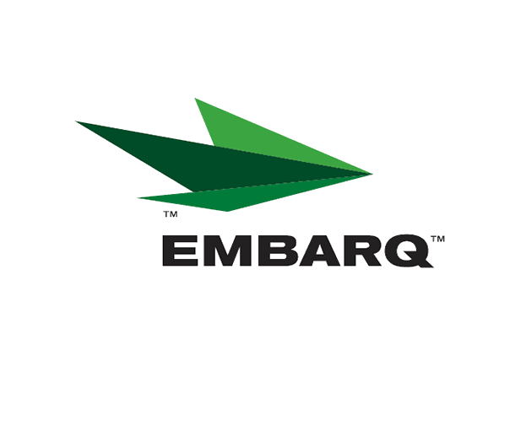


Embarq Corporation
Mailstop: KSOPKJ0502-5022
5454 West 110th Street
Overland Park, KS 66211
Glenda.Munson@EMBARQ.com

Via E-FILE

October 29, 2007

Ms. Renee’ Jenkins, Director of Administration
Public Utilities Commission of Ohio
180 East Broad Street, 13th Floor
Columbus, OH 43215-0573

Re: United Telephone Company of Ohio d/b/a Embarq
Case No. 07-421-TP-ZTA
90-5041-TP-TRF

Dear Ms. Jenkins:

Enclosed for filing is a correction to Section 39, Second Revised Sheet 5 of United Telephone Company of Ohio d/b/a Embarq P.U.C.O. No. 5 General Exchange Tariff that became effective u April 16, 2007, under Case No. 07-421-TP-ZTA. Upon verification of our rates, we discovered that the Clear Solution rate of $35.75 that was approved April 1, 2007, Case No. 90-5041-TP-TRF, was inadvertently changed back to the previous rate of $34.75

If you have any questions regarding this filing, please call Becky Donahue at 614-220-8624.

Sincerely,

/s/ Glenda L. Munson

Glenda L. Munson

Enclosures
cc: B. Donahue

OH 07-10 Correction Letter
Glenda L. Munson
TARIFF ANALYST I
Voice: (913) 315-9346
Fax: (913) 315-0763

