
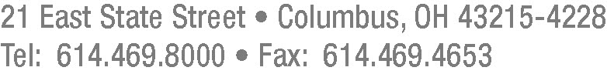

June 25, 2012

Barcy McNeal
Secretary, Docketing Division
Public Utilities Commission of Ohio
180 East Broad Street
Columbus, Ohio 43215

Re: Case No. 12-1450-HT-AEC

Dear Secretary McNeal:

Pursuant to the Commission’s May 23, 2012, Finding and Order in Case No. 12-1450-HT-AEC, Cleveland Thermal Steam Distribution, LLC (“Cleveland Thermal”) hereby submits the enclosed Standard Steam Supply and Distribution Agreements executed between it and TLS Corp., A & G Office Furniture, Inc., and Cleveland Institute of Electronics, Inc. Cleveland Thermal requests that, as provided in Finding 7of the Finding and Order, these agreements be deemed approved within thirty (30) days of this filing unless the Commission affirmatively acts otherwise.

Thank you for your kind attention to this matter.

Very truly yours,

/s/ Gretchen J. Hummel
Gretchen J. Hummel

Attorney for Cleveland Thermal Steam Distribution, LLC

Enclosures
GJH:vlp

