August 18, 2008
Carolyn.Flahive@ThompsonHine.com Fax 614.469.3361 Phone 614.469.3294 | tajg 588426.1

By Electronic Filing
Ms. Reneé J. Jenkins
Director of Administration
Secretary of the Public Utilities Commission of Ohio
180 East Broad Street
Columbus, Ohio 43215
Re: In the Matter of the Application of The Germantown Independent Telephone Company to Add Seasonal Service and Telephone Number Reservation Service to its Tariff; PUCO Case No. 08-981-TP-ATA
Dear Ms. Jenkins:
The Germantown Independent Telephone Company submits an Application for electronic filing. The TRF Number for The Germantown Independent Telephone Company is 90-5021-TP-TRF.
Thank you for your assistance. If you have any questions, please do not hesitate to call.
Very truly yours,

/s/ Carolyn S. Flahive

Enclosures

The Public Utilities Commission of Ohio

TELECOMMUNICATIONS APPLICATION FORM
for
ILECs Not Subject to Alternative Regulation
(Effective July 25, 2008)

In the Matter of the Application of Germantown Independent )
Telephone Company to Add Seasonal Service and Telephone ) Case No.08 -981 -TP - ATA
Number Reservation Service to its Tariff )

Name of Company The Germantown Independent Telephone Company
Address of Company 36 North Plum Street; P.O. Box 157; Germantown, Ohio 45327
Company Web Address
Regulatory Contact Person(s)_ Carolyn S. Flahive Phone (614) 469-3200 Fax (614) 469-3361
Regulatory Contact Person’s Email Address Carolyn.Flahive@ThompsonHine.com
Date TRF Docket No. 90 - 5021 - TP – TRF

Motion for protective order included with filing? Yes No
Motion for waiver(s) filed affecting this case? Yes No [Note: waiver(s) tolls any automatic timeframe]

NOTE: This form must accompany:
- All automatic approval/notice applications filed by incumbent local exchange companies (ILECs) not subject to a qualifying alternative regulation plan when making an application pursuant to Case Nos. 84-944-TP-COI, 86-1144-TP-COI, 89-564-TP-COI, or 99-563-TP-COI.
- All non-automatic approval applications filed by incumbent local exchange companies (ILECs) not subject to a qualifying alternative regulation plan when making an application pursuant to Section 4909.18, Ohio Revised Code.

I. Please indicate the reason for submitting this form (check one)
Retail Filings
1 (AEC) Application For Approval Of A Customer Contract For Competitive Services
a. Stand-Alone Contract (90-day approval, 7 copies)
b. Pre-Approved Contract (0-day notice, 7 copies)
2 (ACO) ILEC Application for Change in Ownership Pursuant to 4905.402, Ohio Revised Code (30-day approval, 10 copies)
3 (ALI) Small, For-Profit, ILEC Application For A Limited Increase In Non-Basic Rates (60-day approval, 10 copies)
4 (ATA) Application For Tariff Amendment That Does Not Result In An Increase In Rates
a. Large ILEC, Competitive Offerings Other Than Those Listed Under 5., Below (60-day approval, 7 copies)
b. Small, for-profit ILECs (45-day approval, 10 copies) (Not-for-profit, see item 6, NFP, below)
5 (ZTA) Tariff Notification Not For An Increase In Rates Involving Message Toll, Toll-Free Service, 900 And 900-Like Services, 500 Service, Calling Card, Prepaid Calling Card, Private Line, and Speed Dialing In Accordance With Waiver Granted in 99-563-TP-COI (5/11/2000 and 11/21/2002) (0-day notice, 7 copies)
NOTE: Notifications do not require or imply Commission Approval.
6 (NFP) Small, not-for-profit ILEC tariff amendment
a. Tariff Change Not Resulting In An Increase In Rates (0-day notice, 7 copies)
b. Tariff Application Resulting In An Increase In Non-Basic Rates (45-day notice, 7 copies)
c. Tariff Application Resulting In An Increase In Basic Rates (60-day notice, 10 copies)
7 (Non-Auto) All Others (non-automatic approval, indicate appropriate 3 letter code for case type in Case No. above)

THE FOLLOWING ARE TRF FILINGS ONLY, NOT NEW CASES
8 Introduction or Extension of Promotional Offering (10-day notice, 3 copies)
9 New Price List Rate Within an Approved Rate Range for Existing Competitive Service (0-day notice, 3 copies)

Carrier to Carrier Filings
10 (NAG) Negotiated Carrier-to-Carrier Interconnection Agreement under Sections 251 and 252 of the Telecommunications Act
(90-day approval, 7 copies)
11 (ARB) Request for Arbitration of a Carrier-to-Carrier Interconnection Agreement under Section 252 of the Telecommunications Act.
(non-automatic, 2 copies)

- The following exhibits corresponding to the list of cases above, at a minimum, are required to be filed:

 | 3, 4, 5, 6, 7 | Current Tariff Sheets (to be superseded), if applicable
 | 3, 4, 5, 6, 7 | Proposed Tariff Sheets
 | 2, 3, 4, 5, 6, 7 | Rationale or Explanation for Change
 | 1.a., 4.a. | Justification for Competitive Treatment
 | 1.a., 4.a. | Cost support for non-MTS service
 | 2, 3, 4, 5, 6, 7, 9 | Customer Notice to customers affected by proposal, and statement as to the form and timing of the notice
 | 1, 10 | Copy of Contract
 | 11 | Filing Requirements are specified in 4901:1-7-09(D) of the Ohio Administrative Code

- Applicant is filing this application under the regulatory requirements:
Established by the Commission in Case No. 89-564-TP-COI.
Established in 4909.18 Ohio Revised Code.
- Applicant respectfully requests the Commission to permit the filing of the proposed tariff sheets, to become effective on the date shown on the proposed tariff sheets (which is a date no earlier than the day after the applicable automatic approval date), modified by any further revisions that have become effective prior to the effective date of the proposed schedule sheets.
Respectfully submitted,

GERMANTOWN INDEPENDENT TELEPHONE COMPANY
By: /s/ Carolyn S. Flahive
Thomas E. Lodge (0015741)
Carolyn S. Flahive (0072404)
THOMPSON HINE LLP
41 South High Street, Suite 1700
Columbus, Ohio 43215-6101
Telephone: 614-469-3200
Facsimile: 614-469-3361
Its Attorneys

VERIFICATION

I verify that all of the information submitted herein, and all additional information submitted in connection with this case, is true and correct to the best of my knowledge.
/s/ Carolyn S. Flahive 8/18/08
*(Signature and Title) (Date)
*Verification is required for every filing, and need not be notarized except for Applications for a Limited Increase in Rates (ALIs). The verification may be signed by an officer of the applicant, its counsel, or an authorized agent of the applicant, except for ALIs. ALI applications must be signed by an officer of the company and be notarized.
Sworn to and subscribed before me this __________ day of __________ 200 .

Notary Public, State of Ohio
My commission expires

EXHIBIT A

(SUPERSEDED TARIFF SHEET)

Alphabetical Index to Topics (Cont’d.)

 | Section | Sheet
Ownership and Use of Facilities | 1 | 2
Payment for Service | 1 | 7
Pay Stations | 2 | 2
Primary and Extension Sets | 2 | 2
Push-Button Service | 2 | 10
Resale and Shared Tenant Service | 2 | 17
Schedule of Principal Monthly Rates | 4 | 1
Service Connection Charges | 2 | 6
Service Connection Charges (Rates) | 4 | 1
 |  |  | (D)
Special Assemblages | 2 | 1
Speed Calling | 2 | 12
 |  |  | (D)
Subscriber Requested Temporary Disconnection | 2 | 8
Telecommunication Service Priority System (TPS) | 2 | 31
Telephone Numbers | 1 | 9
Three-Way Calling | 2 | 1
Toll Blocking Policy | 1 | 8A
Transmitting Messages | 1 | 2
Unauthorized Attachments | 1 | 2
Underground Telephone Service | 2 | 14
Use of Subscriber Service | 1 | 5

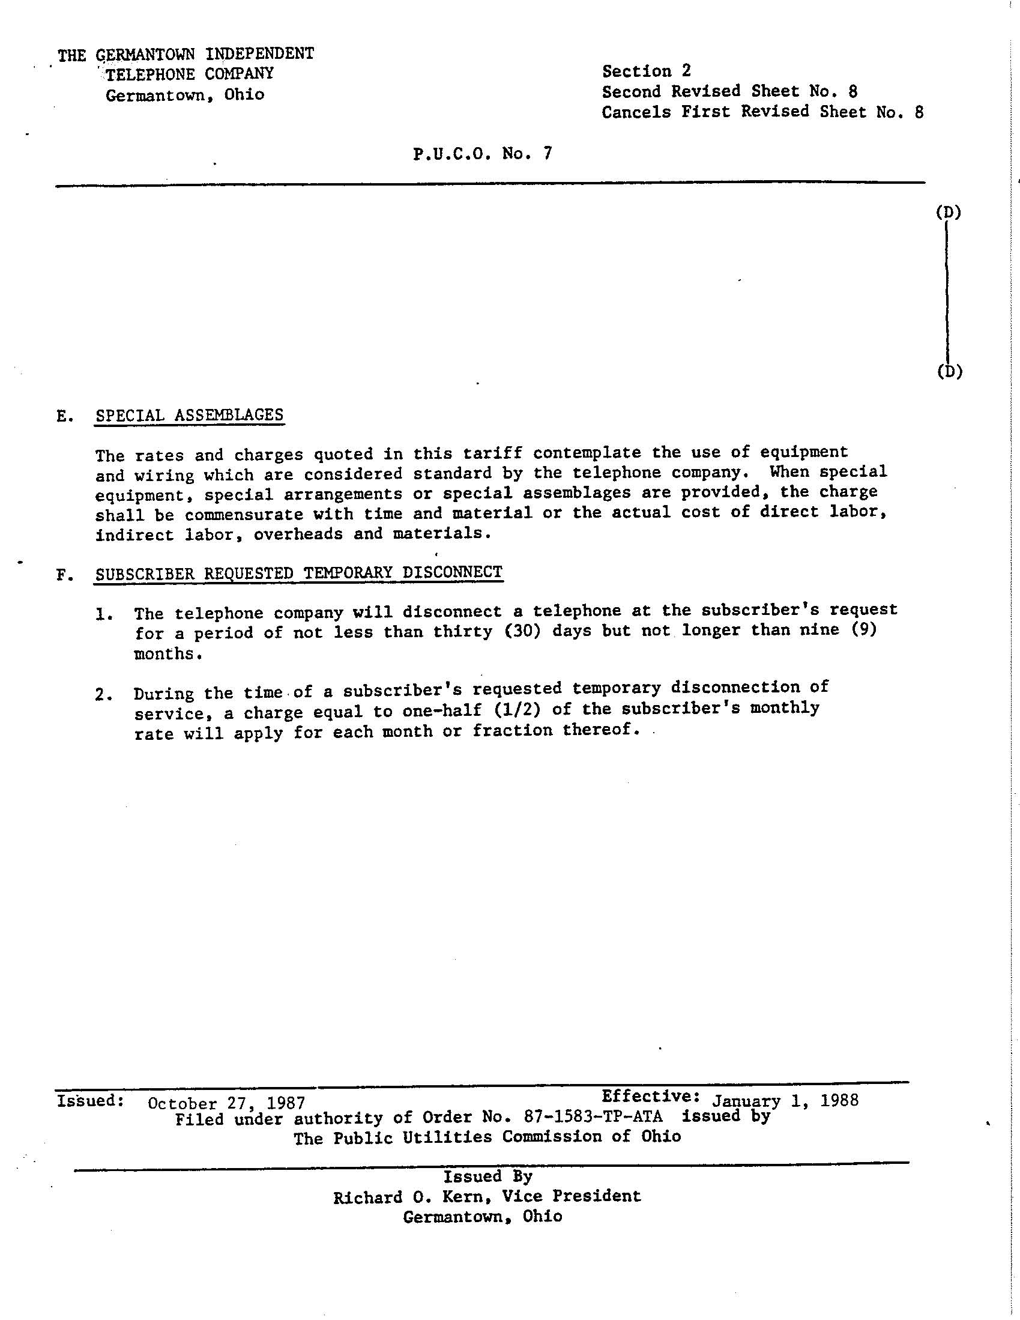

EXHIBIT B

(REVISED TARIFF SHEET)

Alphabetical Index to Topics (Cont’d.)

 | Section | Sheet
Ownership and Use of Facilities | 1 | 2
Payment for Service | 1 | 7
Pay Stations | 2 | 2
Primary and Extension Sets | 2 | 2
Push-Button Service | 2 | 10
Resale and Shared Tenant Service | 2 | 17
Schedule of Principal Monthly Rates | 4 | 1
Seasonal Service | 2 | 8 | (N)
Service Connection Charges | 2 | 6
Service Connection Charges (Rates) | 4 | 1
Special Assemblages | 2 | 1
Speed Calling | 2 | 12
Subscriber Requested Temporary Disconnection | 2 | 8
Telecommunication Service Priority System (TPS) | 2 | 31
Telephone Number Reservation Service | 2 | 8A | (N)
Telephone Numbers | 1 | 9
Three-Way Calling | 2 | 1
Toll Blocking Policy | 1 | 8A
Transmitting Messages | 1 | 2
Unauthorized Attachments | 1 | 2
Underground Telephone Service | 2 | 14
Use of Subscriber Service | 1 | 5

E. | SPECIAL ASSEMBLAGES  The rates and charges quoted in this tariff contemplate the use of equipment and wiring which are considered standard by the telephone company. When special equipment, special arrangements or special assemblages are provided, the charge shall be commensurate with time and material or the actual cost of direct labor, indirect labor, overheads and materials.
F. | SUBSCRIBER REQUESTED TEMPORARY DISCONNECT; SEASONAL SERVICE; TELEPHONE NUMBER RESERVATION SERVICE  Subscriber Requested Temporary Disconnect*: |  |  | (T)
 | 1. | The telephone company will disconnect a telephone at the subscriber’s request for a period of not less than thirty (30) days but not longer than nine (9) months.
 | 2. | During the time of a subscriber’s requested temporary disconnection of service, a charge equal to one-half (1/2) of the subscriber’s monthly rate will apply for each month or fraction thereof.
 | Seasonal Service |  |  | (N)
 | 1. | Seasonal Service is available to residential and business customers who leave the Company’s serving area for an extended period of time but wish to retain their existing telephone service while away.
 | 2. | In order to receive a seasonal discount during any twelve consecutive months of service, a customer must first subscribe to basic local exchange service for at least 6 months. During any twelve consecutive months, a customer cannot receive a seasonal discount for more than the maximum seasonal service period of 6 months.
 | 3. | Terms and Conditions
 |  | a. | Only the basic monthly access line rate and FCC End User Line Charge are reduced by the seasonal discount rate.
 |  | b. | The Company’s practices covering the discontinuance of service for non-payment of any amounts due the Company for telephone service will continue to apply during the Seasonal Service period.
 |  | c. | If service is established at the same location for a second customer, the new customer must also subscribe to basic local exchange service for at least 6 months before Seasonal Service would be available.
 |  | d. | The Company may request that payment for service during the Seasonal Service period be made in advance.
*Subscriber Requested Temporary Disconnect will no longer be available to customers who wish to begin such temporary disconnection after the Effective Date below. Any customers who currently have such temporarily disconnected service will be grandfathered until their disconnection expires and service is reactivated. |  |  |  | (N)

Seasonal Service (Cont’d) |  |  | (N)
4. | Discounts and Nonrecurring Charges:
 | a. | Discount Rate: 50% of the monthly basic access line rate and FCC End User Line Charge.
 | b. | A nonrecurring Service Order Change charge applies to establish Seasonal Service but no nonrecurring charge applies for returning to full service.

Telephone Number Reservation Service |  | (N)
- Use of a directory number assigned to an existing telephone line can be retained by a residential or business customer for a period of time during which central office services associated with the line are terminated.
- A customer must have subscribed to basic local exchange service on the line for a minimum period of six months before subscribing to this service.
- A customer may place his or her telephone number on reservation for up to a maximum period of six months during any twelve consecutive months.
- The rate for this service is 25% of the normal tariffed access line rate for the line plus applicable taxes and surcharges.
- Any applicable monthly construction charges will continue to be billed during the service termination period.
- All unpaid charges such as local service, toll charges, etc. will continue to be billed until such time the account is paid in full.
- The Company may bill for this service on a monthly, quarterly or semi-annually basis at its discretion and may require these charges be paid in advance. If service is disconnected, all unused paid-in-advance portions will be returned to the customer on a pro-rated basis.
- A nonrecurring Service Order Change charge and Line Connection Charge apply to establish Telephone Number Reservation Service but no nonrecurring charges apply for returning to full service.

EXHIBIT C

The Applicant, Germantown Independent Telephone Company, hereby adds two new service offerings: Seasonal Service and Telephone Number Reservation Service. Seasonal Service will replace Subscriber Requested Temporary Disconnect but any customer currently subscribing to Subscriber Requested Temporary Disconnect will be grandfathered and unaffected. The terms and conditions of Seasonal Service are set forth in Exhibit B.

Telephone Number Reservation Service allows a customer to disconnect his or her telephone service yet continue to retain the associated telephone number for up to 6 months during any 12 consecutive months.

The Company is offering these new services to continue providing value to its customers.

