 | Gary L. Kepley  Mailstop KSOPKJ0502-508  Director – Regulatory Systems  5454 West 110th Street  Overland Park, Kansas 66211  Voice: 913-345-7572  Email: Gary.Kepley@embarq.com

Via Electronic Filing

April 27, 2007

Ms. Renee Jenkins, Director of Administration
Public Utilities Commission of Ohio
180 East Broad Street
Columbus, Ohio 43215-3794

Re: United Telephone Company of Ohio d/b/a Embarq
Case No. 07-464-TP-COI
Case No. 90-5041-TP-TRF

Dear Ms. Jenkins:

Submitted as an electronic filing are revisions to United Telephone Company of Ohio d/b/a/ Embarq P.U.C.O. No. 1 Access Service Tariff. These revisions are filed in compliance with the April 25, 2007 Finding and Order in Case No. 07-464-TP-COI. That Order authorizes Embarq to add exceptions to Ohio's intrastate tariff to exclude the shortfall penalty associated with the Premier Term Discount Plan. In addition, Ethernet Transport service and the special access OptiPoint configuration cards and SONET OC Ring interfaces used in conjunction with Ethernet Transport service are excluded from Ohio's intrastate jurisdiction. This filing should be processed as a zero day filing, to become effective April 27, 2007.

The following tariff page is enclosed which adds the exception language:

P.U.C.O. No. 1, Access Service Tariff Section 7 Eighth Revised Sheet 1

Should you have questions or require additional information regarding this filing, please contact Becky Donahue at 614-220-8624.

Sincerely,
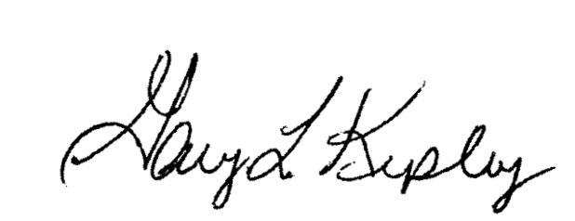

Gary L. Kepley

Attachments
Pc: Becky Donahue
Gary Baki
UNITED TELEPHONE Section 7
COMPANY OF OHIO Eighth Revised Sheet 1
d/b/a EMBARQ Cancels Seventh Revised Sheet 1

P.U.C.O. NO. 1
ACCESS SERVICE TARIFF
7. Special Access Service  7.4 Rate Regulations  7.4.16 Premier Term Discount Plan  (C) Shortfall Penalty  Ohio's intrastate jurisdiction is excluded from the shortfall penalty.  7.5 Rates and Charges (Cont'd)  7.5.8 High Capacity Service (Cont'd)  (C) Optional Features and Functions (Cont'd)  OptiPoint-3, 12 and 48 Configuration Cards at 10 Mbps, 20 Mbps, 50 Mbps, 100 Mbps, 150 Mbps, 300 Mbps, 450 Mbps, 600 Mbps and 1 Gbps are not available in Ohio's intrastate jurisdiction.  (13) NetPoint^{sm}  This service is not available in Ohio’s intrastate jurisdiction.  7.5.15 SONET OC Ring  (B) Customer Configuration Interface  OC3, 12 and 48 Customer Configuration Interfaces at 10 Mbps, 20 Mbps, 50 Mbps, 100 Mbps, 150 Mbps, 300 Mbps, 450 Mbps, 600 Mbps and 1 Gbps are not available in Ohio's intrastate jurisdiction.  (D) Central Office Configuration Interface  OC3, 12 and 48 Central Office Configuration Interfaces at 10 Mbps, 20 Mbps, 50 Mbps, 100 Mbps, 150 Mbps, 300 Mbps, 450 Mbps, 600 Mbps and 1 Gbps are not available in Ohio's intrastate jurisdiction.  7.5.16 Ethernet Transport  Ethernet Transport service is not available in Ohio's intrastate jurisdiction. | (T)  (N)  (N)  (N)  (N)  (N)  (N)
Issued: January 5, 2007 Effective: April 27, 2007

UNITED TELEPHONE COMPANY OF OHIO In accordance with Order No. 07-464-TP-COI
Joseph R. Stewart – Assistant Secretary Issued by the Public Utilities Commission of Ohio
Columbus, Ohio April 25, 2007

