
September 8, 2008

Via E-filing

Ms. Renee Jenkins, Commission Secretary
Public Utilities Commission of Ohio
Docketing Division
180 East Broad Street, 13th Floor
Columbus, Ohio 43215-3793

RE: Detariffing for CenturyTel Long Distance, LLC

Case No. 08-0321-TP-ATA

Dear Ms. Jenkins:

Enclosed for filing please find the original replacement tariff submitted on behalf of CenturyTel Long Distance, Inc. This filing is made per the request of staff to remove the regulations and add the MTSS customer rights to the title page.

Please acknowledge receipt of this filing by date stamping the extra copy of this cover letter and returning it to me in the self-addressed stamped envelope.

Any questions you may have regarding this filing may be directed to me at (407) 740-3001 or via email to tforte@tminc.com.

Thank you for your assistance in this matter.

Sincerely,

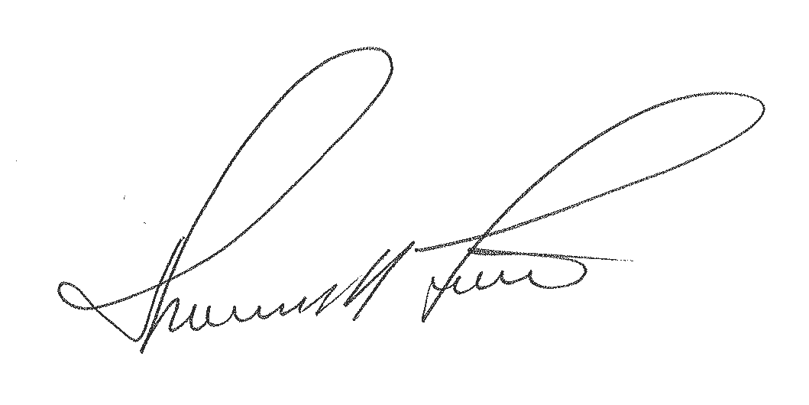

Thomas M. Forte
Consultant to CenturyTel Long Distance, LLC

TMF/rg

cc: T. Manning – CenturyTel
file: CTLD - OH
tms: OHo0805a

CENTURYTEL LONG DISTANCE, LLC P.U.C.O. Tariff No. 3
Original Title Sheet

This P.U.C.O. Tariff No. 3, issued by CenturyTel Long Distance, LLC, cancels and replaces the CenturyTel Long Distance, LLC P.U.C.O. Tariff No. 2 currently on file with the Commission.

TITLE SHEET

OHIO TELECOMMUNICATIONS TARIFF

This Tariff describes the Company’s Regulated Toll Terms, Conditions, Payments and Rates and Charges required in conformance with Competitive Retail Telephone Rules (Case No. 06-1345-TP-ORD). The Company provides Toll regulated services which are not required in the Company’s tariff on file with the Public Utilities Commission of Ohio (Rule 4901:1-06-05(g)).

The Customer may view the Detariffed / Nonregulated Services not included in this tariff on the Company’s website at:

www.centurytel.com

“Customers have certain rights and responsibilities under the Minimum Telephone Service Standards (Ohio Adm. Code 4901:1-5) (MTSS). These safeguards can be found in the Appendix to Ohio Adm. Code 4901:1-5-03, which is entitled “Telephone Customer Rights and Responsibilities”. These rights and responsibilities include complaint handling, ordering or changing service, service repair, payment of bills, and disconnections and reconnection of service.

CENTURYTEL LONG DISTANCE, LLC P.U.C.O. Tariff No. 3
Original Sheet 1

CHECK SHEET

Pages of this Tariff, as indicated below, are effective as of the date shown at the bottom of the respective pages. Original and revised pages, as named below, comprise all changes from the original Tariff and are currently in effect as of the date on the bottom of this page.

PAGE | REVISION |  | PAGE | REVISION |  | PAGE | REVISION
Title | Original | *
1 | Original | *
2 | Original | *
3 | Original | *
4 | Original | *
* - indicates those pages included with this filing

CENTURYTEL LONG DISTANCE, LLC P.U.C.O. Tariff No. 3
Original Sheet 2

APPLICATION OF TARIFF

This tariff filed by the Company describes the Regulated Toll Terms, Conditions, Payments and Rates and Charges required in conformance with Competitive Retail Telephone Rules (Case No. 06-1345-TP-ORD). Services will be provided in compliance with Minimum Telephone Services Standards. The Company provides Toll regulated services which are not required in the Company’s tariff on file with the Public Utilities Commission of Ohio (Rule 4901: 1-06-05(g)).

The Customer may view the Detariffed / Nonregulated Services not included in this tariff on the Company’s website at:
www.centurytel.com

Customers rights, responsibilities and safeguards can be found in the Ohio Administrative Code Appendix (Rule 4901:1-5-03).

The applicable requirements of the Ohio Administrative Code and the Ohio Revised Code apply to the operations of the Company. The Company will comply with the Commission’s policies and requirements for persons with communications disabilities and privacy and number disclosure requirements covered in subject cases. Any changes in terms or conditions of this tariff and/or operations of the Company will generate an obligation of the Company to provide notice of such changes in accordance with the Commission’s Rules.

CENTURYTEL LONG DISTANCE, LLC P.U.C.O. Tariff No. 3
Original Sheet 3

SYMBOLS

The following are the only symbols used for the purposes indicated below:

(C) | - | To signify a changed listing, rule or condition which may affect rates or charges.
(D) | - | To signify discontinued material, including a listing, rate, rule or condition.
(I) | - | To signify an increase in rates or charges.
(L) | - | To signify material relocated from or to another part of this Tariff with no change in text, rate, rule or condition.
(N) | - | To signify new material, including a listing, rate, rule or condition.
(R) | - | To signify a reduction in rates or charges.
(T) | - | To signify a change in the wording of the text, but no change in rate, rule or condition.
(X) | - | To signify a correction or reissued matter.

CENTURYTEL LONG DISTANCE, LLC P.U.C.O. Tariff No. 3
Original Sheet 4

SECTION 1 – MISCELLANEOUS SERVICES

1.1 Late Payment Charge

A late payment charge of 1.50 percent applies to each customer when the previous month's bill has not been paid in full, leaving an unpaid balance carried forward. The 1.50 percent charge is applied to the total unpaid amount carried forward and is included in the total amount due on the current bill. If payment for a current bill is received by the Company before the bill's due date, but for technical or other reasons the payment is not applied to the customer's account prior to the issuance of a subsequent bill, the customer shall not be liable for that portion of any unpaid balance attributable to a Late Payment Charge.

A customer shall not be liable for any Late Payment Charge applicable to a disputed portion of that customer's bill, so long as the customer pays the undisputed portion of the bill and enters into bona fide negotiations to resolve the dispute. Agencies of the Federal government are exempt from the Late Payment Charge.

1.2 Return Check Charge

Charge per check returned $ 25.00

