April 2, 2012

Ms. Betty McCauly
Public Utilities Commission of Ohio
Administration/Docketing
180 East Broad Street, 11th Floor
Columbus, OH 43215-3793

RE: Case Nos. 11- 4920-EL-RDR and 11-4921-EL-RDR

Dear Ms. McCauly:

This letter is to provide notice that the OMA Energy Group will not file initial comments in the above captioned cases. However, the OMA Energy Group reserves its right to file reply comments.

If you have any questions regarding this matter, please do not hesitate to contact me.

Sincerely,
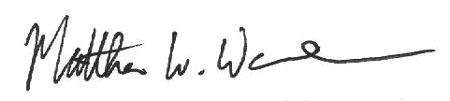

Matthew W. Warnock
On behalf of the OMA Energy Group

cc: Parties of Record

