Memorandum

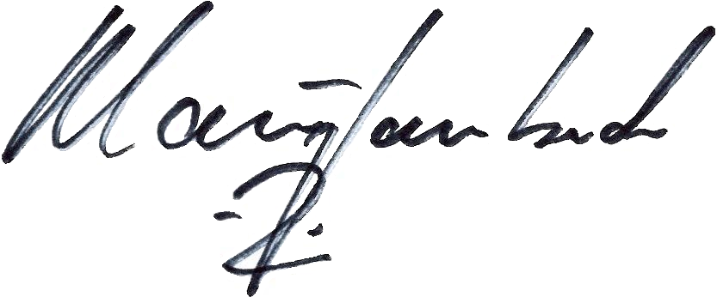
To: Henry Gary-Phillips, Administrative Law Judge
Legal Department
From: Klaus Lambeck, Chief
Facilities, Siting & Environmental Analysis Division
Department of Energy and Environment
Date: January 25, 2010
Re: Motion for Waivers, Case No. 09-0980-EL-BGN

On January 8, 2010, Paulding Wind Farm LLC (Applicant) filed a motion for waivers of 4906.06(A)(6), Ohio Revised Code (ORC) and various rules in Chapter 4906-14, Ohio Administrative Code (OAC)

Staff does not object to certain of these waiver requests, while other of the waiver requests are not supported by Staff Where Staff contests the waiver request. Staff believes the information should be filed as soon as practicable. To the extent that any waiver requests are granted, Staff reserves the right to require information from the Applicant in areas covered by the waiver requests, if Staff later determines it to be necessary during the course of the investigation.

Staff’s specific positions are provided below:

With the provisions stated below, staff does not contest the following waiver requests in this proceeding:

Section 4906.06(A)(6), ORC, waiver of the one year notice period.

4906-17-05(A)(4), OAC, waiver of certain requirements related to cross sectional view and test borings, provided that the Staff is provided with both the cross-sectional views and test boring data for review prior to the determination of final locations for turbine foundations and other project-related features.

Staff Contests the following waiver requests in this proceeding:

Rule 4906-17-05(B)(2)(h), OAC, waiver of certain requirements mapping of all grade elevation modified during construction. Rather than provide a waiver, the Applicant may provide a description of the standard grade elevations that will occur across the project when constructing all project components.

Rule 4906-17-04, OAC, waiver of certain requirements to provide an extensive site selection study which includes an evaluation of all practicable sites. Staff does not believe this waiver is necessary for a generation facility. This is addressed specifically for wind generation facilities in 08-1024-EL-ORD, item 56, on page 21. Staff notes, that while the waiver is not necessary, the applicant shall provide information about its site selection process as described in its waiver request.

Rule 4906-17-05(A)(3)(g), OAC, waiver of certain requirements for mapping of all vegetative cover that may be removed during construction. Staff does not believe that it would be appropriate to grant this waiver as it could impair Staffs ability to assess the ecological impact of the proposed project. The Applicant must provide a map of all vegetative cover to be removed in all disturbances area as a result of the proposed project.

Rule 4906-17-06(B)(l), (B)(3), and (C)(3) OAC, waiver of certain requirements related to the cost of alternatives. The information in this rule was specifically addressed in the Wind Rulemaking as being important for internal evaluation purposes, and should not be waived. To the extent that such information does not exist or is not available, the Applicant can state this in its application.

Rule 4906-17-08(B)(1)(d), OAC, waiver of certain requirements related to studies regarding ecological impacts of the proposed project. Staff does not believe that it is necessary to grant this waiver. The required information should be provided so as to enable Staff to complete its review in accordance with 4906.10(A)(2) and (3), Revised Code. Such information may be filed in this proceeding no later than eight weeks prior to the public hearing to allow Staff sufficient time to incorporate the information in its review.

Rule 4906-17-8(C)(2)(c), OAC, waiver of certain requirements related to tax benefits as a result of the proposed project. Staff does not believe that it is necessary to grant this waiver. The required information should be provided so as to enable Staff to complete its review in accordance with 4906.10(A)(2) and (3), Revised Code. Such information may be filed in this proceeding no later than eight weeks prior to the public hearing to allow Staff sufficient time to incorporate the information in its review.

Rule 4906-17-8(D)(2), OAC, waiver of certain requirements related to studies regarding impacts to cultural recourses as a result of the proposed project. Staff does not believe that it would be appropriate to grant this waiver as it could impair Staffs ability to assess the impacts to cultural resources as a result of the proposed project. Therefore, the required information should be provided so as to enable Staff to complete its review in accordance with 4906.10(A)(2) and (3), Revised Code. Such information should be filed in this proceeding no later than eight weeks prior to the public hearing to allow Staff sufficient time to incorporate the information in its review.

