
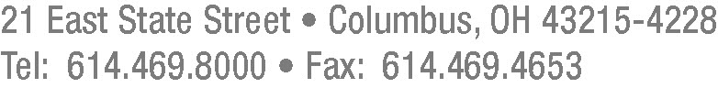

October 2, 2012

Barcy McNeal
Secretary, Docketing Division
Public Utilities Commission of Ohio
180 East Broad Street
Columbus, Ohio 43215

Re: Case No. 12-0320-GA-UEX

Dear Secretary McNeal:

On September 21, 2012, Deloitte & Touche LLP (“D&T”) filed its Report of its audit of the UEX rider of Vectren Energy Delivery of Ohio, Inc. (“VEDO”) in this docket. In its report, D&T reported the following:

- D&T noted two customer balances written off in February 2012 which were eligible for write-off in May and September 2011. D&T found that these write-offs were included in the proper annual UEX filing and noted that VEDO reported that the write-off process exception has been corrected.

- D&T noted that the recalculated revenue requirement for one tested selection revealed an 18-cent difference between its recalculated amount and the amount recorded by VEDO. D&T noted that VEDO reported that the calculation exception has been corrected.

- D&T found differences of $1 and $0 in its comparison of the general ledger Accounts Receivable Regulatory Asset balance at December 31, 2011 and March 31, 2012 to the balances in the filing. D&T noted that VEDO reported that the difference related to rounding.

- D&T noted a write-off of a pre-2006 customer receivables balance which should have been recorded in a previous filing period.

Barcy McNeal
October 2, 2012
Page Two

VEDO concurs with the findings in D&T’s audit report, including those enumerated above and resolutions or explanations thereof or therefor as noted by D&T.

Thank you for your kind attention to this matter.

Very truly yours,

/s/ Gretchen J. Hummel
Gretchen J. Hummel

Attorney for Vectren Energy Delivery
of Ohio, Inc.

GJH:vlp

