May 23, 2008

Via Electronic Filing
Ms. Reneé J. Jenkins
Director of Administration
Secretary of the Public Utilities Commission of Ohio
180 East Broad Street
Columbus, Ohio 43215
Re: In the Matter of the Application of The McClure Telephone Company to Submit Revised Tariff; PUCO Case No. 08-0469-TP-ATA
Dear Ms. Jenkins:
The McClure Telephone Company submits final tariff sheets for electronic filing in connection with the above-referenced matter. The TRF Number for The McClure Telephone Company is 90-5026-TP-TRF.
Thank you for your assistance. If you have any questions, please do not hesitate to call.
Very truly yours,

/s/ Carolyn S. Flahive

Enclosures
Carolyn.Flahive@ThompsonHine.com Fax 614.469.3361 Phone 614.469.3294 | tajg DocID_Info

McCLURE TELEPHONE COMPANY

TELEPHONE SERVICE TARIFF

NOTE: This Tariff PUCO No. 6 cancels and supersedes McClure Telephone Company
P.U.C.O. No. 5.

SECTION 1: | Local Exchange Service Tariff
SECTIONS 2-6: | General Exchange Service Tariff
SECTION 7: | General Rules and Regulations
SECTION 8: | Emergency Telephone Service
SECTION 9: | Basic Telephone Assistance
SECTION 10: | IntraLATA Presubscription
SECTION 11: | Customer-Owned, Coin-Operated Telephone Service
SECTION 12: | Expanded Service Area
SECTION 13: | Shared Tenant Service

SUBJECT | SECTION | SHEET
211 Service for Information and Referral Services | 6 | 1
811 Service for “One Call” Notification Systems | 6 | 8
900 Services Call Blocking | 4 | 3
911 Universal Emergency Telephone Number Service | 8 | 1
- A -
Advance Payments | 7 | 12
Alterations | 7 | 6
Alternate Call Listings | 1 | 1
Application for Service | 7 | 5
Application of Construction Charges | 7 | 12
Application of Rates | 4 | 1
Availability of Facilities | 7 | 1
- B -
- C -
Construction, Installation, and Maintenance Charges | 4 | 2
Custom Calling Features | 2 | 1
Custom Local Area Signalling Services (Class) | 5 | 1
Customer-Owned, Coin-Operated Telephone Service | 11 | 1
- D -
Defacement of Premises | 7 | 2
Denial or Disconnection of Local and Toll Service | 7 | 13
Deposits | 7 | 9
Directory Assistance Service | 3 | 1
Directory Errors and Omissions | 7 | 1
- E -
Emergency Telephone Service | 8 | 1
Establishment and Furnishing of Service | 7 | 5
Exchange Area Map | 1 | 2
Exchange Rates | 1 | 1
Expanded Service Area | 12 | 1
Explanation of Symbols | Subject Index | 4
Extra Listings | 1 | 1

SUBJECT | SECTION | SHEET
- F -
Foreign Exchange Listings | 1 | 1
- G -
General Rules and Regulations | 7 | 1-14
- I -
Initial Contract Periods | 7 | 8
Insufficient Fund Check Charge | 1 | 5
IntraLATA Presubscription | 10 | 1
- K -
- L -
Late Payment Charge | 1 | 5
Liability of the Telephone Company | 7 | 10
Lifeline Assistance | 9 | 5
Line Connection Charge | 1 | 3-5
Link Up | 9 | 3
- M -
Maintenance and Repairs | 7 | 7
Misuse of Facilities | 7 | 4
Move Charge | 1 | 5
- N -
Non-Published Telephone Number | 1 | 1
 | 7 | 5
Number Change Charge | 1 | 5
- O -
Obligation and Liability of Telephone Company | 7 | 1
Obligation of Customer | 7 | 12
Ownership and Use of Equipment | 7 | 3

SUBJECT | SECTION | SHEET
- P -
Payment for Service | 7 | 6
Payment for Service and Facilities | 7 | 9
- Q -
- R -
Reconnect Charge | 1 | 5
- S -
Service Connection Assistance | 9 | 1
Service Order Charge | 1 | 3-5
Shared Tenant Service | 13 | 1
Special Assemblages of Equipment or Extra Equipment | 7 | 12
Special Service and Facilities | 7 | 10
- T -
Telecommunications Service Priority (TSP) System | 7 | 14
Telephone Directories | 7 | 7
Telephone Numbers | 7 | 5
Termination of Service by Customers | 7 | 8
Toll Blocking Policy | 7 | 13
Transmitting Messages | 7 | 2
Touch Tone Service | 1 | 5
- U -
Unusual Installation Costs | 7 | 7
Use of Connecting Company Lines | 7 | 2
Use of Customer Service | 7 | 4
Use of Service and Facilities | 7 | 3
- V -
Vacation Rates | 1 | 1
- W -
- X -
- Y -
- Z -

EXPLANATION OF SYMBOLS
(C) | Signifies a changed regulation.
(D) | Signifies a discontinued rate or regulation.
( I ) | Signifies an increased rate.
(N) | Signifies a new rate or regulation.
(R) | Signifies a reduced rate.
(T) | Signifies a change in text but no change in rate or regulation.
(Z) | Signifies a correction.

MCCLURE EXCHANGE RATES

Customers have certain rights and responsibilities under the Minimum Telephone Service Standards (Ohio Adm.Code 4901:1-5) (the “MTSS”). These safeguards can be found in the Appendix to Ohio Adm.Code 4901:1-5-03, which is entitled “Telephone Customer Rights and Responsibilities.” These rights and responsibilities include complaint handling, ordering or changing service, service repair, payment of bills, and disconnection and reconnection of service.

A. |  |  | The rates hereunder entitle Customers in the McClure Exchange to make calls, without additional charge, to the Grelton-Malinta and Deshler Exchanges of the United Telephone Company of Ohio d/b/a Embarq.
 |  |  |  | Monthly Rates
 |  |  |  | Business |  | Residence |  | Payphones
 |  | Individual access line |  | $27.90 |  | $16.00 |  | $27.90
 |  | Coin Supervision Additive |  | N/A |  | N/A |  | $7.20
 |  | Trunk Line Service, each line |  | $42.70 |  | N/A |  | N/A
 |  |  | Semi-public Telephone Service is furnished at rates set forth in Section 12 of this tariff.
B. |  |  | DIRECTORY LISTINGS
 |  |  |  |  | Business |  | Residence
 |  |  | Non-published telephone number |  | $1.00 |  | $1.00
 |  |  | Extra listings |  | $1.00 |  | $.50
 |  |  | Foreign exchange listings |  | $1.00 |  | $.50
 |  |  | Alternate Call Listings |  | $1.00 |  | $.50
C. |  |  | VACATION RATES
 |  |  | Upon request, a Customer having any class of service except a business, may temporarily suspend service for a period of not less than one month and not more than six months in any year. If any period of suspension is less than thirty days, the vacation rate will not apply. No outward or inward service will be provided during suspension. Service charges are applicable to both suspension and reconnection.
 |  |  | Notice to suspend service may begin on any day of the month provided reasonable notice is given in advance. Notice to restore service must also be given in advance.
 |  |  | The reduction in rate for the period of suspension for both residential and business customers is equal to 50% of the total exchange service charges.

CUSTOM LOCAL AREA SIGNALLING SERVICES (CLASS) (CONTINUED)

McCLURE EXCHANGE AREA MAP

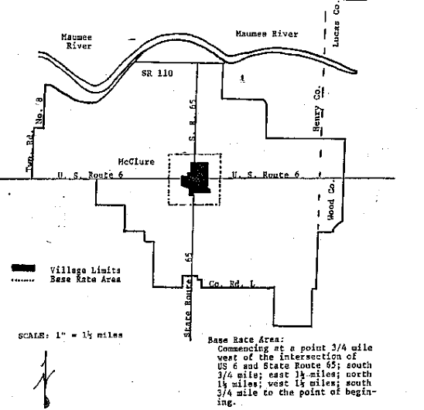

SERVICE CONNECTION CHARGES
A. | SERVICE CHARGES
 | 1. | A Service Order Charge will be applied to every residential and business customer account upon activation of service.
 | 2. | Residential service charges are in addition to all other applicable rates and charges associated with the service provided. All business service charges are based on time and material and are calculated on actual cost of the installation.
 | 3. | Payment of Service Charges: Service charges for the initial establishment of residential or business service are due and payable in advance or on the first billing cycle after installation date of the equipment.
 | 4. | The charges specified herein do not contemplate work performed by Company employees at a time when overtime wages apply due to the request of the Customer nor do they contemplate work interrupted by the Customer. If the Customer requests overtime labor to be performed or interrupts work that has been initiated, a charge in addition to the specified charges will be made equal to the additional cost involved.
 | 5. | Service Charges:
 |  | a. | Service Order Charge: Applicable for work done in receiving, recording and processing information necessary to execute a Customer’s request for connection of service or moves, changes or additions to existing service.
 |  | b. | Line Connection Charge: Applicable to work done in the Central Office and elsewhere in association with providing an access line or making changes thereto.
 | 6. | Service charges are not applicable to the upgrading of basic service, when done in conjunction with a general upgrading of facilities.
 | 7. | Service charges are not applicable to removal of service or equipment.

 | SERVICE CONNECTION CHARGES (Continued)
B. | APPLICATION OF CHARGES
 | 1. | Service Order Charge
 |  | Service order activity is classified as either initial (establishment of service) or subsequent (modification to an existing service).
 |  | a. | One initial Service Order Charge is applicable to each order for connection of the service.
 |  | b. | One subsequent Service Order Charge is applicable to each order for move, change or addition and the following:
 |  |  | 1. | Change or addition of additional directory listings.
 |  |  | 2. | Issuance of order to document the use of customer provided equipment on the service.
 |  |  | 3. | Change of telephone number requested by Customer.
 |  |  | 4. | Only one charge is applicable per order if more than one change is requested on the order.
 | 2. | Line Connection Charge
 |  | a. | One Line Connection Charge is applicable to the provision of each access line in association with any of the following services:
 |  |  | 1. | Residence or Business Service
 |  |  | 2. | Off Premises Extension
 |  | b. | Line connection charges are not applicable when service responsibility is assumed by a Customer prior to discontinuance by another Customer (supersedure) and there is no change of telephone number.
 |  | c. | A line connection is applicable to each change in telephone number made at the request of the Customer.

SERVICE CONNECTION CHARGES (Continued)
B. | APPLICATION OF CHARGES (Continued)
 | 3. | Charges: The following charges apply for Customer initiated services on a non-recurring basis:
 |  |  | Business | Residence
 |  | Initial Service Order | $20.00 | $20.00
 |  | Subsequent Service Order | $15.00 | $15.00
 |  | Line Connection Charge | T&M | $15.00
 |  | Number Change Charge | T&M** | $15.00**
 |  | Reconnect Charge* (formerly known as Restoral of Service) | $20.00 | $20.00
 |  | Move Charge (off premise) | T&M** | $15.00
 |  | Insufficient Fund Check Charge | $10.00 | $10.00
All residential and business installations are charged an initial Service Order Charge and a Line Connection Charge as set forth above. T&M (time and materials) is based on the actual cost of direct labor, indirect labor, overhead, and materials.

**Rate is in addition to Subsequent Service Order Charge set forth above.
C. | MISCELLANEOUS RATES AND CHARGES
 | 1. | Late Payment Charge*: $1.00 or 5%, whichever is greater, will apply to regulated charges not paid at least nineteen (19) days after the postmark on the customer's bill. The late payment charge will not apply to any portion of the bill that is in bona fide dispute, any previous late payment fees included in the amount due, or to service establishment charges for lifeline services. Late payment charges are to be applied without discrimination.
 | 2. | Touch Tone service is furnished to all Customers in the McClure Exchange at no additional charge.
 | *The Company may waive this charge if extenuating circumstances exist.

CUSTOM CALLING FEATURES
A. |  | Descriptions
 | 1. |  |  | Call Forwarding
 |  |  |  | This service provides the Customer with the ability to automatically forward all incoming calls to another telephone number. The telephone can still be used for outgoing calls or long distance calls.
 |  |  | 2. | Call Forward -- Busy
 |  |  |  | This service allows incoming calls to a busy line to be forwarded to a predetermined telephone number.
 |  |  | 3. | Call Forward – No Answer
 |  |  |  | This service allows incoming calls to an unanswered line to be forwarded to a predetermined number.
 |  |  | 4. | Call Waiting
 |  |  |  | This service permits a Customer who is on a call to be informed that another call is waiting. By depressing the switchhook, the Customer can transfer to the new call while holding the original connection. Subsequent depressing of the switchhook will transfer the Customer back and forth between the two connections, but the Customer will not be able to talk to both parties at the same time. Only one call can wait at a time; any other callers will receive a busy tone.
 |  |  | 5. | Three-Way Calling
 |  |  |  | This service permits a Customer to add a third party to an existing connection by depressing the switchhook and dialing the third party. Upon receiving dial tone, the three-way connection is completed by depressing the switchhook again. When one person hangs up, the other two may continue their conversation.

CUSTOM CALLING FEATURES (Continued)
 | 6. | Toll Control with PIN
 |  | Allows Customers to control the origination of toll calls from their telephones by means of a personal identification number (PIN). A Customer’s line would be denied toll origination without the use of the PIN. The customer cannot make any 1+, 0-, or 0+ calls except with this PIN. Customers may still call 911.
 | 7. | Single Party Revert Calling
 |  | Allows a Customer to dial his or her own number, then hang up, so that his or her own telephone will ring.
B. |  | Charges
 |  | MONTHLY CHARGES | Residence | Business
 |  | Call Forwarding | N/C | N/C
 |  | Call Forward – Busy | N/C | N/C
 |  | Call Forward – No Answer | N/C | N/C
 |  | Call Waiting | N/C | N/C
 |  | Three-Way Calling | $1.50 | $2.00
 |  | Toll Control with PIN | $5.00 | $5.50
 |  | Single Party Revert Calling | $1.00 | $1.50

DIRECTORY ASSISTANCE SERVICE
A. |  | Regulations
 | 1. |  | The Telephone Company furnishes Directory Assistance Service whereby customers may request assistance in determining telephone numbers.
 | 2. |  | The charges specified in Section B for Directory Assistance Service are not applicable to calls placed from pay telephone stations, or from hospitals and skilled nursing homes. For the purpose of this tariff, the term “skilled nursing homes” applies to those nursing homes that provide 24 hour per day professional nursing care.
 | 3. |  | Directory assistance service furnished to the visually or physically handicapped:
 |  |  | a. | Charges for Directory Assistance Service are not applicable to calls placed by visually or physically handicapped subscribers to the Directory Assistance attendant. One residence service per handicapped person is designated by that handicapped person who is unable to use a directory due to a visual or other physical handicap. Such person must make application to the Telephone Company for exemption and will be required to provide suitable proof of handicap. Such application shall be established by the following procedures:
 |  |  |  | (i) | A letter to the Telephone Company from a qualified professional familiar with the person’s visual or physical impairment stating that the person qualifies for the exemption, or
 |  |  |  | (ii) | The filling out of a prepared form made available by the Telephone Company, by a qualified professional familiar with the person’s visual or physical impairment.

DIRECTORY ASSISTANCE SERVICE
A. |  | Regulations (Continued)
 |  |  | b. | Exemption may be extended to one business service in lieu of a residence service where the handicapped person subscribes only to business service that is located in the residence of said person.
 |  |  | c. | For the purpose of this tariff, a visually handicapped person is defined as follows:
 |  |  |  | (i) | Visual acuity of 20/60 or worse with best refractive correction with best eye, or
 |  |  |  | (ii) | Visual field of 20º or less in diameter.
 | 4. |  | Directory Assistance Service for the communicatively impaired:
 |  |  | a. | For purposes of this tariff, the definition of impaired refers to those persons with communication impairments, including those hearing impaired, deaf, deaf/blind, and speech impaired persons who have an impairment that prevents them from communicating over the telephone without the aid of a telecommunications device for the deaf.
 |  |  | b. | Residential impaired customers or impaired members of a customer’s household, upon written application and upon certification of their impaired status, which is evidenced by either a certificate from a physician, health care official or state agency or a diploma from an accredited educational institution for the impaired, may receive a discount off their message toll service rates, and, if they utilize telebraille devices, they may receive free access to local and intrastate long distance directory assistance. Additionally, TDD lines maintained by nonprofit organizations and governmental agencies, upon written application and verification that such lines are maintained for the benefit of the impaired, may receive a discount off their message toll services rates.

DIRECTORY ASSISTANCE SERVICE
B. |  | Rates
 | 1. |  | Local
 |  |  | a. | Requests made of Directory Assistance for telephone numbers of individuals or businesses located in the McClure, Deshler/West Hope, and Malinta/Grelton Exchanges are free.
 | 2. |  | National
 |  |  | a. | The rate of $.90 applies when customers of the Telephone Company request assistance in determining telephone numbers of individuals or businesses who are located outside the Local service area described above.

APPLICATION OF BUSINESS AND RESIDENCE RATES
Application of Rates
A. | Business rates apply at business locations; and at other locations when a business listing is furnished, or at residence locations when the subscriber has no regular business telephone and the use of the service either by himself, members of his household, or his guests, or parties calling him can be considered as more of a business than of a residence nature, which fact might be indicated by advertising either by business cards, newspapers, handbills, billboards, circulars, motion pictures, screens, or other advertising matter, such as on vehicles, etc.
B. | Business rates also apply at residence locations, when a telephone connected to the line is also provided in a shop, office, or other place of business.
C. | Residence rates apply at all other locations unless otherwise specifically provided. When the use of a residence service is such that it should be reclassified as a business service, the Company will discontinue the service in the event the subscriber refuses to permit such reclassification and pay the applicable business rate.

CONSTRUCTION, INSTALLATION, AND MAINTENANCE CHARGES
A. | General
 | 1. | Special charges in the form of installation charges, monthly charges, or both, may be applied in addition to the usual service connection charges and monthly rates in certain circumstances, including but not limited to:
 |  | a. | The facilities are provided in remote or undeveloped sections within the Exchange Area;
 |  | b. | Conditions require the provisions of special equipment or unusual methods of plant construction, installation or maintenance; or
 |  | c. | The Customer’s location requires the use of costly private right-of-way.
 | 2. | Title to all construction provided wholly or partly at a Customer’s expense is vested in the Company.
 | 3. | The Company’s costs will include labor and materials, including the usual supervisory expenses.
 | 4. | When attachments are made to poles or buried facilities of other companies in lieu of providing construction for which the Customer would be charged under the provisions of this tariff, the cost to the Company for such attachments shall be borne by the Customer.
 | 5. | The Customer is required to pay construction charges as made by another company providing facilities connecting with the facilities of the Telephone Company.
B. | Line Extensions
 | 1. | Construction costs for one-half mile will be at Company expense. All excess construction costs must be borne by prospective Customer.
 | 2. | Provisions of Private Right-of-Way: Where required by the conditions, applicants for service shall provide, without expense to the Telephone Company, private right-of-way parallel to the public highway; such right-of-way shall be free from tree interference and otherwise suitable.

900 SERVICES CALL BLOCKING
900 SERVICES CALL BLOCKING
A. | Description
 | 900 services call blocking is an optional service providing residential and nonresidential customers with the capability to block the origination of direct dialed calls to all 900 services.
B. | Regulations
 | 1. | LEC-provided blocking of 900 services shall be provided where technologically feasible.
 | 2. | 900 services blocking is to be offered to residential customers at no charge for initial requests.
 | 3. | 900 services blocking is to be provided to nonresidential customer, free of charge, on a one-time basis, during a 60-day period after the inception of service.
 | 4. | Charges associated with nonresidential customers’ initial requests (after the sixty-day free enrollment period has expired) and subsequent requests, and residential customers’ subsequent requests, for 900 services blocking will not exceed the Company’s service order charge.
 | 5. | Residential customers obtaining service at a new location shall be afforded blocking of 900 services at no charge, even if they exercised an option to block services at a previous location at no charge.
 | 6. | Nonresidential customers obtaining service at a new location shall be afforded blocking of 900 services at no charge during a 60-day period after the inception of service, even if they exercised an option to block 900 services at a previous location at no charge.
 | 7. | Customers may elect to remove 900 services blocking free of charge. Requests by Customers to remove 900 services blocking must be in writing.

CUSTOM LOCAL AREA SIGNALLING SERVICES (CLASS)
A. | General
 | 1. | Per Call Blocking
 |  | Enables customers to prevent the disclosure of their telephone number on a per call basis to the called party. The disclosure of the calling party’s number can be prevented on a per call basis by dialing a preassigned access code before making a call. This action must be repeated each time a call is made to prevent the disclosure of the calling party’s telephone number. If the called party has a display device, a privacy indication will appear instead of the calling party’s telephone number. Per Call Blocking will be provided on a universal basis to all eligible customers.
 |  | All public and semi-public payphones in The McClure Telephone Company’s service area will be equipped with Per Call Blocking.
 | 2. | Per Line Blocking
 |  | Enables customers to prevent the disclosure of their telephone number on all outgoing calls, without the necessity of an activation code. If the called party has a display device, a privacy indication will appear instead of the calling party’s telephone number. Per Line Blocking will be provided at no monthly charge on an optional basis to non-published customers. The service is also available to published customers at a monthly charge of $1.00. Law Enforcement, Domestic Shelters and other special agencies will be offered free Per Line Blocking. Per Line Blocking will not be available to public, semi-public, and two-party service customers.
 | 3. | Automatic Callback
 |  | Automatically redials the last outgoing number after the customer activates the service by dialing *66 from a touch-tone phone. Automatic Callback monitors the busy line and performs a call set-up when both the originating and terminating lines become idle. After activation of the feature, the originating and terminating customers may place other calls without affecting the Automatic Callback service status. This service may also be used to recall a called party after the conversation has been terminated.
 |  | This feature is available on either a monthly flat rate basis or on a per-use basis.

CUSTOM LOCAL AREA SIGNALLING SERVICES (CLASS) (CONTINUED)
A. | General (Continued)
 | 4. | Call Return
 |  | Enables a customer to return the last incoming call, whether or not it was answered. The customer dials the activation code of *69 from a touch-tone phone, and the last incoming call is announced. If the incoming call was placed from a line designated as “private”, the recording will indicate that the number is private and will announce only the date and time of the call. To activate the Call Return function, the customer would then dial “1”. If the line is busy when the customer activates the service, a confirmation announcement is heard, the customer hangs up, and a queuing process begins. For the next thirty minutes both the calling and called party’s lines are checked periodically. The call set-up is made when both the originating and terminating lines are idle. After activation of the feature, the originating and terminating customers may place other calls without affecting the Call Return service status. Up to ten (10) calls may be held in queue for the customer’s Call Return activation. The call backs may be to areas where a toll charge would be applicable.
 |  | This feature cannot be activated for calls originating from lines designated as private.
 |  | This feature cannot be activated for certain telephone numbers, such as numbers with the 800 or 900 prefixes, or PBX extensions.
 |  | This feature is available on either a monthly flat rate basic or on a per-use basis.
 | 5. | Caller ID
 |  | Allows the customer to view the telephone number of the calling party when receiving a telephone call. The telephone number of the calling party is displayed on a customer-provided display device. However, the calling party may subscribe to services which will prevent the disclosure of their telephone number. In such instances, a privacy indication will appear on the customer-provided display device instead of the calling party’s telephone number.
 | 6. | Caller ID with Name  Works in the same manner as Caller ID, but in addition to displaying the calling party’s telephone number, it also displays the calling party’s name. The calling party may subscribe to services which will prevent the disclosure of his telephone number and name. In such instances, a privacy indication will appear on the customer-provided display device instead of the calling party’s telephone number and name.

CUSTOM LOCAL AREA SIGNALLING SERVICES (CLASS) (CONTINUED)
A. | General (Continued)
 | 7. | Caller ID with Name/Call Waiting  This combined service provides the customer with the name and telephone number of the person trying to reach him while the customer is on another call. As with the Caller ID with Name service, the calling party may use per call blocking or subscribe to per line blocking services which will prevent the disclosure of his telephone number and name. In such instances, a privacy indication will appear on the customer-provided display device instead of the calling party’s telephone number and name. Subscription to both Call Waiting and Caller ID with Name is required.
 | 8. | Selective Call Rejection
 |  | Provides the customer with a method of blocking calls from certain numbers, which may or may not be known to the customer. The customer may create a screening list of up to thirty-two (32) telephone numbers, and place them in network memory through an interactive dialing sequence. The customer may also activate the service after receiving a call, and thus place the number associated with that call on the Selective Call Rejection screening list. To activate the feature, the customer dials *60 from a touch-tone phone, and the telephone number of each incoming call is checked against the customer’s Selective Call Rejection screening list.
 | 9. | Selective Call Acceptance
 |  | Provides the customer with a method to accept calls from certain numbers only. Up to thirty-two (32) numbers may be added to the screening list through an interactive dialing sequence. The customer dials *64 from a touch-tone phone to activate the service. Each incoming call is then checked against the customer’s Selective Call Acceptance screening list.
 | 10. | Selective Call Forwarding
 |  | Allows customers to create a special list of up to thirty-two (32) telephone numbers and a destination number through an interactive dialing sequence. By dialing *63 from a touch-tone phone, the customer activates the service. Only incoming calls from numbers appearing on the list will be forwarded to the predetermined remote station.

CUSTOM LOCAL AREA SIGNALLING SERVICES (CLASS) (CONTINUED)
A. | General (Continued)
 | 11. | Distinctive Ringing/Call Waiting  Allows customers to designate several numbers that will be recognized immediately as important calls by means of a distinctive alerting signal. Up to thirty-two (32) numbers may be added to the screening list through an interactive dialing sequence. The customer then dials *61 from a touch-tone phone to activate the service. When the incoming call is identified as one of the numbers on the list, a distinctive ring will be produced in the customer’s telephone to alert them that an important call is coming in. If the customer is using the phone and one of the selected numbers comes through on Call Waiting, the customer will receive a distinctive call waiting signal indicating that an important call is awaiting.
 | 12. | Call Trace  Allows customers to request an automatic trace of the last call received by dialing *57 from a touchtone phone immediately following termination of the last incoming call. The customer will hear a recording explaining how to proceed with or terminate the trace and that the customer will be charged $5.00 for a successful trace. An announcement will also inform the customer if the trace has been successful. The Call Trace feature must be activated before receiving another call so that the correct number will be recorded. If the customer subscribed to Call Waiting and the customer gets a Call Waiting signal while an annoying call is in progress, the annoyance call cannot be traced using this feature. The results of a successful trace will only be released outside the Company to legally constituted authorities with proper authorization.
B. | Custom Local Area Signalling Services (CLASS) cannot be functional unless both the called and calling parties are served by, and the call is routed through, appropriately-equipped central offices, and routed over appropriately-equipped facilities for calls between such equipped central offices.  Telemarketers are prohibited from blocking the disclosures of their telephone number when placing calls. Upon receiving complaints that a telemarketer is blocking the disclosure of its telephone number, the Company will investigate the complaints and terminate the number blocking service where appropriate.

CUSTOM LOCAL AREA SIGNALLING SERVICES (CLASS) (CONTINUED)
C. | Rates and Charges
 | 1. | Recurring Charges:
 |  |  | Monthly Rate Per Line
 |  |  | Residential | Business
 |  | Per Call Blocking* | N/C | N/C
 |  | Per Line Blocking
 |  | - Nonpublished Customers | N/C | N/C
 |  | - Published Customers | $1.00++ | $1.00++
 |  | Automatic Callback | $6.00 | $6.00
 |  | Call Return | $6.00 | $6.00
 |  | Caller ID | $6.00 | $7.50
 |  | - Caller ID with Name | $8.00 | $9.50
 |  | - Caller ID with Name/Call Waiting | No charge if customer already subscribes to both services. If not, subscription to both services is required.
 |  | Selective Call Rejection | $6.00 | $7.50
 |  | Selective Call Acceptance | $6.00 | $7.50
 |  | Selective Call Forwarding | $6.00 | $6.00
 |  | Distinctive Ringing/Call Waiting | $6.00 | $6.00
 |  |  | Rate Per Activation
 |  |  | Residential | Business
 |  | Call Trace | $5.00 | $5.00

*Provided automatically to each line
++ Not eligible for discount.

CUSTOM LOCAL AREA SIGNALLING SERVICES (CLASS) (CONTINUED)

C. | Rates and Charges (Continued)
 | 2. | Discounts
 |  | The following discount schedule is available to residential customers:
 |  | 2nd Feature | $2.00 per month
 |  | 3rd Feature | $2.00 per month
 |  | Each additional Feature after 3 | $1.00 per month
 |  | The following discount schedule is available to non-residential customers:
 |  | 2nd Feature | $3.00 per month
 |  | 3rd Feature | $3.00 per month
 |  | Each additional Feature after 3 | $1.50 per month

CUSTOM LOCAL AREA SIGNALLING SERVICES (CLASS) (CONTINUED)

C. | Rates and Charges (Continued)
 | 3. | Promotional Offerings
 |  | Custom Local Area Signalling Services (CLASS) may be offered to Customers for a promotional period not to exceed ninety (90) days. During such a promotional period, the recurring and/or non-recurring charges for the CLASS feature(s) may be waived. Customer requests for CLASS features will be subject to availability of facilities.
 |  | Promotions will be filed with the Public Utilities Commission of Ohio in accordance with the Commission’s rules.
 | 4. | Per-Use Feature Charge
 |  | The Call Return and Automatic Callback features may be accessed by and billed on either a monthly flat rate basis, as set forth herein, or on a per-use basis as specified below:
 |  |  | Rates Per Use | Monthly Cap
 |  | Automatic Callback  Call Return | $0.75  $0.75 | $6.00  $6.00
 |  | The per-use Automatic Callback charge will be incurred upon dialing the Automatic Callback activation code.
 |  | The per-use Call Return charge will be incurred upon dialing the Call Return activation code. If the called line is idle, the Call Return request completes irrespective of whether or not the called party answers. If the called line is busy, the customer is so notified when Call Return is activated.

N11 SERVICE
211 SERVICE FOR INFORMATION AND REFERRAL SERVICES
A. | GENERAL
 | 1. | In Order No. 93-1799-TP-COI, the Public Utilities Commission of Ohio (“P.U.C.O.”) locally assigned the three digit 211 abbreviated dialing code to the Approved Information and Referral Service Provider for use in providing community information and referral services to the public by way of voice grade facilities. The P.U.C.O. ordered incumbent local exchange carriers in each local calling area to make the 211 abbreviated dialing code available to the Approved Information and Referral Service Provider as a tariffed, local calling area based service (the “211 Service”).
 | 2. | The 211 Service allows a Company subscriber to access an Approved Information and Referral Service Provider call center by dialing only the 211 abbreviated dialing code. Subject to other terms and conditions of this Tariff, Company subscribers shall be able to make and the Approved Information and Referral Service Provider shall be able to receive calls using the 211 Service as part of their local exchange services. The 211 Service is supplemental to and is not a replacement for either party’s local exchange service.
 | 3. | All 211 abbreviated dialing code calls shall be local in nature and shall not result in any expanded local calling area (“ELCA”), intraLATA toll, interLATA long distance or pay-per-call charges to Company subscribers. However, 211 Service calls may result in local measured service charges where Company subscribers’ service plans include such charges as part of home and EAS exchange calling.
 | 4. | The 211 Service is not available for the following classes of service:
 |  | a. | Hotel/motel/hospital service
 |  | b. | Inmate service
 |  | c. | 1+ and 0+ calling
 |  | d. | O-operator assisted calling
 |  | e. | 101XXXXX calling
B. | OBLIGATIONS OF THE APPROVED INFORMATION AND REFERRAL SERVICE PROVIDER
 | 1. | The Approved Information and Referral Service Provider shall make written application for 211 Service to the Company at the local exchange level. The Approved Information and Referral Service Provider may establish 211 Service in all, part or none of the Company’s local exchanges.

N11 SERVICE (Continued)
211 SERVICE FOR INFORMATION AND REFERRAL SERVICES (Continued)
B. | OBLIGATIONS OF THE APPROVED INFORMATION AND REFERRAL SERVICE  PROVIDER (Continued)
 | 2. | The Approved Information and Referral Service Provider’s written application to establish 211 Service in a Company local exchange shall include the following:
 |  | a. | The local, foreign exchange or toll free telephone number into which the Company is to translate the dialed 211 abbreviated code. If the Approved Information and Referral Service Provider desires to change the telephone number into which the 211 abbreviated dialing code is translated in an exchange, then the Approved Information and Referral Service Provider shall make a new application.
 |  | b. | A location description of the Approved Information and Referral Service Provider call center where 211 calls made from the Company local exchange will be routed.
 |  | c. | For network sizing and protection, an estimate of annual call volumes, the expected busy hour and holding time for each call to the 211 Service.
 |  | d. | An acknowledgment of the possibility that the Commission’s assignment of the 211 abbreviated dialing code may be recalled at any time.
 | 3. | Local Calling for Company Subscribers
 |  | a. | The Company, in cooperation with the Approved Information and Referral Service Provider, shall assure that all 211 Service calls are local in nature and do not generate ELCA, intraLATA toll, interLATA long distance or pay-per-call charges for Company subscribers.
 |  | b. | When the Approved Information and Referral Service Provider makes application for 211 Service in a Company local exchange, the Approved Information and Referral Service Provider shall supply the Company with a seven (7) or ten (10) digit telephone number that terminates within the Company local exchange or one of the local exchange’s EAS exchanges. The Company’s exchange facilities will translate the dialed 211 dialing code into the telephone number the Approved Information and Referral Service Provider provides once 211 Service is established in the local exchange.

N11 SERVICE (Continued)
211 SERVICE FOR INFORMATION AND REFERRAL SERVICES (Continued)
B. | OBLIGATIONS OF THE APPROVED INFORMATION AND REFERRAL SERVICE  PROVIDER (Continued)
 | 3. | Local Calling for Company Subscribers (Continued)
 |  | c. | When the Approved Information and Referral Service Provider makes application for 211 Service in a Company local exchange and an Approved Information and Referral Service Provider call center is not located within the local exchange or one of the local exchange’s EAS exchanges, then the Approved Information and Referral Service Provider shall establish foreign exchange service or supply the Company with a toll free telephone number so that Company subscribers’ 211 Service calls remain local in nature.
 | 4. | The liability language in Section 1 of this Tariff applies to 211 Service.
 | 5. | The Approved Information and Referral Service Provider shall develop an appropriate method for responding to 211 calls directed to it out of confusion or in error by Company subscribers.
 | 6. | The Approved Information and Referral Service Provider must be prepared to receive all calls to the 211 Service during normal business hours. To this end, the Approved Information and Referral Service Provider agrees to subscribe to termination facilities and lines in sufficient quantities to provide adequate service to the public.
 | 7. | The 211 Service is provided on the condition that the Approved Information and Referral Service Provider subscribes to termination facilities and lines in sufficient quantities to adequately handle calls to the 211 Service without interfering with or impairing any service offered by the Company. For each line subscribed to by the Approved Information and Referral Service Provider, there will be one path available.

N11 SERVICE (Continued)
211 SERVICE FOR INFORMATION AND REFERRAL SERVICES (Continued)
B. | OBLIGATIONS OF THE APPROVED INFORMATION AND REFERRAL SERVICE  PROVIDER (Continued)
 | 8. | The Approved Information and Referral Service Provider shall comply with all present and future rules pertaining to abbreviated dialing codes adopted by the Federal Communications Commission, in rulemaking proceeding CC Docket No. 92-105, CC Docket No. 00-256, and otherwise, including any and all requirements to relinquish the 211 abbreviated dialing code in the event of a national assignment contrary to that made by the P.U.C.O.
 | 9. | The Approved Information and Referral Service Provider is responsible for obtaining all necessary permissions, licenses, written consents, waivers and releases and all other rights from all persons whose work, statements or performances are used in connection with the 211 Service, and from all holders of copyrights, trademarks and patents used in connection with the said service.
 | 10. | If requested by the Company, the Approved Information and Referral Service Provider shall assist the Company in responding to complaints made to the Company concerning the 211 Service.
 | 11. | The Approved Information and Referral Service Provider shall not promote the 211 Service with the use of an autodialer or broadcasting of tones that dial the 211 abbreviated dialing code.
 | 12. | The Company can only make 211 Service available to end users located in Company local exchanges. To establish 211 calling to end users in non-Company local exchanges, the Approved Information and Referral Service Provider must make appropriate arrangements with the companies serving those local exchanges, even where Company subscribers may make local calls to the non-Company local exchanges.
 | 13. | The Approved Information and Referral Service Provider should work separately with competitive local exchange carriers (“CLEC”) operating and serving customers in the Company’s local exchanges to ascertain whether 211 abbreviated dialing will be available to their end users.

N11 SERVICE (Continued)
211 SERVICE FOR INFORMATION AND REFERRAL SERVICES (Continued)
C. | OBLIGATIONS OF THE COMPANY
 | 1. | The Company shall provision 211 Service no later than thirty (30) days after the effective date of its tariff.
 | 2. | When a 211 Service call is placed by the calling party via interconnection with an interexchange carrier, the Company cannot guarantee the completion of said 211 Service call, the quality of the call or any features that may otherwise be provided with 211 Service.
 | 3. | The Company does not undertake to answer and forward 211 Service calls but furnishes the use of its facilities to enable the Approved Information and Referral Service Provider to respond to such calls at the Approved Information and Referral Service Provider established call centers.
D. | LIABILITY
 | The Company’s entire liability to any person or entity for interruption or failure of the 211 Service shall be limited to the terms set forth in Section 7.

N11 SERVICE (Continued)
211 SERVICE FOR INFORMATION AND REFERRAL SERVICES (Continued)
E. | OTHER TERMS AND CONDITIONS
 | 1. | The 211 Service will not provide calling number information in real time to the Approved Information and Referral Service Provider. If this type of information is required, the Approved Information and Referral Service Provider must subscribe to compatible Caller ID service.
 | 2. | The 211 Service is provided solely for the benefit of the Approved Information and Referral Service Provider. The provision of the 211 Service by the Company shall not be interpreted, constructed or regarded, either expressly or implied, as being for the benefit of or creating any Company obligation toward any third person or legal entity other than the Approved Information and Referral Service Provider.
 | 3. | A written notice will be sent to the Approved Information and Referral Service Provider following oral notification when its 211 Service unreasonably interferes with or impairs other services rendered to the public by the Company or by other subscribers of abbreviated dialing codes. If after notification the Approved Information and Referral Service Provider makes no modification in method of operation or in the service arrangements that are deemed service-protective by the Company, or if the Approved Information and Referral Service Provider is unwilling to accept the modifications, or if the Approved Information and Referral Service Provider continues to cause service impairment, the Company reserves the right, at any time, without further notice, to institute protective measures, up to and including termination of service.
 | 4. | In an emergency situation as determined by the Company, the Company reserves the right, at any time, without notice, to institute protective measures, up to and including termination of service.

N11 SERVICE (Continued)
211 SERVICE FOR INFORMATION AND REFERRAL SERVICES (Continued)
F. | RATES AND CHARGES
 | 1. | Subject to other terms and conditions of this Tariff, Company subscribers shall be able to make and the Approved Information and Referral Service Provider shall be able to receive calls using the 211 Service as part of both parties’ local exchange service. The 211 Service is supplemental to and is not a replacement for either party’s local exchange service.
 | 2. | The Approved Information and Referral Service Provider shall pay the normal tariffed charges for the local exchange access arrangements used for transporting and terminating messages at the Approved Information and Referral Service Provider’s designated premises.
 | 3. | The Approved Information and Referral Service Provider shall pay the following nonrecurring charges upon establishment of 211 Service:
 |  |  | Switch Translation Charge  Service Order Charge  Number Change Charge – applicable when the Approved Information and Referral Service Provider makes application to change the telephone number into which the 211 abbreviated dialing code is translated. The Number Change Charge shall be applied on a per telephone number basis. | Non-Recurring Charges  $115.00  $ 15.00  $ 15.00

N11 SERVICE (Continued)
811 SERVICE FOR “ONE CALL” NOTIFICATION SYSTEMS
A. | GENERAL
 | 1. | The Federal Communications Commission (FCC) assigned the 811 dialing code for nationwide access to One Call Notification Systems. The 811 dialing code (“811 Service”) is a nationwide toll-free number to be used by state “One Call” notification systems for providing advanced notice of excavation activities to underground facility operators. Pursuant to PUCO Case No. 05-1306-TP-COI, 811 Service shall be made available within Ohio by May 14, 2007.
 | 2. | The three digit 811 abbreviated dialing One Call Notification code is assigned to the approved “811 Provider” for use in providing One Call notification services to the public by way of voice grade facilities.
 | 3. | 811 Service is available from the Company within its services area only. To provide access to 811 to end users in another company’s service area or to Competitive Local Exchange Carrier (CLEC) end users within the local calling area, the 811 Provider must make appropriate arrangements with the other company or CLEC serving that territory. The 811 Provider should work separately with competing local providers to ascertain that its end user customers will be able to reach one-call services provided by dialing 811.
 | 4. | All 811 abbreviated dialing code calls must be local in nature and will not result in any expanded local calling area (ELCA), intraLATA toll, interLATA long distance, or pay-per-call charges to Company subscribers. However, 811 Service calls may result in local measured service charges where Company subscribers’ service plans include such charges.
 | 5. | The 811 Service is not available for the following classes of service: inmate service, 1+ and 0+ calling, 0- operator assisted calling and 101XXXX calling. 811 Service is otherwise available wherever local service is accessible.

N11 SERVICE (Continued)
811 SERVICE FOR “ONE CALL” NOTIFICATION SYSTEMS (Continued)
B. | OBLIGATIONS OF THE APPROVED “ONE CALL” NOTIFICATION SYSTEMS PROVIDER
 | 1. | The 811 Provider must submit a written application for 811 Service to the Company. The 811 Provider may establish 811 Service in all or part of the Company’s exchanges. There may be only one 811 Provider per exchange.
 | 2. | The 811 Provider’s written application to establish 811 Service in a Company local exchange must include the following:
 |  | a. | The local, foreign exchange, or toll free telephone number into which the Company should translate the dialed 811 abbreviated code. If the 811 Provider desires to change the telephone number into which the 811 abbreviated dialing code is translated, the 811 Provider must pay a Number Change Charge as set forth in Section F. below.
 |  | b. | For network sizing and protection, an estimate of annual call volumes and holding time for calls to the 811 Service.
 |  | c. | An acknowledgement of the possibility that the Commission’s assignment of the 811 abbreviated dialing code may be recalled at any time.
 | 3. | Local Calling for Company Subscribers
 |  | a. | The 811 Provider, in cooperation with the Company, will assure that all 811 Service calls are local and do not generate ELCA, intraLATA toll, interLATA long distance, or pay-per-call charges for Company subscribers.
 |  | b. | When the 811 Provider applies for 811 Service from the Company, the 811 Provider must supply the Company with a toll free number. The Company will translate the 811 digits into the telephone number provided by the 811 Provider.
 | 4. | The 811 Provider is liable for and will indemnify, protect, defend and hold harmless the Company against all suits, actions, claims, demands and judgments, plus any expenses and counsel fees incurred by the Company on account thereof, whether suffered, made, instituted or asserted by the 811 Provider or any other party or person, for any personal injury to or death of any person or persons, or for any loss, damage, or destruction of any property, whether owned by the 811 Provider or others, arising out of or resulting directly from the 811 Service.
 | 5. | The 811 Provider must develop an appropriate method of responding to 811 calls directed to it out of confusion or in error by Company subscribers.

N11 SERVICE (Continued)
811 SERVICE FOR “ONE CALL” NOTIFICATION SYSTEMS (Continued)
B. | OBLIGATIONS OF THE APPROVED “ONE CALL” NOTIFICATION SYSTEMS PROVIDER (Continued)
 | 6. | The 811 Provider must subscribe to termination facilities and lines in sufficient quantities to provide adequate service to the public, and enable the 811 Provider to receive calls to the 811 Service during normal business hours.
 | 7. | The 811 Service is provided on the condition that the 811 Provider subscribes to termination facilities and lines in sufficient quantities to adequately handle calls to the 811 Service without interfering with or impairing any services offered by the Company.
 | 8. | The 811 Provider must comply with all present and future state and federal rules pertaining to abbreviated dialing codes.
 | 9. | The 811 Provider is responsible for obtaining all necessary permissions, licenses, written consents, waivers and releases and all other rights from all persons whose work, statements or performances are used in connection with the 811 Service. The 811 Provider is also responsible for obtaining all necessary permissions, licenses, written consents, waivers, and releases and all other rights from all holders of copyrights, trademarks and patents used in connection with the 811 Service.
 | 10. | The 811 Provider must respond promptly to all complaints lodged with any regulatory authority against the 811 Service. If requested by the Company, the 811 Provider must assist the Company in responding to complaints made to the Company concerning the 811 Service.
 | 11. | The 811 Provider shall not promote the 811 Service with the use of any auto dialer or broadcasting of tones that dial the 811 abbreviated dialing code.
 | 12. | The 811 Provider must work separately with CLECs operating and serving customers in the Company’s exchange(s) to ascertain whether 811 abbreviated dialing will be available to their end users.

N11 SERVICE (Continued)
811 SERVICE FOR “ONE CALL” NOTIFICATION SYSTEMS (Continued)
C. | OBLIGATIONS OF THE COMPANY
 | 1. | The Company will establish the 811 Service within ninety days after receipt of the 811 Provider’s completed application(s) for service or the effective date of this Tariff, whichever is later.
 | 2. | When an 811 Service call is placed by the calling party via interconnection with an interexchange carrier, the Company cannot guarantee the completion of said 811 Service call, the quality of the call or any features that may otherwise be provided with the 811 Service.
 | 3. | The Company will route 811 calls originating from end users on the Company’s local exchange network whether they purchase service directly from the Company or from another provider reselling company service. Otherwise, the Company is not responsible for establishing 811 Service for calls originating from other telecommunications providers.
 | 4. | The Company does not undertake to answer and forward 811 Service calls but furnishes the use of its facilities to enable the 811 Provider to respond to such calls at the 811 Provider-established call centers.
 | 5. | The rates charged for 811 Service, if applicable, do not contemplate the inspection or constant monitoring of facilities to discover errors, defects, and malfunctions in service, nor does the Company undertake such responsibility. The 811 Provider must conduct such operational tests as, in the judgment of the 811 Provider, are required to determine whether the Company’s facilities are functioning properly for its use. The 811 Provider must promptly notify the Company in the event the Company’s facilities are not functioning properly.
D. | LIABILITY
 | 1. | The liability of the Company for losses or damages of any kind arising out of mistakes, omissions, interruptions, delays, errors or defects in transmission, or failure or defects in any facility furnished by the Company, occurring in the course of furnishing 811 Service, or of the Company in failing to maintain proper standards of maintenance and operation or to exercise reasonable supervision, shall in no event exceed an amount equivalent to the proportionate charge to the 811 Provider for the 811 Service and local exchange services for the period of service during which such mistake, omission, interruption, delay, error or defect in transmission or defect of failure in facilities occurs.

N11 SERVICE (Continued)
811 SERVICE FOR “ONE CALL” NOTIFICATION SYSTEMS (Continued)
D. | LIABILITY (Continued)
 | 2. | The Company is not liable for any losses or damages caused by the negligence of the 811 Provider.
 | 3. | The Company’s entire liability to any person for interruption or failure of the 811 Service is limited to the terms set forth in this and other sections of this Tariff.
 | 4. | The Commission’s local assignment and the 811 Provider’s use of the 811 abbreviated dialing code are subject to preemption by the Federal Communications Commission. The Company shall not be liable to the 811 Provider for any damages the 811 Provider may incur that result from a national assignment of the 811 abbreviated dialing code.
 | 5. | The Company will make every effort to route 811 calls to the appropriate 811 Provider call center. However, the Company will not be held responsible for routing mistakes or errors.
E. | OTHER TERMS AND CONDITIONS
 | 1. | The 811 Service will not provide calling number information in real time to the 811 Provider. If this type of information is required, the 811 Provider must subscribe to compatible Caller ID service as described elsewhere in this Tariff.
 | 2. | The 811 Service is provided for the benefit of the 811 Provider. The provision of the 811 Service by the Company shall not be interpreted, constructed or regarded, either expressly or implied, as being for the benefit of or creating any Company obligation toward any third person or legal entity other than the 811 Provider.
 | 3. | A written notice will be sent to the 811 Provider following oral notification when its 811 Service unreasonably interferes with or impairs other services rendered to the public by the Company or by other subscribers of abbreviated dialing codes. If, after such notification, the 811 Provider makes no modification in method of operation or in the service arrangements that are deemed service-protective by the Company, or if the 811 Provider is unwilling to accept the modifications, or if the 811 Provider continues to cause service impairment, the Company reserves the right, at any time, without further notice, to institute protective measures, up to and including termination of service.
 | 4. | In an emergency situation as determined by the Company, the Company reserves the right, at any time, without notice, to institute protective measures, up to and including termination of service.

N11 SERVICE (Continued)
811 SERVICE FOR “ONE CALL” NOTIFICATION SYSTEMS (Continued)
F. | RATES & CHARGES
 | 1. | A Switch Translation Charge applies for each Company host central office out of which the 811 Provider orders 811 Service, as follows:
 |  | a. | When a Company exchange is served by more than one host central office, a Switch Translation Charge is applicable for each host central office in that exchange.
 |  | b. | If the 811 Provider establishes 811 Service in multiple Company exchanges serviced by the same host central office, only one Switch Translation Charge applies.
 | 2. | A Number Change Charge applies when the 811 Provider establishes service or applies to change the telephone number into which the 811 abbreviated dialing code is translated. The Number Change Charge is applied on a per telephone number, per host central office basis.
 | 3. | When translating the seven or ten digit number to the 811 abbreviated dialing code, applicable Service Order Charges will apply.
 | 4. | Rates:
Nonrecurring
Charge
 |  |  |  | Switch Translation Charge * | $115.00
 |  |  |  | Service Order Charge | $15.00
 |  |  |  | Number Change Charge  (per Telephone Number) | $15.00
 |  | * The Switch Translation Charge is applied at the host central office only, and covers all offices that are part of that host complex with a single translated number. This charge applies for each translated number if multiple numbers are required.

A. | APPLICATION
 | The rules and regulations specified herein are in addition to those contained in the Local Exchange Service and General Exchange Service Tariffs and elsewhere in the Company’s tariff. They apply to the intrastate service and facilities furnished by the McClure Telephone Company, in the McClure Exchange, also referred to as the Telephone Company or Company.
 | In the event of a conflict between any rates, rules, regulation or provision contained in these General Rules and Regulations and any rate, rule regulation or provision contained in the other section of this Telephone Service Tariff, the rate, rule, regulation or provision contained in the specific section of this tariff shall prevail.
B. | OBLIGATION AND LIABILITY OF TELEPHONE COMPANY
 | 1. | Availability of Facilities
 |  | The Telephone Company’s obligation to furnish exchange and toll service is dependent upon its ability to secure and retain, without unreasonable expense, suitable facilities and rights in the construction and maintenance of the necessary pole lines, buried facilities, circuits and equipment.
 | 2. | Directory Errors and Omissions
 |  | The Telephone Company, except as provided herein, shall not be liable for damage claimed on account of, or errors in, or omissions from its directories, nor for the result of the publication of such errors in the directory, nor will the Telephone Company be a party to controversies arising between subscribers or others as a result of listing published numbers in the directories.

B. | OBLIGATION AND LIABILITY OF TELEPHONE COMPANY (Continued)
 | 3. | Transmitting Messages
 |  | The Telephone Company does not transmit messages but offers the use of its facilities for communications between patrons. If because of transmission difficulties, the operator, in order to accommodate the subscriber, repeats messages, he or she is deemed to be acting as the agent of the persons involved and no liability shall attach to the Telephone Company because of any errors made by the operator or misunderstanding that may arise between subscribers because of the errors.
 | 4. | Use of Connecting Company Lines
 |  | When suitable arrangements can be made, lines of other telephone companies may be used in establishing wire connections to points not reached by this Company’s lines. In establishing connections with the lines of other companies, the Telephone Company is not responsible for any action of the Connecting Company.
 | 5. | Defacement of Premises
 |  | The Telephone Company shall exercise due care in connection with all work done on Customer’s premises. No liability shall attach to the Telephone Company by reason of any defacement or damage to the Customer’s premises resulting from the existence of the Telephone Company’s instruments, apparatus and associated wiring on such premises, or by the installation or removal thereof, unless such defacement or damage is the result of the sole negligence of the Telephone Company.

C. | USE OF SERVICE AND FACILITIES
 | 1. | Ownership and Use of Equipment
 |  | Equipment furnished by the Telephone Company on the premises of a subscriber are the property of the Telephone Company. The Company, its agents, or its employees shall have the right to enter upon a customer’s premises during normal working hours only as may be required to make repairs to its equipment or to otherwise remove the source of emergency conditions that are, or that the Company has reason to expect soon will be endangering the safety, health, or welfare of Company employees or of other persons or the safety of component parts of the Company’s system or equipment.
 |  | If visitation to the customer’s premises is sought for any other purpose, such visitation shall preferably be prearranged by telephone; however, if such prearrangement is not feasible, the Company’s agent, or employee seeking entrance to the subscriber’s premises shall approach a responsible adult member of the household, shall identify himself to such person’s satisfaction and shall state the reason for his proposed visitation. Entrance shall not be gained by force or subterfuge or by approach to a child or other irresponsible person. The Company shall be responsible for such damage to the subscriber’s property arising from such visitation whether negligently, willfully, or inadvertently caused.
 |  | If the installation and maintenance of service are requested at locations which are or may be hazardous or dangerous to the Telephone Company’s employees or to the public or to property, the Telephone Company may refuse to install and maintain such service and, if such service is furnished, may require the subscriber to install and maintain such service and may also require the subscriber to indemnify and hold the Telephone Company harmless from any claims, loss or damage by reason of the installation and maintenance of such service.

C. | USE OF SERVICE AND FACILITIES (Continued)
 | 2. | Use of Customer Service
 |  | Customer telephone service, as distinguished from public and semi-public telephone service, is furnished only for use by the Customer, his family, employees or business associates, or persons residing in the Customer’s household, except as the use of the service may be extended to persons temporarily sub-leasing a Customer’s residential premises. The Telephone Company has the right to refuse to install Customer service or to permit such service to remain on premises of a public or semi-public character when the instrument is so located that the public in general or patrons of the Customer may make use of the service. At such locations, however, service may be installed, provided the instrument is so located that it is not accessible for public use.
 | 3. | Misuse of Facilities
 |  | The Telephone Company may discontinue telephone service, after notification, to any individual, partnership, association or corporation, who by the use of the facilities furnished them by the Telephone Company uses or permits to be used for the following fraudulent purposes:
 |  | a. | The use of the service in such a manner as to interfere with the service of others or to prevent others from making or receiving calls over their telephone service;
 |  | b. | The use of the service for any purpose other than as a means of communication;
 |  | c. | The use of service or facilities of the Telephone Company to transmit a message or to locate a person or otherwise to give or obtain information, without the payment of the applicable local message charge or message toll charge;
 |  | d. | The obtaining, or attempting to obtain, or assisting another to obtain or attempt to obtain, local or message toll telephone service, by rearranging, tampering with, or making connection with any facilities of the Telephone Company, or by any trick, scheme, false representation, or false credit device, or by or through any other fraudulent means or device whatsoever, with intent to avoid the payment, in whole or part, of the regular charge for service;
 |  | e. | Causing or allowing Telephone Company equipment to be tampered with, damaged or destroyed through negligence;
 |  | When service is restored after denial, the Telephone Company will make a pro rata allowance at the scheduled rate for the service denied for the entire period of denial.

D. | ESTABLISHMENT AND FURNISHING OF SERVICE
 | 1. | Application for Service
 |  | a. | Application for service must be made on the Telephone Company’s standard form of application. These applications become contracts when accepted verbally or in writing by the Telephone Company, or upon the establishment of service. The terms and conditions specified in such contracts are subject to these General Rules and Regulations, the General Exchange Service Tariff and the Local Exchange Service Tariff for the particular exchange from which service is to be furnished. Any change in rates rules or regulations shall act as a modification of the contract to that extent, without further notice.
 |  | b. | Requests from Customers for additional service, equipment, etc., may be made verbally, if the original contract provides for such additional service and equipment as may be ordered, and no advance payment will be required. A move from one location to another (Outside Move) within the same Exchange Area is not considered to terminate the contract and orders for such moves may be made verbally.
 | 2. | Telephone Numbers
 |  | The Customer has no property right in the telephone number or any right to continuance of service through any particular central office, and the Telephone Company may change the telephone number or the central office designation or both, of a Customer whenever it deems it advisable in the conduct of its business to do so.
 | 3. | Non-published Telephone Numbers
 |  | a. | Non-published Telephone Numbers will be permitted upon request by the Customer in the form of a written authorization. If the request involves the change of the Customer’s telephone number, the appropriate change charge as specified under the Company’s tariffs shall apply. The monthly charge for each such non-published telephone number is as set forth in Section 1, Sheet No. 1 of this tariff.

D. | ESTABLISHMENT AND FURNISHING OF SERVICE (Continued)
 | 3. | Non-published Telephone Numbers (Continued)
 |  | b. | The Company shall not be obligated under any circumstances and regardless of any emergency, to complete exchange or message toll calls to any Customers subscribing to this service, unless such calls are directly placed by number. The Company will attempt to prevent the disclosure of the nonpublished number, but shall not be liable for any direct or indirect damages or claims for damages should such number be revealed, except in the amount of the monthly charge for such service.
 | 4. | Alterations
 |  | The Customer agrees to notify the Company promptly whenever alterations or new construction on premises owned or leased by him will necessitate changes in the Company’s existing wiring or equipment. The Customer further agrees to be responsible for any and all charges for such changes as specified in the Company’s Tariffs.
 | 5. | Payment for Service
 |  | The Customer is required to pay all charges for exchange service and facilities and for toll messages (including charges for messenger service) in accordance with provisions contained herein. The Customer is responsible for all charges for telephone service rendered at his or her telephone, both exchange and toll, including charges for toll messages on which the charges have been reversed.

D. | ESTABLISHMENT AND FURNISHING OF SERVICE (Continued)
 | 6. | Maintenance and Repairs
 |  | All ordinary expense of maintenance and repairs, unless otherwise specified in the Company’s Tariffs, is borne by the Company. The Customer agrees to take good care of the equipment connected therewith. In the event of loss of, damage to, or destruction of any of the Company’s instruments or accessories which is not due to ordinary wear and tear, the Customer is held responsible for the cost of restoring the equipment to its original undamaged condition. The Customer agrees not to rearrange, disconnect, remove, or permit others to rearrange, disconnect or remove any apparatus or wiring installed by the Telephone Company, except upon written consent by the Telephone Company.
 | 7. | Unusual Installation Costs
 |  | Where special conditions or special requirements of the Customer involve unusual construction or installation costs, the Customer may be required to pay a reasonable proportion of such costs.
E. | TELEPHONE DIRECTORIES
 | 1. | Distribution
 |  | The Telephone Company will furnish to its Customers without charge one directory per each access line.
 | 2. | Ownership and Use
 |  | Directories regularly furnished to Customers are the property of the Telephone Company, are loaned to subscribers only as an aid to the use of the telephone service, and are to be returned to the Telephone Company upon request. The Telephone Company shall have the right to make a charge for directories issued in replacement of directories destroyed, defaced, or mutilated while in possession of the subscriber.

F. | INITIAL CONTRACT PERIODS AND TERMINATION OF SERVICE
 | 1. | INITIAL CONTRACT PERIODS
 |  | a. | Except as hereinafter provided, the initial (or minimum) contract period for all services and facilities is one month at the same location.
 |  | b. | The length of contract period for directory listings, and where the listing actually appears in the directory, is the directory period. The directory period is from the day on which the directory is first distributed to the Customers to the day the succeeding directory is first distributed to Customers.
 |  | c. | The initial contract period for P.B.X. service shall be at least three years, and the Telephone Company may require longer contract periods depending upon the size and nature of the installation for rendering such service.
 |  | d. | The Telephone Company may require a contract period longer than one month at the same location in connection with special (non-standard) types or arrangements of equipment or for unusual construction necessary to meet special demand and involving extra costs.
 | 2. | TERMINATION OF SERVICE BY CUSTOMERS
 |  | a. | Service may be terminated prior to the expiration of the initial contract period upon notice to the Telephone Company, and upon payment of the termination charges given below, in addition to all charges due for service which has been furnished.
 |  |  | i. | Where the initial contract period is one month, the charges due for the balance of the initial month;
 |  |  | ii. | For directory listings, the charges due to the end of the directory period, except as listed below where charges will be continued only to the date of termination of the extra listing, subject to a minimum charge for one month:
 |  |  |  |  | The contract for the main service is terminated;

F. | INITIAL CONTRACT PERIODS AND TERMINATION OF SERVICE (Continued)
 | 2. | TERMINATION OF SERVICE BY CUSTOMERS (Continued)
 |  |  |  |  | The listed party becomes a Customer to some class of exchange service;
 |  |  |  |  | The listed party moves to a new location;
 |  |  |  |  | The listed party dies.
 |  |  | iii. | For P.B.X. service or special equipment, the charges will be based on the individual circumstances in each case as agreed upon at the time of installation.
 |  |  | iv. | Contracts for periods of longer than one month covering service whose installation required line extensions may be terminated upon payment of all charges that would accrue to the end of the contract period, or the contract will be transferred to a new applicant who is to occupy the same premises and will subscribe to the service effective on the day following termination by the original subscriber.
 |  | b. | Service may be terminated after the expiration of the initial contract period upon payment of all charges due to the date of termination of the service.
 | 3. | PAYMENT FOR SERVICE AND FACILITIES
 |  | a. | Deposits are calculated pursuant to Ohio Adm.Code 4901:1-5-05(B)(1)(a) for new customers and 4901:1-5-05(B)(1)(b) where the customer has a service account billing history.
 |  | b. | The Telephone Company will endeavor to mail its bills for telephone service on or before the same date each month. A Customer’s bill shall not be due earlier than fourteen (14) days from the date of the postmark on the bill. If the bill is not paid by the due date, it then becomes past due. Bills are payable at the office of the Telephone Company or any agency authorized by the Telephone Company to receive such payment.
 |  | c. | The failure of the customer to promptly pay a delinquent bill (regular billing or special toll billings) may subject the customer’s service to either temporary suspension or discontinuance of service pursuant to the MTSS.
 |  | d. | Each month shall be considered to have thirty (30) days for the purpose of computing charges, and shall be the basis for computing fractional portions of monthly billing, pro rata charges and adjustments to Customer accounts.

F. | INITIAL CONTRACT PERIODS AND TERMINATION OF SERVICE (Continued)
 | 3. | PAYMENT FOR SERVICE AND FACILITIES (Continued)
 |  | e. | Failure to receive a bill will not exempt a Customer from payment of any sum or sums due the Company.
 |  | f. | If a temporarily suspended service is reconnected prior to the completion of an order to discontinue the service, the Telephone Company will give a pro rata credit for the entire period of time the service was temporarily suspended; except, in the case where service is reconnected within the day after the day it was temporarily suspended, no credit will be given. Subsequent to the completion of an order to discontinue a Customer’s telephone service, the Telephone Company will reestablish the service only on the basis of a new application for service; in such case, the restoral of service charge is not applicable.
G. | SPECIAL SERVICE AND FACILITIES
 | Special service and facilities, not ordinarily used in the furnishing of telephone service and not otherwise included in the Company’s tariffs may be furnished or leased pursuant to special contract for such period as may be agreed upon, not to exceed one year, provided such special service or facility or the use made thereof is not unlawful and does not interfere with service furnished by the Telephone Company. In the event any such special service or facility or the use made thereof interferes with the furnishing of service by the Telephone Company, the Telephone Company may terminate such contract and cease to furnish such special service or facility after thirty days written notice to the Customer; and provided further that the Commission may terminate such contract whenever, in its opinion, public interest requires such termination.
H. | LIABILITY OF THE TELEPHONE COMPANY
 | 1. | Telephone service furnished by the Telephone Company is not represented as adapted to the recording of telephone conversations by means of voice recording equipment. The use of Customer-owned voice recording equipment in connection with the facilities of the Telephone Company is permitted only on the condition that the liability of the Telephone Company for damages arising out of mistakes, omissions, interruptions, delays or errors or defects in transmission, or failures or defects in the recorder connector equipment occurring in the course of furnishing service or other facilities and not caused by the negligence of the Customer, or of the Telephone Company in failing to maintain proper standards of maintenance and operations and to exercise reasonable supervision, shall in no event exceed an amount of service during which such mistake, omission, interruption, delay, or error or defect in transmission, or failures or defects in the recorder connector equipment occurs.

H. | LIABILITY OF THE TELEPHONE COMPANY (Continued)
 |  | a. | Upon notice from the Telephone Company that the equipment of the Customer is causing or is likely to cause hazard or interference, the Customer shall make such changes as may be necessary to remove or prevent such hazard or interferences.
 |  | b. | The Customer indemnifies and saves the Telephone Company harmless against claim for libel, slander, or infringement of copyright arising from the improper use of material transmitted over its facilities and recorder; against claims for infringement of patents arising from combining with, or using in connection with, facilities of the Telephone Company, apparatus or system of the subscriber and against all other claims arising out of any act of omission of the subscriber in connection with facilities provided by the Telephone Company.
 | 2. | In view of the fact that the Customer has exclusive control of his or her communication over the facilities furnished him by the Telephone Company, and of the other uses for which facilities may be furnished him by the Telephone Company, and because of unavoidableness of errors incident to the service and to the use of such facilities of the Telephone Company, the services and facilities furnished by the Company are subject to the terms, conditions, and limitations herein specified.
 | 3. | Approval of the above tariff language by the Public Utilities Commission of Ohio does not constitute a determination by the Commission that the limitation of liability imposed by the carrier should be upheld in a court of law. Approval by the Commission merely recognizes that since it is a court’s responsibility to adjudicate negligence and consequential claims, it is also the court’s responsibility to determine the validity of the exculpatory clause.
 | 4. | The liability of the Telephone Company for damages arising out of mistakes, omissions, interruptions, delays, or errors or defects, in transmission occurring in the course of furnishing service or other facilities and not caused by the negligence of the customer, shall in no event exceed an amount equivalent to the proportionate charge to the customer for the period of service during which such mistake, omission, interruption, delay, error or defect in transmission occurs. No other liability shall in any case attach to the Telephone Company.
 | 5. | When the lines of other telephone companies are used in establishing connections to points not reached by the Telephone Company’s lines, the Telephone Company is not liable for any act or omission of the other company or companies.

I. | OBLIGATION OF CUSTOMER
 | The calling party (or Customer) shall be solely responsible for establishing the identity of the person or persons with whom connection is made at the called number.
J. | ADVANCE PAYMENTS
 | 1. | Applicants for service involving special construction may be required to make an advance payment.
 | 2. | The amount of the advance payment is credited to the Customer’s account as applying to any indebtedness under the contract.
K. | APPLICATION OF CONSTRUCTION CHARGES
 | When special construction charges for individual customers is necessary, special construction charges may apply as set forth in Section 4 of this tariff.
L. | SPECIAL ASSEMBLAGES OF EQUIPMENT OR EXTRA EQUIPMENT
 | Where Special Assemblages of Equipment or Extra Equipment installations are desired, which are not established under the rates which are listed in other sections of this tariff, such rates will be charged for the equipment, wired and installed, as will produce an annual revenue to equal thirty-three and one-third (33 1/3) percent of the total cost of the equipment, wired and installed including labor, materials and supervision, and the minimum term will be such as will justify the installation. Special Assemblages of equipment or Extra Equipment installations will only be made at the discretion of the Telephone Company.

M. | DENIAL OR DISCONNECTION OF LOCAL AND TOLL SERVICE
 | 1. | Disconnection of a Customer’s toll service for nonpayment of toll charges shall be accomplished through universal toll blocking, offered to all toll service providers on a nondiscriminatory basis. Toll disconnection service shall be provided as follows:
 | Non-Recurring Charge
 | Universal Toll Blocking $5.00/Customer Disconnected
 | 2. | Toll Blocking Policy
 |  | McClure Telephone Company when providing toll service, may “universally” block access to all toll providers for nonpayment of regulated toll charges, so long as the blocked customer is not denied the right to select, through a presubscribed interexchange change (PIC) mechanism, any other 1+ presubscribed toll service provider who is obligated to provide such service under the terms of the Selective Access Policy.
 |  | Under the terms of the Selective Access Policy, McClure Telephone Company when providing toll service, may not deny establishment of 1+ presubscribed toll service on the grounds that the customer has failed to establish creditworthiness, if:
 |  | a. | the customer is able to establish creditworthiness using one of the means for doing so available under the Public Utilities Commission of Ohio’s (PUCO) rules, or
 |  | b. | McClure Telephone Company when providing toll service, exercising its own discretion, does not require the customer to establish creditworthiness (through any of the means available for doing so under the PUCO’s rules), or
 |  | c. | McClure Telephone Company when providing toll service, attempts to require the customer to establish creditworthiness using credit establishment procedures which do not comport with the PUCO’s credit establishment policies and/or are not set forth within a PUCO approved tariff.

M. | DENIAL OR DISCONNECTION OF SERVICE (Continued)
 | 2. | Toll Blocking Policy (Continued)
 |  | When a prospective customer, who has previously been universally blocked for nonpayment of toll charges by another carrier, seeks to select McClure Telephone Company as his or her 1+ carrier of choice, McClure Telephone Company may, subject to our tariffed toll deposit policies and the Commission’s rules on establishment of service (see MTSS), require a deposit for toll service. This deposit shall be in accordance with the MTSS, but McClure Telephone Company may negotiate a lower deposit.
 |  | McClure Telephone Company may furnish credit information, acquired from the Company’s own experiences with the customer, to consumer reporting agencies within the meaning of the Federal Fair Credit Reporting Act. The Company will follow all requirements that consumer reporting agencies must follow in issuing credit reports within the meaning of the Federal Fair Credit Reporting Act.
 |  | Upon payment by the customer of all past due debt to McClure Telephone Company, the Company will remove the block and all 1+ dialing capabilities, including 10-XXX, will be restored.
N. | TELECOMMUNICATIONS SERVICE PRIORITY (TSP) SYSTEM
 | The TSP System is a service, developed to meet the requirements of the Federal Government, which provides the regulatory, administrative and operational framework for the priority installation and/or restoration of National Security Emergency Preparedness (NSEP) telecommunications services. Priority installation and/or restoration of NSEP telecommunications services shall be provided in accordance with Part 64.401, Appendix A, of the Federal Communications Commission’s (FCC’s) Rules and Regulations.
 | Regulations, rates, and charges are specified in FCC No. 5, Access Service Tariff, of the National Exchange Carrier Association, Section 13.3.3.

UNIVERSAL EMERGENCY TELEPHONE NUMBER SERVICE – 9-1-1
General
The McClure Telephone Company will provide a universal number “9-1-1” for the use of Public Safety Answering Points (PSAP’s) engaged in assisting local government in the protection and safety of the general public. Use of the 9-1-1 number will provide each caller with telephone access to the Henry County PSAP.
Regulations
The regulations specified in this section apply to both “Basic 9-1-1” and “Enhanced 9-1-1” service, hereinafter referred to as 9-1-1 service, in addition to regulations as specified in this tariff.
Information contained in the PSAP’s data base management system will be maintained for 9-1-1 service and will be used exclusively for this purpose.
9-1-1 Service information consisting of the name, address, and telephone number of Customers who subscribe to non-published telephone service is confidential and the PSAP agency agrees to use such information only for the purpose of responding to emergency 9-1-1 Service calls. No liability for damages arising from disclosure of a non-published telephone number shall attach to the McClure Telephone Company.
Any party residing within the 9-1-1 Service serving areas forfeits the privacy afforded by non-published telephone numbers to the extent that the Customer’s name, telephone number and address associated with the originating station location are furnished to the PSAP.
Because the McClure Telephone Company serving boundaries and political subdivision boundaries may not coincide, the PSAP must make arrangements to handle all calls received on its 9-1-1 Service lines that originate from all telephones served by the central office within the 9-1-1 Service area whether or not the calling telephone is situated within the geographical boundaries of the county’s public safety jurisdiction.

UNIVERSAL EMERGENCY TELEPHONE NUMBER SERVICE – 9-1-1 (Continued)
Conditions of Furnishing Service
Provision of this service is limited to the use of central office number 9-1-1 as the universal emergency number and once 9-1-1 service has been established in any given area, whether consisting of one or of a combination of more than one participating local government authority, no other 9-1-1 service will be provided within such area.
The 9-1-1 emergency number is not intended to replace the telephone service of the various public safety agencies which may participate in the use of this number.
9-1-1 service is provided solely for the benefit of the local governmental unit; the provision of such service shall not be interpreted, construed, or regarded as being for the benefit of, or creating any Company obligation toward, or any action on behalf of, any third person or other legal entity.
THE McCLURE TELEPHONE COMPANY AND ITS OFFICERS, DIRECTORS, EMPLOYEES, AND AGENTS ARE NOT LIABLE IN DAMAGES IN A CIVIL ACTION FOR INJURIES, DEATH, OR LOSS TO PERSONS OR PROPERTY INCURRED BY ANY PERSON RESULTING FROM THE McCLURE TELEPHONE COMPANY, ITS OFFICERS’, DIRECTORS’, EMPLOYEES’, OR AGENTS’ PARTICIPATION IN ACTS OR OMISSIONS IN CONNECTION WITH SUCH PARTICIPATION IN A 9-1-1 SYSTEM, WHETHER SUCH SYSTEM IS ESTABLISHED PURSUANT TO SECTIONS 4931.40 TO 4931.50 OF THE OHIO REVISED CODE OR OTHERWISE IN ACCORDANCE WITH THE McCLURE TELEPHONE COMPANY’S SCHEDULES REGARDING 9-1-1 SYSTEMS FILED WITH THE PUBLIC UTILITIES COMMISSION PURSUANT TO SECTION 4905.30 OF THIS OHIO REVISED CODE.

UNIVERSAL EMERGENCY TELEPHONE NUMBER SERVICE – 9-1-1 (Continued)
9-1-1 Service Features
 | 1. | Automatic Location Identification (ALI): Will not be provided.
 | 2. | Automatic Number Identification (ANI): A feature by which the calling party’s telephone number is forwarded to the E-9-1-1 control office and to the PSAP’s display and transfer units. Additional telephones with the same number as the calling party’s (secondary locations, off premise, etc.) will be identified with the address of the telephone number at the main location.
Rates and Charges
 | 9-1-1 service is provided to residents who subscribe to the McClure Telephone Company’s local exchange telephone service. The rate for this service will be as indicated for the appropriate county on the County Rate List located at the back of this section.

UNIVERSAL EMERGENCY TELEPHONE NUMBER SERVICE
County Rate List
County | Current  E 9-1-1 Subscriber Charge | Implementation Date for E 9-1-1 Service | Effective Date for Current E 9-1-1 Subscriber Charge | Initial Case No. for E 9-1-1 Implementation | Most Current Case No for  E 9-1-1 Review
Henry | $.34 |  |  | 88-157-TP-EMG
Wood | $.34

BASIC TELEPHONE ASSISTANCE
I. | SERVICE CONNECTION ASSISTANCE
 | A. | General
 |  | Service Connection Assistance is a telephone assistance program that provides certain eligible residential customers requesting local exchange service with the following benefits:
 |  | º | Waiver of applicable deposit requirements under Section 3 of this tariff.
 |  | º | Full or partial waiver of applicable service connection charges for establishing or re-establishing local exchange service as described in Section 2 of this tariff (Service Connection Assistance does not apply to network wiring charges).
 | B. | Regulations
 |  | 1. | Service Connection Assistance is a basic local exchange residential service offering available to customers who are currently participating in one of the following assistance programs:
 |  |  | (a) | Home Energy Assistance Program (HEAP);
 |  |  | (b) | Supplemental Security Income (SSI) under Title XVI of the Social Security Act;
 |  |  | (c) | Food Stamps;
 |  |  | (d) | Federal public housing assistance/Section 8; or
 |  |  | (e) | Medical Assistance under Chapter 5111 of the Ohio Revised Code (Medicaid).

I. | SERVICE CONNECTION ASSISTANCE (Continued)
 | B. | Regulations (Continued)
 |  | 2. | The Telephone Company shall require, as proof of eligibility for Service Connection Assistance, a document signed by the customer, certifying under penalty of perjury that the customer is receiving benefits from one of the programs identified in Section I.B.1, above; identifying the specific program or programs from which the customer receives benefits.
 |  | 3. | Customers of Service Connection Assistance cannot be a dependent (as defined by the Federal Income Tax Code) under the age of 60.
 |  | 4. | Service Connection Assistance is available for all grades of service.
 |  | 5. | Service Connection Assistance is available for a single telephone line at the customer’s principal place of residence.
 |  | 6. | Service Connection Assistance shall be available to eligible customers not more than once in a one-year period at the same address. Customers must pay or make arrangements to pay to the Telephone Company any outstanding bills for regulated telephone services in the customer’s name, and no other members of the household may owe money for such services previously provided at the customer’s current address.
 |  | 7. | Service Connection Assistance customers are not restricted on the optional services to which they may subscribe.

BASIC TELEPHONE ASSISTANCE
II. | LINK UP
 | A. | General
 |  | Link Up is a federal assistance program that provides eligible residential customers with the following benefits:
 |  |  | A reduction of the Telephone Company’s applicable service connection charges equal to one-half of such service connection charges, or $30.00, whichever is less.
 |  |  | A deferred payment plan for service connection charges, for which the customer does not pay interest, where such service connection charges do not exceed $200.00 and the payment plan does not exceed 12 months duration. (Service Connection charges do not include the Telephone Company’s applicable security deposit requirements.)
 | B. | Regulations
 |  | 1. | Link Up Assistance is available to residential customers who are currently participating in one of the following assistance programs:
 |  |  | (a)  (b)  (c)  (d)  (e)  (f)  (g)  (h) | Medical Assistance under Chapter 5111 of the Ohio Revised Code (Medicaid);  Food stamps;  Supplemental Security Income (SSI) under Title XVI of the Social Security Act;  Federal public housing assistance, or Section 8;  Home Energy Assistance Program (HEAP);  National School Lunch Program’s Free Lunch Program (NSL);  Household income at or below 135% of the poverty level; or  Ohio Works First/Temporary Assistance for Needy Families (TANF).

II. | LINK UP (Continued)
 | B. | Regulations (Continued)
 |  | 2. | A customer eligible for Link Up may choose one or both of the Link Up benefits identified in Section III.A., above.
 |  | 3. | The Telephone Company shall require, as proof of eligibility for Link Up Assistance, a document signed by the customer, certifying under penalty of perjury that the customer is receiving benefits from one of the programs identified in Section III.B.1., above; identifying the specific program or programs from which the customer receives benefits. If a customer is applying for both Link Up and Lifeline, such customer may utilize the same document to verify eligibility for both programs. If the customer is applying for Link-Up based on income Section II.B.1.g., examples of income documentation would be 1) the prior year’s state or federal income tax return; 2) a current income statement from an employer or W-2; 3) three consecutive months worth of the most current pay stubs; 4) the most recent Social Security statement of benefits; 5) the most recent Veteran’s Administration statement of benefits; 6) the most recent retirement/pension statement of benefits; 7) the most recent Unemployment/ Workmen’s Compensation statement of benefits; 8) a divorce decree or child support document.
 |  | 4. | The Telephone Company’s Link Up program shall allow a qualifying low-income consumer to receive the benefit of the Link Up program for a second or subsequent time only for a principal place of residence with an address different from the residence address at which the Link Up assistance was provided previously.
 |  | 5. | Link Up customers are not restricted on the optional services to which they may subscribe.
 |  | 6. | If a customer disagrees with a company’s findings regarding eligibility for Link-Up, the customer may file an informal/formal complaint with the Public Utilities Commission of Ohio.

 | BASIC TELEPHONE ASSISTANCE
III. |  | LIFELINE ASSISTANCE
 |  | A. | General
 |  |  | Lifeline Assistance is a federal support program that provides eligible customers with the following benefits:
 |  |  |  | A waiver of the Federal Subscriber Line Charge.
 |  |  |  | A reduction of $1.75 off the customer’s monthly basic local service charges.
 |  |  |  | Free toll limitation services (e.g., toll blocking, toll control), upon customer’s request.
 |  |  |  | A waiver of the Telephone Company’s service deposit requirement, if the customer elects to receive toll blocking.
 |  |  |  | Optional service like Caller ID and Call Waiting are not restricted.
 |  | B. | Regulations
 |  |  | 1. | Lifeline Assistance is available to residential customers who are currently participating in one of the following assistance programs:
 |  |  |  | (a)  (b)  (c)  (d)  (e)  (f)  (g)  (h) | Medical Assistance under Chapter 5111 of the Ohio Revised Code (Medicaid);  Food stamps;  Supplemental Security Income (SSI) under Title XVI of the Social Security Act;  Federal public housing assistance, or Section 8;  Home Energy Assistance Program (HEAP);  National School Lunch Free Lunch Program;  Household income at or below 135% of the poverty level; or  Ohio Works First/Temporary Assistance for Needy Families (TANF).

III. |  | LIFELINE ASSISTANCE (Continued)
 | B. |  | Regulations (Continued)
 |  |  | 2. | Consumers participating in this program may receive service connection and deposit waivers through Link-Up.
 |  |  | 3. | Participants in Lifeline Assistance shall not be disconnected from local service for non-payment of toll charges. In addition, the Company will not deny re-establishment of local service to customers who are eligible for Lifeline Assistance and have previously been disconnected for non-payment of toll charges.
 |  |  | 4. | Partial payments that are received from Lifeline customers will first be applied to local service charges and then to any outstanding toll charges.
 |  |  | 5. | The Telephone Company shall require, as proof of eligibility for Lifeline Assistance, a document signed by the customer, certifying under penalty of perjury that the customer is receiving benefits from one of the programs identified in Section IV.B.1., above; identifying the specific program or programs from which the customer receives benefits, and agreeing to notify the carrier if the customer ceases to participate in such program or programs. If a customer is applying for both Lifeline and Link Up, such customer may utilize the same document to verify eligibility for both programs. If the customer is applying for Lifeline based on income Section III.B.1.g., examples of income documentation would be 1) the prior year’s state or federal income tax return; 2) a current income statement from an employer or W-2; 3) three consecutive months worth of the most current pay stubs; 4) the most recent Social Security statement of benefits; 5) the most recent Veteran’s Administration statement of benefits; 6) the most recent retirement/pension statement of benefits; 7) the most recent Unemployment/Workmen’s Compensation statement of benefits; 8) a divorce decree or child support document.
 |  |  | 6. | At no time will the monthly basic local exchange service charge less the discount cause the local service rates to be less than zero.
 |  |  | 7. | The Telephone Company shall perform a verification audit of a customer receiving Lifeline Assistance.
 |  |  | 8. | The Lifeline discounts and waivers apply to only one access line per household.

III. |  | LIFELINE ASSISTANCE (Continued)
 | C. |  | Enrollment Process
 |  |  | 1. | Existing Customers
 |  |  |  | (a) | Customers with dial tone wanting to establish lifeline service should complete and submit a Company lifeline application, and provide documentation if applicable, within 15 business days of requesting the discount.
 |  |  |  | (b) | The Company will review the customer’s lifeline application to determine customer’s eligibility within 15 days.
 |  |  |  | (c) | If the customer is eligible for the lifeline discount, the Company will credit the customer’s bill retroactive to the date of customer’s request for lifeline service.
 |  |  |  | (d) | If the customer does not return the application with the appropriate documentation, if required, within 15 business days, the customer will need to re-apply for lifeline discounts. Should the Company determine that a customer does not qualify for lifeline assistance or if the customer submits incomplete documentation, the Company will provide written notification to the customer and give the customer an additional 30 days to prove eligibility. If after that additional 30 days the customer has failed to prove eligibility or provide the necessary documentation, the customer must re-apply for the lifeline discounts.
 |  |  | 2. | New Customers
 |  |  |  | (a) | Customers applying for new service and requesting to establish lifeline service should complete and submit a Company lifeline application, and provide documentation if applicable, within 15 business days of requesting the discount. The Company will process the lifeline application without delaying the installation of new service.
 |  |  |  | (b) | The Company will review the customer’s lifeline application to determine the customer’s eligibility within 15 days.
 |  |  |  | (c) | If the customer is eligible for the lifeline discount, the Company will credit the customer’s bill for installation charges and the monthly discount retroactive to the date the customer’s service is established.
 |  |  |  | (d) | If the customer does not return the application with the appropriate documentation, if required, within 15 business days, the customer will need to re-apply for lifeline discounts. Should the Company determine that a customer does not qualify for lifeline assistance or if the customer submits incomplete documentation, the Company will provide written notification to the customer and give the customer an additional 30 days to prove eligibility. If after that additional 30 days the customer has failed to prove eligibility or provide the necessary documentation, the customer must re-apply for the lifeline discounts.

III. |  | LIFELINE ASSISTANCE (Continued)
 | D. |  | Income Eligibility
 |  |  | 1. | The Telephone Company must verify through acceptable documentation that a customer qualifies for Lifeline Assistance. Such verification must be performed within 60 days of a customer’s service establishment. Examples of documentation would include 1) the prior year’s state or federal income tax return; 2) a current income statement from an employer or W-2; 3) three consecutive months worth of the most current pay stubs; 4) the most recent Social Security statement of benefits; 5) the most recent Veteran’s Administration statement of benefits; 6) the most recent retirement/ pension statement of benefits; 7) the most recent Unemployment/ Workmen’s Compensation statement of benefits; 8) a divorce decree or child support document.
 |  |  | 2. | Regardless of when the Company completes the verification process lifeline benefits shall go back to the date the qualified customer requested lifeline service or established new service.
 |  |  | 3. | The Telephone Company shall provide written notification to customers that do not qualify for Lifeline Assistance. The notice shall give the customer an additional 30 day opportunity to prove eligibility or dispute the Company’s determination. If after that additional 30 days the customer has failed to prove eligibility or provide the necessary documentation, the customer must re-apply for the lifeline discounts.
 |  |  | 4. | The Telephone Company shall give customers who do not qualify for lifeline assistance the option of spreading installation charges over three months consistent with Chapter 4901:1-5, O.A.C.
 |  |  | 5. | Written notification must include 1) the earliest date termination of lifeline benefits will occur if the customer has been receiving the benefits or the last date the customer has to provide documentation to prove eligibility to receive the benefits; 2) the reason(s) for termination of lifeline benefits and any actions which the customer must take to demonstrate continued eligibility; 3) contact information for the Telephone Company; and 4) a statement consistent with the disconnect notice set forth in Chapter 4901:1-5, O.A.C., explaining who customers may contact in the event of a dispute.
 |  |  | 6. | If a customer disagrees with the Company’s findings regarding eligibility for lifeline, the customer may file an informal/formal complaint with the Public Utilities Commission of Ohio.

III. |  | LIFELINE ASSISTANCE (Continued)
 | E. |  | Verification for Continued Eligibility
 |  |  | 1. | The Telephone Company must notify customers at least 60 days prior to the Company’s pending termination of the customer’s Lifeline Assistance if the customer fails to submit acceptable documentation for continued eligibility for benefits. Such notice will be separate from the bill and will include: 1) the earliest date termination of lifeline benefits would occur; 2) the reason(s) for the termination of lifeline benefits and any actions which the customer must take to demonstrate continued eligibility; 3) contact information for the Telephone Company and 4) a statement consistent with the disconnect notice requirements outlined in the MTSS Chapter 4901:1-5, O.A.C., explaining who the customer should contact in the event of a dispute.
 |  |  | 2. | Should a customer fail to submit proper documentation within the 60 day period, the Telephone Company will terminate the customer’s lifeline benefits and require the customer to re-apply.
 |  |  | 3. | If a customer disagrees with the Company’s findings regarding eligibility for Lifeline Assistance, the customer may file an informal/formal complaint with the Public Utilities Commission of Ohio.

A. | IntraLATA Presubscription
 | 1. | General
 |  | IntraLATA Presubscription is a procedure whereby a subscriber designates to the Telephone Company the carrier which the subscriber wishes to be the carrier of choice for intraLATA toll calls. Such calls are automatically directed to the designated carrier, without the need to use carrier access codes or additional dialing to direct the calls to the designated carrier. IntraLATA presubscription does not prevent a subscriber who has presubscribed to an intraLATA toll carrier from using carrier access codes or additional dialing to direct calls to an alternative intraLATA toll carrier on a per call basis.
 |  | IntraLATA Presubscription will become effective August 8, 1997.
 | 2. | IntraLATA Presubscription Options
 |  | Option A. Subscriber may select the Telephone Company’s intraLATA carrier as the presubscribed carrier for intraLATA toll calls subject to presubscription.
 |  | Option B: Subscriber may select her/his interLATA toll carrier as the presubscribed carrier for intraLATA toll calls subject to presubscription.
 |  | Option C: Subscriber may select a carrier other than the Telephone Company’s intraLATA carrier or the subscriber’s interLATA toll carrier as the presubscribed carrier for intraLATA toll calls subject to presubscription.
 |  | Option D: Subscriber may select no presubscribed carrier for intraLATA toll calls subject to presubscription which will require the subscriber to dial a carrier access code to route all intraLATA calls to the carrier of choice of each call.
 | 3. | Rules and Regulations
 |  | Subscribers of record on the effective date of this tariff will retain their current dialing arrangements until they request that their dialing arrangements be changed. Until an affirmative choice is made, all subscribers will be assigned to the Telephone Company’s intraLATA carrier.

A. | IntraLATA Presubscription (Continued)
 | 3. | Rules and Regulations (Continued)
 |  | Subscribers of record or new subscribers may select either Options A, B, C, or D for intraLATA Presubscription.
 |  | Subscribers may change their selected Option and/or their presubscribed IntraLATA toll carrier at any time subject to charges specified in Paragraph 5 below.
 | 4. | IntraLATA Presubscription Customer Notices
 |  | The Telephone Company will notify subscribers that intraLATA Presubscription is available no longer than sixty (60) days following the effective date of this tariff. The notice will contain a description of intraLATA toll presubscription, how to make an intraLATA toll presubscription carrier selection, and a description of when and what charges apply related to the selection of an intraLATA toll carrier.
 | 5. | IntraLATA presubscription Charges
 |  | a. | Application of Charges
 |  |  | There will be no charges for a subscriber’s initial intraLATA toll presubscription selection for a period beginning on the effective date of this tariff and ending no sooner than ninety (90) days following the mailing date of subscriber notification of intraLATA presubscription availability.
 |  |  | New local service subscribers will be asked to select a carrier(s) for their intraLATA toll and interLATA calls subject to presubscription at the time they place an order with the Telephone Company for local exchange service. If the new subscriber is unable to make a selection, at that time, the new subscriber will be read a random listing of all available intraLATA toll carriers to aid their selection. If the new subscriber is still unable to make a selection, at that time, the Telephone Company will inform the new subscriber that he/she will be given ninety (90) days in which to inform the Telephone Company of an intraLATA toll presubscription carrier choice at no charge. The new subscriber will also be informed that the Telephone Company will assess a charge for any selections made after the ninety (90) day window and that until a selection is made the subscriber will be required to dial a carrier access code to route all intraLATA toll calls.

A. | IntraLATA Presubscription (Continued)
 | 5. | IntraLATA Presubscription Charges (Continued)
 |  | a. | Application of Charges (Continued)
 |  |  | New subscribers who do not make an intraLATA toll carrier presubscription choice at the time the new subscriber places an order establishing local exchange service with the Telephone Company will not be presubscribed to any intraLATA toll carrier, but rather will be required to dial a carrier access code to route all intraLATA toll calls to the carrier of choice for each call.
 |  |  | After a subscriber’s initial selection for a presubscribed intraLATA toll carrier, for any change thereafter, an IntraLATA Presubscription Change Charge will apply as follows:
 |  |  | (1) |  | The charge shall be no greater than those set forth in Paragraph 5.b., unless modified by a company-specific Commission-approved tariff.
 |  |  | (2) |  | If a Subscriber changes both the InterLATA and IntraLATA Presubscribed Interexchange Carrier at the same time, 50% of the otherwise applicable IntraLATA Presubscription Change Charge will apply.
 |  | b. | Nonrecurring Charges IntraLATA Presubscription Change Charge
 |  |  |  | Per business or residence line, trunk, or port:
 |  |  |  | -- Manual Process $5.50
 |  |  |  | -- Electronic Process $1.25

The McClure Telephone Company, hereinafter called the concurring company, assents to, adopts and concurs in the PUCO 20, Section 13 and Appendix A and B thereto, filed with the Public Utilities Commission of Ohio by AT&T Ohio, hereinafter called the issuing company, as such tariff now exists or as it may be revised, added to or supplemented by superseding sheets or issues, insofar as such tariff applies to customer-owned, coin operated telephone service, and hereby makes itself a party thereto and obliges itself to observe each and every provision thereof, except as set forth below.

Customer-owned, coin-operated equipment shall be compatible with post-pay line conditioning.
The maximum rate for a local call shall not exceed the tariff rate of $.25 authorized by the Public Utilities Commission of Ohio.
The maximum rate restriction is effective until October 7, 1997, at which time end user payphone coin rates and end user directory assistance charges will be deregulated and detariffed pursuant to the FCC’s Report and Order in Docket No. 96-128 issued September 20, 1996 and the PUCO’s Entry in Case No. 96-1310-TP-COI entered May 22, 1997.

Weston, Grand Rapids, Deshler, Grelton-Malinta,
Liberty Center and Napoleon Exchanges

The services, rates, terms and conditions for the Weston, Grand Rapids, Deshler, Grelton-Malinta, Liberty Center and Napoleon exchanges will be identical to those of the McClure Exchange.

Service will be available where facilities permit.

Expanded Service Area Map
Weston Exchange

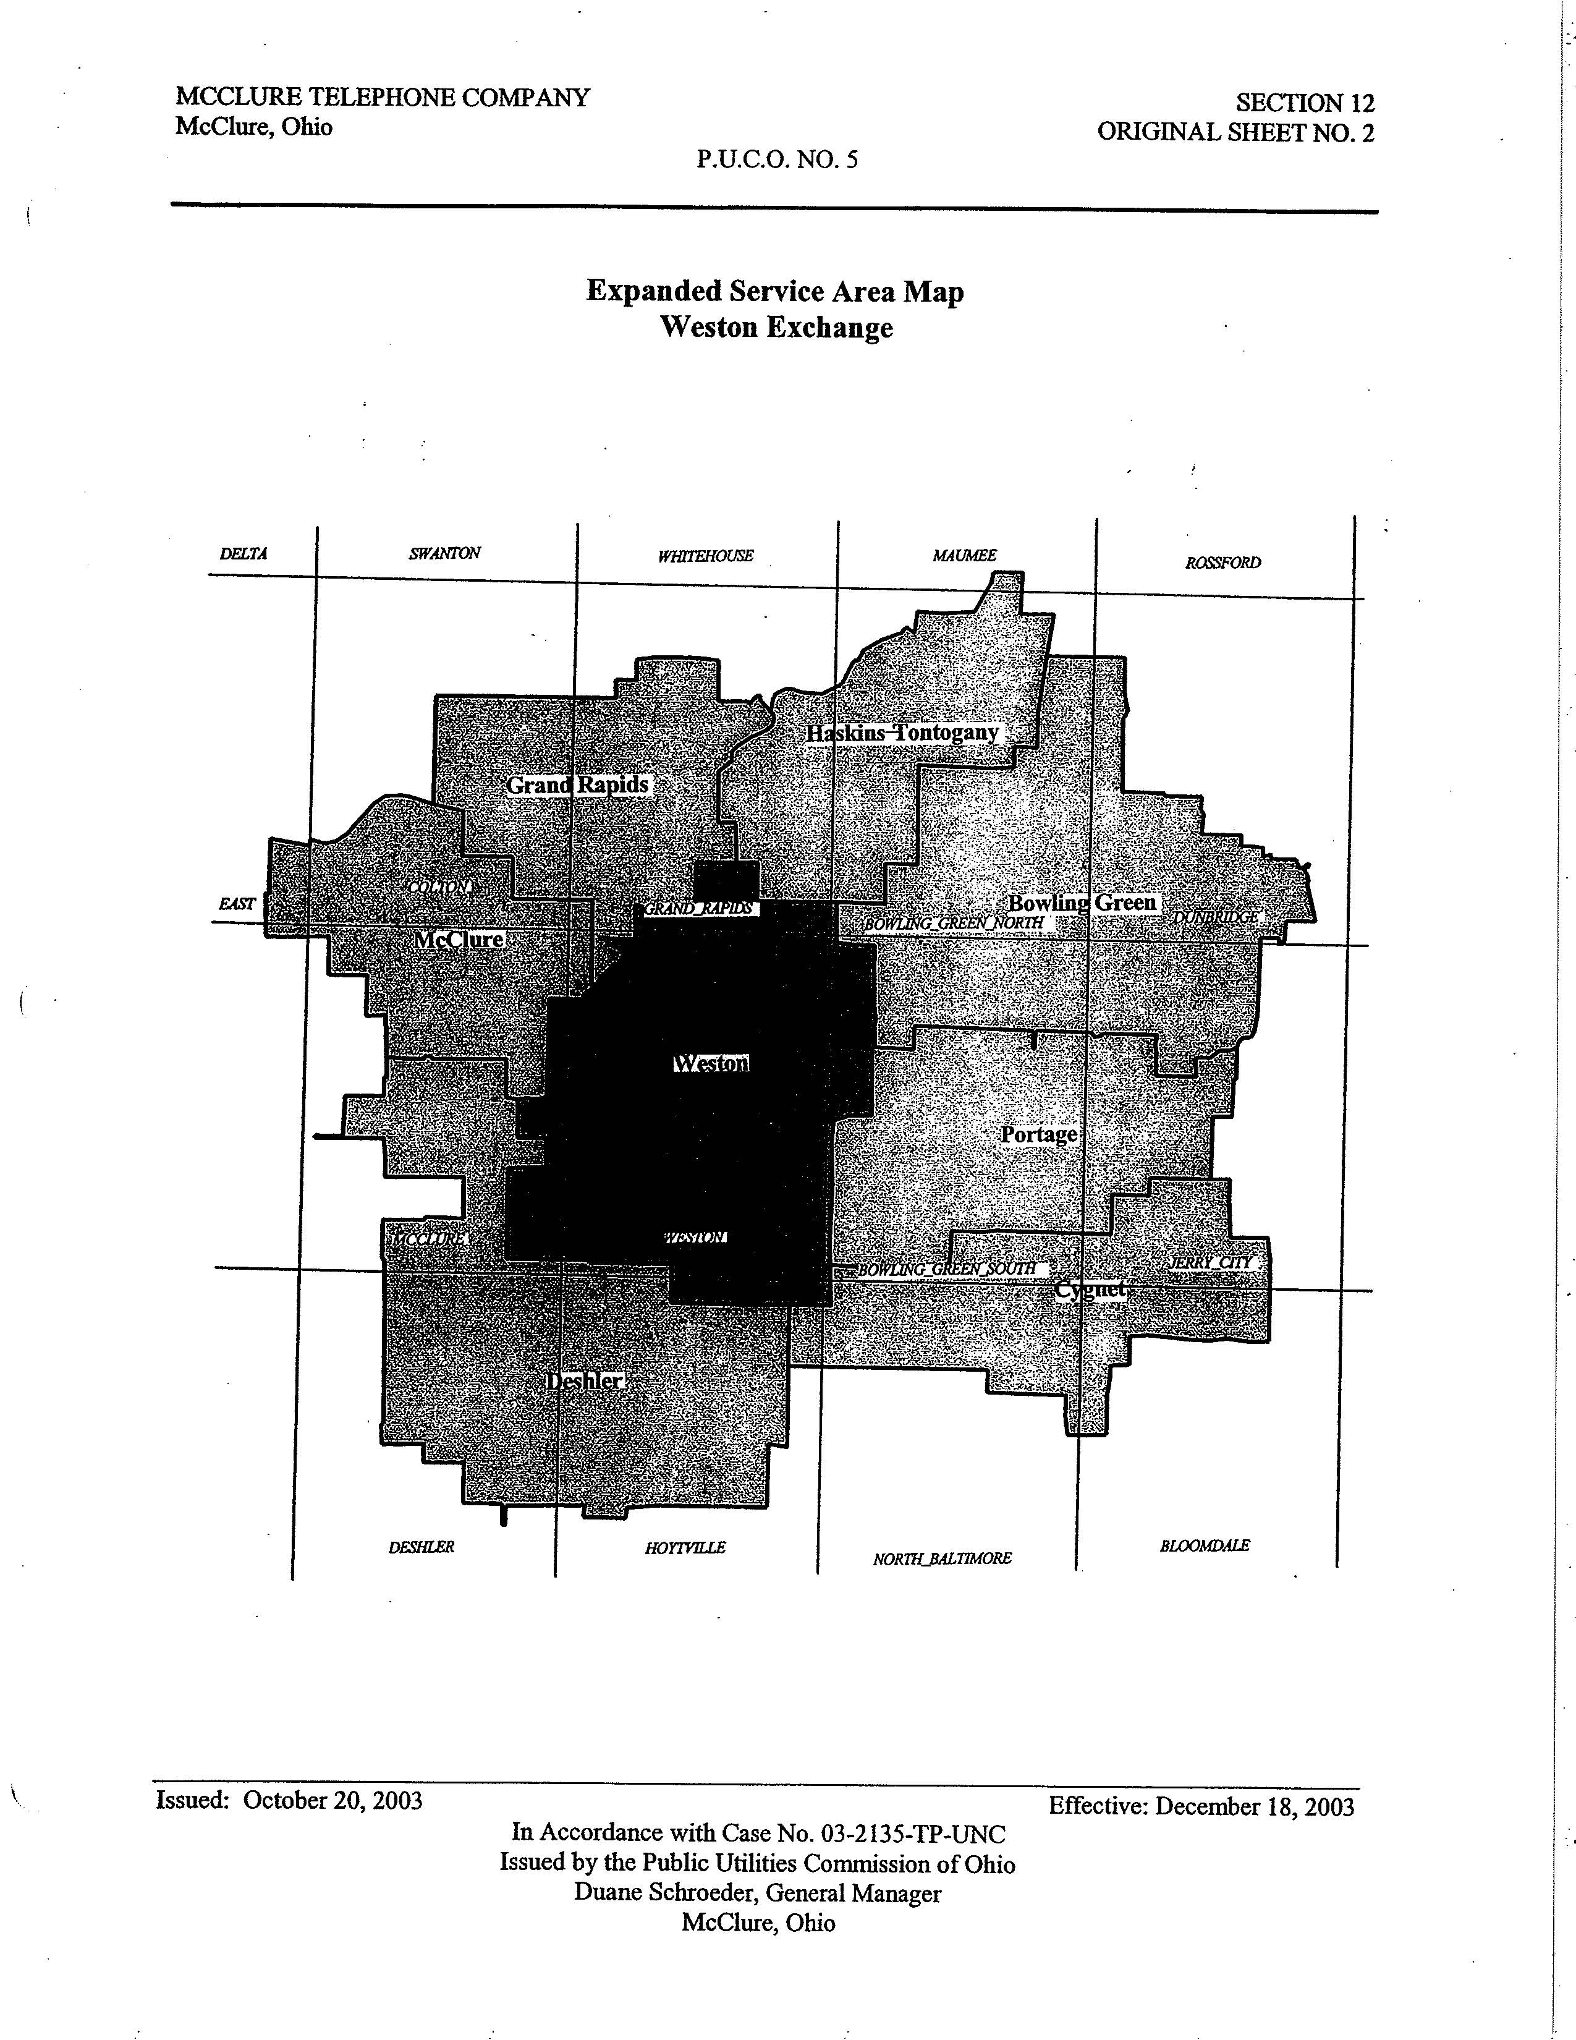

Expanded Service Area Map
Grand Rapids Exchange

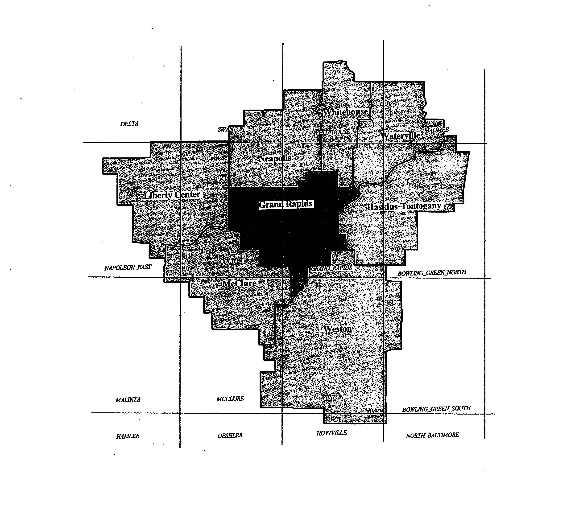

Expanded Service Area Map
Deshler Exchange

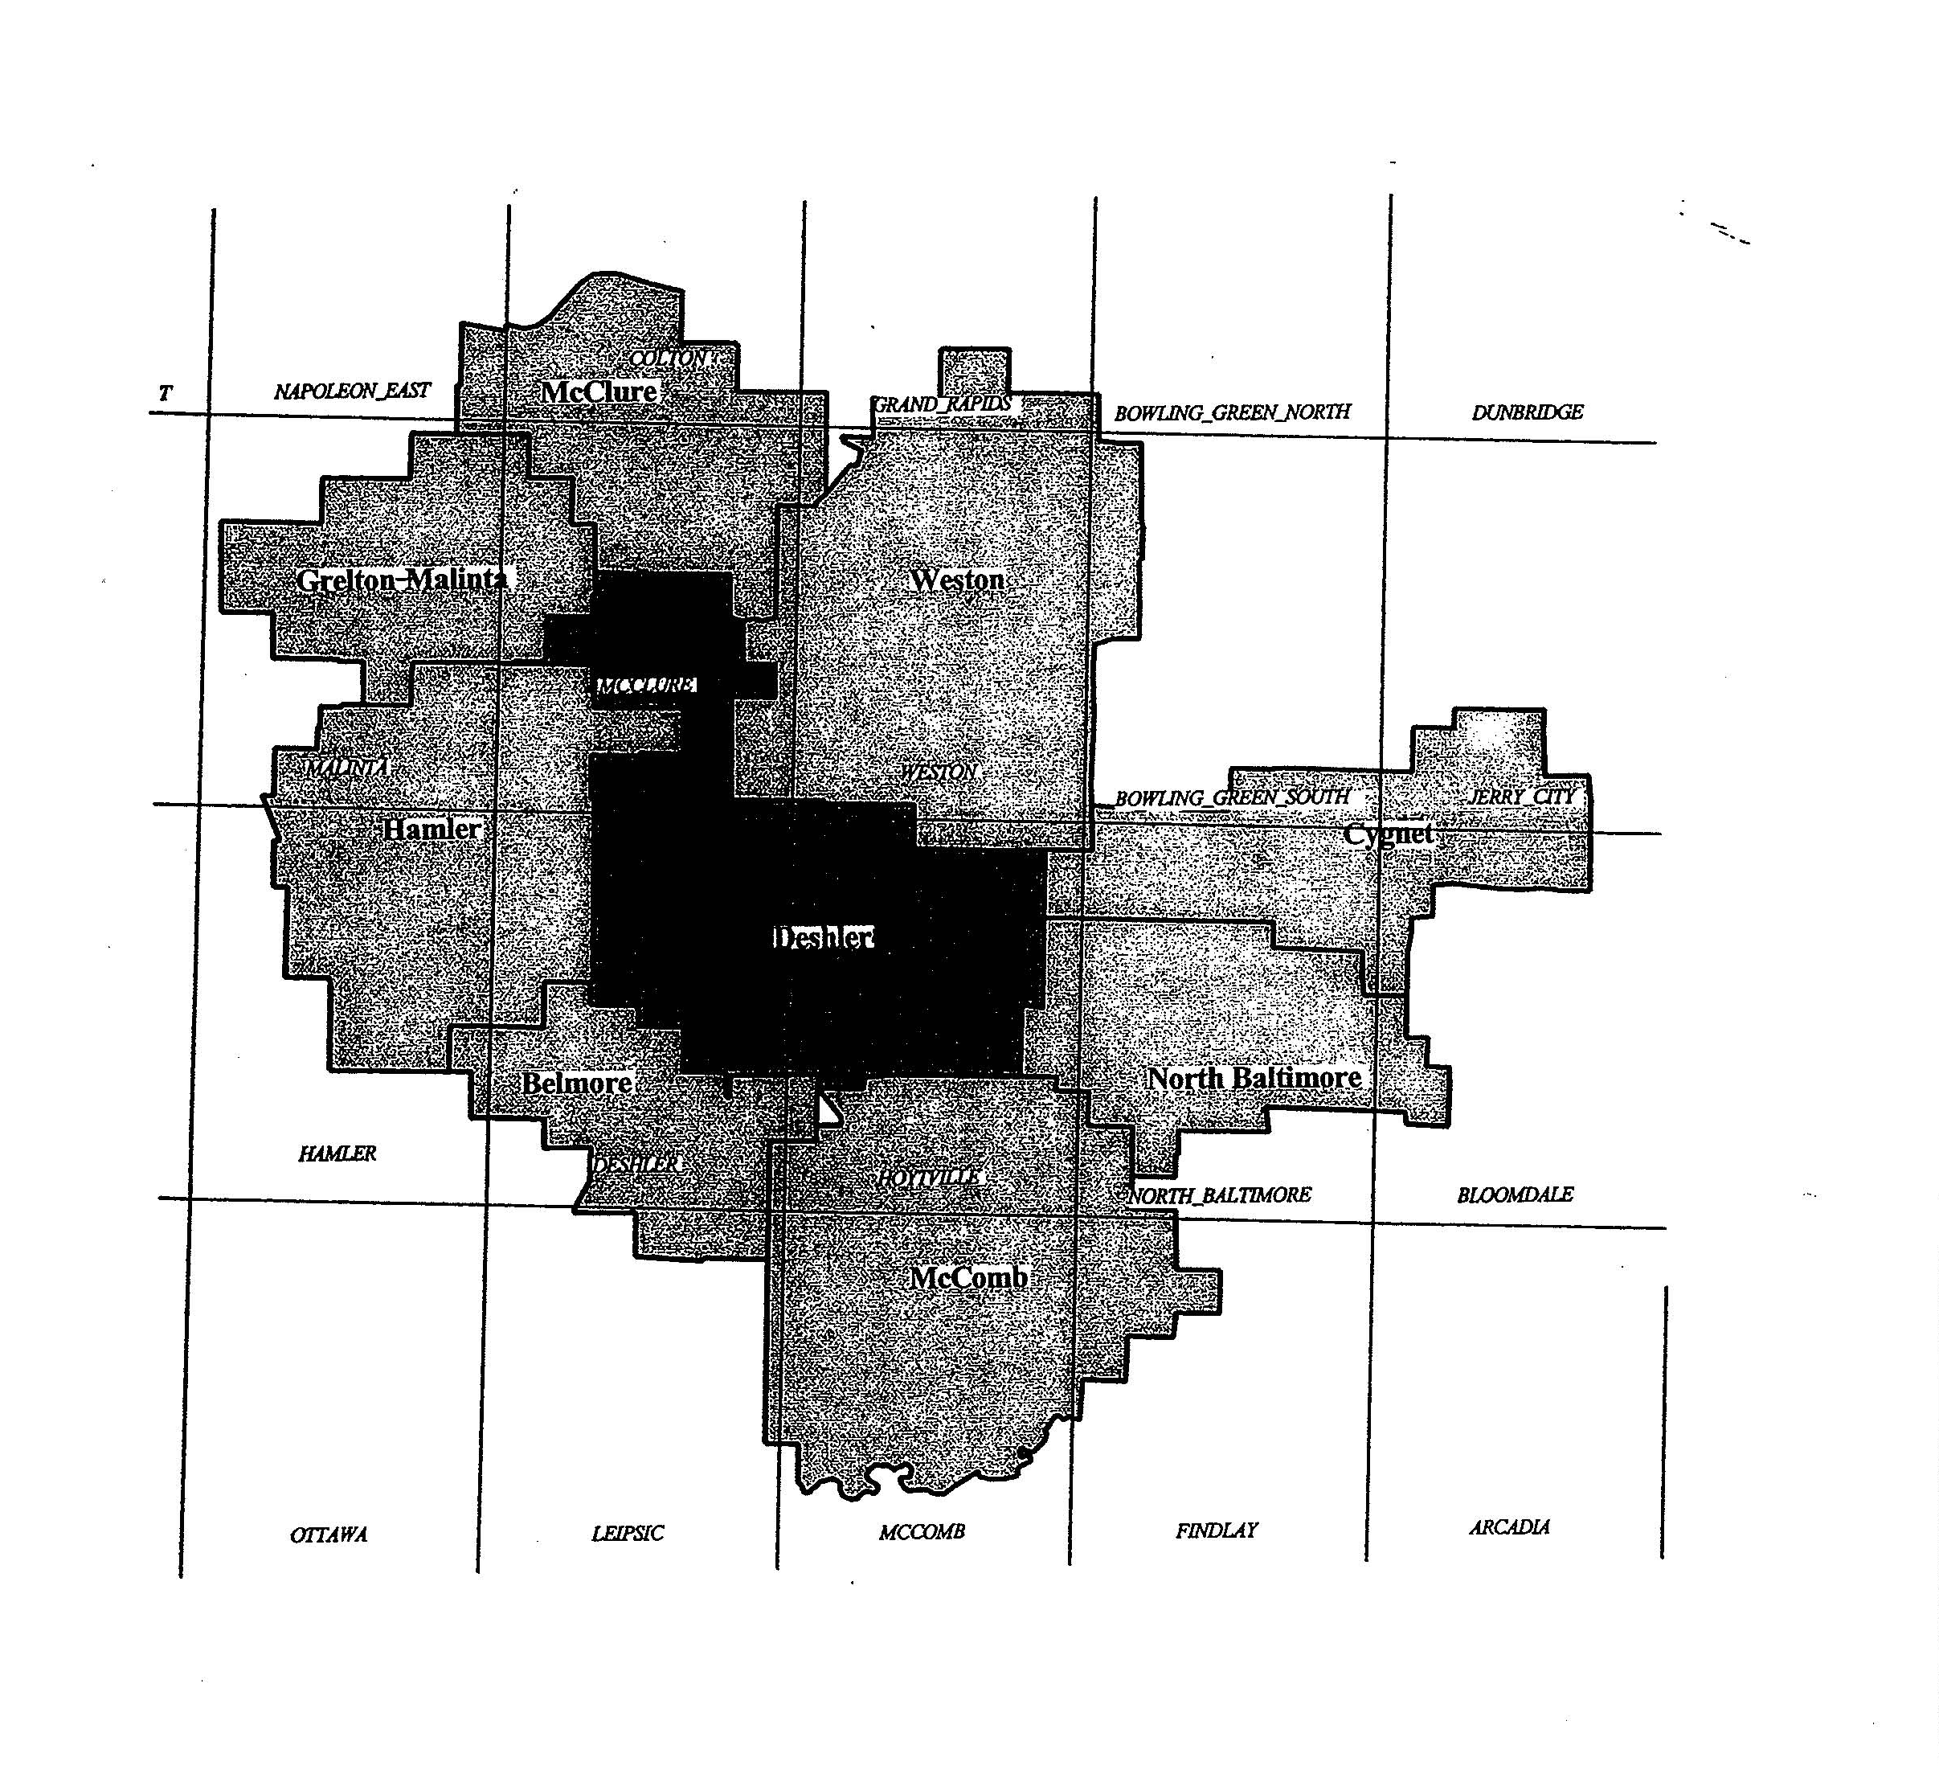

Expanded Service Area Map
Grelton-Malinta Exchange

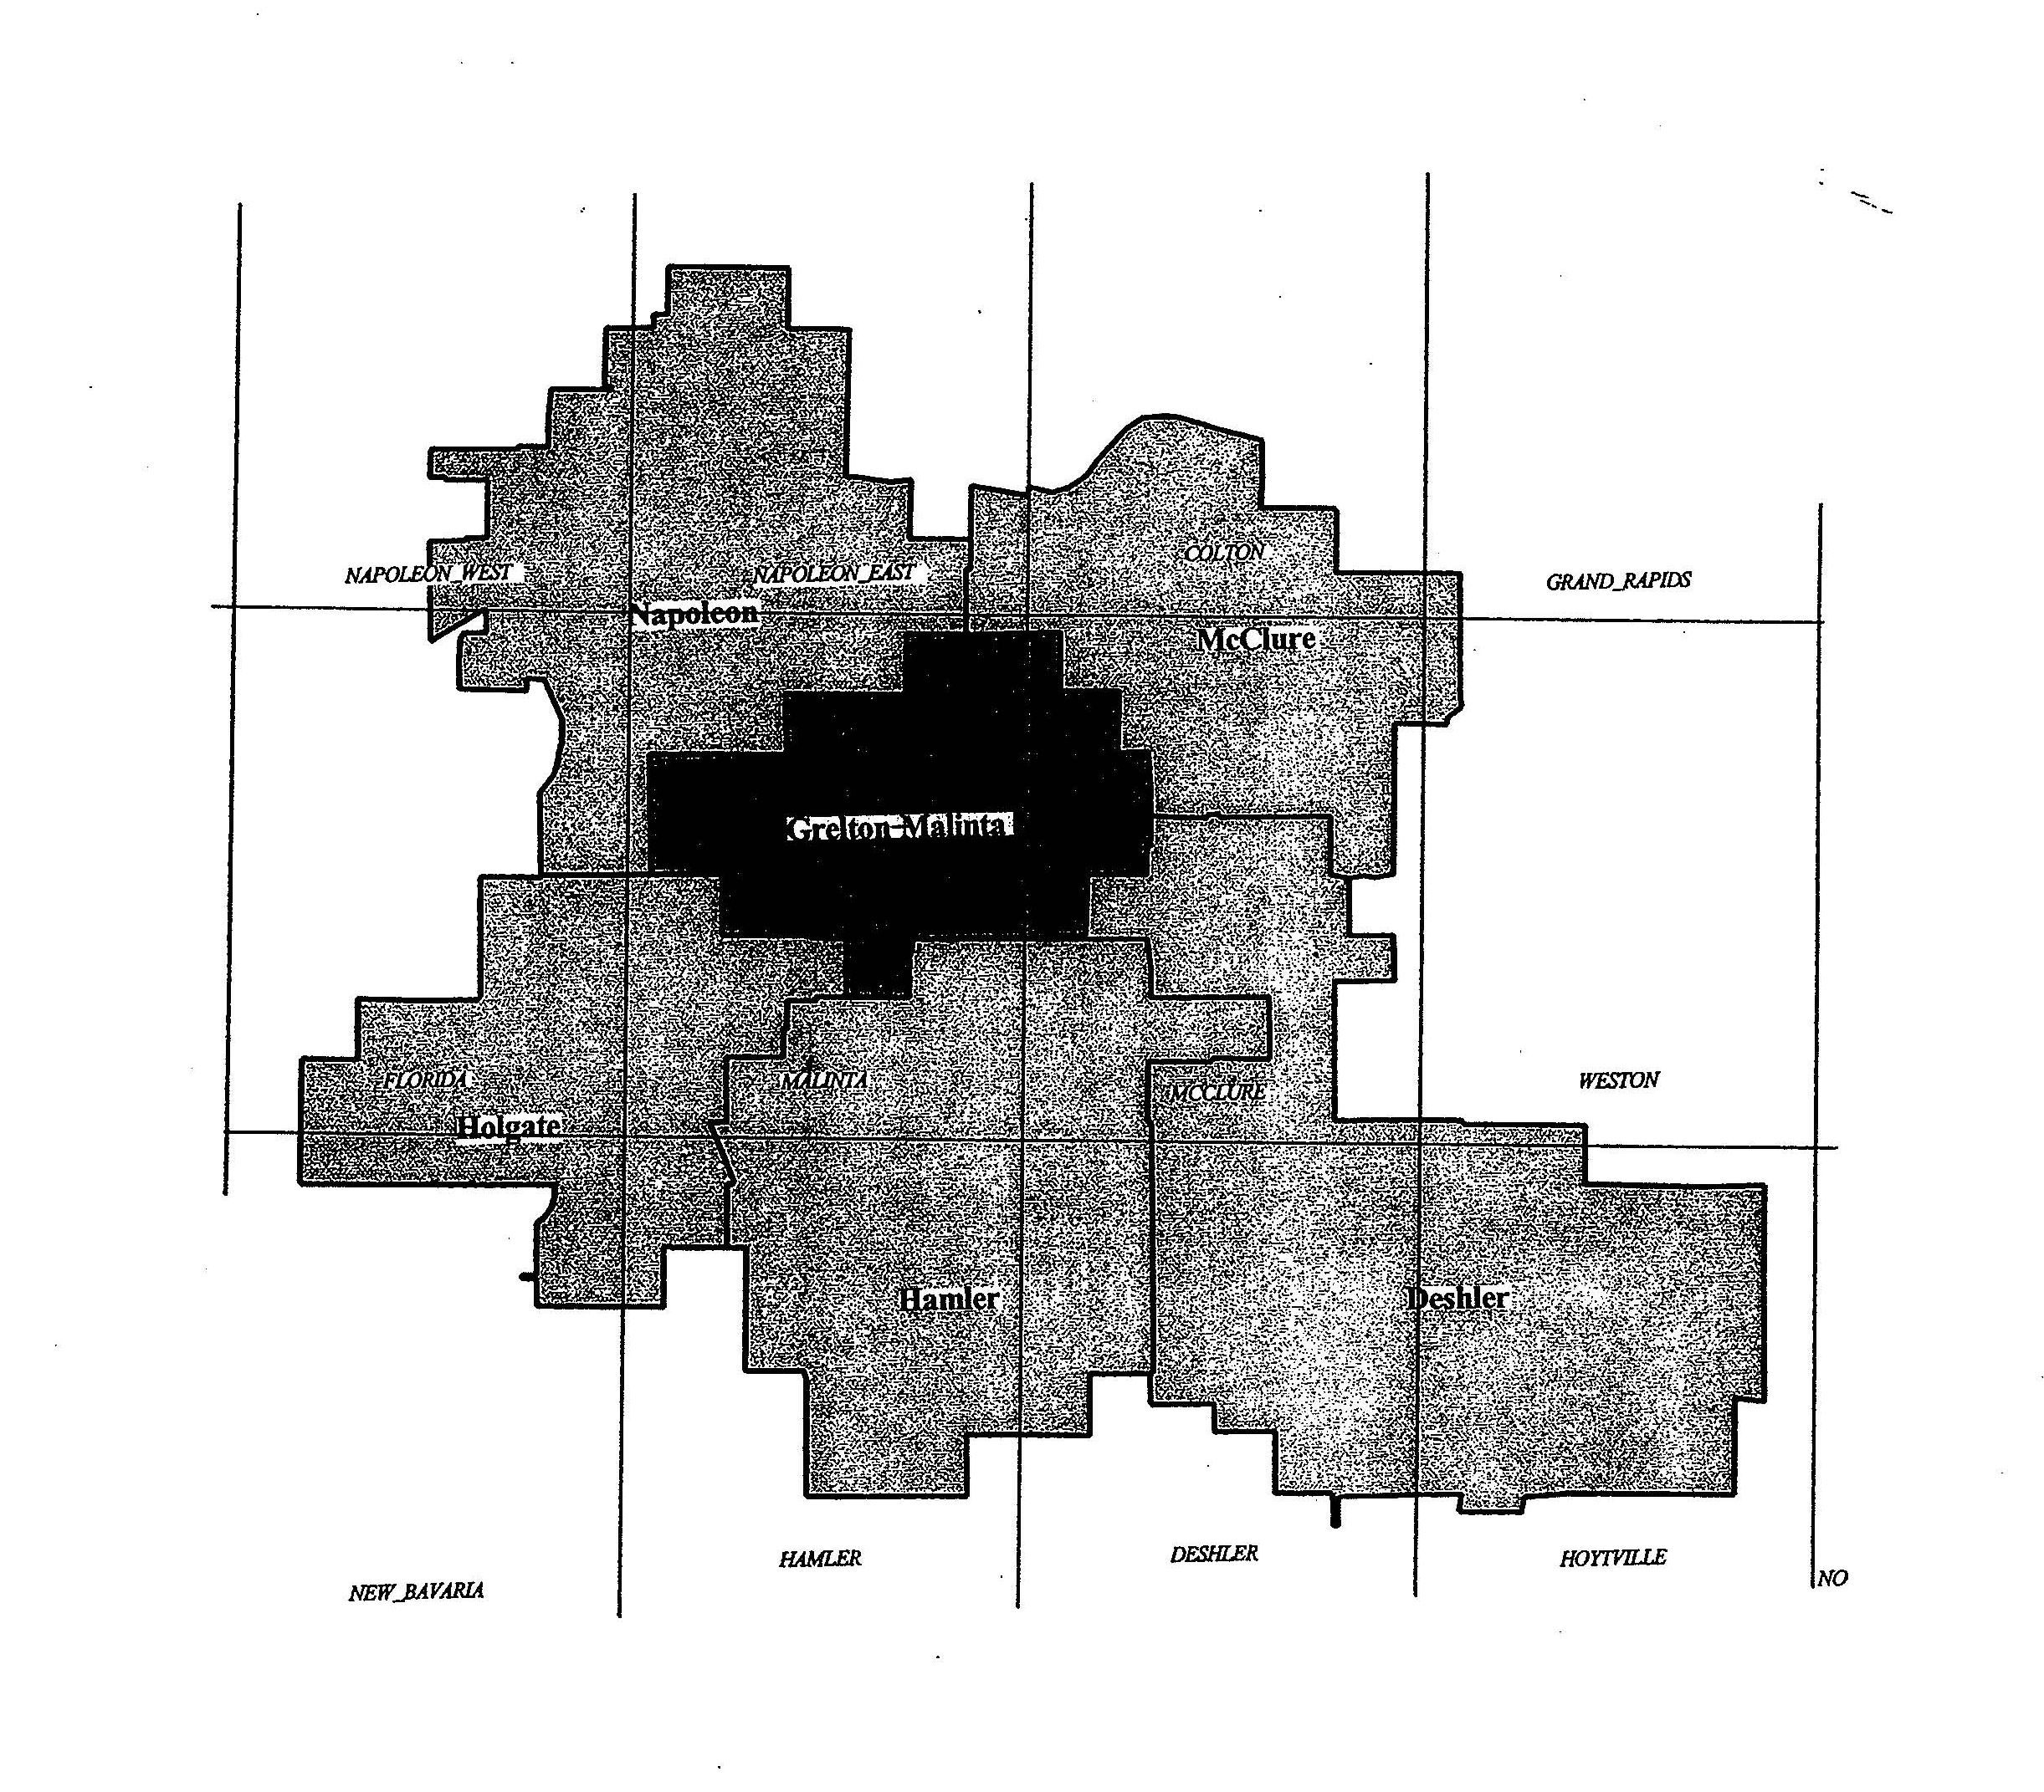

Expanded Service Area Map
Liberty Center Exchange

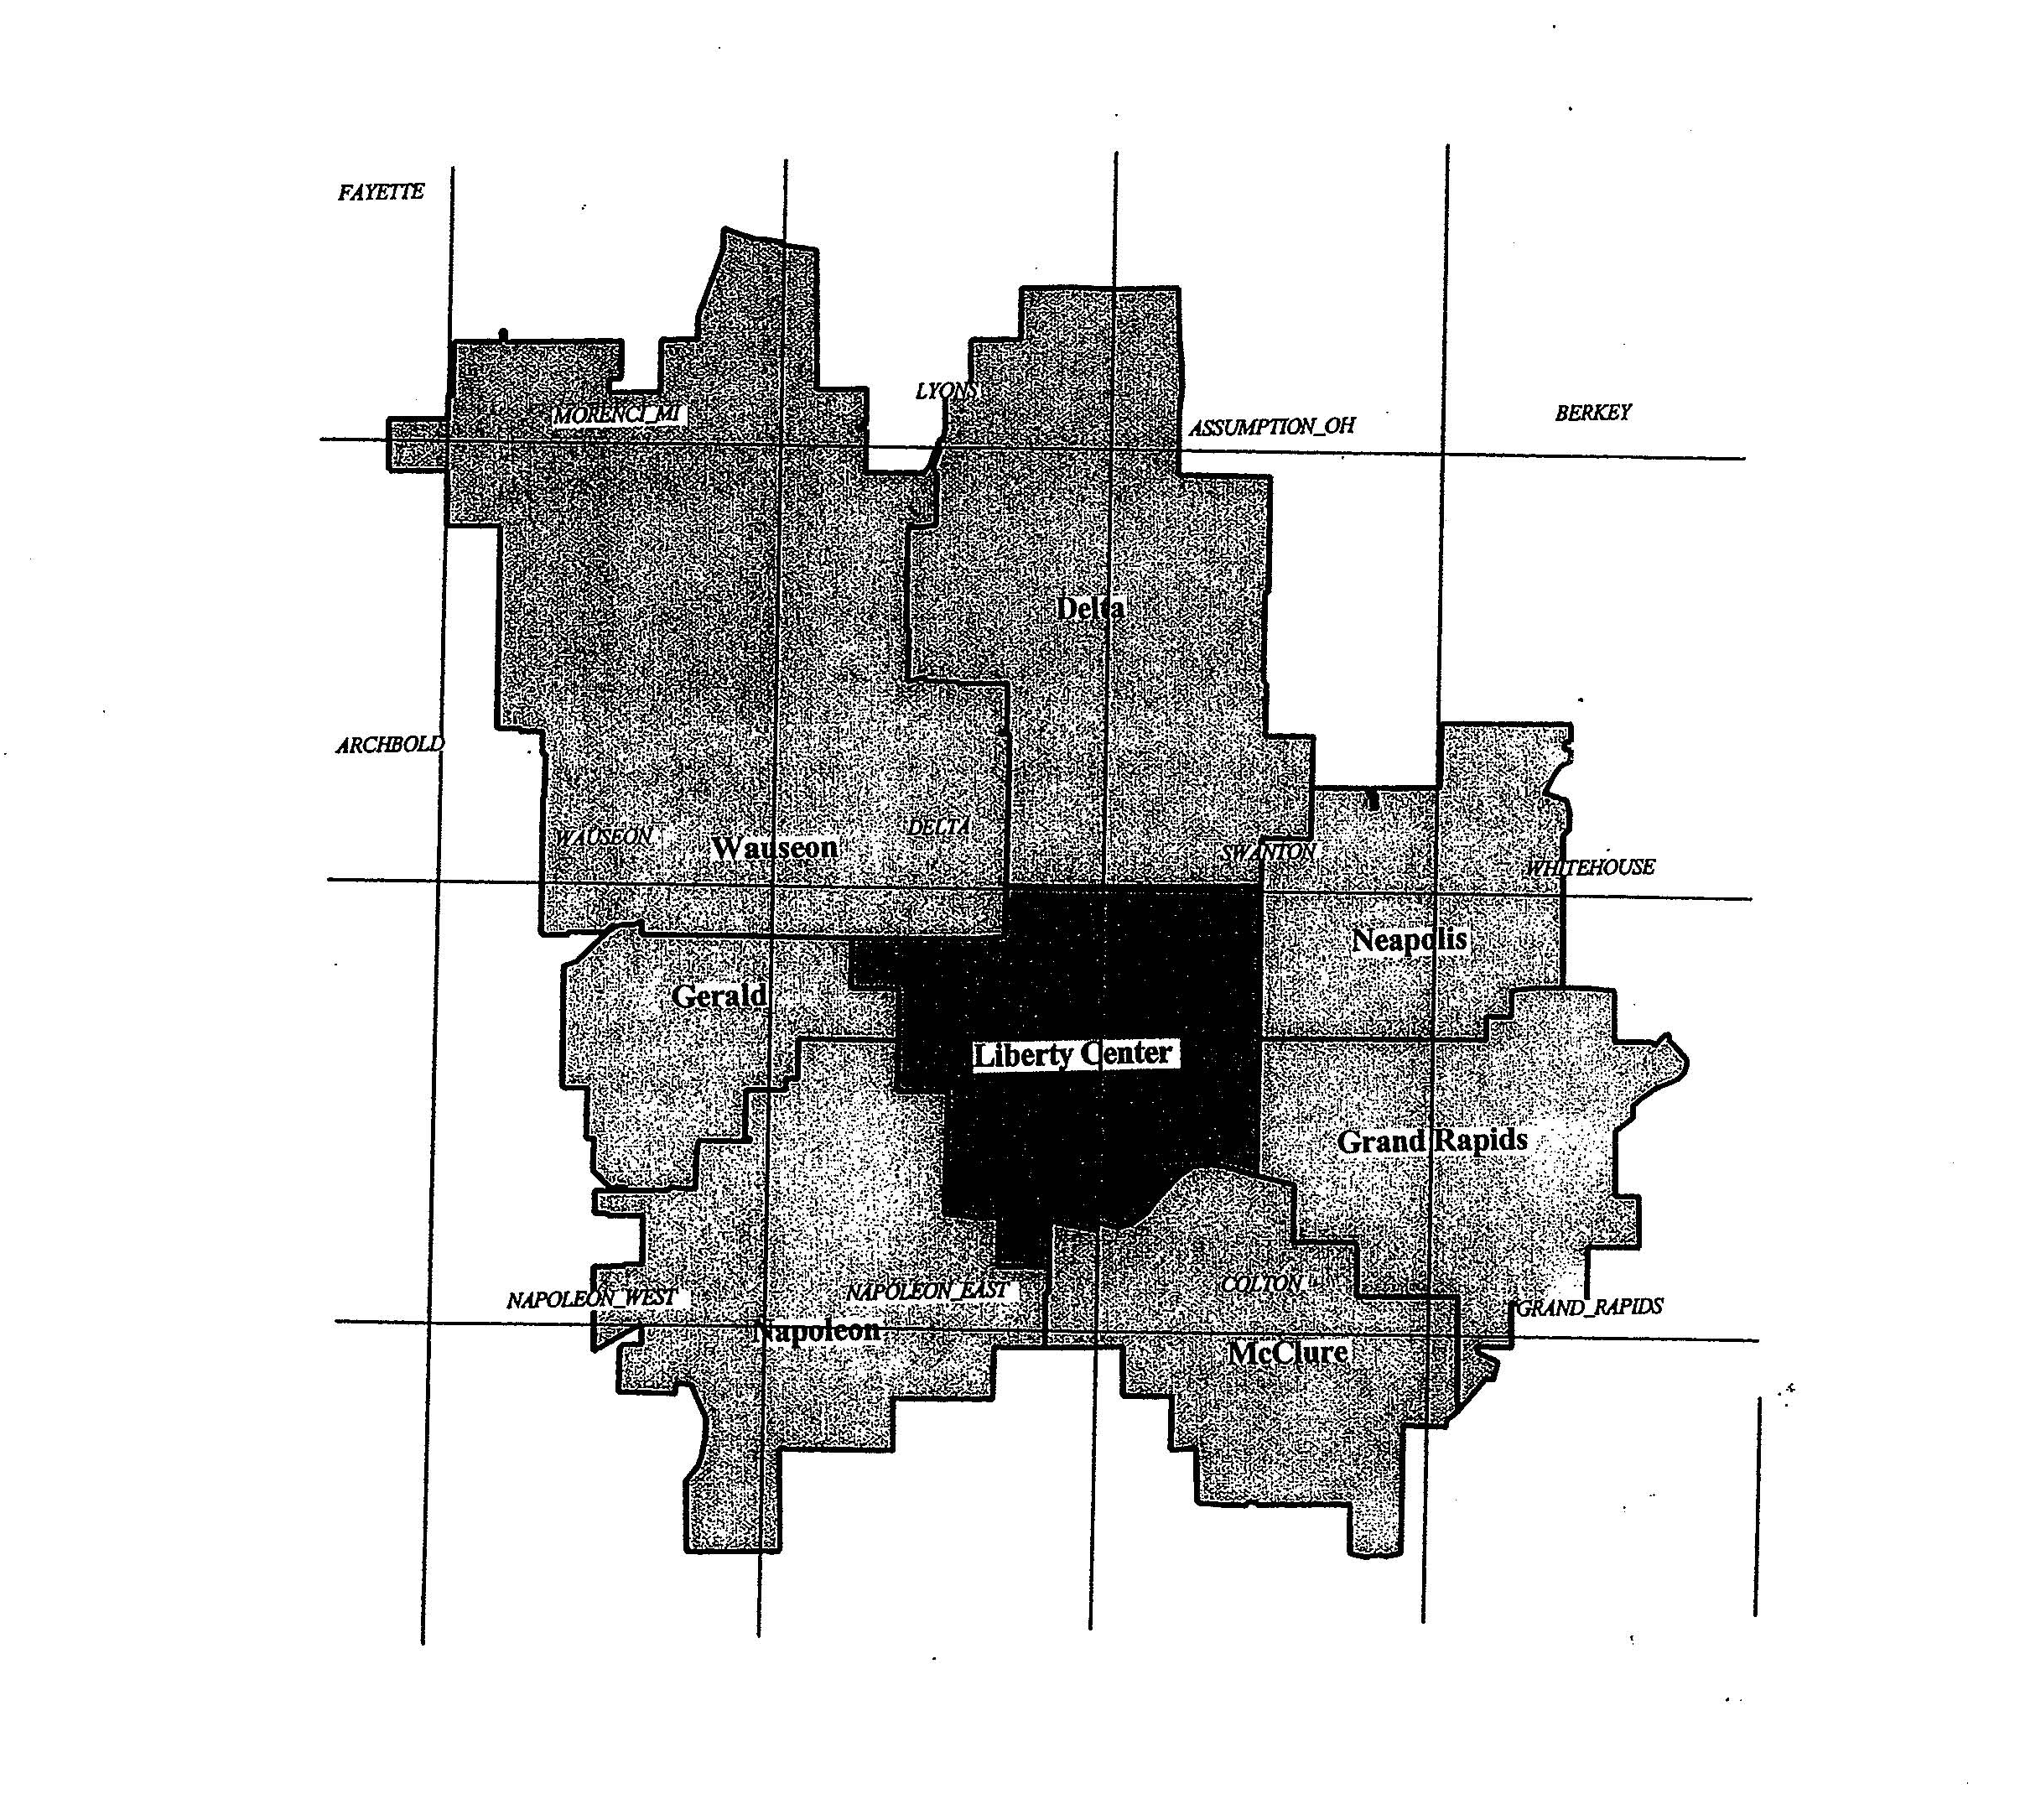

Expanded Service Area Map
Napoleon Exchange

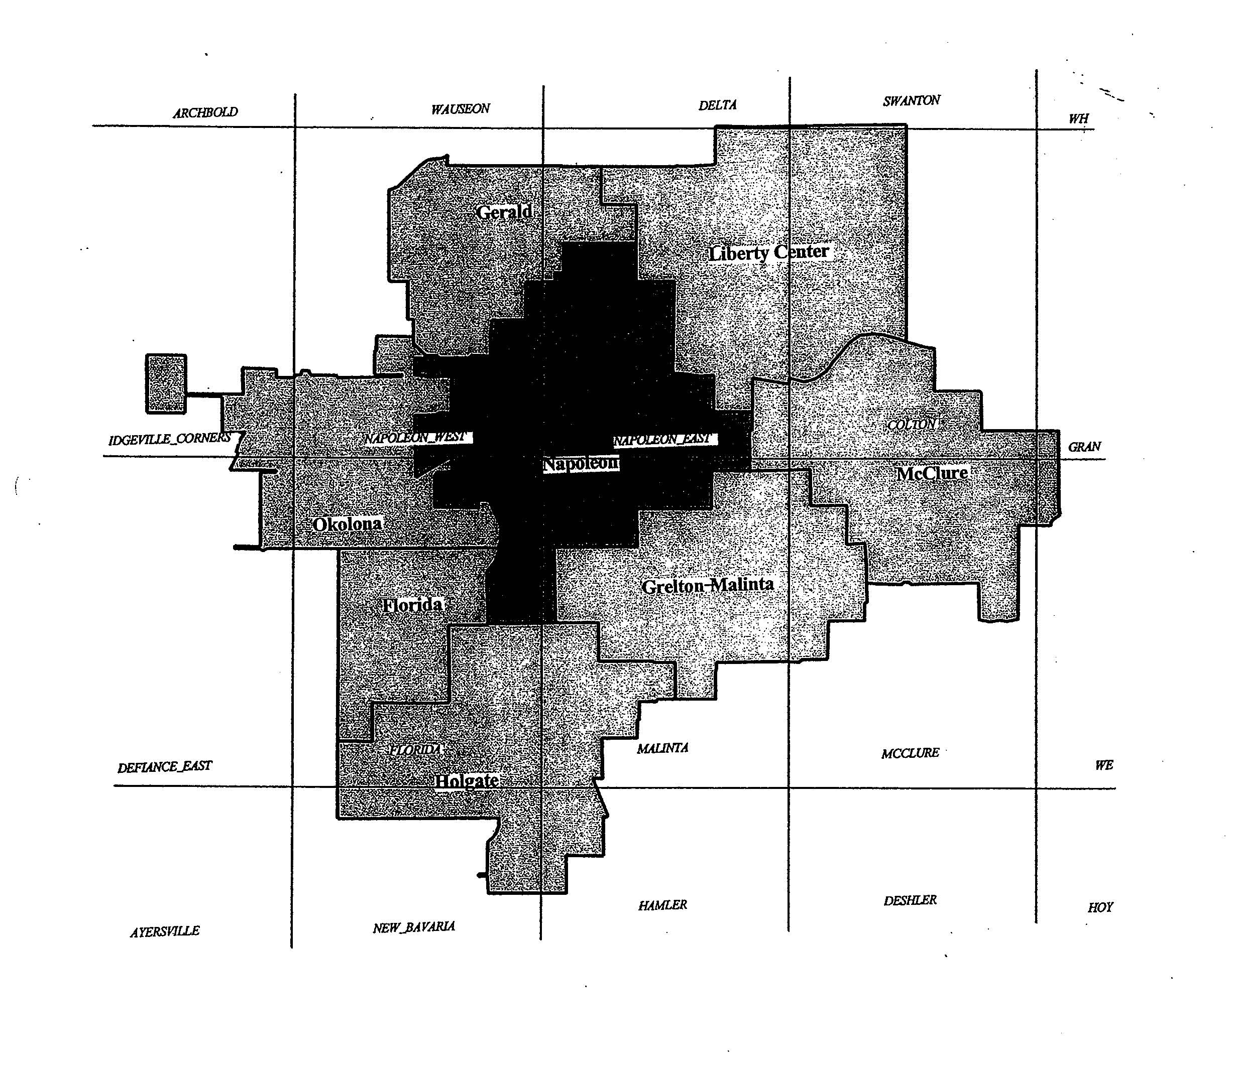

SHARED TENANT SERVICE (STS)
A. | GENERAL
 | 1. | Except where specifically noted herein, this tariff is not intended to apply to the resale of local exchange service by certified local exchange carriers.
 | 2. | This tariff does not permit, by a certified local exchange carrier or any other entity, the purchase of local residential service for resale as business service. Such resale is prohibited.
 | 3. | The STS provider or other reseller may provide service only within a single building, or a contiguous complex of buildings under common ownership or management (such buildings may be intersected by public thoroughfares provided that the property segments created would be continuous in the absence of the thoroughfares). Where separate buildings are involved, they must have a related business purpose (e.g., industrial park, shopping center, university, etc.).
 | 4. | The STS provider or other reseller is the Company’s customer, and will therefore act as the sole point of contact with the Company for orders, service and billing purposes.
 | 5. | Participation in reselling/sharing systems shall be limited to occupants of a building or contiguous complex of buildings which compose a resale/sharing system.
 | 6. | The customer will be responsible for any trouble analysis charges and/or service charges that may be billed by the Company where the Company responds to repair and maintenance requests from the customer’s tenants or users.
 | 7. | Direct interconnection of PBXs serving different resale/sharing systems is prohibited.
 | 8. | Facilities of resellers and/or STS providers must meet FCC Part 68 standards for inside wiring and interconnection of CPE at the point of demarcation with the Company’s switched access network.

 | SHARED TENANT SERVICE (STS) (Continued)
A. | GENERAL (Continued)
 | 9. | Reselling or STS access line service will be provided on a flat business line or trunk rate basis until message rate service facilities become available.
 | 10. | All applicable rates and charges for service will be billed to the customer. The Company will not be responsible for the manner in which the use of service or the charges are allocated to users or tenants by the customer who resells or shares service.
 | 11. | The Company will provide direct local service, upon request, to any tenant in an STS or other resale/sharing system. The Company will obtain access to such tenants either by leasing the existing intra-building wiring from the STS provider, or by utilizing or installing its own facilities.
B. | RATES
 | 1. | The monthly rate for access line service which is resold or shared will be determined as provided in Section 1 of this tariff.
 | 2. | Directory listings for the tenants or users of customers who resell or share services will be provided at the rates for business additional listings as shown in Section 1 of this tariff. Residential tenants listings will be placed in the residential section of the directory, when so notified by the STS provider.
 | 3. | Service Order and Line Connection Charges as specified in Section 1 of this tariff will apply for the installation of access line service.

