The Public Utilities Commission of Ohio
TELECOMMUNICATIONS FILING FORM
(Effective: 01/20/2011)
This form is intended to be used with most types of required filings. It provides check boxes with rule references for the most common types of filings. It does not replace or supersede Commission rules in any way.

In the Matter of the Application of Buckland Telephone Company for Approval of an Amendment to the Agreement for Transport and Termination of Traffic with New Cingular Wireless Headquarters, LLC and its Affiliates

)
)
)
)
TRF Docket No. __________
Case No. 12 - 1240 -TP - NAG
NOTE: Unless you have reserved a Case #, leave the “Case No” fields BLANK.

Name of Registrant(s) Buckland Telephone Company
DBA(s) of Registrant(s)
Address of Registrant(s) 105 S. Main Street, Buckland, OH 45819
Company Web Address
Regulatory Contact Person(s) Carolyn S. Flahive | Phone 614-469-3294 | Fax 614-469-3361
Regulatory Contact Person’s Email Address Carolyn.Flahive@ThompsonHine.com
Contact Person for Annual Report Douglas G. Place, General Manager |  | Phone 419-657-2222
Address (if different from above)
Consumer Contact Information Douglas G. Place, General Manager |  | Phone 419-657-2222
Address (if different from above)
Motion for protective order included with filing? Yes No
Motion for waiver(s) filed affecting this case? Yes No [Note: Waivers may toll any automatic timeframe.]

Notes:

Section I and II are Pursuant to Chapter 4901:1-6 OAC.
Section III – Carrier to Carrier is Pursuant to 4901:1-7 OAC, and Wireless is Pursuant to 4901:1-6-24 OAC.
Section IV – Attestation.

- Indicate the Carrier Type and the reason for submitting this form by checking the boxes below.

(2) For requirements for various applications, see the identified section of Ohio Administrative Code Section 4901 and/or the supplemental application form noted.

(3) Information regarding the number of copies required by the Commission may be obtained from the Commission’s web site at www.puco.ohio.gov under the docketing information system section, by calling the docketing division at 614-466-4095, or by visiting the docketing division at the offices of the Commission.

(4) An Incumbent Local Exchange Carrier (ILEC) offering basic local exchange service (BLES) outside its traditional service area should choose CLEC designation when proposing to offer BLES outside its traditional service area or when proposing to make changes to that service.

All Filings that result in a change to one or more tariff pages require, at a minimum, the following exhibits.
Exhibit | Description:
A | The tariff pages subject to the proposed change(s) as they exist before the change(s)
B | The Tariff pages subject to the proposed change(s), reflecting the change, with the change(s) marked in the right margin.
C | A short description of the nature of the change(s), the intent of the change(s), and the customers affected.
D | A copy of the notice provided to customers, along with an affidavit that the notice was provided according to the applicable rule(s).

Section I – Part I - Common Filings

Carrier Type  Other (explain below) | For Profit ILEC | Not For Profit ILEC | CLEC
Change terms & conditions of existing BLES | ATA 1-6-14(H)  (Auto 30 days) | ATA 1-6-14(H)  (Auto 30 days) | ATA 1-6-14(H)  (Auto 30 days)
Introduce non-recurring charge, surcharge, or fee to BLES |  |  | ATA 1-6-14(H)  (Auto 30 days)
Introduce or Increase Late Payment | ATA 1-6-14(I)  (Auto 30 days) | ATA 1-6-14(I)  (Auto 30 days) | ATA 1-6-14(I)  (Auto 30 days)
Revisions to BLES Cap. | ZTA 1-6-14(F)  (0 day Notice)
Introduce BLES or expand local service area (calling area) | ZTA 1-6-14(H)  (0 day Notice) | ZTA 1-6-14(H)  (0 day Notice) | ZTA 1-6-14(H)  (0 day Notice)
Notice of no obligation to construct facilities and provide BLES | ZTA 1-6-27(C)  (0 day Notice) | ZTA 1-6-27(C)  (0 day Notice)
Change BLES Rates | TRF 1-6-14(F)  (0 day Notice) | TRF 1-6-14(F)(4)  (0 day Notice) | TRF 1-6-14(G)  (0 day Notice)
To obtain BLES pricing flexibility | BLS 1-6-14 (C)(1)(c)  (Auto 30 days)
Change in boundary | ACB 1-6-32  (Auto 14 days) | ACB 1-6-32  (Auto 14 days)
Expand service operation area |  |  | TRF 1-6-08(G)(0 day)
BLES withdrawal |  |  | ZTA 1-6-25(B)  (0 day Notice)
Other* (explain)

Section I – Part II – Customer Notification Offerings Pursuant to Chapter 4901:1-6-7 OAC

Type of Notice | Direct Mail | Bill Insert | Bill Notation | Electronic Mail
15-day Notice
30-day Notice
Date Notice Sent:

Section I – Part III –IOS Offerings Pursuant to Chapter 4901:1-6-22 OAC

IOS | Introduce New | Tariff Change | Price Change | Withdraw
IOS

Section II – Part I – Carrier Certification - Pursuant to Chapter 4901:1-6-08, 09 & 10 OAC

Certification | ILEC  (Out of Territory) | CLEC | Telecommunications Service Provider Not Offering Local | CESTC | CETC
* See Supplemental form | ACE 1-6-08  * (Auto 30- day) | ACE 1-6-08  *(Auto 30 day) | ACE 1-6-08  *(Auto 30 day) | ACE 1-6-10  (Auto 30 day) | UNC1-6-09  *(Non-Auto)
*Supplemental Certification forms can be found on the Commission Web Page.

Section II – Part II – Certificate Status & Procedural

Certificate Status | ILEC | CLEC | Telecommunications Service Provider Not Offering Local
Abandon all Services |  | ABN 1-6-26  (Auto 30 days) | ABN 1-6-26  (Auto 30 days)
Change of Official Name * | ACN 1-6-29(B)  (Auto 30 days) | ACN 1-6-29(B)  (Auto 30 days) | CIO 1-6-29(C)  (0 day Notice)
Change in Ownership * | ACO 1-6-29(E)  (Auto 30 days) | ACO 1-6-29(E)  (Auto 30 days) | CIO 1-6-29(C)  (0 day Notice)
Merger * | AMT 1-6-29(E)  (Auto 30 days) | AMT 1-6-29(E)  (Auto 30 days) | CIO 1-6-29(C)  (0 day Notice)
Transfer a Certificate * | ATC 1-6-29(B)  (Auto 30 days) | ATC 1-6-29(B)  (Auto 30 days) | CIO 1-6-29(C)  (0 day Notice)
Transaction for transfer or lease of property, plant or business * | ATR 1-6-29(B)  (Auto 30 days) | ATR 1-6-29(B)  (Auto 30 days) | CIO 1-6-29(C)  (0 day Notice)

* Other exhibits may be required under the applicable rule(s). ACN, ACO, AMT, ATC, ATR and CIO applications see the 4901:1-6-29 Filing Requirements on the Commission's Web Page for a complete list of exhibits.

Section III – Carrier to Carrier (Pursuant to 4901:1-7), and Wireless (Pursuant to 4901:1-6-24)

Carrier to Carrier | ILEC | CLEC
Interconnection agreement, or amendment to an approved agreement | NAG 1-7-07  (Auto 90 day) | NAG 1-7-07  (Auto 90 day)
Request for Arbitration | ARB 1-7-09  (Non-Auto) | ARB 1-7-09  (Non-Auto)
Introduce or change c-t-c service tariffs, | ATA 1-7-14  (Auto 30 day) | ATA 1-7-14  (Auto 30 day)
Request rural carrier exemption, rural carrier suspension or modification | UNC1-7-04 or 05  (Non-Auto)
Changes in rates, terms & conditions to Pole Attachment, Conduit Occupancy and Rights-of-Way. | UNC 1-7-23(B)  (Non-Auto)
Wireless Providers See 4901:1-6-24 | RCC  [Registration & Change in Operations]  (0 day) | NAG  [Interconnection Agreement or Amendment] (Auto 90 days)

Section IV. – Attestation

Registrant hereby attests to its compliance with pertinent entries and orders issued by the Commission.

AFFIDAVIT
Compliance with Commission Rules

I am an officer/agent of the applicant corporation, Buckland Telephone Company, and am authorized to make this statement on its behalf.

(Name)

Please Check ALL that apply:

I attest that these tariffs comply with all applicable rules for the state of Ohio. I understand that tariff notification filings do not imply Commission approval and that the Commission’s rules as modified and clarified from time to time, supersede any contradictory provisions in our tariff. We will fully comply with the rules of the state of Ohio and understand that noncompliance can result in various penalties, including the suspension of our certificate to operate within the state of Ohio.

I attest that customer notices accompanying this filing form were sent to affected customers, as specified in Section II, in accordance with Rule 4901:1-6-7, Ohio Administrative Code.

I declare under penalty of perjury that the foregoing is true and correct.

Executed on (Date) ____________ |  | at (Location)
 | *(Signature and Title) |  |  | (Date) ______________
- This affidavit is required for every tariff-affecting filing. It may be signed by counsel or an officer of the applicant, or an authorized agent of the applicant.

VERIFICATION

I, Carolyn S. Flahive, verify that I have utilized the Telecommunications Filing Form for most proceedings provided by the Commission and that all of the information submitted here, and all additional information submitted in connection with this case, is true and correct to the best of my knowledge.

*(Signature and Title) /s/ Carolyn S. Flahive, Esq. |  |  | (Date) April 16, 2012
*Verification is required for every filing. It may be signed by counsel or an officer of the applicant, or an authorized agent of the applicant.
Send your completed Application Form, including all required attachments as well as the required number of copies, to:

Public Utilities Commission of Ohio
Attention: Docketing Division
180 East Broad Street, Columbus, OH 43215-3793
Or
Make such filing electronically as directed in Case No 06-900-AU-WVR

BEFORE
THE PUBLIC UTILITIES COMMISSION OF OHIO

In the Matter of the Application of Buckland )
Telephone Company for Approval of an Amendment to the ) Case No. 12-1240-TP-NAG
Agreement for Transport and Termination of Traffic with )
New Cingular Wireless Headquarters, LLC and its Affiliates )

APPLICATION FOR APPROVAL OF AN INTERCONNECTION AGREEMENT
AMENDMENT PURSUANT TO THE TELECOMMUNICATIONS ACT OF 1996

Buckland Telephone Company (“Buckland”) hereby files the attached Amendment to the Agreement for Transport and Termination of Traffic that is dated October 1, 2004, between Buckland Telephone Company and New Cingular Wireless Headquarters, LLC and its affiliates (the “Agreement”) for review and approval by the Commission pursuant to the provisions of Section 252(e) of the Telecommunications Act of 1996, Pub. L. No. 104-104, 110 Stat. 56 (1996) (codified at 47 U.S.C. 151 et. seq.) (“the Act”). The Amendment has been arrived at through good faith negotiations between the Parties as contemplated by Section 252(a) of the Act.
The Agreement was approved by the Commission in Case No. 05-193-TP-NAG. Buckland requests that the Commission approve the Amendment.
Respectfully submitted,
BUCKLAND TELEPHONE COMPANY
By: /s/ Carolyn S. Flahive
Carolyn S. Flahive (0072404)
THOMPSON HINE LLP
41 South High Street
Suite 1700
Columbus, Ohio 43215-6101
Telephone: 614-469-3200
Fax: 614-469-3361
Its Attorney
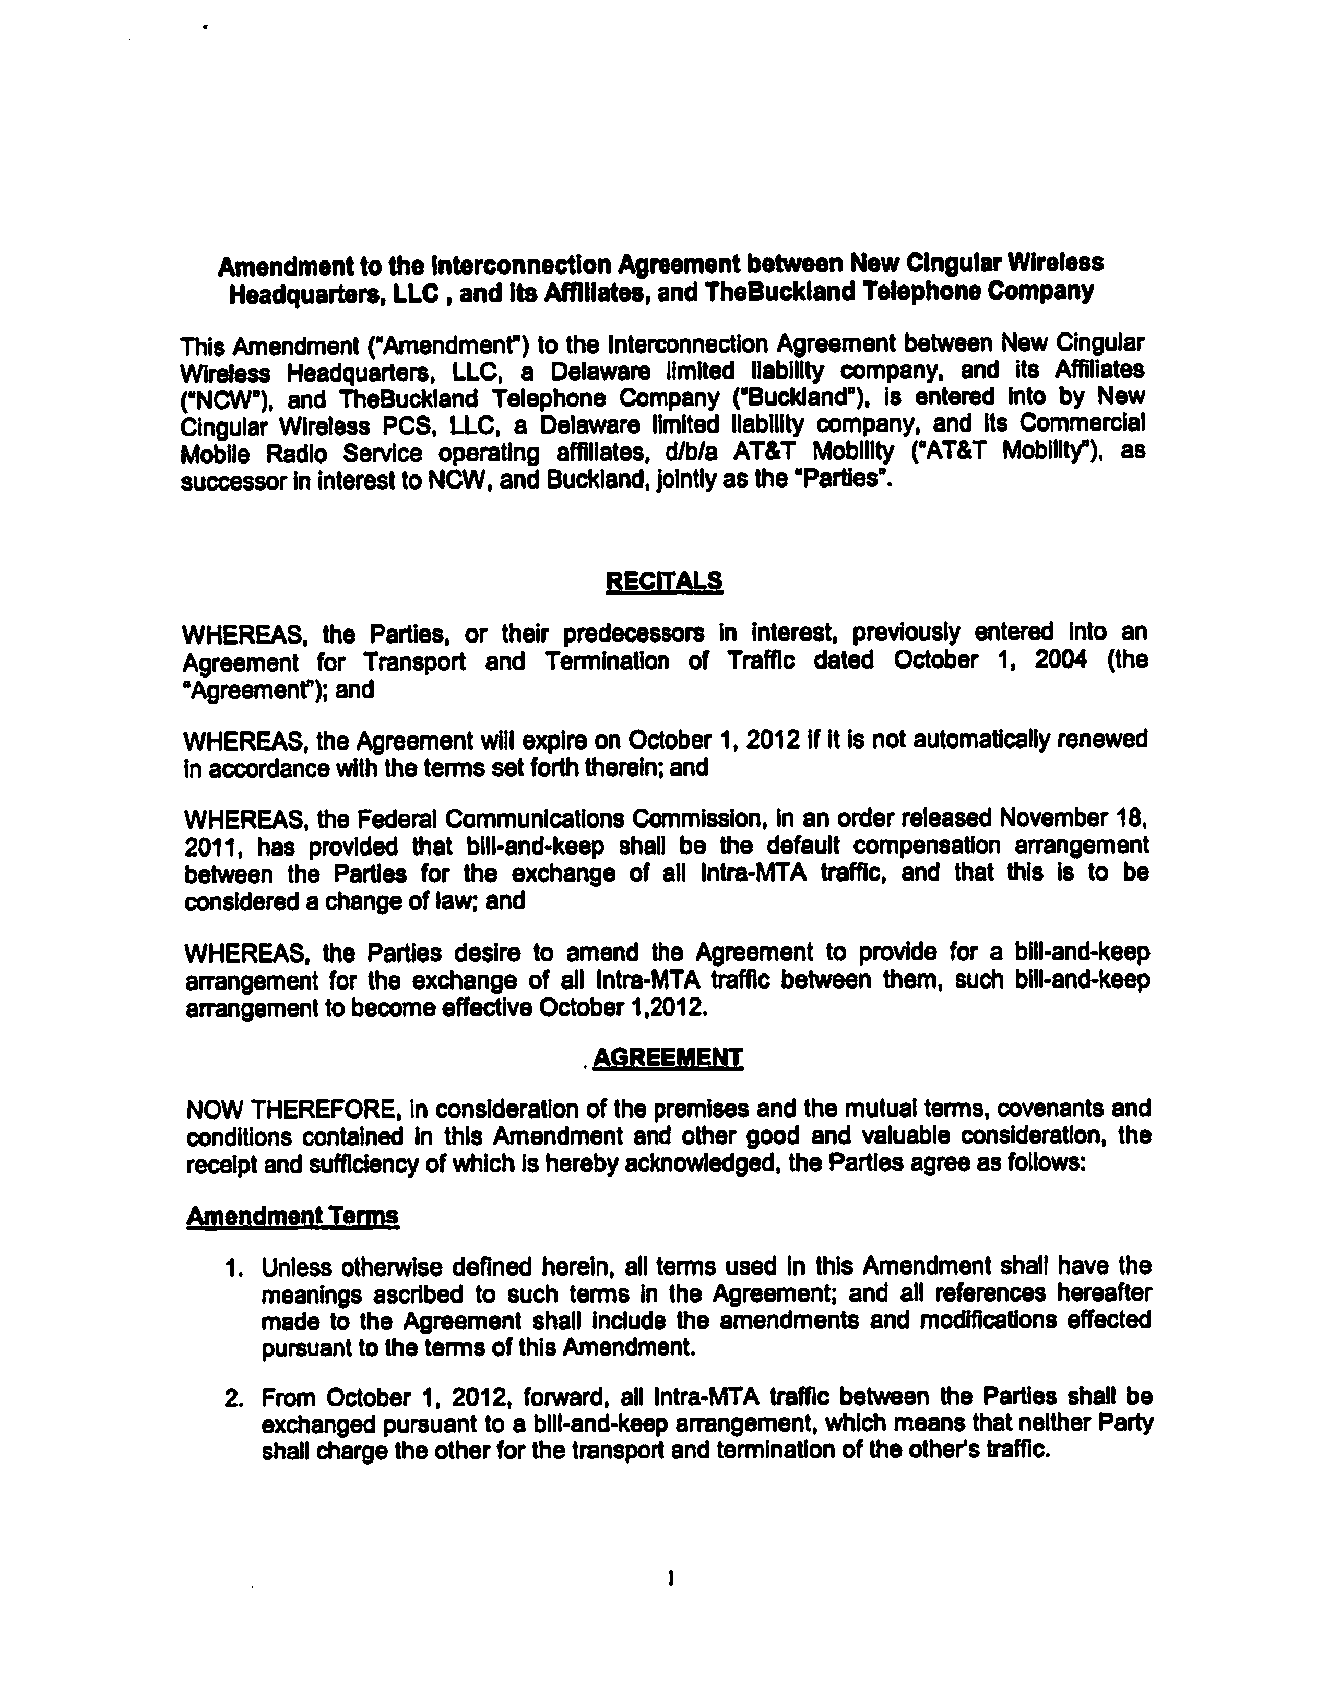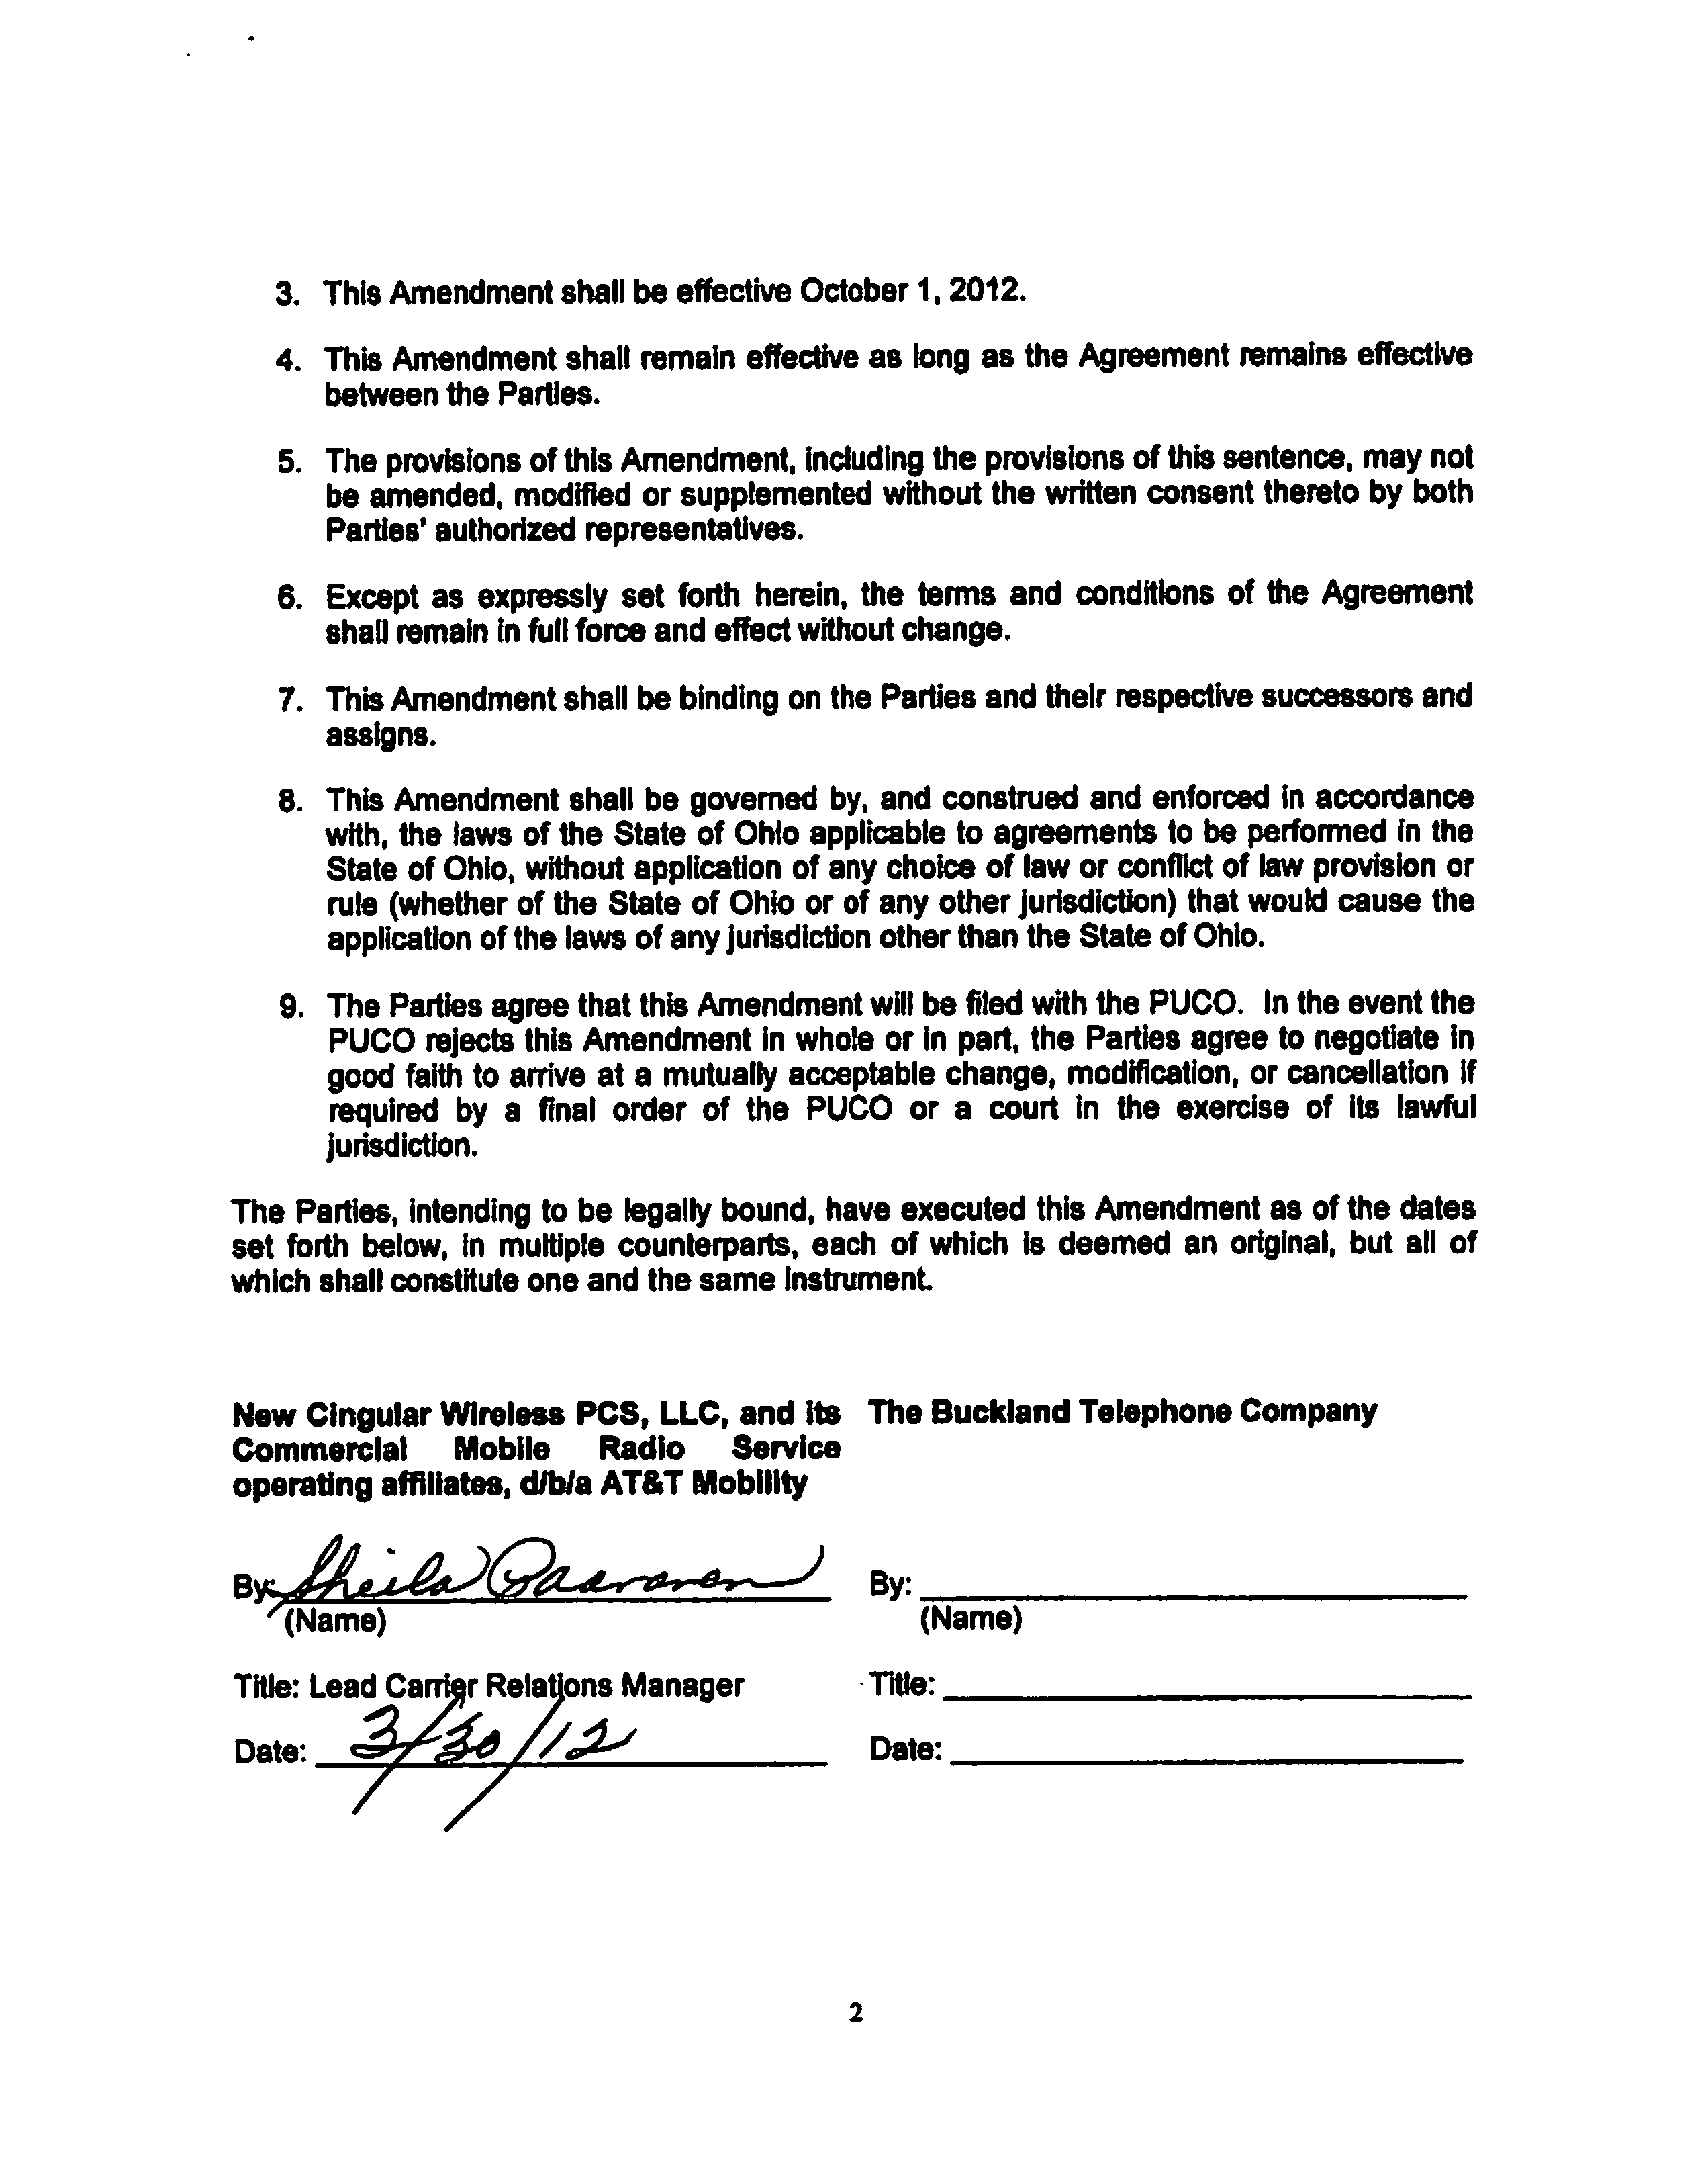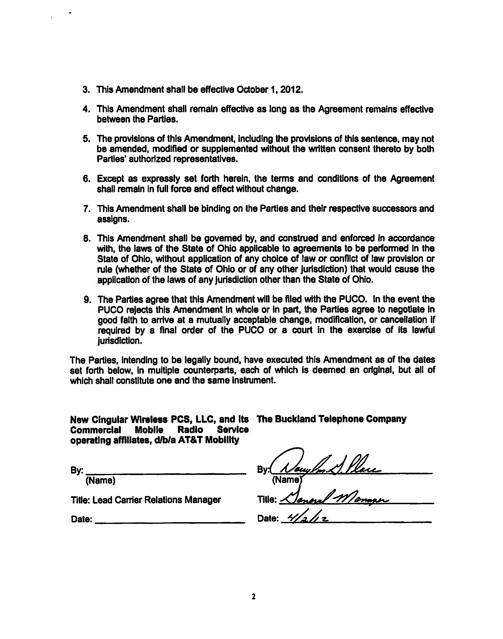

704302.1

