EXCHANGE SERVICES TARIFF
PUCO NO. 1

CINCINNATI BELL EXTENDED TERRITORIES LLC Section 4
1st Revised Page 8
Cancels Original Page 8

SERVICE AREA AND LOCAL CALLING AREAS

B. LOCAL CALLING AREA (Continued)

4. Greater Cincinnati - Dayton Local Calling Area Map

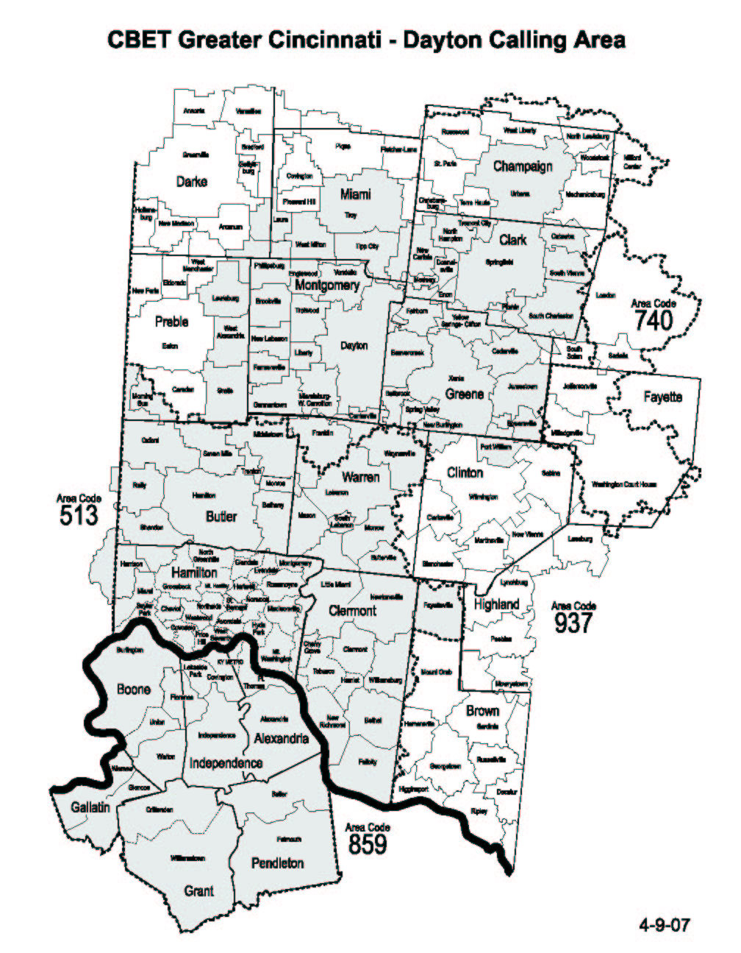

Issued: April 2, 2008 Effective: April 2, 2008
In accordance with Case No.
D. Scott Ringo, Jr., Assistant Secretary 08-369-TP-ATA, issued by the
Cincinnati Bell Extended Territories LLC Public Utilities Commission of Ohio
March 28, 2008

