183 Inverness Drive West
Denver, Colorado 80112

June 16, 2009

Ms. Renée Jenkins
Commission Secretary
Public Utilities Commission of Ohio
180 East Broad Street
Columbus, Ohio 43215-3793

RE: Comcast Business Communications, LLC Tariff No. 1
Docket No. 90-6132-TP-TRF
Case No. 09-0499-TP-ABN

Dear Ms. Jenkins:

Attached for filing with the Commission are revisions to Comcast Business Communications, LLC Interexchange Reseller Communications Services Tariff PUCO No. 1. This filing discontinues the Company’s intrastate interexchange services on July 1, 2009 and requests withdrawal of Tariff No. 1 on that date. The Company’s Notice of Discontinuance of Certain Telecommunications Services was filed with the PUCO on May 5, 2009. All customers of record were sent notification of the discontinuance of service on May 4, 2009.

Please direct any questions concerning this filing to Elizabeth Murray on (484) 398-0142 or to Linda Tipps on (678) 401-8877 or via email to Linda_Tipps@cable.comcast.com.

Sincerely,

David M. Lloyd
Director - Tariffs

Attachment

The Public Utilities Commission of Ohio
TELECOMMUNICATIONS APPLICATION FORM for ROUTINE PROCEEDINGS
(Effective: 01/18/2008)

In the Matter of the Application of Comcast Business Communications, LLC to discontinue its intrastate interexchange services and withdraw its Interexchange Reseller Communications Services Tariff No. 1.
)
)
)
)
TRF Docket No. 90-6132-TP-TRF
Case No. 09 - 0499 -TP - ABN
NOTE: Unless you have reserved a Case # or are filing a Contract, leave the “Case No” fields BLANK.

Name of Registrant(s): Comcast Business Communications, LLC
DBA(s) of Registrant(s): Comcast Long Distance
Address of Registrant(s): One Comcast Center, Philadelphia, PA 19103
Company Web Address: http//www.comcast.com
Regulatory Contact Person(s): Linda Tipps | Phone 678-401-8877 | Fax 678-401-8877
Regulatory Contact Person’s Email Address: LindaTipps@cable.comcast.com
Contact Person for Annual Report: Lisa Moglia |  | Phone 215-320-8667
Address (if different from above): Same as above
Consumer Contact Information: Carrie Lovell |  | Phone 412-747-6645
Address (if different from above): 15 Summit Park Drive, Pittsburgh, PA 15725
Motion for protective order included with filing? Yes No
Motion for waiver(s) filed affecting this case? Yes No [Note: Waivers may toll any automatic timeframe.]

Section I – Pursuant to Chapter 4901:11-6 OAC – Part I – Please indicate the Carrier Type and the reason for submitting this form by checking the boxes below. CMRS providers: Please see the bottom of Section II.
Carrier Type Other (explain below) | ILEC | CLEC | CTS | AOS/IOS
Tier 1 Regulatory Treatment
Change Rates within approved Range | TRF 1-6-04(B)  (0 day Notice) | TRF 1-6-04(B)  (0 day Notice)
New Service, expanded local calling area, correction of textual error | ZTA 1-6-04(B)  (0 day Notice) | ZTA 1-6-04(B)  (0 day Notice)
Change Terms and Conditions, Introduce non-recurring service charges | ATA 1-6-04(B)  (Auto 30 days) | ATA 1-6-04(B)  (Auto 30 days)
Introduce or Increase Late Payment or Returned Check Charge | ATA 1-6-04(B)  (Auto 30 days) | ATA 1-6-04(B)  (Auto 30 days)
Business Contract | CTR 1-6-17  (0 day Notice) | CTR 1-6-17  (0 day Notice)
Withdrawal | ATW 1-6-12(A)  (Non-Auto) | ATW 1-6-12(A)  (Auto 30 days)
Raise the Ceiling of a Rate | Not Applicable | SLF 1-6-04(B)  (Auto 30 days)
Tier 2 Regulatory Treatment
Residential - Introduce non-recurring service charges | TRF 1-6-05(E)  (0 day Notice) | TRF 1-6-05(E)  (0 day Notice)
Residential - Introduce New Tariffed Tier 2 Service(s) | TRF 1-6-05(C)  (0 day Notice) | TRF 1-6-05(C)  (0 day Notice) | TRF 1-6-05(C)  (0 day Notice)
Residential - Change Rates, Terms and Conditions, Promotions, or Withdrawal | TRF 1-6-05(E)  (0 day Notice) | TRF 1-6-05(E)  (0 day Notice) | TRF 1-6-05(E)  (0 day Notice)
Residential - Tier 2 Service Contracts | CTR 1-6-17  (0 day Notice) | CTR 1-6-17  (0 day Notice) | CTR 1-6-17  (0 day Notice)
Commercial (Business) Contracts | Not Filed | Not Filed | Not Filed
Business Services (see “Other” below) | Detariffed | Detariffed | Detariffed
Residential & Business Toll Services (see “Other” below) | Detariffed | Detariffed | Detariffed
NOTES: (1) For requirements for various applications, see the identified section of Ohio Administrative Code Section 4901 and/or the supplemental application form noted. (2) Information regarding the number of copies required by the Commission may be obtained from the Commission’s web site at www.puco.ohio.gov under the docketing information system section, by calling the docketing division at 614-466-4095, or by visiting the docketing division at the offices of the Commission.

Section I – Part II – Certificate Status and Procedural

Certificate Status | ILEC | CLEC | CTS | AOS/IOS
Certification (See Supplemental ACE form) |  | ACE 1-6-10  (Auto 30 days) | ACE 1-6-10  (Auto 30 days) | ACE 1-6-10  (Auto 30 days)
Add Exchanges to Certificate | ATA 1-6-09(C)  (Auto 30 days) | AAC 1-6-10(F)  (0 day Notice) | CLECs must attach a current CLEC  Exchange Listing Form
Abandon all Services - With Customers | ABN 1-6-11(A)  (Non-Auto) | ABN 1-6-11(A)  (Auto 90 day) | ABN 1-6-11(B)  (Auto 14 day) | ABN 1-6-11(B)  (Auto 14 day)
Abandon all Services - Without Customers |  | ABN 1-6-11(A)  (Auto 30 days) | ABN 1-6-11(B)  (Auto 14 day) | ABN 1-6-11(B)  (Auto 14 day)
Change of Official Name (See below) | ACN 1-6-14(B)  (Auto 30 days) | ACN 1-6-14(B)  (Auto 30 days) | CIO 1-6-14(A)  (0 day Notice) | CIO 1-6-14(A)  (0 day Notice)
Change in Ownership (See below) | ACO 1-6-14(B)  (Auto 30 days) | ACO 1-6-14(B)  (Auto 30 days) | CIO 1-6-14(A)  (0 day Notice) | CIO 1-6-14(A)  (0 day Notice) (
Merger (See below) | AMT 1-6-14(B)  (Auto 30 days) | AMT 1-6-14(B)  (Auto 30 days) | CIO 1-6-14(A)  (0 day Notice) | CIO 1-6-14(A)  (0 day Notice)
Transfer a Certificate (See below) | ATC 1-6-14(B)  (Auto 30 days) | ATC 1-6-14(B)  (Auto 30 days) | CIO 1-6-14(A)  (0 day Notice) | CIO 1-6-14(A)  (0 day Notice)
Transaction for transfer or lease of property, plant or business (See below) | ATR 1-6-14(B)  (Auto 30 days) | ATR 1-6-14(B)  (Auto 30 days) | CIO 1-6-14(A)  (0 day Notice) | CIO 1-6-14(A)  (0 day Notice)
Procedural
Designation of Process Agent(s) | TRF  (0 day Notice) | TRF  (0 day Notice) | TRF  (0 day Notice) | TRF  (0 day Notice)
Section II – Carrier to Carrier (Pursuant to 4901:1-7), CMRS and Other
Carrier to Carrier | ILEC | CLEC
Interconnection agreement, or amendment to an approved agreement | NAG 1-7-07  (Auto 90 day) | NAG 1-7-07  (Auto 90 day)
Request for Arbitration | ARB 1-7-09  (Non-Auto) | ARB 1-7-09  (Non-Auto)
Introduce or change c-t-c service tariffs, | ATA 1-7-14  (Auto 30 day) | ATA 1-7-14  (Auto 30 day)
Introduce or change access service pursuant to 07-464-TP-COI | ATA  (Auto 30 day)
Request rural carrier exemption, rural carrier supension or modifiction | UNC 1-7-04 or  (Non-Auto) 1-7-05 | UNC 1-7-04 or (Non-Auto) 1-7-05
Pole attachment changes in terms and conditions and price changes. | UNC 1-7-23(B)  (Non-Auto) | UNC 1-7-05  (Non-Auto)
CMRS Providers See 4901:1-6-15 | RCC  [Registration & Change in Operations]  (0 day) |  | NAG  [Interconnection Agreement or Amendment] (Auto 90 days)
Other* (explain)

*NOTE: During the interim period between the effective date of the rules and an Applicant’s Detariffing Filing, changes to existing business Tier 2 and all toll services, including the addition of new business Tier 2 and all new toll services, will be processed as 0-day TRF filings, and briefly described in the “Other” section above.

All Section I and II applications that result in a change to one or more tariff pages require, at a minimum, the following exhibits. Other exhibits may be required under the applicable rule(s). ACN, ACO, AMT, ATC, ATR and CIO applications see the 4901:1-6-14 Filing Requirements on the Commission's Web Page for a complete list of exhibits.
Exhibit | Description:
A | The tariff pages subject to the proposed change(s) as they exist before the change(s)
B | The Tariff pages subject to the proposed change(s), reflecting the change, with the change(s) marked in the right margin.
C | A short description of the nature of the change(s), the intent of the change(s), and the customers affected.
D | A copy of the notice provided to customers, along with an affidavit that the notice was provided according to the applicable rule(s).
Section III – Attestation
Registrant hereby attests to its compliance with pertinent entries and orders issued by the Commission.

AFFIDAVIT
Compliance with Commission Rules and Service Standards

I am an officer/agent of the applicant corporation, Comcast Business Communications, LLC  (Name) |  |  | , and am authorized to make this statement on its behalf.
I attest that these tariffs comply with all applicable rules, including the Minimum Telephone Service Standards (MTSS) Pursuant to Chapter 4901:1-5 OAC for the state of Ohio. I understand that tariff notification filings do not imply Commission approval and that the Commission’s rules, including the Minimum Telephone Service Standards, as modified and clarified from time to time, supersede any contradictory provisions in our tariff. We will fully comply with the rules of the state of Ohio and understand that noncompliance can result in various penalties, including the suspension of our certificate to operate within the state of Ohio.

I declare under penalty of perjury that the foregoing is true and correct.

Executed on (Date) June 16, 2009 | at (Location) Englewood, Colorado
 |  | *(Signature and Title) /s/ David M. Lloyd, Director |  |  | (Date) June 16, 2009
- This affidavit is required for every tariff-affecting filing. It may be signed by counsel or an officer of the applicant, or an authorized agent of the applicant.

VERIFICATION

I, David M. Lloyd
verify that I have utilized the Telecommunications Application Form for Routine Proceedings provided by the Commission and that all of the information submitted here, and all additional information submitted in connection with this case, is true and correct to the best of my knowledge.

/s/ David M. Lloyd, Director
*(Signature and Title) |  |  |  | (Date) June 16, 2009
*Verification is required for every filing. It may be signed by counsel or an officer of the applicant, or an authorized agent of the applicant.
Send your completed Application Form, including all required attachments as well as the required number of copies, to:

Public Utilities Commission of Ohio
Attention: Docketing Division
180 East Broad Street, Columbus, OH 43215-3793

Or
Make such filing electronically as directed in Case No 06-900-AU-WVR

EXHIBIT A
SUPERSEDED TARIFF PAGES

COMCAST BUSINESS COMMUNICATIONS, LLC P.U.C.O. Tariff No. 1
d/b/a COMCAST LONG DISTANCE Original Page 1

COMCAST BUSINESS COMMUNICATIONS, LLC
d/b/a COMCAST LONG DISTANCE

REGULATIONS APPLYING TO
INTEREXCHANGE RESELLER COMMUNICATIONS SERVICES
WITHIN THE STATE OF OHIO

This Tariff contains the regulations applicable to the furnishing of service for telecommunications reseller services within the State of Ohio by Comcast Business Communications, LLC, d/b/a Comcast Long Distance. This tariff is on file with the Public Utilities Commission of Ohio, and copies also may be inspected during normal business hours at the following location: One Comcast Center, Philadelphia, PA 19103.

ISSUED: February 29, 2008 EFFECTIVE: March 1, 2008
Filed under authority of Entry issued by the Public Utilities Commission of Ohio,
in Case No. 08-0186-TP-ATA
By: David Lloyd, Director – Tariffs, Englewood, Colorado
OH08-001c

EXHIBIT B
PROPOSED TARIFF PAGES

Supplement No. 1 to
COMCAST BUSINESS COMMUNICATIONS, LLC P.U.C.O. Tariff No. 1
d/b/a COMCAST LONG DISTANCE 1st Revised Page 1
Cancels Original Page 1

(N)
(N)

Effective July 1, 2009, Interexchange Reseller Communications Services are discontinued and this tariff is withdrawn in its entirety.

COMCAST BUSINESS COMMUNICATIONS, LLC
d/b/a COMCAST LONG DISTANCE

REGULATIONS APPLYING TO
INTEREXCHANGE RESELLER COMMUNICATIONS SERVICES
WITHIN THE STATE OF OHIO

.

This Tariff contains the regulations applicable to the furnishing of service for telecommunications reseller services within the State of Ohio by Comcast Business Communications, LLC, d/b/a Comcast Long Distance. This tariff is on file with the Public Utilities Commission of Ohio, and copies also may be inspected during normal business hours at the following location: One Comcast Center, Philadelphia, PA 19103.

ISSUED: June 17, 2009 EFFECTIVE: July 1, 2009
Filed under authority of Entry issued by the Public Utilities Commission of Ohio,
in Case No. 09-0499-TP-ABN
By: David Lloyd, Director – Tariffs, Englewood, Colorado
OH09-001c

EXHIBIT C
DESCRIPTION OF FILING

Comcast Business Communications, LLC (CBC) is discontinuing its intrastate interexchange services and withdrawing its Reseller Interexchange Communications Services Tariff No. 1. CBC sent a Notice of Discontinuance of Certain Telecommunications Services to the PUCO on May 6, 2009. Customers were sent notification of the discontinuance of service on May 4, 2009.

EXHIBIT D
CUSTOMER NOTIFICATION

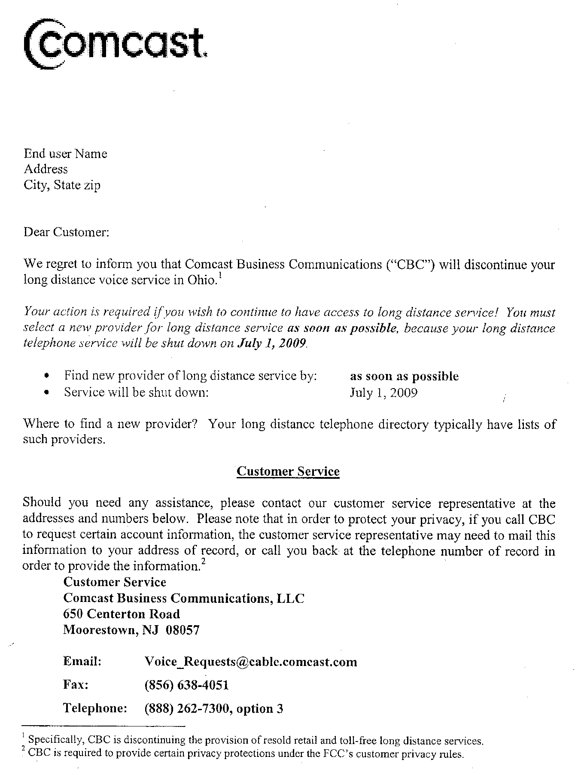

AFFIDAVIT
Customer Notice

I, David M. Lloyd verify that, to the best of my knowledge, the customer notice included herein has been provided to all customers of record prior to this filing.

, Director June 16, 2009______
(Signature and Title) (Date)

