MEMORANDUM

TECHNOLOGIES MANAGEMENT, INC.
2600 Maitland Center Parkway, Suite 300
Maitland, FL 32751
Tel: | 407-740-3009 | Fax: | 407-740-0613

TO: | OH Docketing
FROM: | Thomas M. Forte
DATE: | March 28,2008
SUBJECT: | BellSouth Long Distance, Inc. d/b/a AT&T Long Distance Service  CASE # 08-377-TP-ATA

To Whom It May Concern:

Please be advised that we do not have access to a Word source file for the above-referenced filing submitted via your DIS e-filing system due to the fact that all of the documents are not available to us in Word format.

If you have any additional questions, please don’t hesitate to call us.

Sincerely,

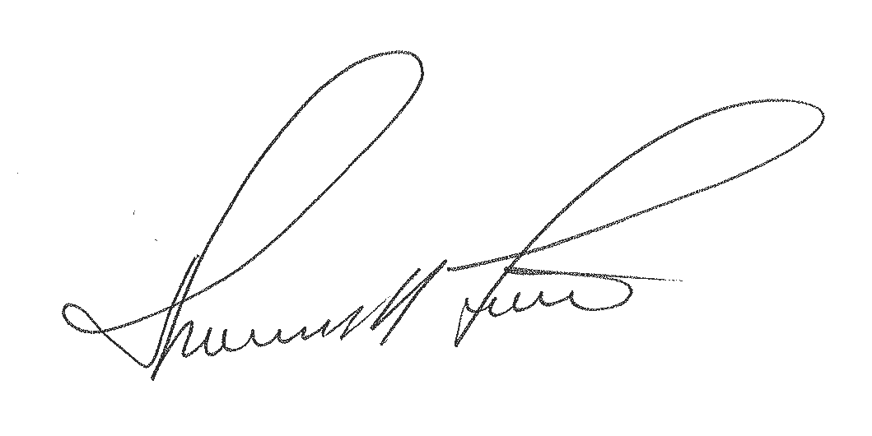

Thomas M. Forte
Consultant for BellSouth Long Distance, Inc. d/b/a AT&T Long Distance Service

407-740-3001

