 | Gary L. Kepley  Mailstop KSOPKJ0502-508  Director – Regulatory Systems  5454 West 110th Street  Overland Park, Kansas 66211  Voice: 913-345-7572  Email: Gary.Kepley@embarq.com

Via Electronic Filing

October 18, 2007

Ms. Renee Jenkins, Director of Administration
Public Utilities Commission of Ohio
180 East Broad Street
Columbus, Ohio 43215-3794

Re: United Telephone Company of Ohio d/b/a Embarq
Case No. 07-464-TP-COI
Case No. 90-5041-TP-TRF

Dear Ms. Jenkins:

Submitted as an electronic filing are revisions to United Telephone Company of Ohio d/b/a/ Embarq P.U.C.O. No. 1 Access Service Tariff. These revisions are filed in compliance with the October 17, 2007 Finding and Order in Case No. 07-464-TP-COI. That Order authorizes Embarq to change the company name from Sprint to Embarq on all tariff pages not previously changed. With the exception of Section 7 which was previously changed April 27, 2007, this tariff is being revised in its entirety as every tariff sheet has changed to incorporate the Embarq company name. This filing did not include changes to current rates, terms or conditions, therefore, customers are not impacted by these changes. This filing should be processed as a zero day filing, to become effective October 18, 2007.

The following tariff pages are enclosed which reflect the company name change:

P.U.C.O. No. 1, Access Service Tariff Third Revised Title Sheet
Third Revised Concurrence Sheet 1
First Revised Symbols Sheet 1
Section 1 Revised Sheet 1
Section 2 Revised Sheet 1
Section 3 Revised Sheet 1
Section 4 Revised Sheets 1 – 5
Section 5 Revised Sheet 1
Section 6 Revised Sheet 1
Section 8 Revised Sheet 1
Section 9 Revised Sheet 1
Section 10 Revised Sheet 1
Section 11 Revised Sheet 1
Section 12 Revised Sheet 1
Section 13 Revised Sheet 1
Section 14 Revised Sheet 1
Section 15 Revised Sheet 1
Section 16 Revised Sheet 1

Renee Jenkins
October 18, 2007
Page 2

P.U.C.O. No. 1, Access Service Tariff Section 17 Revised Sheet 1
(Cont'd) Section 18 Revised Sheet 1
Section 19 Revised Sheet 1
Section 20 Revised Sheet 1
Section 21 Revised Sheets 1 – 3
Section 22 Revised Sheet 1

Should you have questions or require additional information regarding this filing, please contact Becky Donahue at 614-220-8624.

Sincerely,
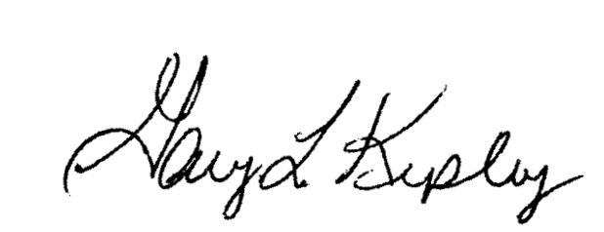

Gary L. Kepley

Attachments
Pc: Becky Donahue
Gary Baki

OH 07-43

