
September 30, 2008

Via Overnight Delivery

Ms. Renee Jenkins, Secretary of Commission
Public Utilities Commission of Ohio
180 East Broad Street, 13th Floor
Columbus, Ohio 43215-3793

RE: Access tariff Access Point, Inc.
Docket No. 08-1043-TP-ATA

Dear Ms. Jenkins:

Enclosed for filing please find the original copy of the revised Access tariff submitted on behalf of Access Point, Inc. This filing is to submit the finalized pages with the approved case number in the footer.

The following pages are included with this filing:

1st Revised Page 1 | Updates Check Sheet
1st Revised Page 55 | Increases Access rates

Please acknowledge receipt of this filing by date-stamping the extra copy of this cover letter and returning it to me in the self-addressed, stamped envelope provided for this purpose.

Any questions you may have regarding this letter may be directed to my attention at (407) 740-3001 or via e-mail to tforte@tminc.com. Thank you for your assistance.

Sincerely,

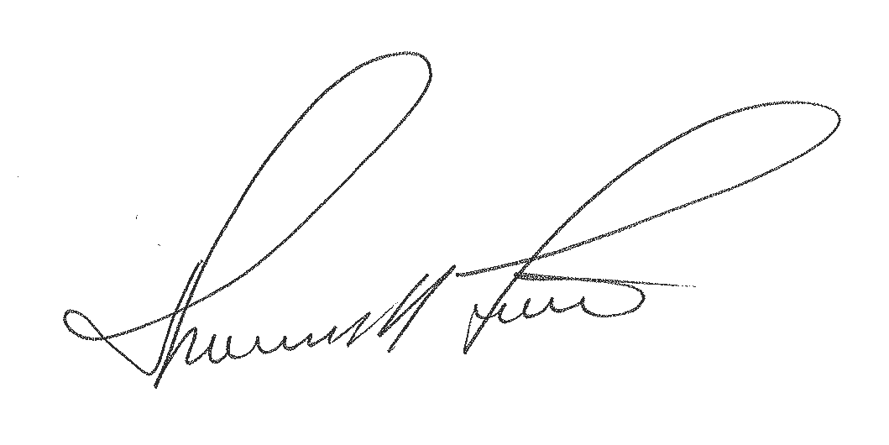

Thomas M. Forte
Consultant to Access Point, Inc.

TMF/rg

cc: Jason Brown, Access Point
file: Access Point - OH - Access
tms: OHa0804a

Access Point, Inc. Ohio Tariff No. 4
1st Revised Page 1
Cancels Original Page 1

CHECK SHEET

Pages of this tariff, as indicated below, are effective as of the date shown at the bottom of the respective pages. Original and revised pages, as named below, comprise all changes from the original tariff and are currently in effect as of the date on the bottom of this page.

PAGE | REVISION |  | PAGE | REVISION |  | PAGE | REVISION
Title | Original |  | 20 | Original |  | 40 | Original
1 | 1st Rev. | * | 21 | Original |  | 41 | Original
2 | Original |  | 22 | Original |  | 42 | Original
3 | Original |  | 23 | Original |  | 43 | Original
4 | Original |  | 24 | Original |  | 44 | Original
5 | Original |  | 25 | Original |  | 45 | Original
6 | Original |  | 26 | Original |  | 46 | Original
7 | Original |  | 27 | Original |  | 47 | Original
8 | Original |  | 28 | Original |  | 48 | Original
9 | Original |  | 29 | Original |  | 49 | Original
10 | Original |  | 30 | Original |  | 50 | Original
11 | Original |  | 31 | Original |  | 51 | Original
12 | Original |  | 32 | Original |  | 52 | Original
13 | Original |  | 33 | Original |  | 53 | Original
14 | Original |  | 34 | Original |  | 54 | Original
15 | Original |  | 35 | Original |  | 55 | 1st Rev. | *
16 | Original |  | 36 | Original |  | 56 | Original
17 | Original |  | 37 | Original |  | 57 | Original
18 | Original |  | 38 | Original
19 | Original |  | 39 | Original
* - indicates those pages included with this filing

Access Point, Inc. Ohio Tariff No. 4
1st Revised Page 55
Cancels Original Page 55

SECTION 5 - SWITCHED ACCESS RATES, (CONT’D.)

5.4 Rates and Charges

5.4.1 Switched Access Service

(A) Switched Transport
Tandem-Switched Termination (per access minute) | $0.00010500
Tandem-Switched Facility (per access minute per mile) | $0.00001400
Tandem Switching (per access minute per tandem) | $0.00115500 (I)
Common Transport Multiplexing (per access minute) | $0.00001800
Common Trunk Port (per access minute) | $0.00037100 (I)
(B) End Office Switching
Local Switching (per access minute) | $0.00315300 (I)
Information Surcharge (per access minute) | $0.00000000

5.4.2 Database Query

800 Database Query. Per Call | $0.00230400 (I)

5.4.3 Host Remote

All host-remote rate elements presently mirror the respective Switched Transport and End Office Switching rate elements listed above due to limitations of the access billing system.

