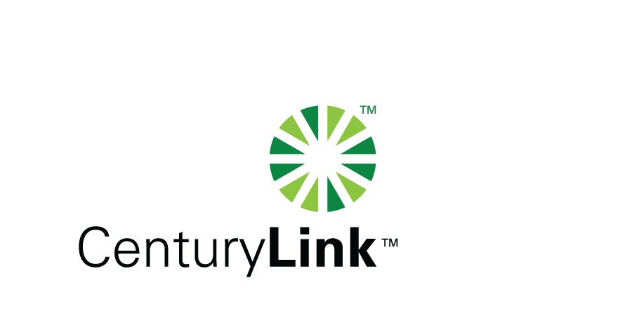
Via E-FILE

May 21, 2010
www.CenturyLink.com
5454 W. 110th Street
Overland Park, KS 66211

Ms. Renee´ Jenkins, Director of Administration
Public Utilities Commission of Ohio
180 East Broad Street, 13th Floor
Columbus, OH 43215-0573

Re: United Telephone Company of Ohio d/b/a CenturyLink
Case No. 90-5041-TP-TRF

Dear Ms. Jenkins:

Enclosed for filing are revisions to United Telephone Company of Ohio d/b/a CenturyLink P.U.C.O. No. 6, Local Exchange Tariff. This filing should be processed as a zero day filing, to become effective May 21, 2010. The following tariff sheets are enclosed:
www.CenturyLink.com
5454 W. 110th Street
Overland Park, KS 66211

Section B | Thirteenth Revised Sheet 4
Section E | Sixth Revised Sheet 3

This filing increases the operator service charge for special billing of local measured service calls and adds a charge for local calls completed by the operator when the customer has the ability to complete the call. These are Tier 2 services. The customer notice included in this filing package was completed via bill message.

If you have any questions regarding this filing, please call me or Gary Baki at (614) 220-8629.

Sincerely,

/s/ Debra A. Levy

Debra A. Levy

Enclosures

cc: Gary Baki

OH 10-02 Letter
Debra A. Levy
Tariff Analyst II
Debra.Levy@CenturyLink.com
Voice: (913) 345-7571
Fax: (913) 345-6756

