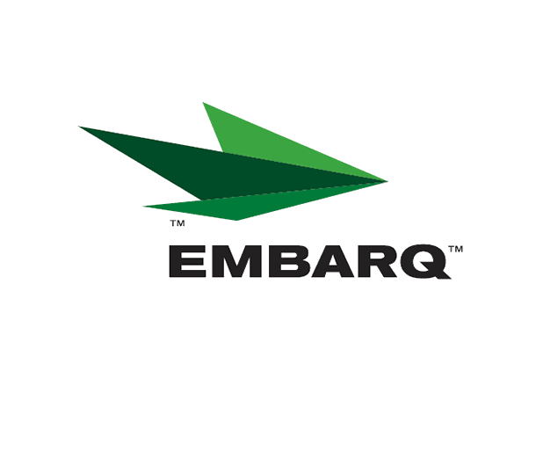


Embarq Corporation
Mailstop: KSOPKJ0502-5022
5454 West 110th Street
Overland Park, KS 66211
Glenda.Munson@EMBARQ.com

Via E-FILE

January 16, 2008

Ms. Renee’ Jenkins, Director of Administration
Public Utilities Commission of Ohio
180 East Broad Street, 13th Floor
Columbus, OH 43215-0573

Re: United Telephone Company of Ohio d/b/a Embarq
Case No. 90-5041-TP-TRF

Dear Ms. Jenkins:

Enclosed for filing are revisions to United Telephone Company of Ohio d/b/a Embarq P.U.C.O. No. 5 General Exchange Tariff. This filing should be processed as a day filing, to become effective January 16, 2008.

The following tariff sheets are enclosed:

P.U.C.O. No. 5, General Exchange Tariff | Section 21 | Fourth Revised Sheet 2
 |  | First Revised Sheet 6
 |  | First Revised Sheet 7
 |  | First Revised Sheet 10
 | Section 35 | Second Revised Sheet 10
 |  | Second Revised Sheet 11
 | Section 39 | Eighth Revised Sheet 1
 |  | Eighth Revised Sheet 2
 |  | Fifth Revised Sheet 3
 |  | Fourth Revised Sheet 4
 |  | Second Revised Sheet 5
 |  | First Revised Sheet 6
 |  | First Revised Sheet 7
 |  | First Revised Sheet 8
 |  | First Revised Sheet 9
 |  | First Revised Sheet 10
 |  | First Revised Sheet 13
 |  | First Revised Sheet 14
 |  | First Revised Sheet 15
 |  | First Revised Sheet 16
Glenda L. Munson
TARIFF ANALYST I
Voice: (913) 315-9346
Fax: (913) 315-0763

Ms. Renee’ Jenkins, Director of Administration
Page 2
January 16, 2008

This filing proposes to grandfather various Solutions – Residence packages and various residential and business ExpressTouch feature packages. Customers were notified of this change in accordance with 4901:1-6-17 of the Administrative Code. A copy of the notice is attached as Exhibit C with the supporting affidavit. In addition, text changes are being made to clarify and standardize the formal name of the Enhanced Call Waiting feature. References to “call waiting” that are not being revised under this filing speak generally to that particular functionality rather than to the feature name itself.

This filing also includes text changes for certain bundles to reflect the inclusion of Anonymous Call Rejection (ACR) in all packages that include Caller ID. ACR is inherent in the Caller ID feature. However, certain packages previously reflected ACR as a component of the package while ACR was not referenced in other packages. This filing standardizes the reference to ACR for each package by better describing ACR as a component of the package due to its inclusion in the Caller ID feature.

If you have any questions regarding this filing, please call Gary Baki at 614-220-8629.

Sincerely,

/s/ Glenda L. Munson

Glenda L. Munson

Enclosures
cc: Gary Baki
OH 07-57

