March 24, 2008

By Electronic Filing
Ms. Reneé J. Jenkins
Director of Administration
Secretary of the Public Utilities Commission of Ohio
180 East Broad Street
Columbus, Ohio 43215
Re: In the Matter of the Application of Orwell Communications, Inc., d/b/a FairPoint Long Distance to Detariff Certain Tier 2 Services and make other changes related to the Implementation of Case No. 06-1345-TP-ORD; PUCO Case No. 08-0286-TP-ATA
Dear Ms. Jenkins:
Orwell Communications, Inc., d/b/a FairPoint Long Distance submits an Application for electronic filing. The TRF Number for Orwell Communications, Inc., d/b/a FairPoint Long Distance is 90-5954-CT-TRF.
Thank you for your assistance. If you have any questions, please do not hesitate to call.
Very truly yours,

/s/ Carolyn S. Flahive

Enclosure
Carolyn.Flahive@ThompsonHine.com Fax 614.469.3361 Phone 614.469.3294 | tajg DocID_Info

The Public Utilities Commission of Ohio
TELECOMMUNICATIONS APPLICATION FORM for
DETARIFFING AND RELATED ACTIONS
Per the Commission’s 09/19/07 “Implementation Order” in Case No. 06-1345-TP-ORD
(Effective: 10/01/2007 through 04/01/2008)

In the Matter of the Application of Orwell Communications, Inc. to Detariff Certain Tier 2 Services and make other changes related to the Implementation of Case No. 06-1345-TP-ORD
)
)
)
)
TRF Docket No. 90-5954-CT-TRF
Case No.08 - 0286 -TP - ATA
NOTE: Unless you have reserved a Case No. leave the “Case No.” fields BLANK.

Name of Registrant(s) Orwell Communications, Inc.
DBA(s) of Registrant(s) FairPoint Long Distance
Address of Registrant(s) 70 South Maple Street, P.O. Box 337, Orwell, Ohio 44076
Company Web Address
Regulatory Contact Person(s) Carolyn S. Flahive | Phone 614-469-3294 | Fax 614-469-3361
Regulatory Contact Person’s Email Address Carolyn.Flahive@ThompsonHine.com
Contact Person for Annual Report Eric Doane, Regional Controller |  | Phone 207-642-7297
Address (if different from above) 155 Gannett Drive, S. Portland, ME 04106 Fax 207-642-7221
Consumer Contact Information Dottie Nesmith, Manager Regulatory Compliance |  | Phone 800-437-6215
Address (if different from above) 908 W. Frontview, Dodge City, KS 67801 Fax 620-227-8576

Part I – Tariffs
Please indicate the Carrier Type and the reason for submitting this form by checking the boxes below.
NOTE: All cases are ATA process cases, tariffs are effective the day they are filed, and remain in effect unless the Commission acts to suspend.
Carrier Type | ILEC | CLEC | CTS
Business Tier 2 Services
Residential & Business Toll Services
Other Changes required by Rule
(Describe in detail in Exhibit C)

Part II – Exhibits
Note that the following exhibits are required for all filings using this form.
Included | Identified As: | Description of Required Exhibit:
 | Exhibit A | The existing affected tariff pages.
 | Exhibit B | The proposed revised tariff pages.
 | Exhibit C | Matrix or narrative summarizing all changes proposed in the application, and/or other information intended to assist Staff in the review of the Application.
 | Exhibit D | Explanation of how the Applicant intends to comply with Rule 4901:1-6-05(G)(3) regarding disclosure of rates, terms, and conditions for detariffed services, including:  - citation to the appropriate Web Page if any, in accordance with rule 4901:1-6-05(G)(4), and/or  - copy of other materials and publications to be used to comply with 4901:1-6-05(G)(3).
 | Exhibit E | One-time customer notice of detariffing and related changes consistent with rule 4901:1-06-16(B) , including where customers may find the information regarding such services as required by rule 4901:1-6-05(G)(3).
 | Exhibit F | Affidavit that the Customer Notice described in Exhibit C has been sent to Customers.
Part III. – Attestation
Registrant hereby attests to its compliance with pertinent entries and orders issued by the Commission.

AFFIDAVIT
Compliance with Commission Rules and Service Standards

I am an attorney of the applicant corporation, Orwell Communications, Inc.  (Name) |  |  | , and am authorized to make this statement on its behalf.
I attest that these tariffs comply with all applicable rules, including the Minimum Telephone Service Standards (MTSS) Pursuant to Chapter 4901:1-5 OAC for the state of Ohio. I understand that tariff notification filings do not imply Commission approval and that the Commission’s rules, including the Minimum Telephone Service Standards, as modified and clarified from time to time, supersede any contradictory provisions in our tariff. We will fully comply with the rules of the state of Ohio and understand that noncompliance can result in various penalties, including the suspension of our certificate to operate within the state of Ohio.

I declare under penalty of perjury that the foregoing is true and correct.

Executed on (Date) 3/24/08 | at (Location) Columbus, Ohio
 |  | *(Signature and Title) /s/ Carolyn S. Flahive |  |  | (Date) 3/24/08
- This affidavit is required for every tariff-affecting filing. It may be signed by counsel or an officer of the applicant, or an authorized agent of the applicant.

VERIFICATION

I, Carolyn S. Flahive, verify that I have utilized the Telecommunications Application Form for Detariffing and Related Actions provided by the Commission and that all of the information submitted here, and all additional information submitted in connection with this case, is true and correct to the best of my knowledge.

*(Signature and Title) /s/ Carolyn S. Flahive |  |  |  | (Date) 3/24/08
*Verification is required for every filing. It may be signed by counsel or an officer of the applicant, or an authorized agent of the applicant.
Send your completed Application Form, including all required attachments as well as the required number of copies, to:

Public Utilities Commission of Ohio
Attention: Docketing Division
- East Broad Street, Columbus, OH 43215-3793

Or
Make such filing electronically as directed in Case No 06-900-AU-WVR

EXHIBIT A

(Existing Affected Tariff Pages)

Rules, Regulations and Rates applying to the provision of  Intrastate long distance service for customers of  Orwell Communications, Inc. d/b/a FairPoint Long Distance  in the state of Ohio.  Orwell Communications, Inc.  d/b/a FairPoint Long Distance  Located in  Orwell, Ohio |  | (T)  (T)

Check Sheet

Number of Revision Number of Revision
Page Except as Indicated Page Except as Indicated

Title First Revised
Page 1 Fifth Revised*
Page 2 Original
Page 3 Original
Page 4 Original
Page 5 Original
Page 6 Original
Page 7 Original
Page 8 First Revised
Page 9 Original
Page 10 Original
Page 11 Original
Page 12 Original
Page 13 Original
Price List Sheet 1 Second Revised
Price List Sheet 2 First Revised*

*Denotes New or Revised Sheet

CONCURRING CARRIERS

None

CONNECTING CARRIERS

None

OTHER PARTICIPATING CARRIERS

None

Table of Contents

Subject Matter Page No.
Check Sheet 1
Concurring Carriers 2
Table of Contents 3
Explanation of Symbols 4
1. Application of Intrastate Tariff 5
2. Liability of the Company 5
3. Use of Service 6
4. Payment Arrangements 7
5. Application of Rates 10
LDMTS 10
Promotional Rates 10
6. Measured Usage Charges 11
7. Rate Periods 11
8. Directory Assistance 12
9. Calling Card 12
10. 800 Service 13

Explanation of Symbols

X - To signify reference to other published tariffs
I - To signify a rate or rate range increase
R - To signify a rate or rate range reduction
C - To signify changed regulation
T - To signify a change in text but no change in rate or regulation
N - To signify new rate or regulation
D - To signify a discounted rate or regulation
Z - To signify a correction
M - To signify text which has been moved but not changed
1. Application of Intrastate Tariff

This Tariff contains the rules, regulations and rates for intrastate long distance services offered to The Orwell Telephone Company (Company) customers.

2. Liability of the Company

(A) The Company shall be indemnified and held harmless by the Customer against:

(1) Claims for libel, slander, infringement of copyright or unauthorized use of any trademark, trade name or service mark arising out of the material transmitted over the Company’s facilities; and

(2) Claims for patent infringement arising from combining or connecting the Company’s facilities with apparatus and systems of the Customer; and

(3) All other claims arising out of any act or omission of the Customer in connection with any service provided by the Company.

(B) The Company shall be indemnified and held harmless from any and all loss, claims, demands, suits, or other action, whether suffered, made, instituted, or asserted by the Customer or by any other party or persons, for any personal injury to, or death of any person or persons, and for any loss, damage, defacement or destruction of the premises of the Customer or any other property, whether owned by the Customer or others, caused or claimed to have been caused directly or indirectly by the installation, operation, failure to operate, maintenance, removal, presence, condition, location or use that is not the direct result of the Company’s negligence. No agents or employees of other carriers shall be deemed to be agent or employees of the Company.

(C) The liability of the Company for damages arising out of mistakes, omissions, interruptions, delays, errors or defects in transmission occurring in the course of furnishing service, and

2. Liability of the Company (Continued)

not caused by the negligence of the Company, shall in no event exceed an amount equivalent to the proportionate charge to the Customer for the period during which the call was affected. No other liability shall in any case attach to the Company.

(D) The Company and/or Customer shall not be liable to the other for any failure of performance due to causes beyond its control including fire, flood, epidemic, earthquake, other acts of God, explosion, strike or other labor disputes, riot or civil disturbance, war (whether declared or undeclared) or armed conflict, failure of common carrier or “carrier’s carrier” or municipal ordinance, any state or federal law, governmental order or regulation or order of any court, or any other occurrence not within the control of Carrier or Customer, as the case may be.

(E) Approval of limitation of liability language by the PUBLIC UTILITIES COMMISSION OF OHIO does not constitute a determination by the Commission that the limitation of liability imposed by the company should be upheld in a court of law. Approval by the Commission merely recognizes that since it is a court’s responsibility to adjudicate negligence and consequent damage claims, it is also the court’s responsibility to determine the validity of the exculpatory clause.

3. Use of Service

Intrastate Long Distance Message Telecommunications Service (LDMTS) may only be used to transmit communications of the customer and authorized users in a manner consistent with the terms of this tariff and the policies and regulations of the Federal Communications Commission (FCC) and local authorities having jurisdiction over the service. It is the responsibility of the Customer to guard and protect against any unauthorized use of any Company issued codes to which billing may be charged.

4. Payment Arrangements

(A) Payment for Service

The Customer is responsible for the payment of all charges for services furnished to the Customer.

(B) Taxes and Other Surcharges

Customer shall pay all sales, use, access, or other Local, State and Federal taxes, charges or surcharges, however designated, imposed on or based upon the provision, sale or use of the Services (excluding taxes on Company’s net income). Such taxes shall be separately stated on the applicable invoice.

(C) Billing and Payment of Charges

The Customer is responsible for payment of all charges incurred by the Customer or users for services furnished to the Customer by Company.

Recurring charges shall be billed in advance after the Service Date is determined and will be due no later than thirty (30) days after the date of the invoice. Usage charges and other charges shall be billed as incurred, and will be due no later than thirty (30) days after the date of the invoice. State and Federal Government agencies may be billed in arrears.

In the event that Company’s computerized usage recording system fails or is otherwise unavailable for all or part of any billing period, Company shall be entitled to make a reasonable estimate of Customer’s usage of Services in the period in question for billing purposes.

(D) Billing Disputes

In the event of a dispute between a Customer and Company regarding charges billed by Company, Company will investigate the particular case and report the results thereof to the Customer. During the period that the disputed amount is under investigation, Company will not pursue any collection procedures or assess late fees with regard to the disputed amount. The Customer shall be required to pay the undisputed part of the bill, and if not paid, Company may discontinue service.

4. Payment Arrangements (Continued)

(E) Deposits

To safeguard its interests, before a service is furnished, Company may require a Customer to make a deposit to be held as a guarantee for the payment of charges. A deposit does not relieve the Customer of the responsibility for the prompt payment of bills on presentation. The Company will comply with applicable portions of Rules 4901:1-5-14 and 4901:1-17 of the Ohio Administrative Code concerning deposits.
(T)
(T)
A Customer may be required to post a deposit if the Customer account meets one of the following criteria:

1) The Customer has not made full payment or payment arrangements by the due date for two consecutive bills during the preceding twelve (12) months.

2) The Customer has been issued a disconnection notice for nonpayment on two or more occasions during the preceding twelve (12) months.

The Company may require a deposit if the applicant for service was a customer of that utility during the preceeding twelve (12) months, and had service disconnected for nonpayment, a fraudulent practice, tampering, or unauthorized reconnection.
(T)
If a deposit is requested, the Company will comply with applicable portions of Rules 4901:1-5-13 and 4901:1-17 of the Ohio Administrative Code.
4. Payment Arrangements (Continued)

(F) Discontinuance of Service

If Customer fails to pay timely any amount required and such failure continues for ten (10) days after written notice to Customer, Company at its sole option may discontinue existing services, suspend existing services, or refuse to accept orders for additional services, and/or pursue any other remedies as may be provided at law or in equity.
Company shall incur no liability for such discontinuance, suspension or refusal to accept orders. The Company will abide by applicable portions of Rule 4901:1-5-19 of the Ohio Administrative Code and order of the Public Utilities Commission of Ohio in Case NO. 95-790-TP-COI as respects application of payments and discontinuation of service.

5. Application of Rates

(A) Long Distance Message Telecommunications Service (LDMTS)

Long Distance Message Telecommunications Service (LDMTS) is offered on a Direct Distance Dialed basis or an Operator Assisted basis. The rates are specified in Sections 8 and 10 following.

The measured usage ate for Intrastate LDMTS will depend on whether the call terminates within the Cleveland or Toledo LATA’s (an “intraLATA” call) or terminates elsewhere within the State of Ohio (an “interLATA” call).

The measured usage rates for Intrastate LDMTS may depend on the time periods in which the call occurs. If a call is initiated in one rate period, and continues into another rate period, the per minute charges will change accordingly for any full minutes occurring in the next rate period. The rates are divided among day, evening, and night rate periods. Volume discounts may apply depending on usage.

The unit of measure used for timing of messages is one minute increments.

Fractional rates will be rounded to the nearest penny using the conventional rounding method.

(B) Promotional Rates

The Company may offer discounted promotional rates for one or more of its services to increase customer awareness and/or customer usage of these services. Promotions are limited to (1) reductions in the monthly recurring charges and/or non-recurring charges for these services or, (2) waiver of monthly recurring charges and/or non-recurring charges for these services.

The discounted usage rates would be no lower than the LDMTS Night Rate that would be in effect at that time. Promotional rates will be effective for one or more days not to exceed one billing period in a calendar year.

6. Measured Usage Charges

See Price List

7. Rate Periods

(A) Day Rate

8:00 am to 5:00 pm(*) Monday through Friday except for holidays which are billed at the holiday rate specified in Section 7(D) following.

(B) Evening Rate

5:00 pm to 11:00 pm(*) Sunday through Friday, except holidays.

(C) Night/Weekend Rate

11:00 pm to 8:00 am(*) all days, including holidays. 8:00 am to 11:00 pm(*) Saturdays. 8:00 am to 5:00 pm(*) Sundays.

(D) Holiday Rate

The Holiday Rate is applicable for New Year’s Day, Martin Luther King Day, President’s Day, Memorial Day, Independence Day, Labor Day, Columbus Day, Veteran’s Day, Thanksgiving Day, and Christmas Day. If the holiday falls on a Saturday, the Holiday Rate will be effective on the preceding Friday. If the holiday falls on a Sunday, the Holiday Rate will be effective on the following Monday. The applicable rates from 8:00 am to 11:00 pm(*) will be the evening rate schedule and from 11:00 pm to 8:00 am(*) the night rate schedule is applicable.

(*) Denotes up to but not including

8. Directory Assistance

The rates and charges for Directory Assistance calls handled by the Company include a surcharge applicable on each billed intrastate message.

The Directory Assistance charge applies per each intrastate listing provided, other than local numbers within the local-exchange service area of the Company.

Current Rates for Directory Assistance

See Price List

9. Calling Card

Calls may be placed using number based calling cards issued by the company.

It is the responsibility of the Customer to guard and protect against any unauthorized use of any Company issued codes to which billing may be charged.

Calls made using the Calling Card will be assessed a per call surcharge and per minute usage rates, as described below.

(1) Calling Card Surcharge - A surcharge applies to each Intrastate Calling Card call.

See price list for current surcharge.

(2) Per Minute Usage rates - the maximum per minute usage rate applied to Intrastate Calling Card calls is set forth below.

The unit of measure used for timing of messages is whole minutes.

See price list for current per minute of use rate.
10. 800 Service

(A) Description of Service

The Orwell Telephone Company 800 Service is a common-line inward telecommunications service allowing a station to receive long distance calls without charge to the caller.

(B) Rates and Charges

There is a monthly subscription charge, as well as per-minute usage charges for all calls received. For an additional charge, customers can receive a monthly message detail listing all telephone calls received.

(1) Recurring Subscription Charge
$5.00 per month

(2) Usage Charges
$0.22 per minute
PRICE LIST

EFFECTIVE JUNE 1, 2007

Long Distance Message Telecommunications Service (LDMTS)
 | Monthly Fee: $3.95  Measured Usage Charges |  |  |  |  | ( I )
 |  | InterLATA Distance Dialed Calls – Residence and Business
 |  |  | PERIOD  Day  Evening  Night | RATE  $ .15  $ .15  $ .15
 |  |  | Calls are billed in six (6) second increments.
 |  | IntraLATA Residence and Business
 |  |  | PERIOD  Day  Evening  Night | RATE  $ .15  $ .15  $ .15
 |  |  | Calls are billed in six (6) second increments.
 |  | Calling Card (InterLATA and IntraLATA) $0.22
 |  |  | All calls are billed thirty (30) second initial and in six (6) second increments thereafter.
 | Directory Assistance Service Charges
Direct Dialed $0.95
Operator Dialed $2.80
Credit Card $2.80
 | Calling Card Service Charge
 |  | Operator Dialed $2.15

PRICE LIST

 |  |  |  | (T)
Orwell Long Distance 10 Cents Per Minute Plan:
Residence and Business:

 | Monthly Fee  Per Minute Rate | $3.95  $ .10
Rates apply to all direct dialed intrastate and interstate calls, and are not applicable to international and/or inbound toll-free number service, unless otherwise indicated.
Business Premier IntraLATA Long Distance Plan*:  Monthly Fee: $4.95 per account**  Per Minute Direct Dial Rate: $0.06  Per Minute Calling Card Rate: $0.15  Per Minute 800 Service Rate: $0.06  Rates apply to all direct dialed intraLATA calls, and are not applicable to international service.  *Available to business customers only.  **The monthly fee will be waived upon Customer's commitment to subscribe to the Plan for one year. |  |  |  | (N)
 |  |  |  | (N)

EXHIBIT B

(Proposed Revised Tariff Pages)

Orwell Communications, Inc.  d/b/a FairPoint Long Distance  Located in  Orwell, Ohio |  | (D)

Customers have certain rights and responsibilities under the Minimum Telephone Service (N)
Standards (Ohio Adm.Code 4901:1-5) (the “MTSS”). These safeguards can be found in the
Appendix to Ohio Adm.Code 4901:1-5-03, which is entitled “Telephone Customer Rights and
Responsibilities.” These rights and responsibilities include complaint handling, ordering or changing
service, service repair, payment of bills, and disconnection and reconnection of service.

As of the Effective Date below, the rates, service descriptions, and the terms and (N)
conditions for all residential and business long distance services will no longer be included in
this tariff, which is on file with the Public Utilities Commission of Ohio. You may view or
receive a paper copy of such information for those services by calling the Company toll free
at 800-400-5568.

EXHIBIT C

(Summary of Tariff Revisions)

EXHIBIT C

Intrastate Long Distance Services Tariff

Orwell Communications, Inc. d/b/a FairPoint Long Distance (“FairPoint”) has deleted all of the provisions from its Intrastate Long Distance Services Tariff (the “LD Tariff”) and added a) the general MTSS reference pursuant to the September 26, 2007 Entry in Case No. 05-1102-TP-ORD and b) an explanation that residential and business long distance services have been detariffed, with direction to call the Applicant if the Customer wishes to view or receive a paper copy of such information.

The previous version of the LD Tariff did not include any of the following provisions: primary interexchange carrier (PIC) change charges, Alternative Operator and Inmate Operator Services (AOS/IOS), late payment or bad check charges, per call or per line blocking, intrastate special or switched access services provided to carriers, N-1-1 services, pole attachments or conduit occupancy, pay telephone service, or telecommunications relay service. Therefore, such services are not included in FairPoint’s revised LD Tariff.

All tariff sheets not filed herein within Exhibit B are deleted.

EXHIBIT D

The Applicant intends to comply with Ohio Adm. Code 4901:1-6-05(G)(3) by providing its customers with a paper copy of the rates, service descriptions, and terms and conditions of the detariffed services upon request.

EXHIBIT E

(Customer Notice)

The following notices were mailed to customers on March 1, 2008 as a bill message.

In addition, on February 28, 2008 the Applicant forwarded the customer notice template to the following Commission-provided electronic mailbox: Telecomm-Rule16@puc.state.oh.us in accordance with the Entry issued September 19, 2007 in Case No. 06-1345-TP-ORD.

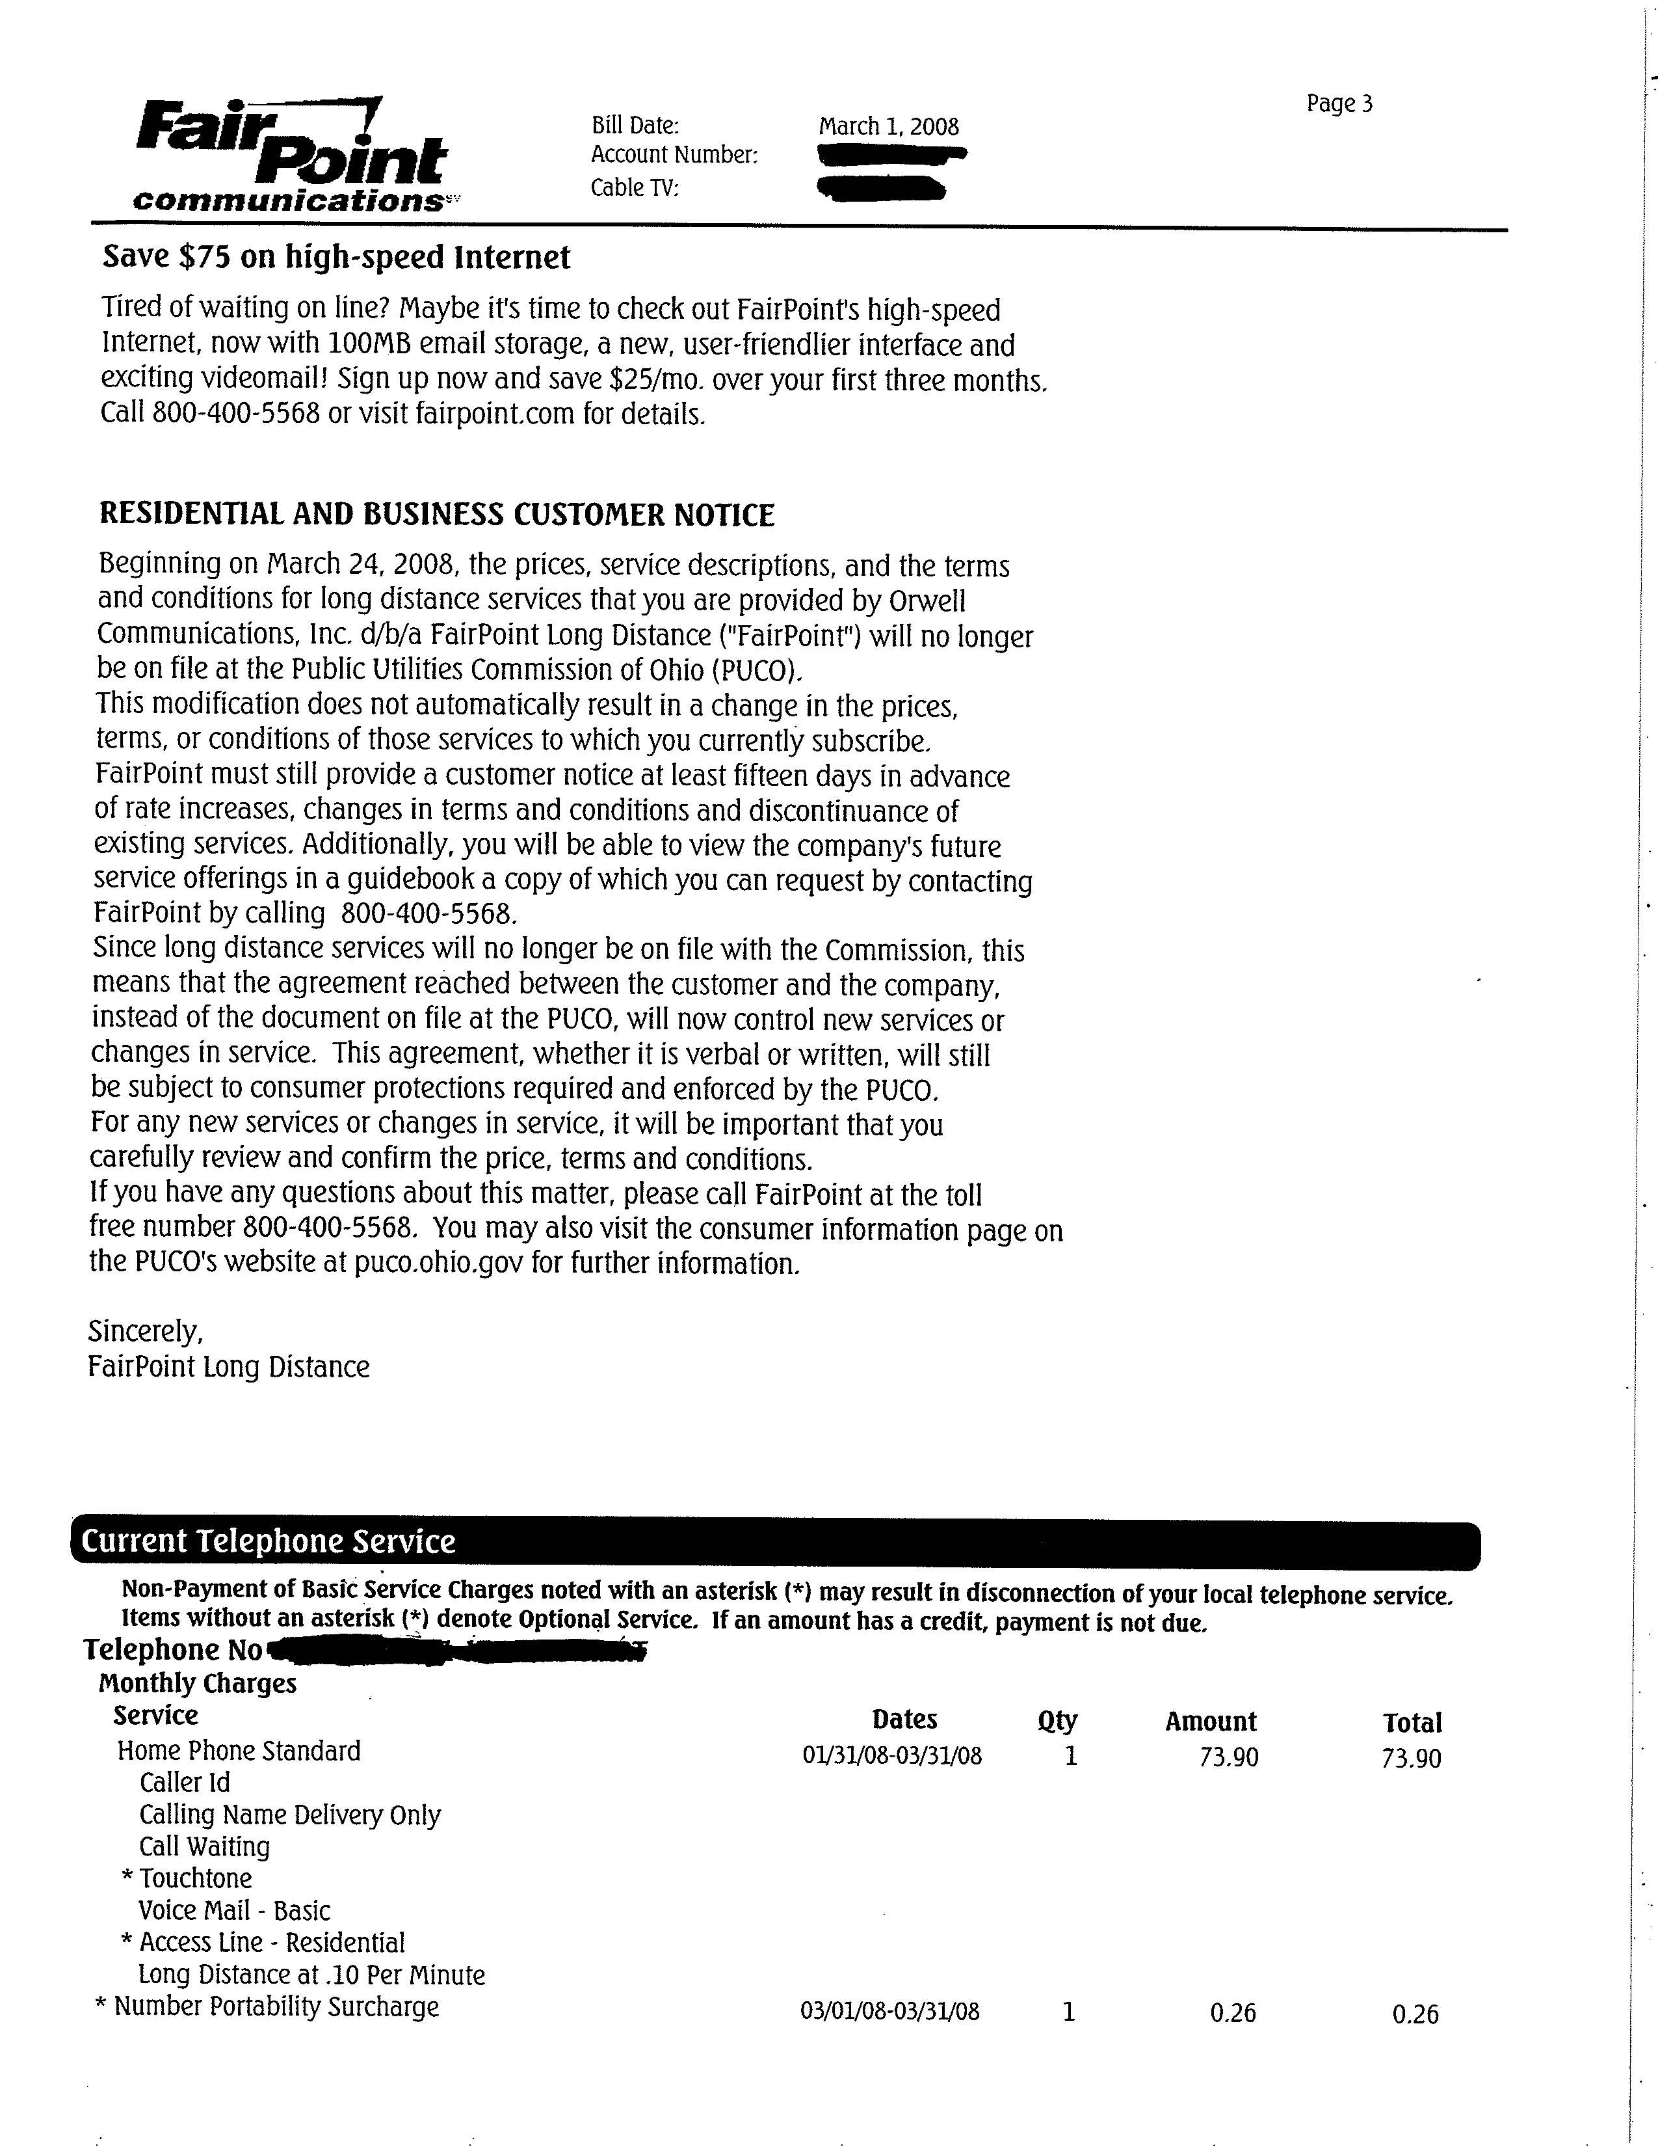
EXHIBIT F

(Affidavit)

