
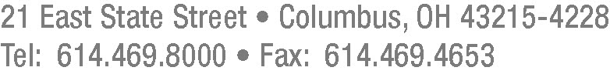

July 29, 2015

Barcy McNeal
Secretary, Docketing Division
Public Utilities Commission of Ohio
180 East Broad Street
Columbus, Ohio 43215

RE: Case No. 15-311-GA-UEX and 89-8015-GA-TRF

Dear Secretary McNeal:

Pursuant to the Application filed by the Ohio Gas Company (“Ohio Gas”) in Case No. 15-311-GA-UEX dated May 4, 2015, Ohio Gas hereby submits P.U.C.O. No. 1, Eleventh Revised Sheet No. 3, which replaces P.U.C.O. No. 1, Tenth Revised Sheet No. 3. P.U.C.O. No. 1, Eleventh Revised Sheet No. 3 is being filed electronically in the case docket and in Ohio Gas Company’s TRF docket.

Thank you for your kind attention to this matter.

Very truly yours,

_/s/ Frank P. Darr
Frank P. Darr

Attorney for Ohio Gas Company

Enclosure
FPD:vlp

OHIO GAS COMPANY Eleventh Revised Sheet No. 3
(Cancels Tenth Revised Sheet No. 3)

P.U.C.O. No. 1

GAS SERVICE

GROSS RECEIPTS EXCISE TAX RIDER

The Gross Receipts Excise Tax Rider is applicable to all gas cost recovery charges billed by the Company under all of its current rate schedules.

All bills shall be adjusted for the Ohio gross receipts excise tax on gas cost recovery revenues at a rate of 4.970%.

UNCOLLECTIBLE EXPENSE RIDER

Applicability. Applicable to all volumes served under the General Service and Transportation Rates. An additional charge shall be applied to all volumes for service rendered to recover costs associated with uncollectible accounts arising from those customers responsible for paying the Uncollectible Expense Rider. The Company shall file an application with the Public Utilities Commission of Ohio requesting approval to change the rate if the Company determines that an adjustment of more than plus or minus ten percent is needed to adjust for prior period over- or under-collections. The current Uncollectible Expense Rider rate is $0.0220 per Mcf.

