
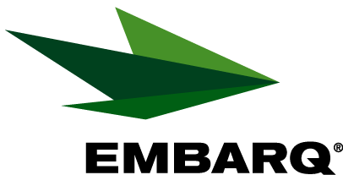

Embarq Corporation
Mailstop: KSOPKJ0502-5022
5454 West 110th Street
Overland Park, KS 66211
Glenda.Munson@EMBARQ.com

Via E-FILE

July 1, 2009

Ms. Renee’ Jenkins, Director of Administration
Public Utilities Commission of Ohio
180 East Broad Street, 13th Floor
Columbus, OH 43215-0573

Re: United Telephone Company of Ohio d/b/a Embarq
Case No. 90-5041-TP-TRF

Dear Ms. Jenkins:

Enclosed for filing are revisions to United Telephone Company of Ohio d/b/a Embarq P.U.C.O. No. 5 General Exchange Tariff. This filing should be processed as a zero day filing, to become effective July 1, 2009. The following tariff sheets are enclosed:

Section 31 | Second Revised Sheet 5
 | Second Revised Sheet 6
 | Second Revised Sheet 7
 | Second Revised Sheet 8

This filing grandfathers Selective Call Screening Service and Toll Restriction for residence customers. Toll Restriction was not previously available with payphone lines. Selective Call Screening Service will remain available with Pay Telephone Access Line Service.

These services are being grandfathered because of minimal customer demand. Customers are alternatively subscribing to the Toll and Casual Dialing Restriction options. Lifeline customers are not impacted by this change as prospective Lifeline customers may subscribe to a Toll and Casual Dialing Restriction option at no charge.

If you have any questions regarding this filing, please call Gary Baki at 614-220-8629.

Sincerely,

/s/ Glenda L. Munson

Glenda L. Munson

Enclosures
cc: Gary Baki
OH 09-07 Letter
Glenda L. Munson
TARIFF ANALYST I
Voice: (913) 315-9346
Fax: (913) 315-0763

