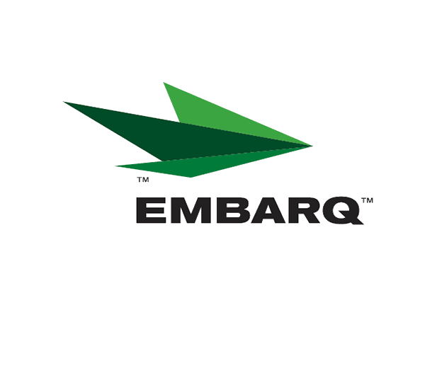


Embarq Corporation
Mailstop: KSOPKJ0502-5022
5454 West 110th Street
Overland Park, KS 66211
Glenda.Munson@EMBARQ.com

Via E-File/DHL

June 15, 2007

Ms. Renee’ Jenkins, Director of Administration
Public Utilities Commission of Ohio
180 East Broad Street, 13th Floor
Columbus, OH 43215-0573

Re: United Telephone Company of Ohio d/b/a Embarq
Case No. 07-706-TP-ZTA
90-5041-TP-TRF

Dear Ms. Jenkins:

Enclosed for filing are revisions to United Telephone Company of Ohio d/b/a Embarq P.U.C.O. No. 5 General Exchange Tariff. This filing should be processed as a day filing, to become effective June 15, 2007.

The following tariff sheets are enclosed:

P.U.C.O. No. 5, General Exchange Tariff | Section 15 | Sixth Revised Sheet 1
 | Section 39 | Second Revised Sheet 8

This filing clarifies and corrects the language for Standard Home Phone II. The original filing neglected to define that the subscriber could purchase Privacy ID at a discount rate and that Enhanced Call Waiting could be replaced with Talking Call Waiting at no additional charge. Customers have been informed of these options at the point of sale as well as through customer correspondence immediately after the sale.

In addition, housekeeping changes were made to the Privacy ID add-on list that was inadvertently omitted in a previous filing.

If you have any questions regarding this filing, please call Becky Donahue at 614-220-8624.

Sincerely,

/s/ Glenda L. Munson

Glenda L. Munson

Enclosures
cc: B. Donahue
OH 07-31
Glenda L. Munson
TARIFF ANALYST I
Voice: (913) 315-9346
Fax: (913) 315-0763

