BEFORE

THE PUBLIC UTILITIES COMMISSION OF OHIO

In the Matter of the Application for Establishment of a Reasonable Arrangement between ASHTA Chemicals Inc. and The Cleveland Electric Illuminating Company. | )  )  )  )  ) | Case No. 12-1494-EL-AEC

____________________________________________________________________________

MOTION TO INTERVENE OF
THE CLEVELAND ELECTRIC ILLUMINATING COMPANY _____________________________________________________________________________

Pursuant to Ohio Revised Code § 4903.221 and O.A.C. 4901-1-11, The Cleveland Electric Illuminating Company (“Company”) moves to intervene in this proceeding. The Company has a real and substantial interest in this proceeding and its interests, which may be prejudiced by the results of this proceeding, are not adequately represented by the existing parties. Thus, for these reasons, and as set forth more fully in the attached memorandum in support, the Company respectfully requests that the Commission grant this timely request to intervene.

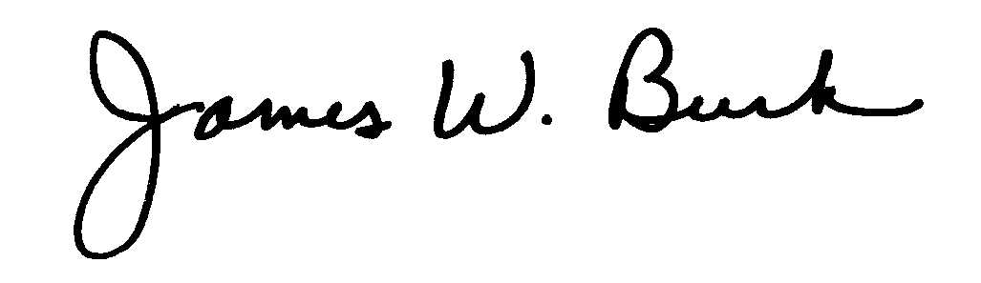
Respectfully submitted,

_____________________________________
James W. Burk
FIRSTENERGY SERVICE COMPANY
76 South Main Street
Akron, OH 44308

ATTORNEY FOR THE CLEVELAND ELECTRIC ILLUMINATING COMPANY

BEFORE

THE PUBLIC UTILITIES COMMISSION OF OHIO

In the Matter of the Application for Establishment of a Reasonsable Arrangement between ASHTA Chemicals Inc. and The Cleveland Electric Illuminating Company. | )  )  )  )  ) | Case No. 12-1494-EL-AEC

____________________________________________________________________________

MEMORANDUM IN SUPPORT OF THE MOTION TO INTERVENE OF
THE CLEVELAND ELECTRIC ILLUMINATING COMPANY
_____________________________________________________________________________

ASHTA Chemicals, Inc. (“ASHTA”) filed an Application for a Reasonable Arrangement on May 7, 2012 seeking Commission approval of a contract with the Company for a reasonable arrangement. As an expected signatory party to the contract for which ASHTA seeks approval, the Company has a real and substantial interest in this proceeding. The Company’s Motion should be granted so that its interests can be adequately represented and properly presented for the Commission’s consideration.
Ohio Revised Code § 4903.221 provides that any “person who may be adversely affected by a public utilities commission proceeding” may intervene in a Commission proceeding. The Commission’s own rules reinforce the right to intervene and provide that:
Upon timely motion, any person shall be permitted to intervene in a proceeding upon a showing that . . . [t]he person has a real and substantial interest in the proceeding, and the person is so situated that the disposition of the proceeding may, as a practical matter, impair or impede his or her ability to protect that interest, unless the person’s interest is adequately represented by existing parties.

O.A.C. 4901-1-11(A) (emphasis added). “The regulation’s text is very similar to Civ.R. 24 – the rule governing intervention in civil cases in Ohio – which is generally liberally construed in favor of intervention.” Ohio Consumers’ Counsel v. Pub. Util. Comm., 111 Ohio St. 3d 384, 387 (2006) (internal quotations omitted). In considering a motion to intervene, the Commission is directed by both O.R.C. § 4903.221 and O.A.C 4901-1-11(B) to consider a number of criteria, each of which is clearly satisfied by the Company’s Motion to Intervene. The following criteria are as follows:
(B) In deciding whether to permit intervention under paragraph (A)(2) of this rule, the commission, the legal director, the deputy legal director, or an attorney examiner shall consider:
(1) The nature and extent of the prospective intervenor’s interest.
(2) The legal position advanced by the prospective intervenor and its probable relation to the merits of the case.
(3) Whether the intervention by the prospective intervenor will unduly prolong or delay the proceedings.
(4) Whether the prospective intervenor will significantly contribute to full development and equitable resolution of the factual issues.
(5) The extent to which the person’s interest is represented by existing parties.

The Company has a number of real and substantial interests in this proceeding that are central to the requested reasonable arrangement. The Company will be one of the signatory parties to the contract underlying the reasonable arrangement requested in this proceeding. Therefore, the outcome of this proceeding will have a direct impact upon the Company. The Company has already met with both the Applicant and Staff to discuss the reasonable arrangement being sought, and therefore is already knowledgeable about the approach being proposed as part of the reasonable arrangement.
The Company plans to participate in the proceeding to help assure that any customer benefits identified as arising from the Reasonable Arrangement will remain in effect throughout the expected term of the reasonable arrangement. The Company plans to continue working with the Staff and the Applicant and to provide testimony in this proceeding to help develop the record for the Commission’s consideration.
The Company’s participation in this proceeding will not unduly delay or prolong the proceeding and this Motion to Intervene was filed prior to the due date for interventions. The Company’s participation will provide assistance to the Commission and its evaluation of the proposed reasonable arrangement. The Company has worked with many customers over the years in the development and implementation of reasonable arrangements and will use that historical knowledge and expertise in this proceeding to assist the Commission in reaching a reasonable result and to provide a solid precedent to be relied upon going forward.
The Companies are also uniquely positioned to protect and balance the interests of their customers and shareholders through supporting efforts that will help mitigate costs that may be imposed upon customers and then providing for a reasonable recovery mechanism for those costs.
As shown above, the Company’s Motion to Intervene satisfies each of the criteria the Commission must consider in granting intervention. Therefore, the Company respectfully requests that the Commission grant its Motion to Intervene and allow it to represent its interests in this proceeding.

Respectfully submitted,

___________________________
James W. Burk (0043808)
Managing Counsel
FirstEnergy Service Company
76 South Main Street
Akron, OH 44308
(330) 384-5861
Fax: (330) 384-3875
On behalf of The Cleveland Electric
Illuminating Company

CERTIFICATE OF SERVICE
A copy of the foregoing Motion to Intervene of and the Memorandum in Support thereof have been served by electronic mail, this 19th day of October, 2012, upon the following parties as shown on the attached service list.

__________________________________
James W. Burk

William Wright
Chief, Public Utilities Section
Thomas McNamee
Assistant Attorney General
Public Utilities Commission of Ohio
180 East Broad Street, 6th Floor
Columbus, OH 43215
E-mail: William.wright@puc.state.oh.us
Thomas.McNamee@puc.state.oh.us

Attorneys for the Staff of the Public Utilities Commission of Ohio

Samuel C. Randazzo
Scott E. Elisar
McNees Wallace & Nurick LLC
21 East State St., 17th Floor
Columbus, OH 43215
Email: sam@mwncmh.com
selisar@mwncmh.com

Attorneys for Applicant

This criterion is found only in O.A.C. 4901-1-11(B), and not in O.R.C. § 4903.221.

