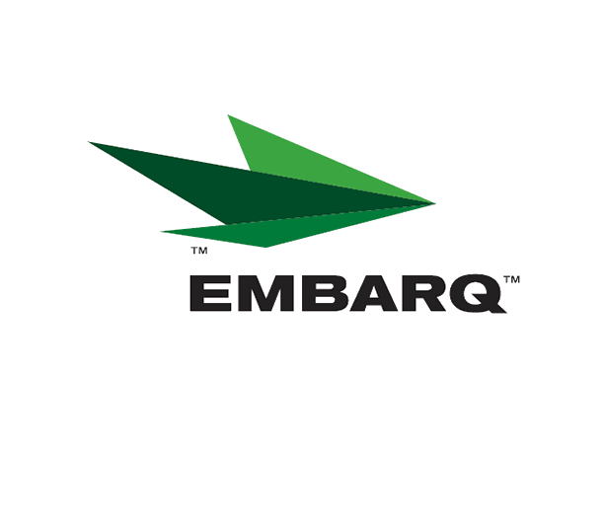



Embarq Corporation
Mailstop: KSOPKJ0502-5022
5454 West 110th Street
Overland Park, KS 66211
Glenda.Munson@EMBARQ.com

Via E-File

September 11, 2007

Ms. Renee’ Jenkins, Director of Administration
Public Utilities Commission of Ohio
180 East Broad Street, 13th Floor
Columbus, OH 43215-0573

Re: United Telephone Company of Ohio d/b/a Embarq
Case No. 07-1005-TP-ZTA

Dear Ms. Jenkins:

Enclosed for filing are revisions to United Telephone Company of Ohio d/b/a Embarq P.U.C.O. No. 5 General Exchange Tariff. This filing should be processed as a day filing, to become effective September 11, 2007.

The following tariff sheets are enclosed:

P.U.C.O. No. 5, General Exchange Tariff | Section 1 | 6th Revised Sheet 5

This filing introduces language to clarify the Company's policy regarding its recovery of collection costs associated with attempts to collect amounts due from business customers. The Company may assert it claim for collections costs and attorneys' fees against the Business Customer's bankruptcy estate. Customer notice is not required.


If you have any questions regarding this filing, please call Becky Donahue at 614-220-8624.

Sincerely,

/s/ Glenda L. Munson

Glenda L. Munson

Enclosures
cc: B. Donahue

OH 07-49
Glenda L. Munson
TARIFF ANALYST I
Voice: (913) 345-7550
Fax: (913) 345-6756

