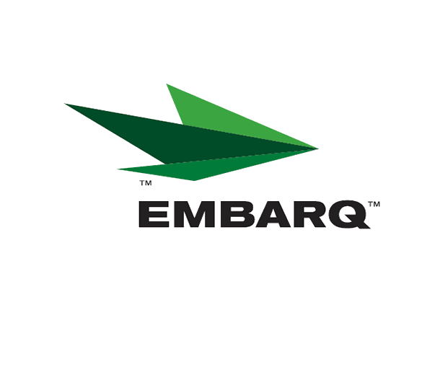


Embarq Corporation
Mailstop: KSOPKJ0502-5022
5454 West 110th Street
Overland Park, KS 66211
Glenda.Munson@EMBARQ.com

Via E-FILE

August 1, 2008

Ms. Renee’ Jenkins, Director of Administration
Public Utilities Commission of Ohio
180 East Broad Street, 13th Floor
Columbus, OH 43215-0573

Re: United Telephone Company of Ohio d/b/a Embarq
Case No. 90-5041-TP-TRF

Dear Ms. Jenkins:

Enclosed for filing are revisions to United Telephone Company of Ohio d/b/a Embarq P.U.C.O. No. 5 General Exchange Tariff. This filing should be processed as a day filing, to become effective August 1, 2008.

The following tariff sheets are enclosed:

P.U.C.O. No. 5, General Exchange Tariff | Section 21 | Fourth Revised Sheet 1

This filing makes tariff revisions that are for clarification only, with no change in intent, and no impact to customers.

If you have any questions regarding this filing, please call Gary Baki at 614-220-8629.

Sincerely,

/s/ Glenda L. Munson

Glenda L. Munson

Enclosures
cc: Gary Baki

OH 08-01
Glenda L. Munson
TARIFF ANALYST I
Voice: (913) 315-9346
Fax: (913) 315-0763

