 | Gary L. Kepley  Mailstop KSOPKJ0502-508  Director – Regulatory Systems  5454 West 110th Street  Overland Park, Kansas 66211  Voice: 913-345-7572  Email: Gary.Kepley@embarq.com

December 14, 2007

Ms. Renee Jenkins, Director of Administration
Public Utilities Commission of Ohio
180 East Broad Street
Columbus, Ohio 43215-3794

Re: United Telephone Company of Ohio d/b/a Embarq
Case No. 07-1181-TP-ATA
Case No. 07-464-TP-COI and
Case No. 90-5041-TP-TRF

Dear Ms. Jenkins:

Submitted as an electronic filing are revisions to United Telephone Company of Ohio d/b/a Embarq, P.U.C.O. No. 1 Access Service Tariff. These revisions are filed in compliance with Case Nos. 07-1181-TP-ATA, 07-464-TP-COI and 90-5041-TP-TRF. These orders authorize Embarq to establish pricing flexibility for switched dedicated, special access and ordering options, additional labor and miscellaneous services in the Lima, Ohio metropolitan statistical area (MSA) where Embarq Local Operating Companies has been granted Phase II pricing flexibility in accordance with subpart H of the Federal Communications Commission's Part 69 Rules. This filing should be processed as a zero day filing, to become effective December 14, 2007.

The following tariff pages are enclosed which establish pricing flexibility:

P.U.C.O. No. 1, Access Service Tariff Section 21 Revised Sheets 1 – 3
Section 22 Revised Sheet 1
Section 23 Original Sheet 1
Section 24 Original Sheet 1
Section 25 Original Sheets 1 – 3

On November 9, 2007, Embarq Local Operating Companies filed Transmittal No. 38 with the Federal Communications Commission to establish regulations, rates and charges for the provision of interstate switched dedicated, special access and ordering options, additional labor and miscellaneous services in the Lima, Ohio MSA. This filing became effective on November 24, 2007.

Renee Jenkins
December 14, 2007
Page 2

Should you have questions or require additional information regarding this filing, please contact Gary Baki at (614) 220-8629.

Sincerely,
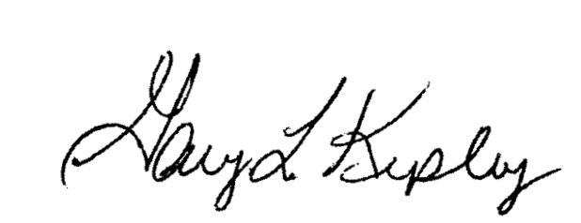

Gary L. Kepley

Attachments

pc: Gary Baki

OH 07-60

In the Matter of Petition of the Embarq Local Operating Companies for Phase I and Phase II Pricing Flexibility for Special Access and Dedicated Transport Services in the Lima, Ohio and Mansfield, Ohio Metropolitan Statistical Areas and Phase I and Phase II Pricing Flexibility for Channel Termination Services in the Lima, Ohio Metropolitan Statistical Area, WCB/Pricing File No. 07-13, Order, (DA 07-3840), released September 5, 2007.

