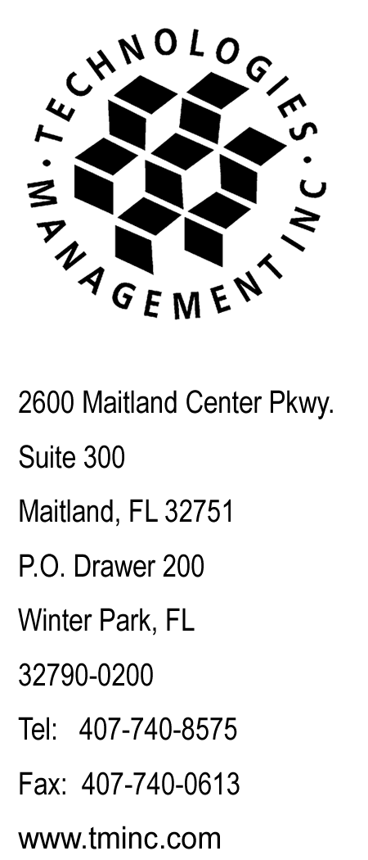
August 29, 2008

Via E-file

Ms. Renee Jenkins, Commission Secretary
Public Utilities Commission of Ohio
180 East Broad Street, 13th Floor
Columbus, OH 43215-3793

RE: Interexchange Startec Global Operating Company
Case No. 08-733-TP-ATA

Dear Ms. Jenkins:

Enclosed for filing please find the original copy of the replacement page 3 to add the Customer Rights and replacement page 16 corrected the floor and hours of the Commission Hotline per the request of Paula Garrettson on August 29, 2008.

Please acknowledge receipt of this filing by date stamping the extra copy of this cover letter and returning it to me in the self-addressed stamped envelope.

Any questions you may have regarding this filing may be directed to me at 407-740-3001 or via email to tforte@tminc.com.

Thank you for your assistance with this matter.

Sincerely,

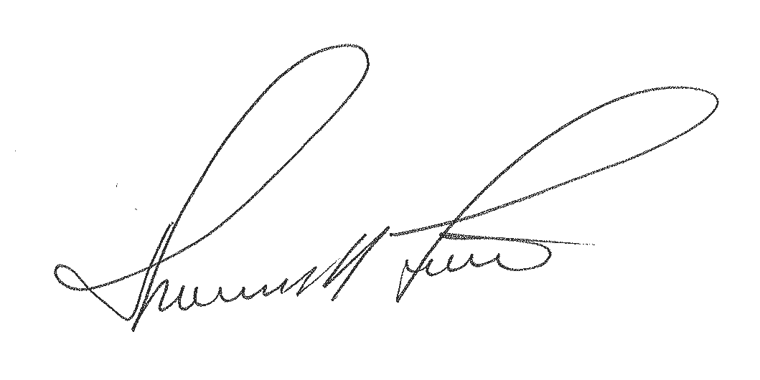

Thomas M. Forte
Consultant to Startec Global Operating Company

TMF/rg

cc: R. Felgar - Startec
file: Startec – OH IXC
tms: OHi0801b

STARTEC GLOBAL OPERATING COMPANY P.U.C.O. Tariff No. 3
Original Sheet 3

APPLICATION OF TARIFF

This tariff filed by the Company describes the Regulated Toll Terms, Conditions, Payments and Rates and Charges required in conformance with Competitive Retail Telephone Rules (Case No. 06-1345-TP-ORD). Services will be provided in compliance with Minimum Telephone Services Standards. The Company provides Toll regulated services which are not required in the Company’s tariff on file with the Public Utilities Commission of Ohio (Rule 4901: 1-06-05(g)).

The Customer may view the Detariffed / Nonregulated Services not included in this tariff on the Company’s website at:
www.startec.com

Customers rights, responsibilities and safeguards can be found in the Ohio Administrative Code Appendix (Rule 4901:1-5-03).

The applicable requirements of the Ohio Administrative Code and the Ohio Revised Code apply to the operations of the Company. The Company will comply with the Commission’s policies and requirements for persons with communications disabilities and privacy and number disclosure requirements covered in subject cases. Any changes in terms or conditions of this tariff and/or operations of the Company will generate an obligation of the Company to provide notice of such changes in accordance with the Commission’s Rules.

Customers have certain rights and responsibilities under the Minimum Telephone Service Standards (Ohio Adm.Code 4901:1-5) (MTSS). These safeguards can be found in the Appendix to Ohio Adm. Code 4901:1-5-03, which is entitled "Telephone Customer Rights and Responsibilities". These rights and responsibilities include complaint handling, ordering or changing service, service repair, payment of bills, and disconnection and reconnection of service.

STARTEC GLOBAL OPERATING COMPANY P.U.C.O. Tariff No. 3
Original Sheet 16

SECTION 2 - RULES AND REGULATIONS, (CONT'D.)

2.5 Payment and Credit Regulations, (Cont'd.)

2.5.3 Regarding the manner in which the creditworthiness of service applicants is established, as well as the manner in which disconnection of service for nonpayment of charges occurs, the Company will comply with rules adopted by the Public Utilities Commission of Ohio and codified in the MTSS.

2.5.4 If the customer and the Company are unable to resolve the dispute to their mutual satisfaction, the Customer may file a complaint with the Public Utilities Commission of Ohio in accordance with the Commission’s rules of procedure. The address of the Commission is as follows:

Service Monitoring and Enforcement Department
Public Utility Commission of Ohio
180 East Broad Street, 7th Floor
Columbus, Ohio 43215-3793
Toll Free Telephone: 800-686-7826
TTY Toll Free Telephone: 800-686-1570
From 8:00 AM to 5:00 PM (EST) weekdays or at www.PUCO.ohio.gov

Residential Customers may also contact the Ohio Consumers’ Counsel for assistance with complaints and utility issues at:

Toll Free Telephone: 877-742-5622
From 8:00 AM to 5:00 PM (EST) weekdays or at www.pickocc.org

