DEO EXHIBIT 2.1

before
the public utilities commission of ohio

JUDY ALEXANDER,  Complainant,  v.  THE EAST OHIO GAS COMPANY D/B/A DOMINION EAST OHIO,  Respondent. | )  )  )  )  )  )  )  )  )  ) | Case No. 11-5601-GA-CSS
SUPPLEMENTAL DIRECT TESTIMONY OF
MICHAEL A. KAZMER
ON BEHALF OF THE EAST OHIO GAS COMPANY
D/B/A DOMINION EAST OHIO

TABLE OF CONTENTS
I. INTRODUCTION 1
II. METER PROOF TESTING 1
III. DEO'S TEST OF MS. ALEXANDER'S METER 3

Supplemental Direct Testimony of

Michael A. Kazmer

I. INTRODUCTION

Q1. Please state your name, occupation and business address.
A1. My name is Michael A. Kazmer. I am employed by The East Ohio Gas Company d/b/a Dominion East Ohio ("DEO" or "Company") as an Operations Manager. My business address is 1201 E. 55th Street, Cleveland, Ohio 44103.
Q2. Are you the same Michael A. Kazmer that previously filed direct testimony in this proceeding?
A2. Yes.

Q3. What is the purpose of your supplemental direct testimony?
A3. My testimony explains the procedure followed by DEO in conducting a proof test of the gas meters formerly at Judy Alexander's premises.
II. METER PROOF TESTING
Q4. What is a meter proof test?
A4. DEO performs meter proof tests to ensure that a gas meter is accurately measuring the gas that passes through the meter. DEO typically conducts meter proof tests in two scenarios. First, DEO tests meters when requested by the customer. Second, DEO maintains a statistical meter-testing program.
Q5. Are meter tests commonly run in the ordinary course of business for DEO?
A5. Yes, the Company regularly tests its meters to ensure accuracy. DEO's tariff includes language discussing a customer's right to request a meter test. As I explained above, DEO maintains a statistical meter-testing program.
Q6. Are you familiar with DEO's procedures and equipment to test gas meters?
A6. Yes.
Q7. What equipment does DEO use to conduct meter tests?
A7. DEO currently uses the American Meter Sonic Nozzle Prover, Series III ("Sonic Prover"). In the past, we have used prior models of this machine to perform meter tests.
Q8. Describe the procedure for testing a meter using the Sonic Prover.
A8. The operator logs into the machine and sets it to the proper specifications, based on the size and type of the meter that is being tested. The operator then mounts the meter to the Sonic Prover, enters the serial number of the meter, and initiates the test. To determine the accuracy of the meter, the Sonic Prover draws air through the meter at a pre-set volume and flow rate, and compares the actual volume of air with the volume registered by the meter. For a single meter we typically run two tests at different volumes and flow rates to ensure consistency in the results.
Q9. What do you mean by standardized volume and flow rate?
A9. "Volume" refers to the volume of air drawn through the meter. The standard volume in gas meter tests is 0.5 cf. "Flow rate" refers to the speed at which the particular volume of air is drawn through the meter. There are two standard flow rates used in meter testing: the "open load," in which air is drawn at 100% of the meter's capacity (250 cfh) and the "check load," in which air is drawn at 20% of the meter's capacity (50 cfh). Other volumes and flow rates can be used if necessary.
Q10. How are the results of a meter test determined?
A10. The machine calculates the percent variability between the pre-set volume of air sent through the meter and the amount measured by the meter. For example, if the actual volume drawn through the meter is 0.5 cf, and the meter measures 0.5025 cf, then the percent variability is 0.5% (i.e., 0.5025 is 0.5% greater than 0.5). These figures are automatically displayed on the machine at the conclusion of each test.
III. DEO'S TEST OF MS. ALEXANDER’S METERS
Q11. Did DEO test Ms. Alexander’s meters?
A11. Yes. DEO removed Ms. Alexander's meters at 8207 and 8209 Beman Avenue on May 8, 2012, and tested them on May 11, 2012. The results from these meter tests are attached to my testimony as DEO Exhibits 2.11 and 2.12.
Q12. What were the results of the test conducted on the Downstairs Meter (8207 Beman)?
A12. The average variability of the tests at the open load was -0.5%. This means the meter was running slow by 0.5% at the meter's full volumetric capacity. The average variability of the check load was -0.6%. This means the meter was running slow by 0.6% when the pre-set volume was lessened to a more typical customer load. The average of these figures is -0.55%. This means, on average, Ms. Alexander’s Downstairs Meter was running slow by 0.55%.
Q13. What were the results of the test conducted on the Upstairs Meter (8209 Beman)?
A13. The average variability of the tests at the open load was 1.4%. This means the meter was running fast by 1.4% at the meter's full volumetric capacity. The average variability of the check load was 1.6%. This means the meter was running fast by 1.6% when the pre-set volume was lessened to a more typical customer load. The average of these figures is 1.5%. This means, on average, Ms. Alexander’s meter was running fast by 1.5%.
Q14. If a meter tests slow, how does that impact a customer?
A14. A meter which tests slow is actually not measuring the full quantity of gas being billed to a customer. Instead, the customer is receiving some gas for free.
Q15. If a meter tests fast, how does that impact a customer?
A15. A meter which tests fast is actually measuring more gas than the amount of gas used by the customer.
Q16. Are you familiar with Ohio Revised Code Section 4933.09?
A16. Yes. That provision requires gas meters to have a percent variability of no greater than three percent (3%).
Q17. Based on the tests you described, did Ms. Alexander’s meters meet this standard?
A17. Yes, Ms. Alexander’s meters easily met this standard. Ms. Alexander’s meter tested well within the 3% threshold. The Downstairs Meter tested a variability of -.05% to -.06%. The Upstairs Meter tested a variability of 1.4% to 1.6%. Based on these results, Ms. Alexander’s meters comply with that provision.
Q18. Does this conclude your supplemental direct testimony?
A18. Yes.
CERTIFICATE OF SERVICE
I hereby certify that a copy of the foregoing Supplemental Direct Testimony of Michael A. Kazmer on behalf of The East Ohio Gas Company d/b/a Dominion East Ohio was served by regular U.S. mail to the following person on this 18th day of May, 2011:
Ms. Judy Alexander
4931 East 86th Street
Cleveland, Ohio 44105

One of the Attorneys for The East Ohio Gas Company d/b/a Dominion East Ohio

DEO EXHIBIT 2.11

METER TEST RESULTS
DOWNSTAIRS METER

8207 Beman Avenue

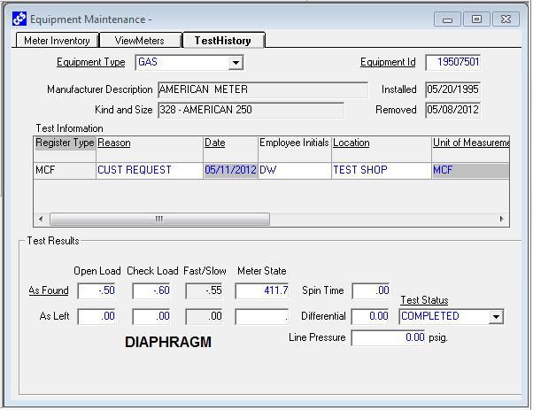

DEO EXHIBIT 2.12

METER TEST RESULTS
UPSTAIRS METER

8209 Beman Avenue

