The Estimated Economic and Fiscal Impacts
of the Ormet Aluminum Smelter Operation in Hannibal, Ohio

by
Paul A. Coomes, Ph.D.
Consulting Economist

a research report for
The Ormet Corporation

July 30, 2011

EXECUTIVE SUMMARY

Ormet Corporation, headquartered in Hannibal Ohio, is a major producer of primary aluminum in the United States. The operation is on the Ohio River at the southeastern edge of the state, across the border from West Virginia. It currently employs around 1,000 people and pays wages and salaries annually of about $63 million. Employees live in eighteen counties in three states, of which sixty percent reside in Ohio. Activity at Hannibal has ebbed and flowed over the past decade, reflecting changing conditions in the international market for aluminum.

The Ormet Corporation is interested in learning about and documenting the regional economic importance of its operations, so they can better communicate the ramifications of rising electricity costs should prices reach a threshold such that the smelting operations were financially threatened. The purpose of this report is to document and communicate the regional economic and fiscal importance of this aluminum plant.

I have used regional data and industry-specific multipliers to estimate the economic and fiscal impacts of the operation. These estimates can be used to quantify the likely impact were the plant closed due to low aluminum prices or high electricity prices. I estimate that the total net annual impact in the region is 3,117 jobs and $238 million in total employee compensation. State and local governments in Ohio would lose about $9 million annually in tax revenues. These estimates are for the economic and fiscal categories most easily quantified. There are other impacts, though they are harder to measure with any precision. Local real estate and retail markets are linked to the payrolls at the smelter. Social indicators, like unemployment and crime, also are related to the plant’s employment levels, as are public costs for unemployment benefits, retraining, and social services.

BACKGROUND
Aluminum is made from alumina, or aluminum oxide, essentially by passing enormous electric current through steel ‘pots’ containing a cryolite-alumina mixture. This process is often called reduction, because the electrolysis process separates alumina into its elements, one of which is the aluminum metal. The process is also called smelting. The molten aluminum is siphoned off the pots and formed into crucibles, which when cooled become the familiar ingots traded on the international metals market. Alumina is made from bauxite, most of which is obtained from Australia, Brazil, Guinea, and Jamaica. Ormet has an alumina production facility in Louisiana. Because of the extremely large electricity requirements, most aluminum smelting is done near sources of inexpensive electricity, such as hydroelectric plants. Moreover, since the least cost method of shipping alumina and aluminum is by barge, smelters are often located on major rivers such as the Ohio.

The Ormet smelter is among the largest private sector employers in the regional economy, and clearly the largest industrial employer in Monroe County. The Ohio Department of Development produces statistical profiles for each county. It shows the top employers in Monroe County to be:

Monroe County Government
Ormet Corporation
Riesbeck Food Markets
Safe Auto Insurance Group
Slay Transportation Company
Switzerland of Ohio Local Board of Education
Extendicare/Woodsfield Nursing Center

The government, grocery, insurance, school and nursing home organizations exist to serve the local market, and hence do not bring in new dollars to the regional economy. Ormet and Slay Transportation are apparently the only two major employers in the County that generate dollars there, through their sales of goods and services to the rest of the world.

Moreover, federal data reveal that $52.1 million of the County’s $118.0 million in total wages and salaries for 2010 are attributed to the manufacturing industry, of which Ormet is essentially the only firm. With the average pay of $61,000, no other place of work in the County comes close to this employment opportunity. Moreover, employee benefits are very lucrative. The company reports that its contributions to the social security and Medicare programs for its employees, plus the value of retirement, health insurance, and other fringe benefits is almost as large as the base wages and salaries.

We can also now discern in published county-level economic data the effects of activity at the Ormet facility over the last decade. Indeed the total payroll in the County seems to ebb and flow with activity at the smelter. See chart below. The company emerged from bankruptcy in April 2005, but the Hannibal smelter lines had been operating well below capacity for two years prior. The facility was essentially idle from 2005 until late 2006, when it was restarted to take advantage of rising aluminum prices. BLS data show that wage and salary payments by all employers in Monroe County fell about 9 percent in 2004, another 26 percent in 2005, and a further 7 percent in 2006. County payrolls bounced back in 2007 after the smelter was brought back into full production. The smelter operated at full capacity in 2007 and 2008, and at partial capacity in 2009 and 2010, and the pattern carries over to the Monroe County payroll totals shown in the chart. All six potlines were back in production beginning in February 2011, so publicly available data on County payroll will show an uptick when it is released over the next year. Clearly, the local economy is very sensitive to production activity at Ormet.

The effect of losing a large employer, particularly in a lightly populated county, goes far beyond the loss of payrolls. Often the company is the primary force in the local housing market, the largest contributor of property taxes to the local school system, the largest contributor of health care benefits and therefore the largest indirect customer of the local hospital, and the largest contributor of dollars and time to local charities. Moreover, when a large plant closes, not only do public revenues fall but public costs go up. Other statewide employers and employees must contribute to pay for the unemployment benefits to laid off workers, increased Medicaid costs as families lose income and health insurance coverage, and overall increased social services costs. Crime rates tend to rise with unemployment, as do alcohol and drug addiction. Local community and technical colleges see enrollments surge as laid off workers try to retrain. And major community investments must be made in economic development efforts to replace the lost engines.

The linkage between smelter closures and local unemployment is clear from the public data on Monroe County. In the next chart I provide the official estimates of unemployment rates in Monroe and for the state of Ohio as a whole. The state of Ohio tracks the national unemployment rate fairly closely, and one can see the effects of the 2001-02 recession, with Ohio’s unemployment rate rising from four to six percent, before falling in 2005. The 2007-09 recession was more severe in Ohio, with the unemployment rate jumping above 10 percent the last two years. Monroe County’s rate has been consistently higher than the state average over the last decade. However, the pattern of unemployment in the County tends to follow activity at the aluminum smelter, rising when the smelter was idled during the 2004-06 period, falling in 2007-08 after the plant was back in full production, then rising again when production was limited to four potlines in 2009-10. Monroe’s rate is likely to fall in 2011, now that the smelter is fully operating again. Preliminary monthly data for 2011 show a decline in the County unemployment rate of 3-4 percent compared to 2010.
METHODOLOGY
Because the aluminum and related manufacturing operations serve primarily national and international markets, they bring new dollars into the regional economy. In this sense, a shut-down of the smelter would have large and predictable negative economic and fiscal impacts in these Ohio and West Virginia counties. The activity supports thousands of jobs and millions of dollars in payrolls, and ultimately large tax revenues for Ohio and West Virginia state and local governments. In this section, I explain how I defined the regional economic footprint for purposes of this impact study, and discuss in some detail the input-output model and tax rate calculations used to measure the regional impacts.

The Regional Economy
While Monroe County is the site for the aluminum plant, the economic and fiscal impacts permeate a much larger region. I define the impact region based on the geographic footprint of the workforce. Workers commute in to the aluminum plant, and take their paychecks to their home county, where they pay for housing and many retail and personal services. Ormet provided a breakdown of employment by county of residence for a pay period, as shown in the accompanying table. Workers reside in eighteen counties in three states. Note however that 96 percent of employees reside in the top seven counties, those nearest to Monroe County. Three of these counties are in Ohio and four are in West Virginia. Interestingly, almost as many workers live in West Virginia (427) as in Ohio (598).

The map on the next page shows the regional counties, major cities, road and water features in the economic impact area. The counties shaded yellow are the top places of residence for Ormet employees, and these are the ones we use to investigate impacts. The red star denotes the approximate location of the Ormet plant and Hannibal, Ohio.

The 2010 Census reveals that that region has been losing population. All counties in the region except Belmont lost residents the last decade, while the states of Ohio and West Virginia added residents. Overall, the seven-county region lost 8,700 people, a decline of 3.4 percent. Monroe County, site of the Ormet aluminum smelter and home to one-third of the Ormet employees, has about 500 less residents now than at the beginning of the decade, a decline of 3.5 percent.
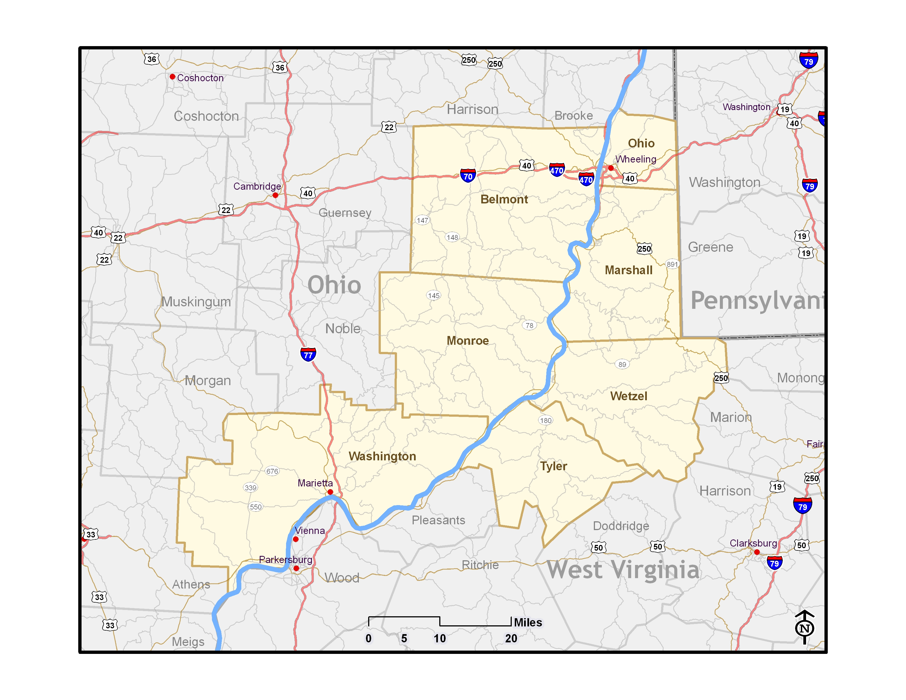
I have also organized some aggregate economic indicators on the counties in the region. Estimates for the last five year period available are shown in the next table. Clearly, the idling of the Ormet facility during part of the decade had a major effect on jobs and payroll in the region. Note that Monroe County suffered by far the greatest job loss, and was the only county to have less wages and salaries in 2009 than in 2001. Moreover, Monroe County had almost no growth in average pay per job during this period. Presumably all these indicators will improve now that the smelter is back to full production. However, it will be a year or two before there is sufficient data to measure the regional economic improvements.

Input-output model of the region
I use standard regional economic impact methods to evaluate the economic and fiscal impacts of the aluminum plant. I purchased detailed economic data for the seven counties most impacted, and used them to build an IMPLAN input-output model of the region. The model is able to simulate the effects of changes in economic activity for any of 440 regional industries. It also can predict detailed inter-industry purchases and household spending related to industrial changes.
In IMPLAN the sector of interest for this study is number 172, Primary Aluminum Production. This industry is defined according to the North American Industrial Classification System (NAICS) code 331312. The official definition is as follows:
This U.S. industry comprises establishments primarily engaged in (1) making aluminum from alumina and/or (2) making aluminum from alumina and rolling, drawing, extruding, or casting the aluminum they make into primary forms (e.g., bar, billet, ingot, plate, rod, sheet, strip). Establishments in this industry may make primary aluminum or aluminum-based alloys from alumina.
www.census.gov/epcd/naics02/def/ND331312.HTM#N331312
Input-output models are all based on a table of estimated transactions among industries. An industry like aluminum must purchase many goods and services from other industries to produce its finished product. Economists call the relationship between an output and its inputs a production function. IMPLAN’s production function for primary aluminum is shown in the accompanying table, ranked by most important. The first entry, aluminum products, refers to purchased alumina. The model predicts that $232,708 of alumina must be purchased for every $1 million of aluminum produced. Next most important is electricity, at $168,429, and so on. This is the foundation for the input-output model I have constructed for the Ormet seven county region. The model has information about the local availability of industrial supplies and retail spending opportunities, and makes adjustments to account for what must be imported into the region to produce aluminum and provide goods and services to the impacted households. The regional economic impact of the aluminum industry is derived from those linkages, often summarized by ‘multipliers’ showing the predicted change in total regional activity per change in industry activity.

The IMPLAN model provides estimates of indirect (inter-industry purchases) and induced (household spending) effects on sales, jobs, and payrolls for export-based expansions or contractions of any of 440 local industries. For example, the job multiplier for the primary aluminum production industry in the Hannibal region economic area is 3.026, meaning that for every job at the aluminum smelter, another 2.026 jobs are created elsewhere in the regional economy. Similarly, the employee compensation multiplier for the industry there is 2.329, meaning that for every dollar of payroll created at the aluminum smelter another $1.329 in payrolls are created in other sectors around the region.

Regional economists often make the distinction between the indirect and induced components of a multiplier, and in some cases make separate estimates for each. The indirect effects refer to the linkages between the exporting industry (aluminum) and their industrial vendors (transportation, electricity, barges, tools, computers, insurance). When the directly impacted industry expands, it raises its purchases from its vendors, thus lifting their employment and payrolls. The induced effects refer to the impact of the new export-based sales on the local economy through the rounds of re-spending of the additional household income caused by the expansion. Regional sales of cars, groceries, building supplies, banking services, and so on are all sensitive to growth in disposable income. In the next table, I show the top 24 regional industries linked to primary aluminum activity, as predicted by the IMPLAN model. I simulated the impact of 1,030 aluminum jobs on the 7-county region, and investigated the decomposition of the impacts in terms of interindustry linkages and household purchases. One can see the largest inter-industry impacts are in power supply, trucking, and wholesale trade industries. Aluminum employees spend much of their paychecks in the region and this creates other jobs, primarily in retail and personal service industries. The greatest impact is on restaurants, followed by three health care industries.

Taxes and fiscal linkages
There are no good national sources of data on which to make estimates of the fiscal impacts of an industrial expansion or contraction in a region. The company has provided detailed records on direct tax payments to local and state governments, including property taxes, sales taxes, and electricity taxes. We aggregate these in our fiscal impact statement in the next section. However, the impacts on governments are much greater than these direct payments. Employees pay sales taxes when they spend their wages in the local economy, and are liable for income taxes in Ohio and West Virginia, depending on their county of residence. We can estimate these payments using published data on tax receipts from Ohio and West Virginia state governments, as well as tax information from city and county governments in the region. By comparing the growth in tax receipts to the growth in payrolls historically, I calculate ‘effective’ tax rates and use those to estimate the amount of income and sales taxes linked to the aluminum industry payrolls.

The calculations are shown in the table on the last page of this report. Good county-level detail is available for Ohio, and in West Virginia I rely on state totals only. Note, for example, that residents of the three Ohio counties paid an average of $68.3 million in state individual income taxes the last five years for which data are published. This amounts to 3.9 percent of all wages and salaries paid in those counties. I use this as the effective state income tax rate of Ohio County government, and apply it to the Ormet-related wages and salaries flowing to Ohio residents to estimate income tax payments. A similar calculation was made for Ohio state and local sales taxes generated. County level tax collections were not available for West Virginia, so we use the statewide average of income and sales tax collections as a share of wages and salaries paid there. We apply the resulting effective tax rates to the portion of Ormet-related wages and salaries predicted to flow to West Virginia residents.

Additional tax impacts are also likely, though much harder to quantify. For example, proprietors and corporations around the region are liable for state individual and corporate income taxes. Gasoline taxes, unemployment insurance taxes, insurance premiums taxes, building permit fees, motor vehicle sales taxes, and many other business tax categories would see some decline if the smelter were to shut-down. Employees would also pay less in the way of gasoline taxes, motor vehicle sales taxes, and there would be a dampening effect on the regional real estate market. These categories are much harder to measure than the income and general sales taxes, but fortunately are not as important dollar-wise as the main taxes I do measure in this report.

IMPACTS
In this section, I display and explain my estimates of the economic and fiscal impacts of the aluminum smelter. I am essentially simulating what would happen if the operation was removed from the region. The plant employs over 1,000 persons with an annual payroll of about $63 million, plus $39 million in employee benefits. Direct tax payments by the company plus tax withholdings for employees are over $4 million.

On lines 8 and 9, I provide estimates of the total effects – direct plus spinoff. Here I use economic multipliers to estimate the job and employee compensation impacts regionally. I estimate the total job impact in the 7-county region to be over 3,100 jobs, and the employee compensation impact to be about $238 million annually. Employee compensation includes many company provided fringe benefits, most of which are not taxable. So, I estimate the share (62 percent) of the total employee compensation that is taxable wages and salaries, and use that to estimate fiscal impacts.

The company does not know the amount of Ohio and West Virginia state income taxes actually paid by their employees, since employees file income tax returns from their place of residence. The company does withhold state income taxes from workers paychecks, but have no way of knowing how much additional tax employees ultimately end up paying, or how big of a tax refund they receive each year. To estimate the state income taxes paid, I applied effective income tax rates, as described in the previous section. These estimates are shown in lines 10 and 11. I estimate that Ohio state government is receiving about $8.7 million annually in individual income taxes, sales taxes, and electricity taxes from Ormet-related activity. West Virginia state government receives about $6.1 million. And local governments receive over $400,000 in tax revenues.

See http://mii.org/Minerals/photoal.html for a simple explanation of the production process.
See www.monroecountyohio.net/Cost%20of%20Business.html .
See US Bureau of Labor Statistics, Quarterly Census of Employment and Wages program www.bls.gov/data/ .
The full fiscal impact would be more than the tax receipts lost, since the state would have to incur tens of millions of dollars in costs for unemployment compensation and increased Medicaid expenditures in the region if the plant shut down and the employees lost their jobs.

