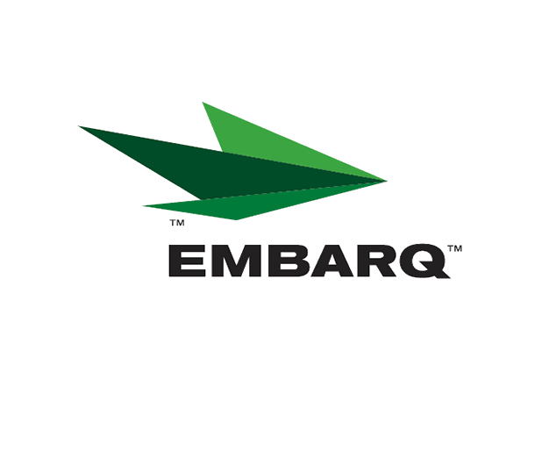


Embarq Corporation
Mailstop: KSOPKJ0502-5022
5454 West 110th Street
Overland Park, KS 66211
Glenda.Munson@EMBARQ.com

Via E-File

June 26, 2007

Ms. Renee’ Jenkins, Director of Administration
Public Utilities Commission of Ohio
180 East Broad Street, 13th Floor
Columbus, OH 43215-0573

Re: United Telephone Company of Ohio d/b/a Embarq
Case No. 90-5041-TP-TRF

Dear Ms. Jenkins:

Enclosed for filing is a replacement page for Section 28, Sheet 31 to United Telephone Company of Ohio d/b/a Embarq P.U.C.O. No. 5 General Exchange Tariff. The replacement sheet corrects the duplicate use of First Revised Sheet 31 to Second Revised Sheet 31. The First Revised Sheet 31 that became effective on June 20, 2007, introduced a new promotional offering for residential customers. When duplicate First Revised Sheet 31 revisions were submitted this promotion was inadvertently omitted. Please replace the tariff sheet submitted under cover letter dated June 22, 2007 with this replacement sheet.

If you have any questions regarding this filing, please call Becky Donahue at 614-220-8624.

Sincerely,

/s/ Glenda L. Munson

Glenda L. Munson

Enclosures
cc: B. Donahue

OH 07-41 Replacement Letter
Glenda L. Munson
TARIFF ANALYST I
Voice: (913) 345-7550
Fax: (913) 345-6756

United Telephone Section 28
Company of Ohio Second Revised Sheet 31
d/b/a Embarq P.U.C.O. NO. 5 Cancels
GENERAL EXCHANGE TARIFF First Revised Sheet 31

SPECIAL PROMOTIONS
During the period May 14, 2007 through June 24, 2007, business customers who subscribe to Key Trunks, PBX Trunks, ISDN-BRI, ISDN-PRI, Enhanced Frame Relay Service, ATM, analog Private Line Services, Digilink, Translink, Lightlink, Centrex, PRI Bundle, or Individual Voice Channels for Custom Access Solution will be eligible for a one-time bill credit when they contact the Company to disconnect service(s) and agree to retain their service(s) with the Company. The customer’s charges for the specific service(s) must equal or exceed $50 (excluding long distance, taxes, surcharges, and other fees). The credit, as specified below, may be up to this amount, but will not exceed the customer’s monthly charges (excluding long distance, taxes, surcharges, and other fees) and will be reflected on the customer’s bill in the next full month’s billing cycle. | (C)
Monthly Charges Credit Amount
$50 - $ 99.99 $ 99.99
$100 - $ 199.99 $ 199.99
$200 - $ 299.99 $ 299.99
$300 - $ 399.99 $ 399.99
$400 - $ 499.99 $ 499.99
$500 - $ 599.99 $ 599.99
$600 - $ 699.99 $ 699.99
$700 - $ 799.99 $ 799.99
$800 - $ 899.99 $ 899.99
$900 - $1,000.00 $ 1,000.00
During the period of June 20, 2007 through July 20, 2007, residence customers who contact the Company to cancel service and who subscribe to Simple Solution or Progressive Plan with Voicemail plus Embarq Communications, Inc. Solutions Unlimited – Option 4, may receive a credit on their local phone bill when they agree to retain their services. The customer’s account must be in good standing to receive this offer.
Customers with Simple Solution will receive a credit of $19.99. Customers with Progressive Plan, Voicemail plus Embarq Communications, Inc. Solutions Unlimited – Option 4 will receive a total credit of $44.95. $29.95 of the credit will appear on the first bill following the acceptance of the promotion with a $15.00 credit appearing on the subsequent bill.
Issued: June 24, 2007 Effective: June 24, 2007

United Telephone Company of Ohio In accordance with Case No. 90-5041-TP-TRF
By Joseph R. Stewart, Assistant Secretary Issued by the Public Utilities Commission of Ohio
Columbus, Ohio

