Memorandum

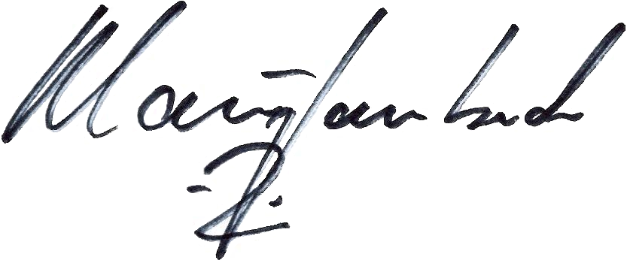
To: Henry Phillips-Gary, Administrative Law Judge
Legal Department
From: Klaus Lambeck, Chief
Facilities, Siting & Environmental Analysis Division
Department of Energy and Environment
Date: May 27, 2010
Re: Motion for Waivers, Case No. 10-0369-EL-BGN

On May 13, 2010, Paulding Wind Farm II LLC (Applicant) filed a motion for waivers of 4906.06(A)(6), Ohio Revised Code (ORC) and various rules in Chapter 4906-17, Ohio Administrative Code (OAC).
Staff does not object to certain of these waiver requests. To the extent that any waiver requests are granted, Staff reserves the right to require information from the Applicant in areas covered by the waiver requests if Staff later determines it to be necessary during the course of the investigation.
With the provisions stated below, Staff does not object to the following waiver requests in this proceeding:
- Section 4906.06(A)(6), ORC, waiver of the one year notice period.
- 4906-17-05(A)(4), OAC, waiver of certain requirements related to cross-sectional view and test borings, provided that the Staff is provided with both the cross-sectional views and test boring data for review prior to the determination of final locations for turbine foundations and other project-related features.
- Rule 4906-17-05(B)(2)(h), OAC, waiver of certain requirements for mapping of all grade elevations modified during construction. Rather than provide a detailed map, the Applicant may provide a description of the standard grade elevations that will occur across the project when constructing all project components.
Staff does not recommend granting the following waiver requests in this proceeding:
- Rule 4906-17-08(A)(3), OAC, waiver of certain requirements related to studies regarding impacts of the proposed project to public and private water supplies. Staff does not believe that it is necessary to grant this waiver. The required information should be provided so as to enable Staff to complete its review in accordance with 4906.10(A)(2) and (3), Revised Code. Staff requests this information to be filed in this proceeding no later than the Applicant’s requested submission date of June 15, 2010, to allow Staff sufficient time to incorporate the information in its review.
- Rule 4906-17-08(B)(2), OAC, waiver of certain requirements related to studies regarding impacts of the proposed project to wetlands. Staff does not believe that it is necessary to grant this waiver. The required information should be provided so as to enable Staff to complete its review in accordance with 4906.10(A)(2) and (3), Revised Code. Staff requests this information to be filed in this proceeding no later than the Applicant’s requested submission date of July 15, 2010, to allow Staff sufficient time to incorporate the information in its review.
- Rule 4906-17-08(C)(2)(c), OAC, waiver of certain requirements related to tax benefits as a result of the proposed project. Staff does not believe that it is necessary to grant this waiver. The required information should be provided so as to enable Staff to complete its review in accordance with 4906.10(A)(2) and (3), Revised Code. Staff requests this information to be filed in this proceeding no later than eight weeks prior to the public hearing to allow Staff sufficient time to incorporate the information in its review.
- Rule 4906-17-08(D)(2), OAC, waiver of certain requirements related to studies regarding impacts to cultural recourses as a result of the proposed project. Staff does not believe that it would be appropriate to grant this waiver as it could impair Staff’s ability to assess the impacts to cultural resources as a result of the proposed project. Therefore, the required information should be provided so as to enable Staff to complete its review in accordance with 4906.10(A)(2) and (3), Revised Code. Staff requests this information to be filed in this proceeding no later than eight weeks prior to the public hearing to allow Staff sufficient time to incorporate the information in its review.

