Steven T. Nourse
Senior Counsel –
Regulatory Services
(614) 716-1608 (P)
(614) 716-2014 (F)
stnourse@aep.com

December 22, 2009

ELECTRONIC FILING
Ms. Renee J Jenkins
Secretary of the Commission
Public Utilities Commission of Ohio
180 East Broad Street
Columbus Ohio 43215-3793

Re: Case Nos. 09-1860-EL-REN

Dear Ms. Jenkins:

On November 12, 2009, Columbus Southern Power Company (CSP) filed an application to initiate these cases on October 26, 2009. On December 11, 2009, Staff sent CSP a data request and asked that the responses be docketed. Enclosed are CSP’s responses to Staff’s data request.

Thank you for your attention to this matter.

Cordially,

/s/ Steven T. Nourse__________
Steven T. Nourse
Senior Attorney
American Electric Power Service Corporation
1 Riverside Plaza, 29th Floor
Columbus, Ohio 43215
Telephone: (614) 716-1608
Facsimile: (614) 717-2950
Case No. 09-1860-EL-REN
Conesville Generating Station Unit 3
Staff Interrogatories – Initial Set

Question 1: In Section B, the application asks for a person’s name as the representative of the facility owner, title, and e-mail address. Please provide this information.

Answer 1: Joe Hamrock, President & Chief Operating Officer - AEP Ohio, email: jhamrock@aep.com, phone: 614.883.6670

Question 2: Please provide the date that the photograph was taken of the installed facility.

Answer 2: Please see the attached photograph taken on May 7, 2008. We were unable to identify the exact date of the previously submitted photograph.

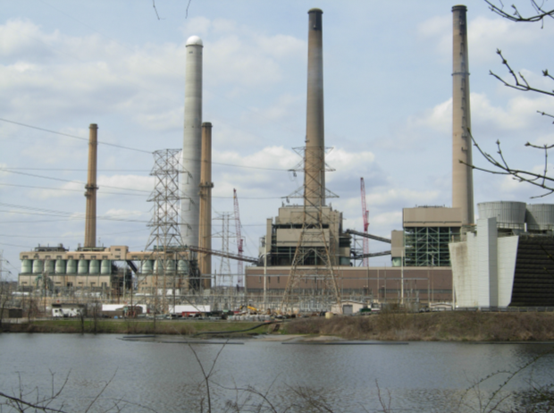

Question 3: In Section I, what is the expected heat content (BU/lb.), moisture, ash and sulfur content for each of the potential fuel types listed, biomass sources, coal, and natural gas. Please describe the source and process for determining these heating values, how they may be verified, as well as the frequency of this calculation under a regular schedule of operation.

Answer 3: The response to this question includes confidential data and is being submitted to Staff on a confidential basis.

Question 4: In addition to the projected annual generation given for each unit, what is the projected annual generation from the renewable biomass resource for Unit 3?

Answer 4: As stated in Section G10a. of the application:

“Solid biomass fuel including but not limited to Torreifed biomass, raw wood chips, sawdust, wood pellets, herbaceous crops, agricultural waste will be co-fired with coal and/or natural gas in proportions up to 100% of total heat input.

Initially a testing period will be required to determine the optimal percentage of biomass that can be consumed.

The long range goal will depend on the results of the initial tests as well as fuel availability and market economics. For the test burns, efforts have been made to minimize modifications that may be required for long term fuel consumption.”

At this time the projected annual generation from the renewable biomass resource for Unit 3 is currently not available because the testing is not complete.

Question 5: In I.1, please provide the actual place-in-service date of Unit 3; and the initial date of operation using the renewable resource when available.

Answer 5: The initial place-in-service date of Unit 3 is 1962. The plan is to initial test the renewable resource as early as April of 2010. This is subject to change based on fuel availability.

Question 6: Please indicate the frequency with which the generation (MWh) of the renewable biomass resource will be calculated and reported to the GATS tracking system.

Answer 6: The renewable generation will be submitted into GATS once per month.
Question 7: Please explain how the quantities of each fuel type used will be measured and verified.

Answer 7: The quantities will be measured and verified on an as received truck scale basis.

Question 8: What are the estimated time frames for the use of the biomass resources and at what levels? In section G.10, you will be expected to provide an update to the Commission on the respective proportions of electricity output from the facility by fuel type.

Answer 8: Please see the response to question #4

Question 9: As requested in Section H, please provide a detailed description of all of the modifications or retrofits that rendered the facility eligible for consideration as a qualified renewable energy resource. These may include modifications that will be made to the facility, equipment, or process, including fuel use. Some indication has already been given under G, although please provide in greater detail, such information as how the quantity, and heat content of the biomass fuels will be measured; what will be the modifications to fuel handling and storage; and the process and frequency of the use of the biomass resources at the Conesville Generating Station. Please include this description as an exhibit and identify the subject matter in the heading of the exhibit.

Question 9: Please describe the content (fully characterize the fuel material) and sources of the biomass resources.

Answer 9: Please see the response to question #4

To fully characterize the fuel material and source of the biomass resource a supply agreement would need to be in place. Testing and final fuel specification is required prior to executing a fuel supply agreement for the long term.

