
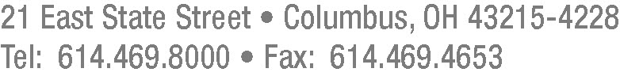

February 15, 2013

Barcy McNeal
Secretary, Docketing Division
Public Utilities Commission of Ohio
180 East Broad Street
Columbus, Ohio 43215

RE: Notice of Withdrawal and Substitution of Counsel
PUCO Case Nos. 09-702-EL-AEC, 09-1700-EL-EEC, and
09-1701-EL-EEC

Dear Ms. McNeal:

Pursuant to Rule 4901-1-08(G), Ohio Administrative Code, please be advised of the withdrawal of Joseph M. Clark and the substitution of Matthew R. Pritchard as counsel in the proceedings listed above. Additionally, please be advised of the withdrawal of Lisa G. McAlister and the substitution of Matthew R. Pritchard and Samuel C. Randazzo in Case No. 09-1700-EL-EEC. Accordingly, please revise the Public Utilities Commission of Ohio records and parties’ service lists.

Please do not hesitate to contact me if you have any questions regarding this matter.

Respectfully submitted,

/s/ Matthew R. Pritchard
Samuel C. Randazzo
Matthew R. Pritchard
McNees Wallace & Nurick LLC
21 East State Street, 17th Floor
Columbus, OH 43215-4228
Telephone: (614) 469-8000
Telecopier: (614) 469-4653
sam@mwncmh.com
mpritchard@mwncmh.com
cc: Parties of Record

