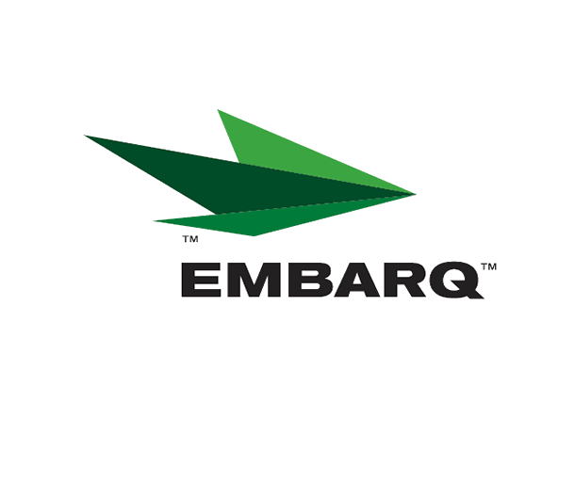


Embarq Corporation
Mailstop: KSOPKJ0502-5022
5454 West 110th Street
Overland Park, KS 66211
Glenda.Munson@EMBARQ.com

Via E-FILE

October 26, 2007

Ms. Renee’ Jenkins, Director of Administration
Public Utilities Commission of Ohio
180 East Broad Street, 13th Floor
Columbus, OH 43215-0573

Re: United Telephone Company of Ohio d/b/a Embarq
Case No. 90-5041-TP-TRF

Dear Ms. Jenkins:

Enclosed for filing are revisions to United Telephone Company of Ohio d/b/a Embarq P.U.C.O. No. 5 General Exchange Tariff. This filing should be processed as a day filing, to become effective October 26, 2007.

The following tariff sheets are enclosed:

P.U.C.O. No. 5, General Exchange Tariff | Master Index | Third Revised Sheet 3
 | Section 21 | Third Revised Sheet 2
 |  | First Revised Sheet 3
 |  | First Revised Sheet 4
 |  | Second Revised Sheet 11

This filing removes Call Forward No Answer-Customer Controlled and Call Forward Busy-Customer Controlled from the tariff. There is no current or anticipated demand for these custom calling features. Therefore, customer notice was not required with this filing.

If you have any questions regarding this filing, please call Becky Donahue at 614-220-8624.

Sincerely,

/s/ Glenda L. Munson

Glenda L. Munson

Enclosures
cc: B. Donahue

OH 07-56
Glenda L. Munson
TARIFF ANALYST I
Voice: (913) 315-9346
Fax: (913) 315-0763

