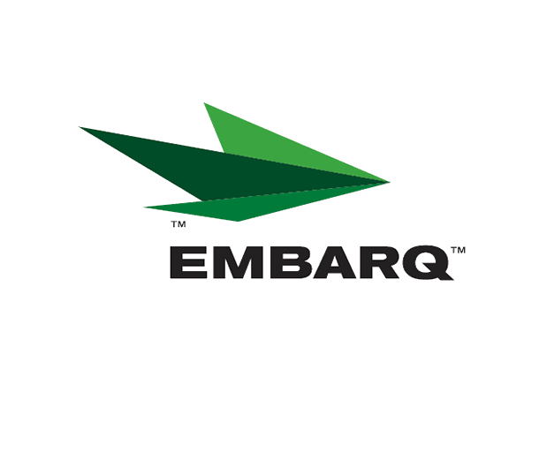


Embarq Corporation
Mailstop: KSOPKJ0502-5022
5454 West 110th Street
Overland Park, KS 66211
Glenda.Munson@EMBARQ.com

Via E-FILE

November 18, 2008

Ms. Renee’ Jenkins, Director of Administration
Public Utilities Commission of Ohio
180 East Broad Street, 13th Floor
Columbus, OH 43215-0573

Re: United Telephone Company of Ohio d/b/a Embarq
Case No. 08-385-TP-ATA

Dear Ms. Jenkins:

Enclosed for filing are replacement tariff pages to United Telephone Company of Ohio d/b/a Embarq P.U.C.O. No. 5 General Exchange Tariff and P.U.C.O. No. 6 Local Exchange Tariff. These final pages are being filed at this time due to recent communications with Commission staff. Included in these pages are approved tariff pages that were filed after the April 2, 2008 date. Those pages reflect the actual approval date.

If you have any questions regarding this filing, please call Gary Baki at 614-220-8629.

Sincerely,


/s/ Glenda L. Munson

Glenda L. Munson

Enclosures
cc: Gary Baki
OH 08-05 Final Page Letter
Glenda L. Munson
TARIFF ANALYST I
Voice: (913) 315-9346
Fax: (913) 315-0763

