August 21, 2008

Ms. Reneé J. Jenkins
Director of Administration
Secretary of the Public Utilities Commission of Ohio
180 East Broad Street
Columbus, Ohio 43215
Re: In the Matter of the Application of The Buckland Telephone Company to Begin Transitioning its Intrastate Access Rates in its Edge Out Exchanges Pursuant to Case No. 06-1344-TP-ORD; PUCO Case No. 08-1009-TP-ATA
Dear Ms. Jenkins:
The Buckland Telephone Company submits an Application for electronic filing in connection with the above-referenced matter. The TRF Number for The Buckland Telephone Company is 90-5008-TP-TRF.
Thank you for your assistance. If you have any questions, please do not hesitate to call.
Very truly yours,

/s/ Carolyn S. Flahive

Enclosure

Carolyn.Flahive@ThompsonHine.com Fax 614.469.3361 Phone 614.469.3294 | tajg 588206.1

The Public Utilities Commission of Ohio

TELECOMMUNICATIONS APPLICATION FORM
for
ILECs Not Subject to Alternative Regulation
(Effective July 25, 2008)

In the Matter of the Application of The Buckland Telephone )
Company to Begin Transitioning its Intrastate Access Rates in ) Case No. 08 - 1009 -TP - ATA
its Edge Out Exchanges Pursuant to Case No. 06-1344-TP-ORD )

Name of Company The Buckland Telephone Company
Address of Company 105 S. Main Street; Buckland, Ohio 45819
Company Web Address
Regulatory Contact Person(s) Carolyn S. Flahive Phone (614) 469-3200 Fax (614) 469-3361
Regulatory Contact Person’s Email Address Carolyn S. Flahive@ThompsonHine.com
Date TRF Docket No. 90-5008-TP-TRF

Motion for protective order included with filing? Yes No
Motion for waiver(s) filed affecting this case? Yes No [Note: waiver(s) tolls any automatic timeframe]

NOTE: This form must accompany:
- All automatic approval/notice applications filed by incumbent local exchange companies (ILECs) not subject to a qualifying alternative regulation plan when making an application pursuant to Case Nos. 84-944-TP-COI, 86-1144-TP-COI, 89-564-TP-COI, or 99-563-TP-COI.
- All non-automatic approval applications filed by incumbent local exchange companies (ILECs) not subject to a qualifying alternative regulation plan when making an application pursuant to Section 4909.18, Ohio Revised Code.

I. Please indicate the reason for submitting this form (check one)
Retail Filings
1 (AEC) Application For Approval Of A Customer Contract For Competitive Services
a. Stand-Alone Contract (90-day approval, 7 copies)
b. Pre-Approved Contract (0-day notice, 7 copies)
2 (ACO) ILEC Application for Change in Ownership Pursuant to 4905.402, Ohio Revised Code (30-day approval, 10 copies)
3 (ALI) Small, For-Profit, ILEC Application For A Limited Increase In Non-Basic Rates (60-day approval, 10 copies)
4 (ATA) Application For Tariff Amendment That Does Not Result In An Increase In Rates
a. Large ILEC, Competitive Offerings Other Than Those Listed Under 5., Below (60-day approval, 7 copies)
b. Small, for-profit ILECs (45-day approval, 10 copies) (Not-for-profit, see item 6, NFP, below) 30-DAY APPROVAL PURSUANT TO CASE NO. 06-1344-TP-ORD
5 (ZTA) Tariff Notification Not For An Increase In Rates Involving Message Toll, Toll-Free Service, 900 And 900-Like Services, 500 Service, Calling Card, Prepaid Calling Card, Private Line, and Speed Dialing In Accordance With Waiver Granted in 99-563-TP-COI (5/11/2000 and 11/21/2002) (0-day notice, 7 copies)
NOTE: Notifications do not require or imply Commission Approval.
6 (NFP) Small, not-for-profit ILEC tariff amendment
a. Tariff Change Not Resulting In An Increase In Rates (0-day notice, 7 copies)
b. Tariff Application Resulting In An Increase In Non-Basic Rates (45-day notice, 7 copies)
c. Tariff Application Resulting In An Increase In Basic Rates (60-day notice, 10 copies)
7 (Non-Auto) All Others (non-automatic approval, indicate appropriate 3 letter code for case type in Case No. above)

THE FOLLOWING ARE TRF FILINGS ONLY, NOT NEW CASES
8 Introduction or Extension of Promotional Offering (10-day notice, 3 copies)
9 New Price List Rate Within an Approved Rate Range for Existing Competitive Service (0-day notice, 3 copies)

Carrier to Carrier Filings
10 (NAG) Negotiated Carrier-to-Carrier Interconnection Agreement under Sections 251 and 252 of the Telecommunications Act
(90-day approval, 7 copies)
11 (ARB) Request for Arbitration of a Carrier-to-Carrier Interconnection Agreement under Section 252 of the Telecommunications Act.
(non-automatic, 2 copies)

- The following exhibits corresponding to the list of cases above, at a minimum, are required to be filed:

 | 3, 4, 5, 6, 7 | Current Tariff Sheets (to be superseded), if applicable
 | 3, 4, 5, 6, 7 | Proposed Tariff Sheets
 | 2, 3, 4, 5, 6, 7 | Rationale or Explanation for Change
 | 1.a., 4.a. | Justification for Competitive Treatment
 | 1.a., 4.a. | Cost support for non-MTS service
 | 2, 3, 4, 5, 6, 7, 9 | Customer Notice to customers affected by proposal, and statement as to the form and timing of the notice
 | 1, 10 | Copy of Contract
 | 11 | Filing Requirements are specified in 4901:1-7-09(D) of the Ohio Administrative Code

- Applicant is filing this application under the regulatory requirements:
Established by the Commission in Case No. 89-564-TP-COI.
Established in 4909.18 Ohio Revised Code.
- Applicant respectfully requests the Commission to permit the filing of the proposed tariff sheets, to become effective on the date shown on the proposed tariff sheets (which is a date no earlier than the day after the applicable automatic approval date), modified by any further revisions that have become effective prior to the effective date of the proposed schedule sheets.
Respectfully submitted,

THE BUCKLAND TELEPHONE COMPANY

By: /s/ Carolyn S. Flahive
Thomas E. Lodge (0015741)
Carolyn S. Flahive (0072404)
THOMPSON HINE LLP
41 South High Street, Suite 1700
Columbus, Ohio 43215-6101
Telephone: 614-469-3200
Facsimile: 614-469-3361
Its Attorneys

VERIFICATION
I verify that all of the information submitted herein, and all additional information submitted in connection with this case, is true and correct to the best of my knowledge.

/s/ Carolyn S. Flahive 8/21/08
*(Signature and Title) (Date)

*Verification is required for every filing, and need not be notarized except for Applications for a Limited Increase in Rates (ALIs). The verification may be signed by an officer of the applicant, its counsel, or an authorized agent of the applicant, except for ALIs. ALI applications must be signed by an officer of the company and be notarized.
Sworn to and subscribed before me this __________ day of __________ 200 .

Notary Public, State of Ohio
My commission expires

EXHIBIT A

(SUPERSEDED TARIFF SHEETS)

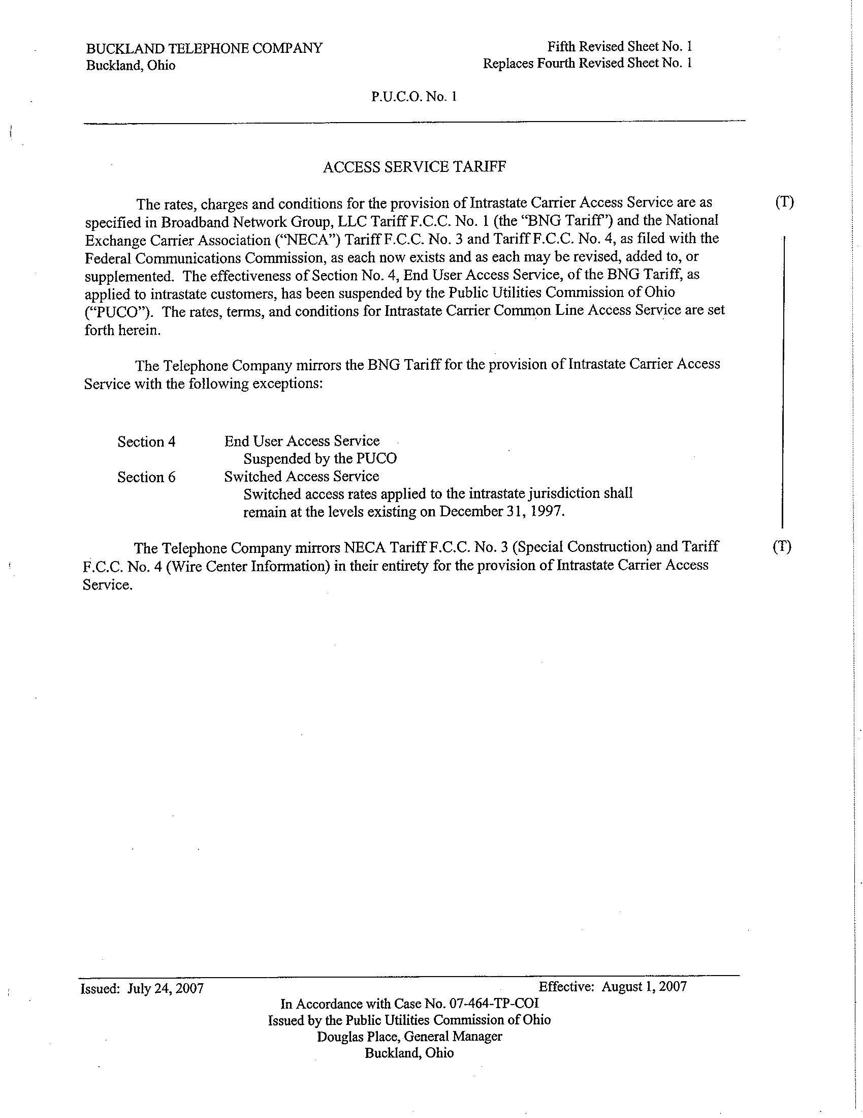

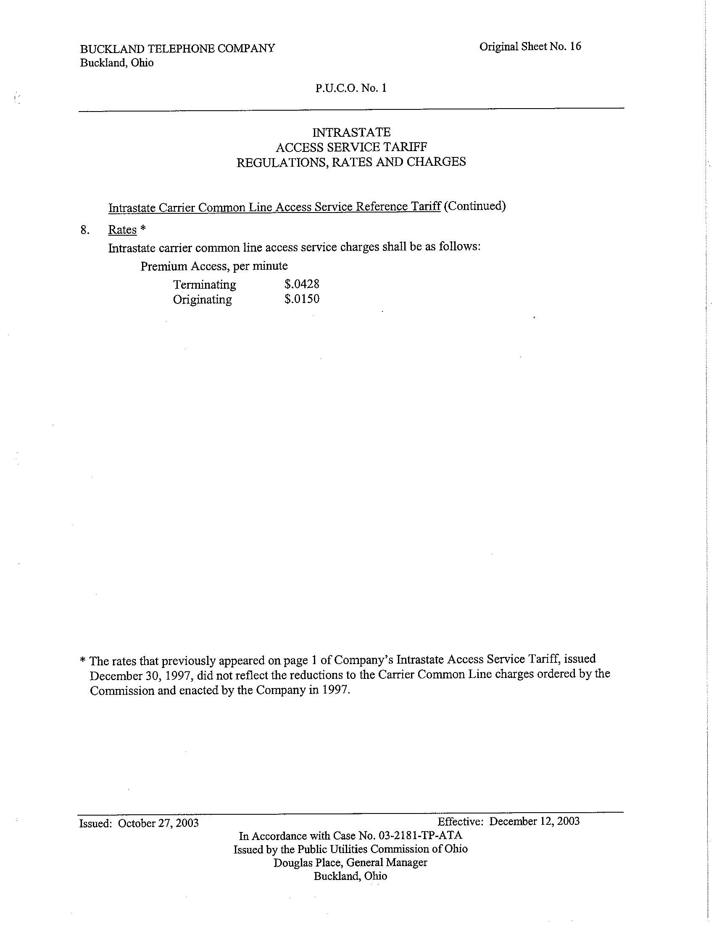

EXHIBIT B

(REVISED TARIFF SHEETS)

ACCESS SERVICE TARIFF

The rates, charges and conditions for the provision of Intrastate Carrier Access Service are as specified in Broadband Network Group, LLC Tariff F.C.C. No. 1 (the “BNG Tariff”) and the National Exchange Carrier Association (“NECA”) Tariff F.C.C. No. 3 and Tariff F.C.C. No. 4, as filed with the Federal Communications Commission, as each now exists and as each may be revised, added to, or supplemented. The effectiveness of Section No. 4, End User Access Service, of the BNG Tariff, as applied to intrastate customers, has been suspended by the Public Utilities Commission of Ohio (“PUCO”). The rates, terms, and conditions for Intrastate Carrier Common Line Access Service are set forth herein.

The Telephone Company mirrors the BNG Tariff for the provision of Intrastate Carrier Access Service with the following exceptions:
 | Section 4  Section 6 | End User Access Service  Suspended by the PUCO  Switched Access Service  Buckland Exchange: Switched access rates applied to the intrastate jurisdiction shall remain at the levels existing on December 31, 1997.  Edge Out Exchanges (as set forth in the Company’s Tariff PUCO No. 4): Pursuant to the Commission’s Opinion and Order issued August 22, 2007 in Case No. 06-1344-TP-ORD, the Company shall, over a 3-year period, reduce its intrastate access rates annually by one-third of the difference between the rates charged in the Buckland Exchange (as “frozen” in 1997) and the current switched access rates set forth in NECA Tariff FCC No. 5. Therefore, the intrastate switched access rates in the Company’s Edge Out exchanges shall be calculated as follows:  - Effective September 21, 2008: 2/3(Buckland 1997 “frozen” rates minus current NECA switched access rates) plus then-current NECA switched access rates.  - Effective September 21, 2009: 1/3(Buckland 1997 “frozen” rates minus NECA switched access rates effective September 21, 2008) plus NECA switched access rates effective September 21, 2008.  - Effective September 21, 2010: Equal to then-current NECA switched access rates.  Buckland Telephone Company is a rural ILEC competing with a nonrural ILEC in a rural area. |  | (T)  (T)
The Telephone Company mirrors NECA Tariff F.C.C. No. 3 (Special Construction) and Tariff F.C.C. No. 4 (Wire Center Information) in their entirety for the provision of Intrastate Carrier Access Service.

INTRASTATE
ACCESS SERVICE TARIFF
REGULATIONS, RATES AND CHARGES

 | Intrastate Carrier Common Line Access Service Reference Tariff (Continued)
8. | Rates *
 | Intrastate carrier common line access service charges shall be as follows:
 |  | Premium Access, per minute
 |  |  |  | Buckland Edge Out  Exchange Exchanges** |  |  |  | (T)

 |  |  | Terminating | $.0428 Effective September 21, 2008: $.028533  Effective September 21, 2009: $.014267  Effective September 21, 2010: $.0 |  | (N)  (N)  (N)
 |  |  | Originating | $.0150 Effective September 21, 2008: $.010  Effective September 21, 2009: $.005  Effective September 21, 2010: $.0 |  | (N)
 |  |  |  |  |  | (N)
 |  |  |  |  |  | (N)
** Pursuant to the Commission’s Opinion and Order issued August 22, 2007 in Case No. 06-1344-TP-ORD, the Company shall, over a 3-year period, reduce its intrastate access rates annually by one-third of the difference between the rates charged in the Buckland Exchange and the current rates rates set forth in NECA Tariff FCC No. 5 (the “NECA Tariff”). The carrier common line access service charge (“CCL”) was eliminated from the NECA Tariff in 2003. Therefore, as of the Effective Date below, the CCL in the Company’s Edge Out exchanges shall be reduced by one-third. The CCL shall be reduced by two-thirds on the anniversary of the Effective Date below and reduced to $0 on the second anniversary of the Effective Date below. Buckland Telephone Company is a rural ILEC competing with a nonrural ILEC in a rural area. |  |  |  |  |  | (N)

* The rates that previously appeared on page 1 of Company’s Intrastate Access Service Tariff, issued December 30, 1997, did not reflect the reductions to the Carrier Common Line charges ordered by the Commission and enacted by the Company in 1997.

EXHIBIT C

The Applicant, The Buckland Telephone Company, hereby files tariff revisions necessary to reflect the transition of intrastate access rates in the Applicant’s “edge out” exchanges, pursuant to the Commission’s Opinion and Order issued August 22, 2007 in Case No. 06-1344-TP-ORD. The Applicant is a rural ILEC competing with a nonrural ILEC in a rural area.

