ATTACHMENT 1

Customer Notice

< Customer Name>
<Customer Address>
<City, OH, ZIP >
Date
<Account Number>
Notice of Price Increase

This notice is to inform you that effective August 31, 2007, First Communications will be increasing some of our rates. The local telephone service industry has experienced many changes over the last few years. The most significant of these changes is the increased cost to support our customers.

Please review the rate changes listed below as they will affect your account:

Local Service:

Current Package Price | New Package Price | Package
<insert current price> | <insert new price> | <insert package name>

Below are the new rates for certain Directory Assistance, Pay Per Use Features and Non-Reoccurring Charges:

Directory Assistance Current Price New Price
Direct-Dial - Local DA -metro area <insert current price> <insert new price> Direct-Dial - National DA -metro area <insert current price> <insert new price>

Non-Reoccurring Charges
Account Adjustment Charge, per order <insert current price> <insert new price> Account Change Charge, per order <insert current price> <insert new price>

Pay Per Use:
Three Way calling <insert current price> <insert new price>
Call Return <insert current price> <insert new price> Repeat Dialing <insert current price> <insert new price>

You have the right to cancel your phone service with First Communications, or change to another carrier at any time.
We at First Communications appreciate your business and are committed to the highest quality customer care. If you have questions please contact Customer Care at 1-800-274-1015 or visit our website at www.firstcomm.com.

Code: OHZ2

ATTACHMENT 2

Affidavit of Customer Notice

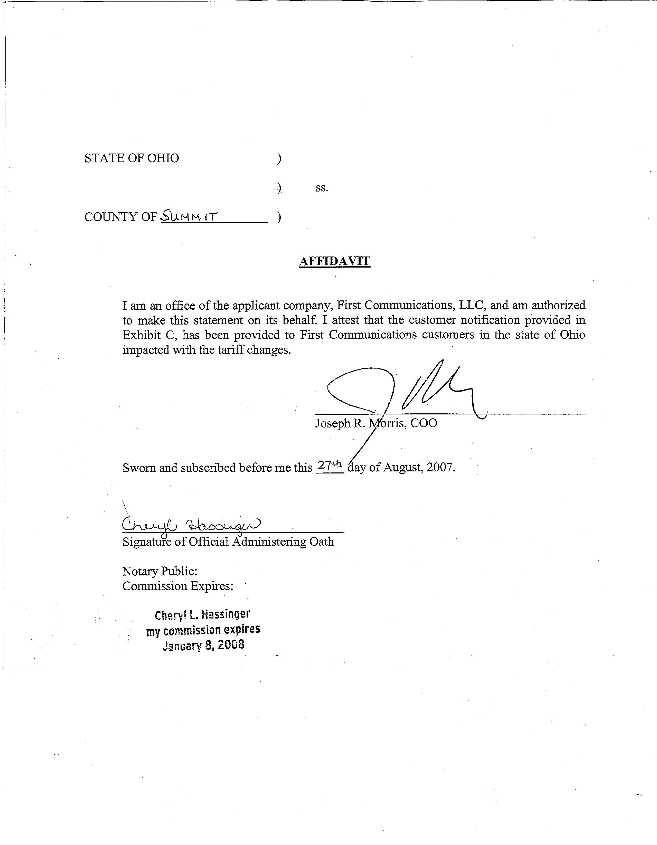

ATTACHMENT 3

PUCO Tariff No. 5

