Exhibit A
Back of Dominion East Ohio’s Current Bill
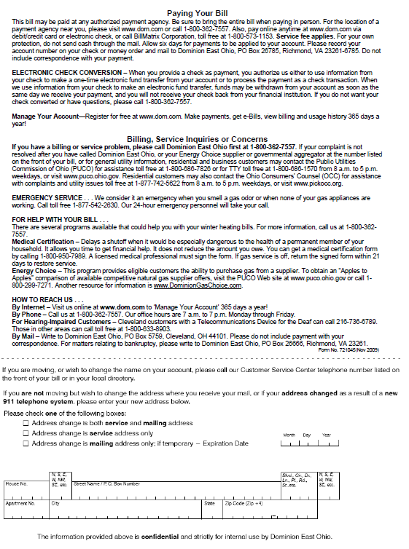

Proposed Text Changes to the Back of Dominion East Ohio’s Bill
Paying Your Bill
All bills may be paid from your bank account for free by registering in Manage Your Account as described below. Or, it may be paid at any authorized payment center. A convenience fee may be charged by the authorized payment center, which must be paid in cash. Be sure to bring the entire bill when paying in person. For the location of a payment center near you, please visit www.dom.com or call 1-800-362-7557. Also, pay online anytime at www.dom.com via debit/credit card or electronic check, or call BillMatrix Corporation, toll free at 1-800-573-1153. Service fee applies. For your own protection, do not send cash through the mail. Allow six days for payments to be applied to your account. Please record your account number on your check or money order and mail to Dominion East Ohio, PO Box 26785, Richmond, VA 23261-6785. Do not include correspondence with your payment.

AUTO PAY - Sign up for Bank Draft and have your bill automatically deducted from your checking or savings account. Enroll online at www.dom.com to ‘Manage Your Account’ or by completing the form below.

ELECTRONIC CHECK CONVERSION – When you provide a check as payment, you authorize us either to use information from your check to make a one-time electronic fund transfer from your account or to process the payment as a check transaction. When we use information from your check to make an electronic fund transfer, funds may be withdrawn from your account as soon as the same day we receive your payment, and you will not receive your check back from your financial institution. If you do not want your check converted or have questions, please call 1-800-362-7557.
MANAGE YOUR ACCOUNT—Register for free at www.dom.com. Make payments, get eBills, view billing and usage history 365 days a year!

Billing, Service Inquiries or Concerns
If you have a billing or service problem, please call Dominion East Ohio first at 1-800-362-7557 between 7 a.m. and 7 p.m. weekdays. If your complaint is not resolved after you have called Dominion East Ohio, or your Energy Choice supplier or governmental aggregator at the number listed on the front of your bill, or for general utility information, residential and business customers may contact the Public Utilities Commission of Ohio (PUCO) for assistance at 1-800-686-7826 (toll free) from 8 a.m. to 5 p.m. weekdays, or at http://www.puco.ohio.gov. Hearing or speech impaired customers may contact the PUCO via 7-1-1 (Ohio Relay Service). The Ohio Consumers' Counsel (OCC) represents residential utility customers in matters before the PUCO. The OCC can be contacted at 1-877-742-5622 (toll free) from 8 a.m. to 5 p.m. weekdays, or at http://www.pickocc.org.

EMERGENCY SERVICE . . . We consider it an emergency when you smell a gas odor or when none of your gas appliances are working. Call toll free 1-877-542-2630. Our 24-hour emergency personnel will take your call.
FOR HELP WITH YOUR BILL . . .
There are several programs available that could help you with your winter heating bills. For more information, call us at 1-800-362-7557.
Medical Certification – Delays a shutoff when it would be especially dangerous to the health of a permanent member of your household. It allows you time to get financial help. It does not reduce the amount you owe. You can get a medical certification form by calling 1-800-950-7989. A licensed medical professional must sign the form. If gas service is off, return the signed form within 21 days to restore service.
Energy Choice – This program provides eligible customers the ability to purchase gas from a supplier. To obtain an “Apples to Apples” comparison of available competitive natural gas supplier offers, visit the PUCO Web site at www.puco.ohio.gov or call 1-800-299-7271. Another resource for information is www.DominionGasChoice.com.
HOW TO REACH US . . .
By Internet – Visit us online at www.dom.com to ‘Manage Your Account’ 365 days a year!
By Phone – Call us at 1-800-362-7557. Our office hours are 7 a.m. to 7 p.m. Monday through Friday.
For Hearing-Impaired Customers – Cleveland customers with a Telecommunications Device for the Deaf can call 216-736-6789. Those in other areas can call toll free at 1-800-633-8903.
By Mail – Write to Dominion East Ohio, PO Box 5759, Cleveland, OH 44101. Please do not include payment with your correspondence. For matters relating to bankruptcy, please write to Dominion East Ohio, PO Box 26666, Richmond, VA 23261.
Form No. 721045(Feb 2012)

Proposed Artwork Changes to the Back of Dominion East Ohio’s Bill
(located at the bottom of the page)
Replace Change of Address Section:
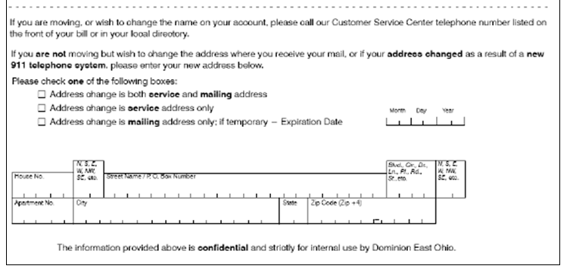
With a Revised Change of Address/Bank Draft Enrollment Section:
