BEFORE
THE PUBLIC UTILITIES COMMISSION OF OHIO
In the Matter of the 2018 Long-Term Forecast Report of Ohio Power Company and Related Matters.  In the Matter of the Application of Ohio Power Company for Approval to Enter into Renewable Energy Purchase Agreements for Inclusion in the Renewable Generation Rider.  In the Matter of the Application of Ohio  Power Company for Approval to Amend its Tariffs. | )  )  )  )  )  )  ) | Case No. 18-501-EL-FOR  Case No. 18-1392-EL-RDR  Case No. 18-1393-EL-ATA

REVISED DIRECT TESTIMONY OF PAUL LEANZA ON BEHALF OF INTERSTATE GAS SUPPLY, INC. AND IGS SOLAR, LLC

INTRODUCTION AND PURPOSE OF TESTIMONY
Q. Please introduce yourself.

A. My name is Paul Leanza. I am employed by Interstate Gas Supply, Inc. (“IGS” or “IGS Energy”) as Gas Supply Director. My business address is 6100 Emerald Parkway, Dublin, Ohio 43016.
Q. Please describe your educational background and work history.
A. I received a BSBA degree from The Ohio State University in 1989 and have worked exclusively in the energy industry since 1991. My experience includes positions on both the regulated utility side of the business and non-regulated side including wholesale, retail, and trading for both natural gas and power. I am well versed in futures, swaps, and options and currently execute or oversee all NYMEX future and swap transactions and manage the fixed price position for Interstate Gas Supply, Inc.. As the Director for the Northeast Desk at Enron Energy Services I was responsible for purchasing and selling physical supplies under short and long term contractual arrangements including fixed and floating pricing for fixed and variable volumes. The position also included the management of storage contracts and supply peaking arrangements. My experience also includes power and gas trading at AEP Energy Services where I traded power in the NYISO region and traded natural gas in the Northeast region.
Q. What is the purpose of your testimony?
A. Ohio Power Company (“Ohio Power” or “AEP”) has requested that the Commission make a finding of “need” for 900 megawatts of renewable generation resources. AEP’s proposal relies upon a forecast of future electricity and natural gas prices provided by AEP witness Bletzacker. The purpose of my testimony is to demonstrate how AEP’s forecast is unreliable and to provide a more realistic outlook for the Commission’s consideration.
Q. Why is AEP’s forecast unreliable?
A. As I will explain, AEP’s forecast is unreliable for three main reasons: (1) AEP’s conclusions are based upon a flawed and overstated projection of natural gas prices; (2) AEP’s forecasts have been incorrect time and again; (3) AEP and its affiliates clearly have no confidence in their own forecast; therefore, the Commission should give it little credibility.
Q. Has AEP provided natural gas projections as part of its Long-Term Forecast Report.
A. Yes, in testimony filed on September 19, 2018, Mr. Bletzacker quantified natural gas price projections as part of the Long-Term North American Energy Market Forecast referred to as the “Fundamentals Forecast” used by Ohio Power. Specific to natural gas, the Fundamentals Forecast lists prices for the Henry Hub, and various basis locations including TCO Pool, TCO Delivered, Dominion South Point, HSC, and PEPL TX-OK.
Q. Do you agree with Mr. Bletzacker’s testimony that natural gas prices are an important factor in determining power prices?
A. Yes, I agree with Mr. Bletzacker in that natural gas prices are an important component when determining the dispatch order of generating units. As the number of gas generating power units increase the more important gas prices become when determining power prices. If gas prices delivered to the generating units increase and gas is needed in the dispatch order, then power prices should increase by the same relative ratio for long term forecasting purposes. This ratio is shown in AEP’s Nominal Forecast on the Y2018H2 Annual Prices-Nominal tab as Heat Rates (mmbtu/MWh). The forecasted annual Heat Rate at the AEP GEN HUB averages 9.63 over the 20-year period from 2020 to 2040.
Q. Do you see a strong correlation between AEP’s forecasted On Peak power prices and AEP’s forecasted gas prices provided by Mr. Bletzacker?
A. Yes, based on the Fundamentals Forecast, AEP’s On-Peak price for the PJM AEP area is very strongly correlated to the TCO IPP gas price times the AEP heat rate in the Fundamentals Forecast. TCO IPP is located in the Southwest Appalachian region and makes a good proxy for gas supplies into AEP’s PJM region. In fact, as you can see from Figure 1, AEP’s on peak price is virtually indiscernible from the AEP forecasted TCO IPP gas price time the AEP heat rate.

Figure 1
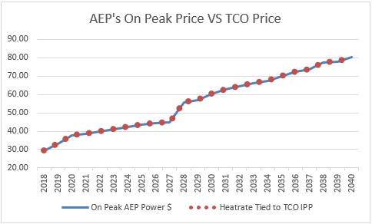
Q. Do you believe the natural gas price forecast developed by Mr. Bletzacker and used by AEP is accurate?
A. No, while no one can accurately and reliably predict what commodity prices will be ten or twenty years from now, I believe the AEP projected gas prices are greatly skewed to the high side. I believe that the AEP forecast does not place enough emphasis on existing market conditions and pricing. For example, Figure 2 shows the Henry Hub settlement from December 4, 2018, in green compared to AEP’s nominal Henry Hub price forecast is blue. Both prices are in nominal values and, as you can tell, AEP’s forecast is well above what the market believes gas prices are valued at through 2030. In fact, by 2030, AEP’s natural gas price estimate is $6.479 while the market is valuing natural gas prices in 2030 at $3.389 or almost half of AEP’s forecasted prices.

Figure 2
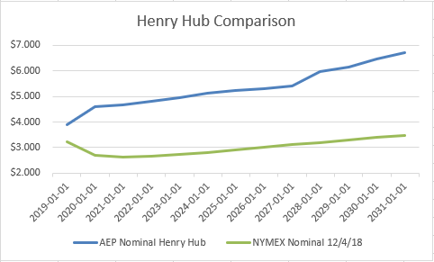
Q. Can an unreliable natural gas forecast impact forecasted power prices?
A. Yes. As mentioned earlier, gas prices and power prices are connected by a ratio called the heat rate and while this heat rate ratio can and will change over time as generation plants become more efficient and the fuel mix changes this ratio ties gas and power prices together in areas that use gas as a feedstock for power generation. Using the average Heat Rate of 9.63 from AEP’s Nominal Forecast, a $1.00 increase in the price of natural gas will increase power prices by approximately $9.63 or $1.00 times the heat rate ratio. Generally speaking, if Ohio Power uses the AEP Nominal Forecast price of $6.48 for natural gas in 2030 and the market is valuing gas in 2030 at $3.39, the price difference of $3.09 translates to an overinflated power price by approximately $29 per megawatt hour in 2030. In other words, higher forecasted gas prices translate into higher forecasted power prices.
Q. Do you agree with Mr. Bletzacker’s testimony that it is unreasonable to rely on NYMEX futures for long term corporate planning purposes?
A. No. Disregarding the market sentiment and market views of pricing is irresponsible and falls more into speculation than forecasting. Specific to gas, the market is always sending price signals that change the expectations of market participants either positively or negatively. For example, on November 28, 2018, the Department of the Interior, US Geological Survey (USGS) identified the largest continuous oil and gas resource potential ever, located in Texas and New Mexico’s Wolfcamp Shale and Bone Spring Formation. The USGS estimates this formation contains 46.3 Billion barrels of oil, 281 Trillion cubic feet of natural gas, and 20 Billion barrels of natural gas liquids. This new production find is in the Permian basin where there is already more supply than demand and pipeline capacity is fully utilized leading to very low regional prices. Recently prices at the Waha Hub (benchmark hub for the Permian Basin) have traded negative meaning owners of supply have paid counterparties to take their gas.
Q. Can you identify specific examples where NYMEX futures prices impact the corporate planning process?
A. Yes, corporate decisions are made all the time based on NYMEX futures prices. For example, just as the market is currently giving price signals that additional transportation is needed out of the Permian Basin, increased pipeline capacity was constructed out of the Marcellus and Utica production region specifically because the market was given a price signal that the Northeast regional supply was higher than the demand which was driving regional prices down. Investor owned companies built and contracted for pipelines based on the price signal determined by the market. As another example, the US is in the center of a rather dramatic race to build liquified natural gas (LNG) exporting facilities. To provide an acceptable rate of return, investor owned companies are spending billions of dollars in capital costs to build the LNG facilities and low cost natural gas as a feedstock is a must if they expect to earn a decent rate of return. If the investor owed LNG facilities believed that Henry Hub natural gas prices would average $6.48 by 2030, as Mr. Bletzacker has forecasted, these facilities might have trouble recovering their variable costs, let alone the billions in capital costs.
In the examples above, the market evaluated information and make an educated decision on future prices. Unfortunately, the AEP Nominal Forecast will be oblivious to the market conditions which could lead to poor investment decisions for AEP’s captive rate payers.
Q. Historically, do you feel AEP has done an adequate job forecasting short and long-term commodity prices, specifically, natural gas prices?
A. No. In 2015, Mr. Bletzacker provided AEP forecasted natural gas prices as part of his testimony in Case No. 14-1694-EL. In his testimony, Mr. Bletzacker’s forecast of natural gas prices at the Henry Hub, in nominal dollars, would average $6.01 in 2017, $6.12 in 2018, $6.19 in 2019 and by 2027 natural gas prices would average $8.04. On the date Mr. Bletzacker’s testimony was filed, May 15, 2015, the NYMEX showed a natural gas average closing price of $3.37 for 2017, $3.46 for 2018, $3.56 for 2019 and by 2027, the NYMEX price for natural gas averaged $4.655. As you can see in Figure 3, if we compare AEP’s Forecasted prices to the value assigned by the market via the NYMEX on May 15, 2015, you will notice that the market did a much better job in determining the future value of natural gas. AEP’s forecast came nowhere near the prices that actually occurred and continues to be well out of step with reality. In fact, AEP’s forecasting of commodity prices was so far out of touch with reality that approximately 18 months after Mr. Bletzacker’s forecasting testimony, AEP took an economic impairment of $2.3 Billion, which according to AEP’s news release, “…largely relates to AEP’s ownership of 2,684 megawatts of competitive generation in Ohio, including the Cardinal, Conesville, Stuart and Zimmer plants.” (from AEP’s Securities and Exchange Commission Form 8-K dated November 1, 2016).
Figure 3 shows AEP’s forecasted natural gas prices from 2015, along with NYMEX closing natural gas prices from May 15, 2015, compared to the actual NYMEX settlements and the future NYMEX curve as of December 4th, 2018.

Figure 3
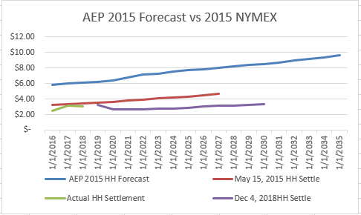
Moreover, each of AEP’s fundamental forecasts since 2008 has missed the mark by a wide margin. I reviewed AEP Price Exhibits going back to 2008 and as you can tell from Figure 4, AEP always manages to forecast very high Henry Hub gas prices. Figure 4 shows AEP forecasts from 2008 through 2016, compared to where prices actually settled (thick black line) and the NYMEX settlement from December 4th (thick red line). In three of the years below, 2012, 2015, & 2016, AEP forecasted Henry Hub prices to 2046 but it shows up as one line since the prices are virtually identical over the four year stretch. But, the big take away for me is that AEP can’t seem to accurately forecast 2 years out and becomes increasingly bad at forecasting the further out in time they project prices.

Figure 4
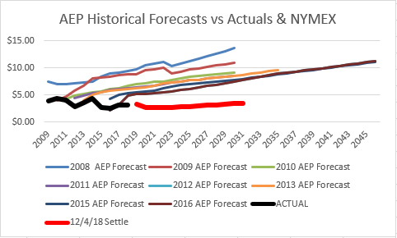
Q. Do you feel that NYMEX adequately represent market natural gas prices into the late 2020s?
A. Yes. The forward natural gas markets, that include the NYMEX, Intercontinental Exchange (ICE), the broker market and various others brings together short and long-term buyer, speculators, and investors who help determine market sentiment and develop market pricing. These daily interactions are captured by the NYMEX/CME and vigorously regulated by the Commodity Futures Trading Commission (CFTC). The NYMEX merged with the Chicago Mercantile Exchange (CME) Group in 2008, and the CME is now responsible for all the NYMEX products that include futures, options, and cleared over the counter financial instruments. One of the CME’s important responsibilities is to determine the daily closing settlement prices as far out in time as the life of the contract which in the case of natural gas is through December 2031. The CME looks at a variety of prices that includes Futures, Henry Hub Natural Gas Look-A-Like contracts, and time spreads to determine settlement prices when actual Futures have not traded in a future month. For contract settlements beyond six months the CME has a process and views all forms of trading and just not Futures.
Q. Do you have reason to believe that AEP does not have faith in its own forecast?
A. Yes. I have several reasons. First, one only need observe current power market trends. Given the comparatively low cost of long-term natural gas it’s hard for other types of generation to compete with combined cycle gas plants even if those non-gas plants are already built. Specifically, we’ve seen coal plants retiring at a quick pace and nuclear plants are feeling the price pressure also. Also, at a recent Global Energy Forum in New York, AEP’s CEO Nick Akins stated that:
“The power generation resource rebalancing occurring today at AEP is centered on less coal and moving toward other forms of energy. . . There is nothing more risky for us to make in our industry today than a generation-related investment.” If AEP’s forecast was truly supported by the company, it would clearly not have such bearish sentiments regarding unregulated generation investment.
Q. If AEP truly had faith in the Fundamentals Forecast, would it need Commission authorization to undertake these projects?
A. No, if AEP truly believed that these renewable energy projects would generate the benefit of $173 million as suggested in Table 3 of AEP’s Exhibit JFT-1 then they should structure these projects under an unregulated AEP generation entity and not force the AEP customers to foot the bill. Also, if these projects were built under an unregulated AEP entity, then this would help AEP recoup some of the $2.3 Billion in impairment charges related, in part, to owning coal plants, as mentioned earlier. In fact, the only reason that Table 3 of AEP’s Exhibit suggests a benefit of $173 million is because the AEP Fundamental Forecast grossly overestimates natural gas prices which inflate power prices which then look good compared to a renewable project with somewhat fixed costs. In addition, as we know from recent history, AEP is not reliable when it comes to forecasting energy prices.
Q. Why would AEP want to inflate power prices?
A. It all comes down to comparable price. If you’re looking at a renewable project you have a fairly good idea what your fixed cost components are and since they’re renewable projects the energy feedstock price, wind and solar, is somewhat negligible. If your comparable future price, in this case AEP’s Fundamental Forecast, is grossly overinflated then the project looks profitable or favorable. But if you compare the renewable price to future market prices currently expected by the market (NYMEX) than your project profitability looks entirely different.
Q. Are there other reasons that you feel AEP does not put much faith in the Fundamental Forecast?
A. Yes, if AEP believed in their natural gas forecast, an affiliate could purchase natural gas futures at current market prices and collect all the associated profits once the natural gas price reaches their forecasted price. The profit, given the large gap between market prices and AEP’s forecast, would be substantial and this substantial profit could be monetized by AEP’s affiliates.
Q. Can you quantify the profit opportunity you describe above?
A. At a very high level yes. Essentially you take the difference between the price that natural gas contracts can be purchased at and what AEP’s shows as their forecasted price going out into the future and times that by the amount of gas you need to purchase annually. The price difference between the market and AEP’s forecast is shown in Table 1.
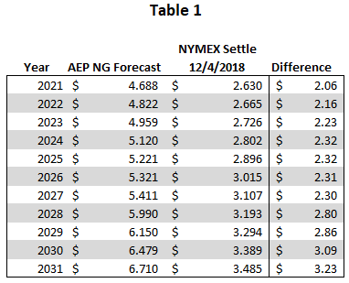
The amount of gas to purchase annually can be somewhat subjective so I considered two scenarios. The first scenario is very conservative as it considers only a straight energy conversion from MWh to MMBtu - this is the standard MWh to MMBtu energy conversion of 3.412. Under the energy only conversion I used the total annual MWh from AEP’s Exhibit JFT-1 and converted the amount to MMBtus which can then be purchased as natural gas contracts at the market rate. I then applied the Difference from Table 1 to the MMBtu amounts to come up with a Total Annual Gain column which quantifies the profit opportunity. As you can tell the nominal gain over the 20-year period is over $281 million shown in Table 2.
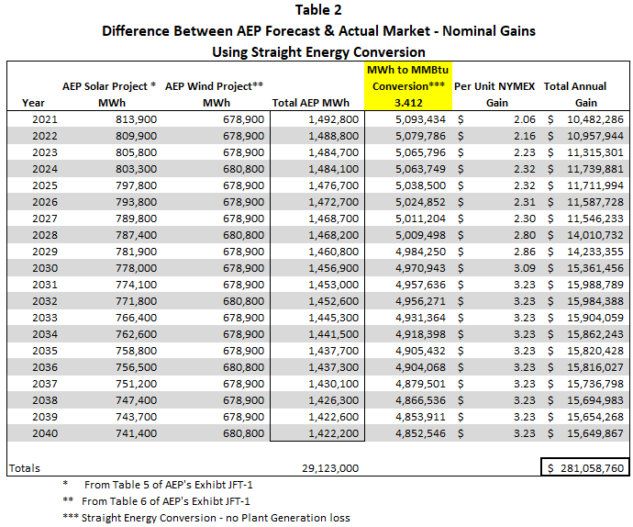
In the second scenario, I considered offsetting AEP’s renewable energy projects with a very efficient combined cycle gas fired power unit using a heat rate of 6.5. A heat rate of 6.5 is well below the average natural gas heat rate of 7.812 which was determined by the EIA for the year 2017. I’ve added the Average Operating Heat Rate table from the EIA as a reference at the end of my testimony. In Table 3, I used the 6.5 heat rate factor which increases the amount of natural gas purchased which increases the profit opportunity from roughly $281 million to over $535 million over the 20-year period.
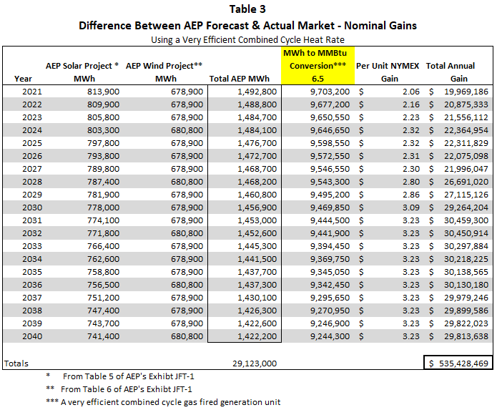
Q. Are there any risk to AEP for implementing this type of NYMEX natural gas buying strategy?
A. Yes. As mentioned above, the amount of natural gas purchased would change the amount of profit so there’s a volumetric risk. Second, I’m assuming AEP’s affiliate can buy natural gas contracts close to the market but once it buys the contracts they know the price delta between what was purchased and AEP’s forecast so the Per Unit Gain becomes somewhat locked in. Third, there are a lot of factors that go into AEP’s power price forecast that are not determined by the natural gas price and if any of these factors change there could be a corresponding change to the AEP power price forecast. Lastly, and most importantly, only considering future natural gas prices, if AEP’s natural gas price forecast fails to materialize than this strategy unravels very quickly. If natural gas prices come in well below what Mr. Bletzacker forecasted as they did in 2008, 2009, 2010, 2011, 2012, 2013, 2014, 2015, and 2016 then, due to heat rate correlations, power prices will also fall well below Mr. Bletzacker power forecast. If power prices come in well below AEP’s forecasted price than many of the assumptions made in AEP’s Exhibit JFT-1 fall apart.
Q. Do you agree with Mr. Bletzacker that a Fundamentals Forecast should be used in lieu of the NYMEX market for corporate planning purposes?
A. No. As mentioned earlier, many if not most privately held and investor owned corporations rely, at least in some part, on NYMEX market prices for planning purposes when natural gas is involved. Specifically, for planning purposes, step one is to look at forward market prices whether it’s for commodities or interest rates or any financial element where a market exists. But, based on page 4 and 5 of Mr. Bletzacker’s testimony:
“The primary tool used to develop the North American long-term energy market pricing forecast is the Aurora energy market simulation model… AEPSC also has ample energy market research information available for its reference, from sources including third-party consultants, industry groups, governmental agencies, trade press, investment community, AEP-internal expertise, various stakeholders, and others.”
Nowhere in Mr. Bletzacker’s testimony does it show that forward NYMEX market prices are used for natural gas and if so, why the internal AEP price forecast stray so far away from what the market believes. Had Mr. Bletzacker used the market prices for natural gas instead of very inflated internal AEP prices, forecasted power prices would be much lower and the project break-even analysis in AEP’s Exhibit JFT-1 would be much different.
Q. Is there anything else in Mr. Bletzacker’s testimony that you would like to address?
A. Yes, on page 6, lines 6-9 of Mr. Bletzacker’s testimony, he states that
“For example, the last four winters in the lower 48 states were significantly warmer than normal, resulting in reduced natural gas demand and materially depressed natural gas prices.”
In fact, only two of the past four winters have been significantly warmer than normal – the winter of November 2015- March 2016, and the winter of November 2016 to March 2017. Based on a Gas Weighted Heating Degree Days (GWHDDs) provided by Radiant Solutions (MDA), the winter of November 2014 to March 2015 was cooler than both the 10-year and 30-year average. The winter of November 2017 to March 2018 was cooler than the 10-year average but warmer than the 30-year average which I’ll call average especially when you add in a much cooler than normal April 2018, which extended the winter heating season. GWHDDs properly address the heat load for customers in the lower 48 states. For example, cooler than normal in Chicago and normal weather condition in Montana impact natural gas usage much more than very cold conditions in Montana and normal conditions in Chicago.
Q. Does that conclude your testimony?
A. Yes, it does. But I reserve the right to supplement my testimony.

CERTIFICATE OF SERVICE

The undersigned hereby certifies that a copy of the foregoing Revised Direct Testimony of Paul Leanza on behalf of Interstate Gas Supply, Inc.’s and IGS Solar, LLC, was served this 10th day of January 2019 via electronic mail upon the following:

Thomas.mcnamee@ohioattorneygeneral.gov  William.wright@ohioattorneygeneral.gov  Tonnetta.scott@ohioattorneygeneral.gov  kboehm@BKLlawfirm.com  jkylecohn@BKLlawfirm.com  mpritchard@mwncmh.com  fdarr@mwnchm.com  paul@carpenterlipps.com  bojko@carpenterlipps.com  dressel@carpenterlipps.com  mleppla@theOEC.org  jstock@beneschlaw.com  llee@beneschlaw.com  jrego@beneschlaw.com  msilberman@beneschlaw.com  dparram@bricker.com  dborchers@bricker.com  mdortch@kravitzllc.com  cpirik@dickinsonwright.com  todonnell@dickinsonwright.com  wvorys@dickinsonwright.com  cluse@dickinsonwright.com  cpirik@dickinsonwright.com | stnourse@aep.com  cmblend@aep.com  egallon@porterwright.com  bhughes@porterwright.com  christopher.miller@icemiller.com  Jason.rafeld@icemiller.com  tony.mendoza@sierraclub.org  rsahli@columbusrr.com  cmoooney@opae.org  mnugent@igsenergy.com  rdove@keglerbrown.com  whitt@whitt-sturtevant.com  glover@whitt-sturtevant.com  callwein@keglerbrown.com  mjsettineri@vorys.com  glpetrucci@vorys.com  ktreadway@oneenergyllc.com  Maureen.willis@occ.ohio.gov  William.michael@occ.ohio.gov  Christopher.healey@occ.ohio.gov

/s/ Joseph Oliker_______
Joseph Oliker

https://www.usgs.gov/news/usgs-announces-largest-continuous-oil-assessment-texas-and-new-mexico.
Ex. PL-1 and PL-2.
https://www.cmegroup.com/confluence/plugins/servlet/mobile?contentId=78446889#content/view/78446889 (last viewed on Jan. 2, 2019).
Ex. PL-3 “AEP Chief Sees Market Rule Changes Falling Behind Investment Shifts” (Dec. 6, 2018) (emphasis added).
https://www.eia.gov/energyexplained/index.php?page=about_energy_conversion_calculator (last viewed on Jan. 2, 2019).
Ex. PL-4. (found at https://www.eia.gov/electricity/annual/html/epa_08_01.html)

