OCC EXHIBIT NO. ______

BEFORE
THE PUBLIC UTILITIES COMMISSION OF OHIO

In the Matter of the Application of  The Dayton Power and Light Company for Approval of Its Electric Security Plan.  In the Matter of the Application of  The Dayton Power and Light Company for Approval of Revised Tariffs.  In the Matter of the Application of  The Dayton Power and Light Company for Approval of Certain Accounting Authority Pursuant to Ohio Rev. Code § 4905.13. | )  )  )  )  )  )  )  )  )  )  )  ) | Case No. 16-395-EL-SSO  Case No. 16-396-EL-ATA  Case No. 16-397-EL-AAM

DIRECT TESTIMONY
OF
ROBERT B. FORTNEY

On Behalf, of
The Office of the Ohio Consumers’ Counsel
10 West Broad Street, Suite 1800
Columbus, Ohio 43215-3485

MARCH 29, 2017

Q1. PLEASE STATE YOUR NAME, ADDRESS AND POSITION.
A1. My name is Robert B. Fortney. My business address is 10 West Broad Street, Suite 1800, Columbus, Ohio 43215-3485. I am employed by the Office of the Ohio Consumers’ Counsel (“OCC”) as a Rate Design and Cost of Service Analyst.

Q2. WHAT ARE YOUR RESPONSIBILITIES AS A RATE DESIGN AND COST OF SERVICE ANALYST?
A2. I am responsible for investigating utility applications regarding rate and tariff activities related to tariff language, cost of service studies, revenue distribution, cost allocation, and rate design that impact the residential consumers of Ohio. My primary focus is to make recommendations to protect residential consumers from unnecessary utility rate increases and unfair regulatory practices.

Q3. PLEASE SUMMARIZE YOUR EDUCATIONAL BACKGROUND.
A3. I earned a Bachelor of Science degree in Business Administration from Ball State University in Muncie, Indiana in 1971. I earned a Master of Business Administration degree from the University of Dayton in 1979.

Q4. PLEASE SUMMARIZE YOUR PROFESSIONAL BACKGROUND AS IT RELATES TO UTILITY REGULATION.
A4. From July 1985 to August 2012, I was employed by the Public Utilities Commission of Ohio (“PUCO”). During that time, I held a number of positions (e.g., Rate Analyst, Rate Analyst Supervisor, Public Utilities Administrator) in various divisions and departments that focused on utility applications regarding rates and tariff issues. In August 2012, I retired from the PUCO as a Public Utilities Administrator 2, Chief of the Rates and Tariffs Division, which focused on utility rates and tariff matters. The role of that division was to investigate and analyze the rate- and tariff-related filings and applications of the electric, gas, and water utilities regulated by the PUCO and to make Staff recommendations to the PUCO regarding those filings.

Q5. HAVE YOU PREVIOUSLY SUBMITTED TESTIMONY BEFORE THE PUCO?
A5. Yes. I have testified on numerous occasions to advocate to the PUCO the positions of the PUCO Staff (“Staff”). Over the course of my career at the PUCO, I often recommended to the PUCO cost allocation methodologies needed to develop a reasonable distribution of revenues. I also was responsible for recommending reasonable rate designs needed to recover the revenue requirement, by class of service and in total. In addition, I testified for the OCC in two proceedings since joining its staff. A list of proceedings that I have submitted testimony to the PUCO is provided in Attachment RBF-1 to this testimony.
Q6. WHAT DOCUMENTS HAVE YOU REVIEWED IN THE PREPARATION OF YOUR TESTIMONY?
A6. I have reviewed various filings by Dayton Power and Light Company (“DP&L” or “Utility”) in Case Nos. 02-2770-EL-ATA, 05-0276-EL-AIR, 08-1094-EL-SSO, 12-0426-EL-SSO and 16-0395-EL-SSO. As related to case No. 16-0395-EL-SSO the filings include the application and amended application, various Utility and intervenor testimonies, various responses to OCC Interrogatories, the proposed Stipulation and Recommendation filed on January 30, 2017, and the Amended Stipulation and Recommendation filed on March 13, 2017 (“the Settlement”) that is the subject of this hearing.

Q7. WHAT IS THE PURPOSE OF YOUR TESTIMONY IN THIS PROCEEDING?
A7. On March 13, 2017, DP&L filed a proposed Settlement to resolve all issues in its third electric security plan, which was originally filed on February 22, 2016. Upon considering the reasonableness of a settlement or stipulation, the PUCO applies three criteria: (1) Is the settlement a product of serious bargaining among capable, knowledgeable parties? (2) Does the settlement, as a package, benefit customers and the public interest? (3) Does the settlement package violate any important regulatory principle or practice?

The purpose of this Testimony is to address whether the allocation of the costs associated with the Distribution Modernization Rider (“DMR”) under the Settlement comport with criteria (2) and (3) of the three-part test employed by the PUCO in the evaluation of proposed settlements.

OCC opposes the DMR in principle. However, if the PUCO finds the DMR to be reasonable, in some form, my testimony addresses the allocation of the costs associated with the DMR.

Q8. ARE YOU TESTIFYING AS TO WHETHER THE ALLOCATION OF THE COSTS ASSOCIATED WITH THE DMR SETTLEMENT MEETS THE THREE PRONG TEST WHICH THE PUCO USES TO EVALUATE THE REASONABLENESS OF SETTLEMENTS?
A8. Yes. Other OCC witnesses address the three-prong test as it relates to the Settlement as a whole and the DMR as a policy. However, if the PUCO were to find that the DMR, as a policy, is reasonable, then the allocation of the costs associated with the DMR under the Settlement violates both the second and third prong of the three-prong test.

Q9. IN THE PROPOSED SETTLEMENT, HOW ARE THE DMR COSTS ALLOCATED TO RESIDENTIAL CUSTOMERS?
A9. The allocation is as follows: 34% allocated based on 5 coincident peaks (“5CP”), 33% allocated based on distribution revenue, and 33% based on the allocation of the current Rate Stabilization Charge (RSC). I will refer to this as “the combination allocation methodology.” As shown in Appendix A to the Settlement, the combination allocation methodology results in 48.6% of the DMR costs being allocated to the Residential Tariff Class customers.

Q10. DOES THE SETTLEMENT ADDRESS THE RATIONALE FOR THE WAY IT ALLOCATES DMR COSTS TO CUSTOMERS?
A10. Yes. It states that, “The cost allocation of the DMR to tariff classes will balance the bill impact to customers, fairness, and cost-causation principles.”

Q11. DO YOU AGREE WITH THAT RATIONALE?
A11. Yes, I agree that balancing the bill impact to customers, fairness, and cost allocation are reasonable principles to follow in cost allocation. However, the cost allocation methodology proposed in the Settlement does not accomplish the goals of the rationale. Instead, it assigns a disproportionate share of the DMR costs to the Residential Class.
Q12. IS THE PROPOSED DMR ALLOCATION METHODOLOGY IN THE SETTLEMENT HARMFUL TO CUSTOMERS AND NOT IN THE PUBLIC INTEREST IN VIOLATION OF PRONG TWO OF THE PUCO’S EVALUATION OF SETTLEMENTS?
A12. Yes it is. The proposed cost allocation methodology included in the Settlement is harmful to consumers and not in the public interest because it is contrary to the recommendations of DP&L’s own witness and unfairly and unjustly causes inter-class shifts in revenue that harms the residential class.

Q13. WHAT WAS DP&L’S ORIGINAL RECOMMENDATION ON HOW THE COSTS OF THE DMR SHOULD BE ALLOCATED TO CUSTOMERS?
A13. The direct testimony of Claire E. Hale, filed on October 11, 2016, was intended to support the DMR’s rate design. Exhibit CEH-1, attached to her testimony, which I include as Attachment RBF-2 to this testimony, shows the calculation of the proposed DMR rates by beginning with the then-current Service Stability Rider (“SSR”), applying rate design modifications rates, and scaling those rates to meet the DMR revenue requirement. CEH-1 shows that DP&L intended to use the same revenue allocation to the tariff classes of service that was utilized for the SSR. There the allocation to the Residential Class was 43.92%. Ms. Hale states, on page 2, lines 17 -19 that, “Using the current SSR rates as a starting point promotes the retail rate stability intended by the DMR.” Ms. Hale continues by stating, “These rate design changes impact the revenue calculated for each class, so the new rates are the scaled up or down to bring the revenue for each class back in line with that originally calculated from the SSR rates. This prevents rate design changes from causing any inter-class shifts in revenue.”

Clearly DP&L intended to maintain rate stability by utilizing the same revenue allocation to customer tariff classes as was utilized in the SSR. The different cost allocation methodology proposed in the Settlement results in inter-class revenue shifts that are clearly not consistent with the original intent of the DMR rider’s rate design. The revenue allocation shift to the Residential Class from 43.92% to 48.65%, when applied to the proposed $105,000,000 DMR, results in approximately $4,961,935 in additional revenues being paid by the Residential Class on an annual basis. This revenue shift is harmful to residential consumers and not in the public interest. This amounts to an additional $0.91per month ($9.40 less $8.49) being borne by a typical residential customer using 1,000 kWh per month, or an additional $10.92 per year.

Q14. HOW SHOULD THE COSTS OF THE DP&L DMR RIDER BE ALLOCATED TO CUSTOMERS?
A14. The cost allocation methodology that appears to best embody the concept of cost causation is allocating the revenue based in equal share on energy and demand. According to the testimony of Sharon R. Schroder in support of the Settlement filed on March 22, 2017, page 3, lines 14 – 19, “Customers of DP&L rely upon DP&L to provide safe and reliable service, and the principle goal of the Amended Stipulation is to allow DP&L to continue to provide such service to customers during a six-year Electric Security Plan (“ESP”). DP&L is currently facing a financial crisis, and will not be able to continue to provide such service without financial support. The Amended Stipulation provides the needed financial support, along with numerous commitments by the Company, that benefit customers.” On page 10, lines 10 through 17, she further states that, “DP&L will be entitled to collect a $105 million per year Distribution Modernization Rider (“DMR”), as established in Amended Stipulation, paragraph II.2.a., to be used to pay down debt. The DMR is targeted toward putting DPL Inc. and DP&L on a path towards achieving and maintaining an investment grade (i.e., not be in the junk bond category) credit rating. DPL Inc. and DP&L need the DMR to maintain access to reasonably priced debt, so that they can borrow money at reasonable rates to maintain and make investments in DP&L’s distribution system.”

When I worked at the PUCO, I often referenced the NARUC Cost Allocation Manual for electric-related cost allocation issues. This manual does not address the allocation of costs associated with riders designed for credit support in order to maintain the financial integrity of electric companies or their parent or affiliates. This is a new concept for utility riders and requires the use of common sense when allocating the costs.

The principle service provided by an electric distribution utility to its customers is the provision of energy, instantaneously and over time. The allocation methodology that best represents that service is an allocation based on both energy and demand. A 50% energy and a 50% 5CP demand allocation results in residential customers paying 38.435% of the DMR’s costs (an average of 38.09% (energy) and 38.78% (demand)). 38.435% of the $105,000,000 in DMR charges equals an annual cost to residential consumers of $40,356,750. This equates to a $0.00743 rate per kWh or $7.43 to a residential customer using 1,000 kWh per month.

If the allocation methodology proposed in the Stipulation is adopted, it would amount to an unjustified additional $1.97 per month being borne by a typical residential customer using 1,000 kWh per month ($9.40 - $7.43), or an additional $23.64 per year. OCC strongly opposes the adoption of Rider DMR for a number of reasons, as set forth in the testimony of OCC Witnesses Kahal and Williams. But if a DMR is adopted, I recommend that the DMR be allocated on a 50% energy and 50% 5 CP demand basis to better reflect a more balanced and fair cost allocation to residential customers. Therefore, if the PUCO approves the DMR, it should not authorize the combination cost allocation methodology provided for in the Settlement.
Q15. HOW DOES THE ALLOCATION OF THE COSTS ASSOCIATED WITH THE DMR UNDER THE SETTLEMENT VIOLATE PRONG THREE -- A REGULATORY PRINCIPLE OR PRACTICE?
A15. The allocation of the costs of the DMR is simply one piece of the settlement package as a whole. But I believe that one of the most important guidelines of cost allocation and rate design is that costs should be allocated and rates should be designed to best reflect the “causers” of the costs (i.e., cost causation). It is my belief that the combination allocation methodology as proposed in this Settlement does not best reflect the causers of the cost of the DMR, and allocates a disproportionate share of the costs to the Residential Class of customers. As such, the Settlement violates the regulatory principle of cost causation. Therefore, the Settlement should not be adopted with the combination cost allocation methodology for DMR as a provision of the Settlement.

Q16. DOES the proposed cost allocation in the settlement disregard A past PUCO PRECEDENT, ALSO IN VIOLATION OF THE PUCO’S THIRD PRONG?
A16. Yes. In the PUCO’s recent Fifth Entry on Rehearing issued on October 12, 2016, in Case No. 14-1297-EL-SSO, the PUCO approved a DMR for the FirstEnergy Companies. Beginning on page 8, paragraph 211, of that Entry, the PUCO states:
With respect to rate design, we note that we agree with OEG witness Baron that Rider DMR is primarily a distribution-related rider since the revenues received by the Companies under the Rider are intended to incentivize increased investment in distribution modernization (OEG Ex. 7 at 2). We further agree that the Commission should take a different approach to Rider DMR and take a hybrid approach to allocating Rider DMR costs (OEG Ex. 7 at 3). However, the allocation and rate design proposed by Mr. Baron results in the allocation of 44 percent of the Rider DMR cost to residential customers (Rehearing Tr. Vol. IV at 1303-04; OEG Ex. 8). The Commission finds that this allocation would excessively impact residential customers. Therefore, the Commission will adopt the rate design and allocation proposed by Staff witness Turkenton on cross-examination, based on 50 percent energy and 50 percent demand (Rehearing Tr. Vol. II at 431). This rate design appears to best embody the concept of gradualism by allocating the revenue and designing rates based in equal share on energy and demand (Rehearing Tr, Vol. II at 430-31). This allocation will mitigate the impact of Rider DMR on residential customers. The Commission finds that Rider DMR revenue should also be allocated between Ohio Edison, Cleveland Electric Illuminating, and Toledo Edison cased upon 50 percent energy and 50 percent demand.
Q17. IS THE FIRSTENERGY RIDER DMR SIMILAR TO THE DP&L RIDER DMR?
A17. Essentially, yes. However, there are some slight variations that are important. FirstEnergy’s DMR, as noted above, is primarily a distribution-related rider intended to incent increased investment in distribution modernization and to improve FirstEnergy’s credit position, as determined by its Cash Flow from Operations per-Working Capital (CFO) to debt ratio (Case No. 14-1297-EL-SSO, Fifth Entry on Rehearing, October 12, 2016, page 51). Thus, one of its prime purposes is to address the need for credit support for the FirstEnergy Utilities in order to ensure that they have access to capital market in order to make investments in their distribution systems (Case No. 14-1297-EL-SSO, Fifth Entry on Rehearing, October 12, 2016, page 87).

Cash flow from the DP&L DMR will be used to (a) pay interest obligation on existing debt at DPL Inc. and DP&L; (b) make discretionary debt prepayments at DPL Inc. and DP&L; and (c) position DP&L to make capital expenditures to modernize and/or maintain DP&L’s transmission and distribution infrastructure.

It appears to me that both the FirstEnergy and DP&L DMRs are meant to help the utilities maintain financial integrity and to allow better access to capital and equity. Therefore, the PUCO’s decision in the FirstEnergy proceeding regarding the allocation of the DMR’s costs is relevant to the similar cost allocation issues in this proceeding. Here, there is even less reason to base any allocation on distribution revenues because DP&L’s proposed DMR focuses significantly less (if at all) on distribution infrastructure investment as a goal than does FirstEnergy’s DMR. Rather, DP&L’s proposed DMR focuses solely on credit support by reducing debt.

Q18. DOES THIS CONCLUDE YOUR TESTIMONY OPPOSING THE SETTLEMENT?
A18. Yes, it does. However, I reserve the right to incorporate new information that may subsequently become available. I also reserve the right to supplement my testimony in the event DP&L or any other party submits new or corrected information in connection with this proceeding and, specifically, this Settlement.
CERTIFICATE OF SERVICE
It is hereby certified that a true copy of the foregoing Direct Testimony of Robert B. Fortney on Behalf of The Ohio Consumers’ Counsel was served via electronic transmission this 29th day of March 2017.
/s/ William J Michael_____
William J. Michael
Assistant Consumers’ Counsel

SERVICE LIST

william.wright@ohioattorneygeneral.gov  dboehm@bkllawfirm.com  mkurtz@bkllawfirm.com  jkylercohn@bkllawfirm.com  kboehm@bkllawfirm.com  fdarr@mwncmh.com  mpritchard@mwncmh.com  mjsettineri@vorys.com  smhoward@vorys.com  glpetrucci@vorys.com  ibatikov@vorys.com  wasieck@vorys.com  tdougherty@theOEC.org  cmooney@ohiopartners.org  joliker@igsenergy.com  mswhite@igsenergy.com  ebetterton@igsenergy.com  Slesser@calfee.com  jlang@calfee.com  talexander@calfee.com  mkeaney@calfee.com  slesser@calfee.com  jlang@calfee.com  amy.spiller@duke-energy.com  elizabeth.watts@duke-energy.com  jeanne.kingery@duke-energy.com  gthomas@gtpowergroup.com  stheodore@epsa.org  laurac@chappelleconsulting.net  todonnell@dickinsonwright.com  Attorney Examiners:  gregory.price@puc.state.oh.us  nicholas.walstra@puc.state.oh.us | michael.schuler@aes.com  cfaruki@ficlaw.com  djireland@ficlaw.com  jsharkey@ficlaw.com  mfleisher@elpc.org  kfield@elpc.org  jeffrey.mayes@monitoringanalytics.com  evelyn.robinson@pjm.com  schmidt@sppgrp.com  rsahli@columbus.rr.com  tony.mendoza@sierraclub.org  kristin.henry@sierraclub.org  gpoulos@enernoc.com  mdortch@kravitzllc.com  rparsons@kravitzllc.com  Bojko@carpenterlipps.com  perko@carpenterlipps.com  Ghiloni@carpenterlipps.com  paul@carpenterlipps.com  sechler@carpenterlipps.com  rick.sites@ohiohospitals.org  mwarnock@bricker.com  dparram@bricker.com  dborchers@bricker.com  lhawrot@spilmanlaw.com  dwilliamson@spilmanlaw.com  charris@spilmanlaw.com  ejacobs@ablelaw.org  rseiler@dickinsonwright.com  cpirik@dickinsonwright.com  wvorys@dickinsonwright.com  jdoll@djflawfirm.com  mcrawford@djflawfirm.com

Attachment RBF-1
Page 1 of 2

Robert Fortney
Proceedings with Testimony Submitted to the Public Utilities Commission of Ohio

Company | Docket No. | Date
Cleveland Electric Illuminating Company | 85-675-EL-AIR | 1986
Cleveland Electric Illuminating Company | 86-2025-EL-AIR | 1987
Toledo Edison Company | 86-2026-EL-AIR | 1987
Ohio Edison Company | 87-689-EL-AIR | 1987
Cleveland Electric Illuminating Company | 88-170-EL-AIR | 1988
Toledo Edison Company | 88-171-EL-AIR | 1988
Ohio Edison Company | 89-1001-EL-AIR | 1990
Cincinnati Gas & Electric Company | 91-410-EL-AIR | 1991
Columbus Southern Power Company | 91-418-EL-AIR | 1992
Cincinnati Gas & Electric Company | 92-1464-EL-AIR | 1993
Ohio Power Company | 94-996-EL-AIR | 1994
Toledo Edison Company | 94-1987-EL-CSS | 1995
Cleveland Electric Illuminating Company | 94-1964-EL-CSS | 1995
Toledo Edison Company | 95-299-EL-AIR | 1995
Cleveland Electric Illuminating Company | 95-300-EL-AIR | 1996
All Electric Companies (Rulemaking Proceeding) | 96-406-EL-COI | 1998
Cleveland Electric Illuminating Company | 97-358-EL-ATA | 1998
Toledo Edison Company | 97-359-EL-ATA | 1998
Cleveland Electric Illuminating Company | 97-1146-EL-COI | 1998
Toledo Edison Company | 97-1147-EL-COI | 1998
FirstEnergy | 96-1211-EL-UNC | 1998
Columbus Southern Power Company | 01-1356-EL-ATA | 2002
Columbus Southern Power Company | 01-1357-EL-AAM | 2002
Rulemaking Proceeding | 01-2708-EL-COI | 2002
FirstEnergy | 01-3019-EL-UNC | 2002
Ohio Power Company | 01-1358-EL-ATA | 2002
Ohio Power Company | 01-1359-EL-AAM | 2002
The Dayton Power and Light Company | 02-0570-EL-ATA | 2003
Dayton Power and Light Company | 02-2364-EL-CSS | 2003
Dayton Power and Light Company | 02-2879-EL-AAM | 2003
Dayton Power and Light Company | 02-2779-EL-ATA | 2003
FirstEnergy Corporation | 03-2144-EL-ATA | 2004
Cincinnati Gas & Electric Company | 03-0093-EL-ATA | 2004
Cincinnati Gas & Electric Company | 03-2079-EL-AAM | 2004
Cincinnati Gas & Electric Company | 03-2081-EL-AAM | 2004
Monongahela Power Company | 04-0880-EL-UNC | 2004
Monongahela Power Company | 05-0765-EL-UNC | 2005
Dayton Power and Light Company | 05-0276-EL-AIR | 2005

Attachment RBF-1
Page 2 of 2

FirstEnergy | 07-0551-EL-AIR | 2008
FirstEnergy | 08-0936-EL-SSO | 2008
FirstEnergy | 08-0935-EL-SSO | 2008
Ormet Primary Aluminum Corporation | 09-0119-EL-AEC | 2009
Cleveland Electric Illuminating Company | 08-1238-EL-AEC | 2009
Columbus Southern Power Company | 09-0516-EL-AEC | 2009
FirstEnergy | 10-0388-EL-SSO | 2010
FirstEnergy | 10-0176-EL-ATA | 2011
Columbus Southern Power Company | 11-0346-EL-SSO | 2011
Ohio Power Company | 11-0348-EL-SSO | 2011
Columbus Southern Power Company | 10-0343-EL-ATA | 2011
Ohio Power Company | 10-0344-EL-ATA | 2011
AEP Ohio | 10-2376-EL-UNC | 2011
AEP Ohio | 10-2929-EL-UNC | 2011
AEP Ohio | 11-4921-EL-RDR | 2011
FirstEnergy | 12-1230-EL-SSO | 2012
AEP Ohio  Aqua | 14-1693-EL-RDR  16-0907-WW-AIR | 2015  2016

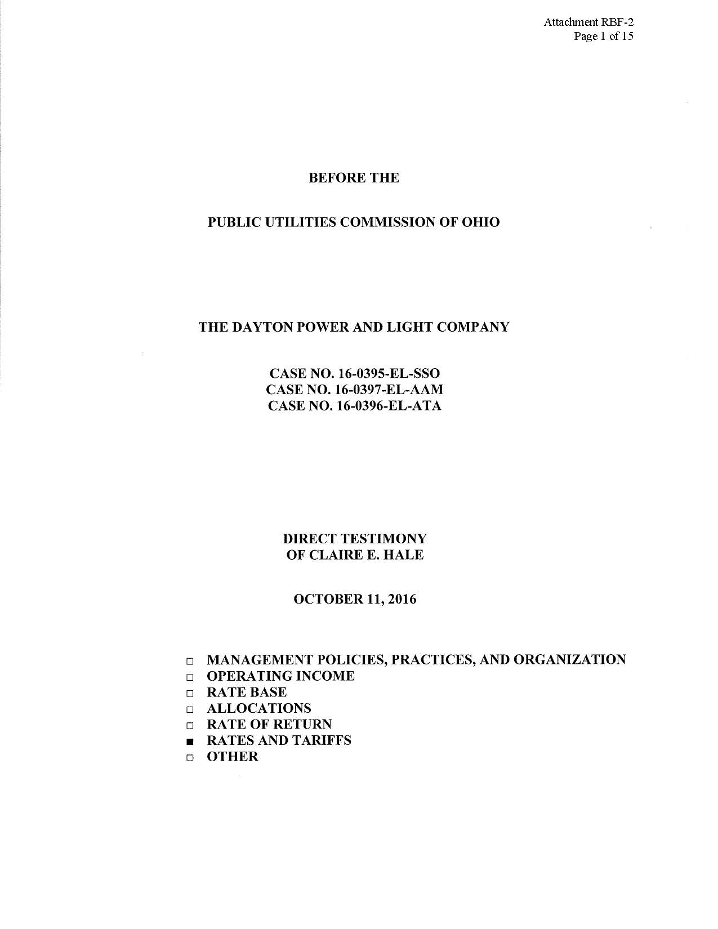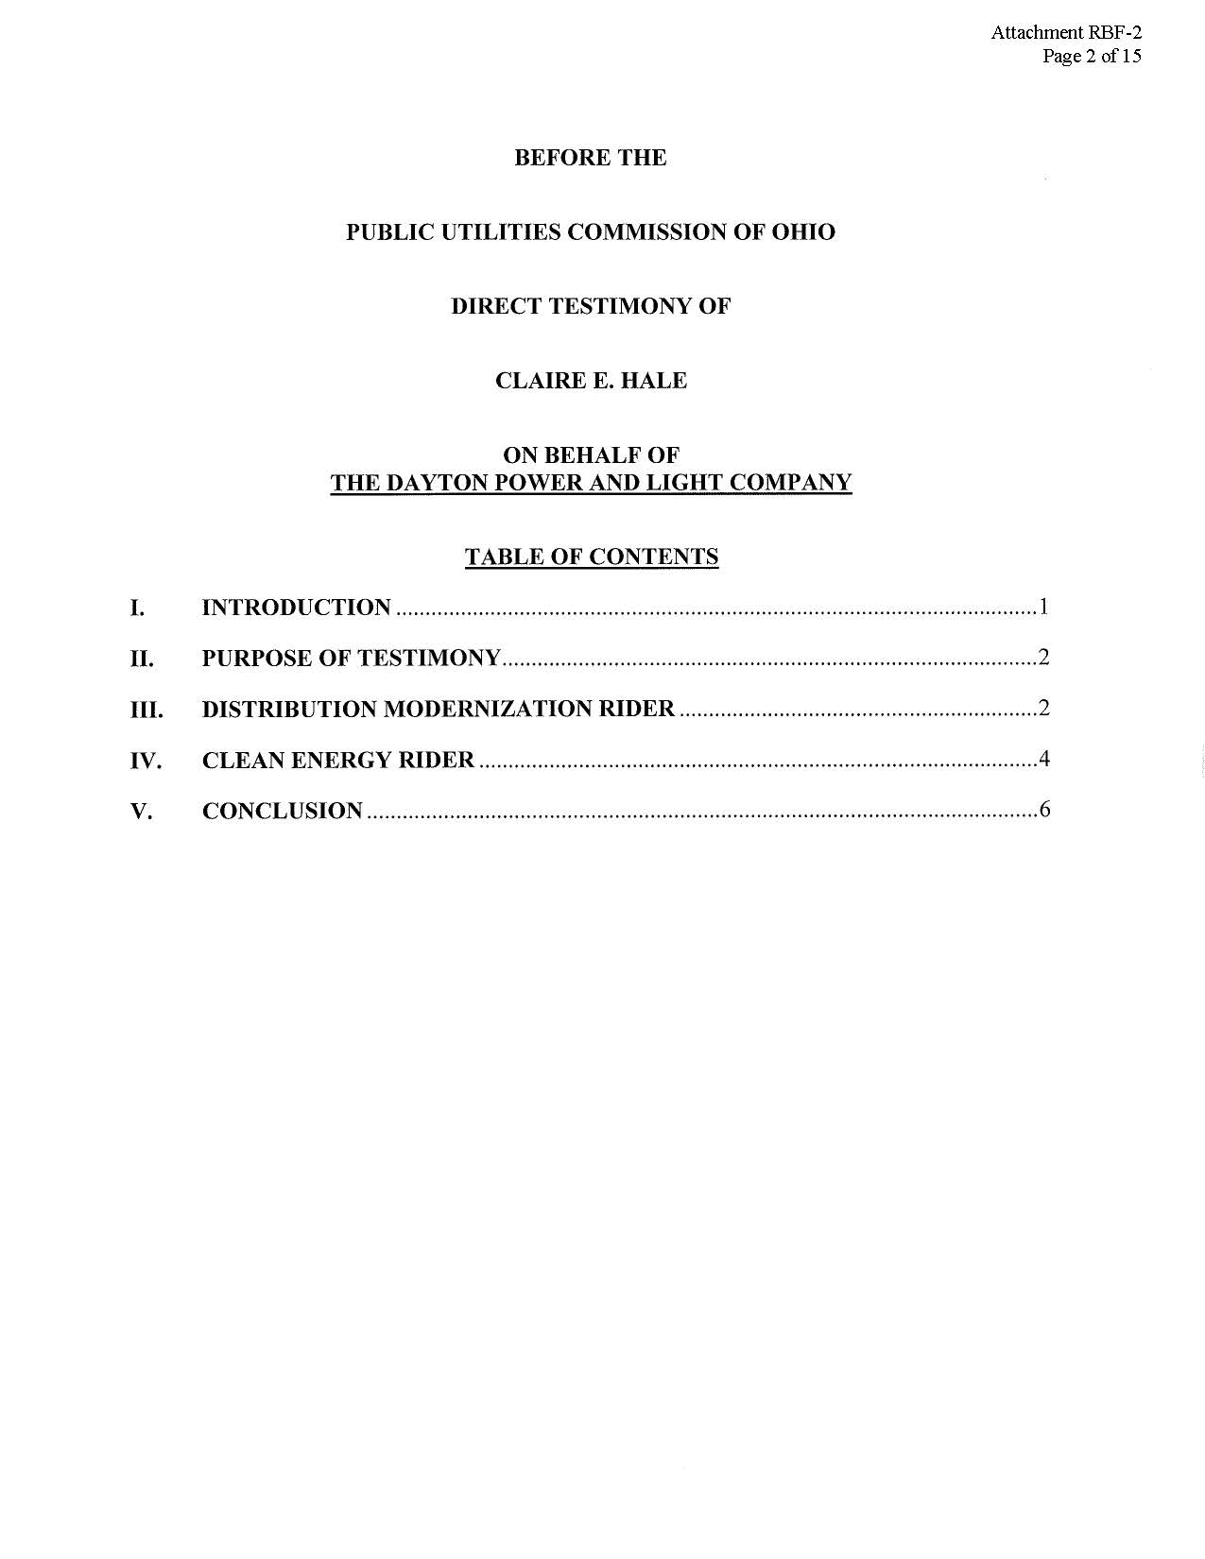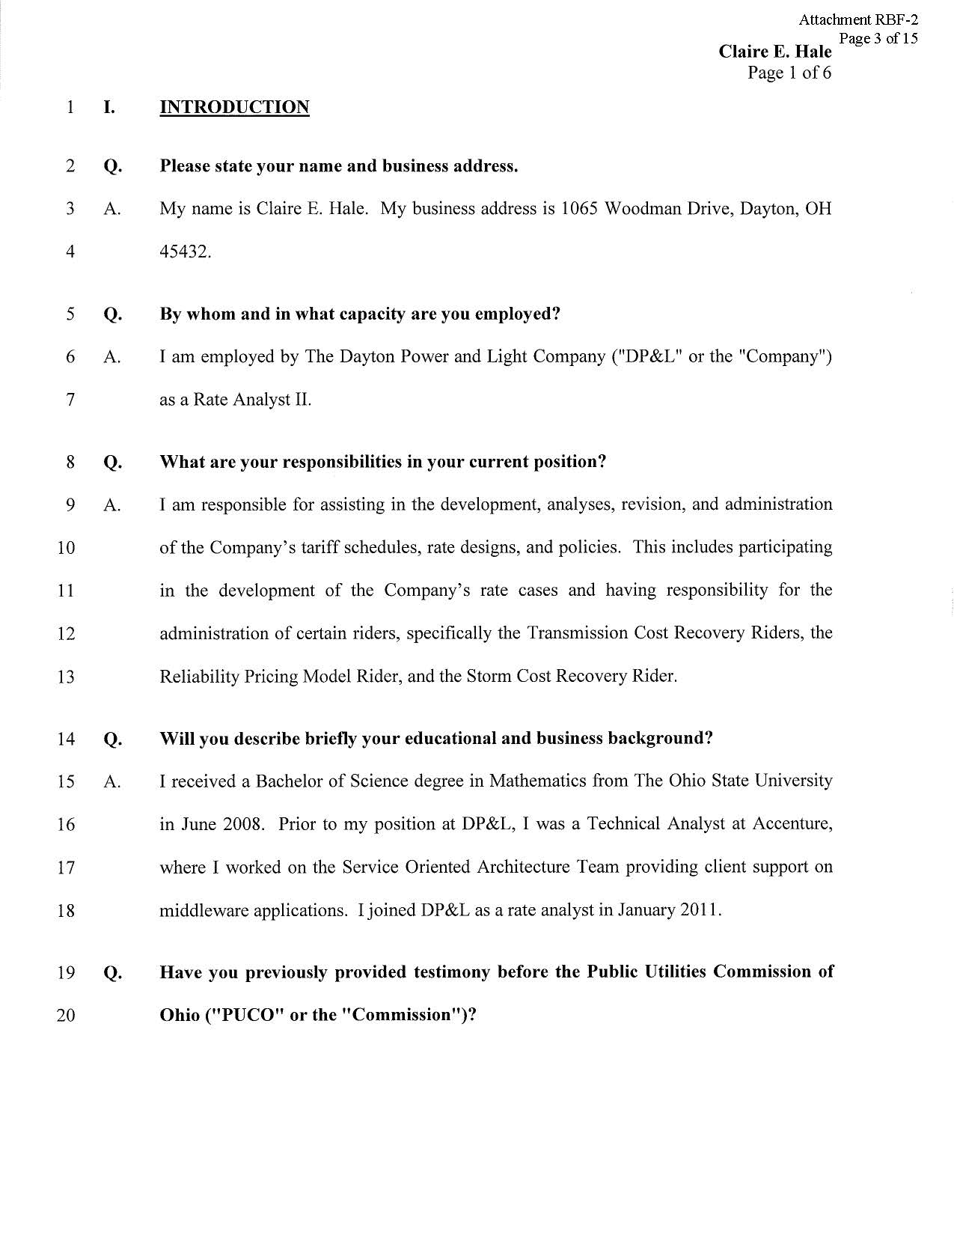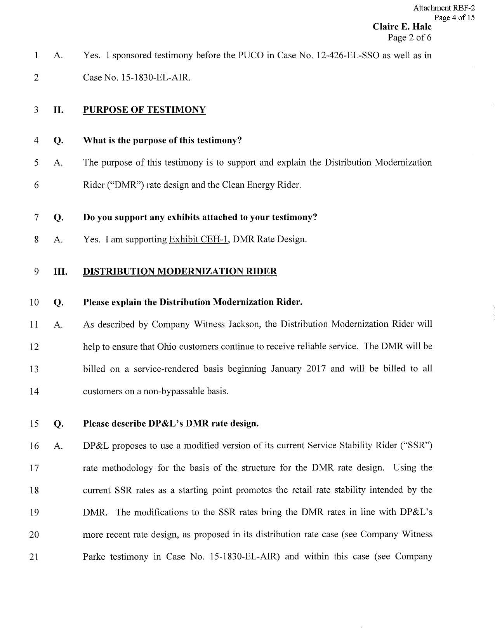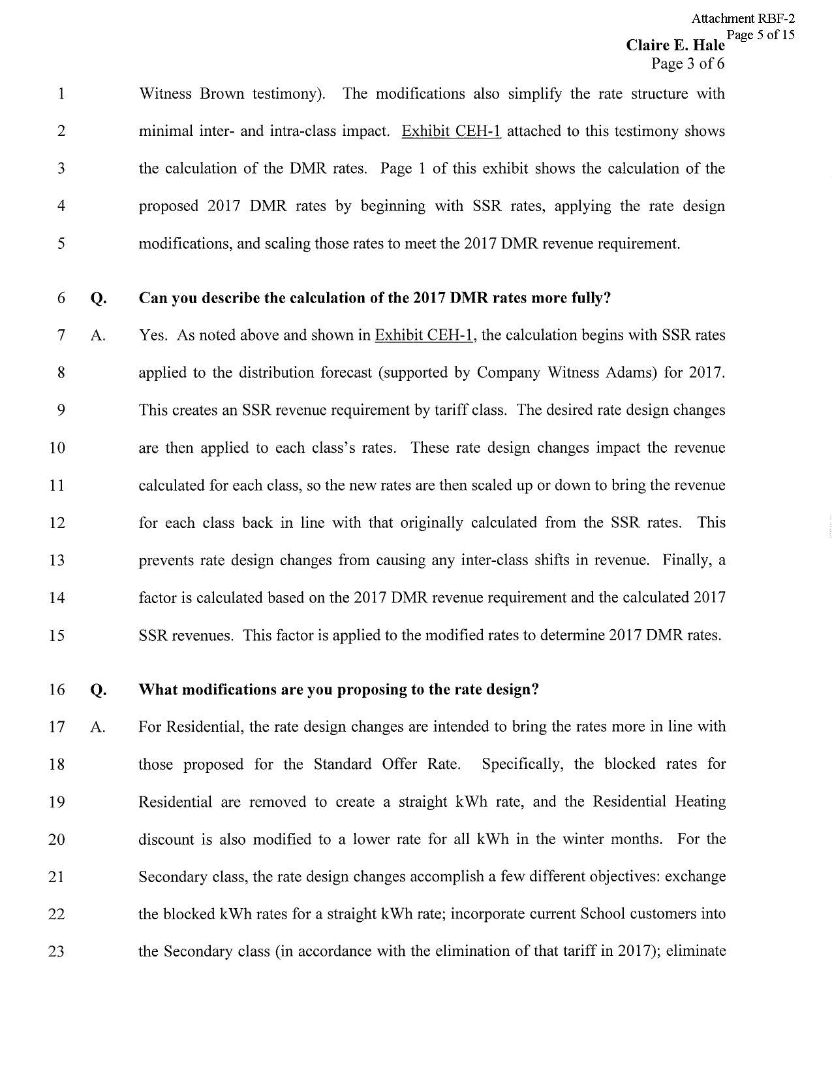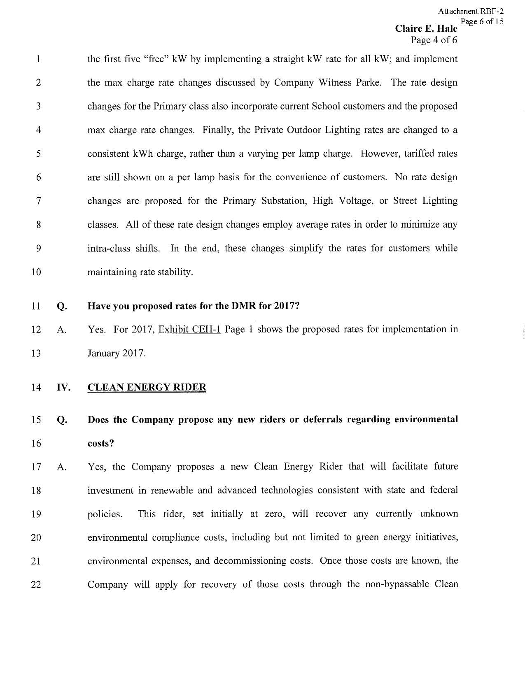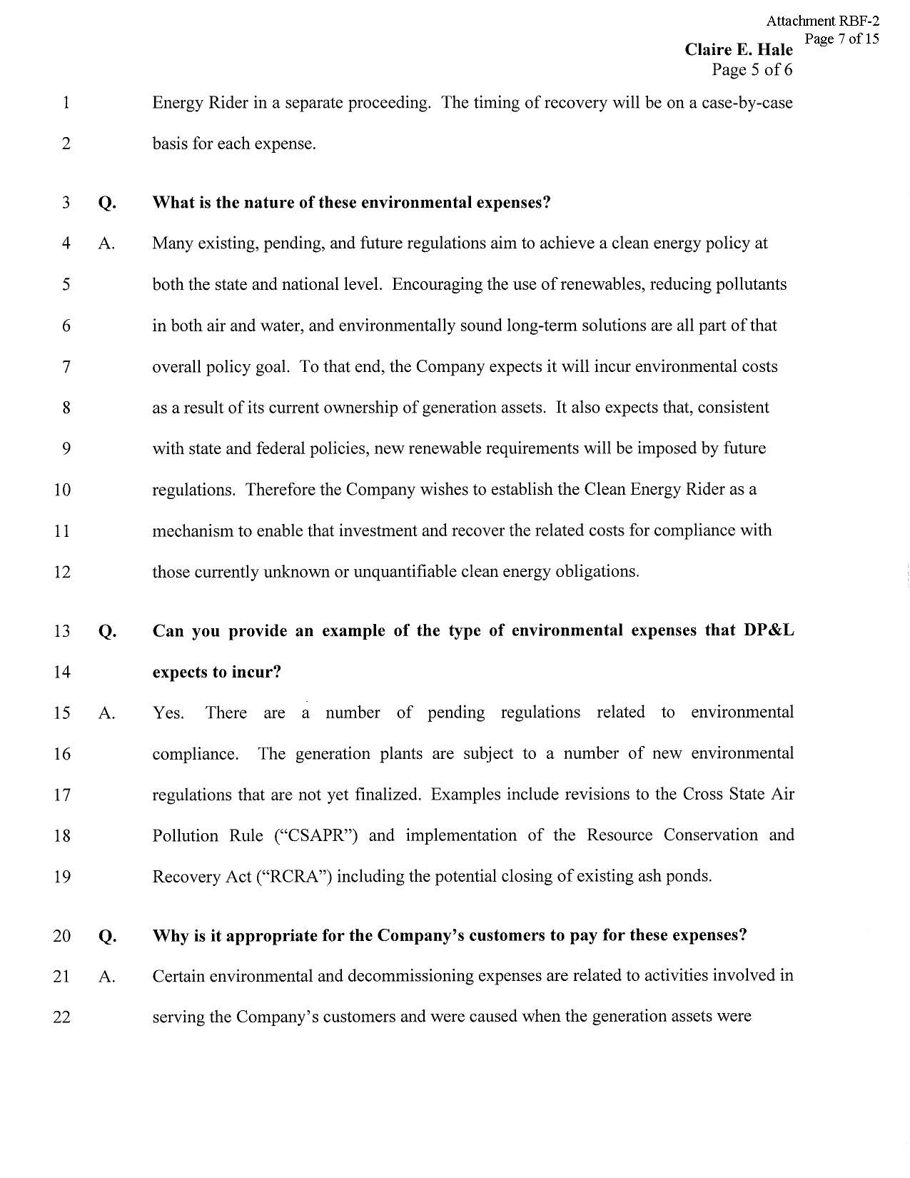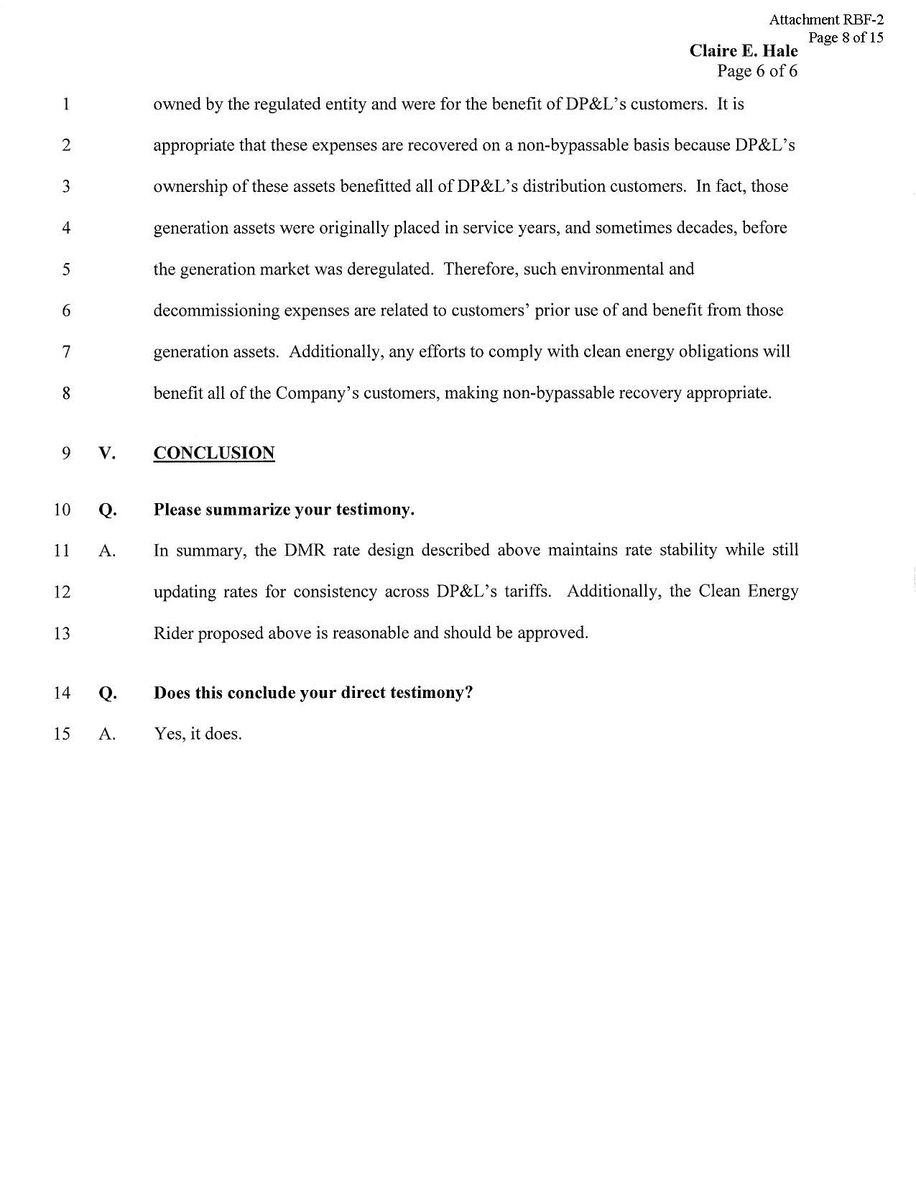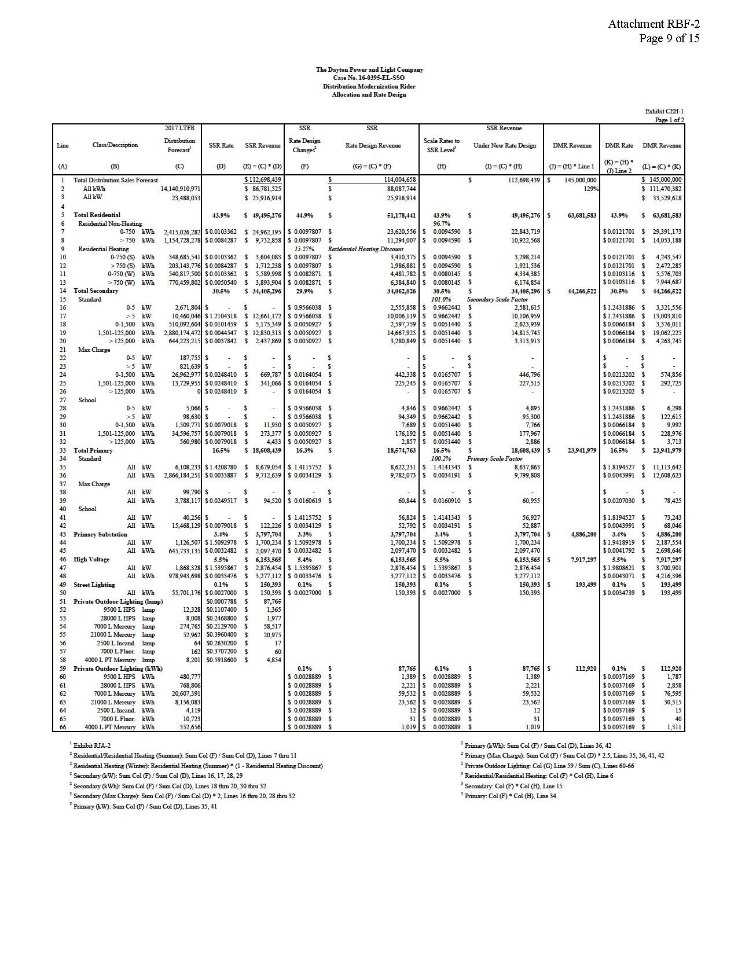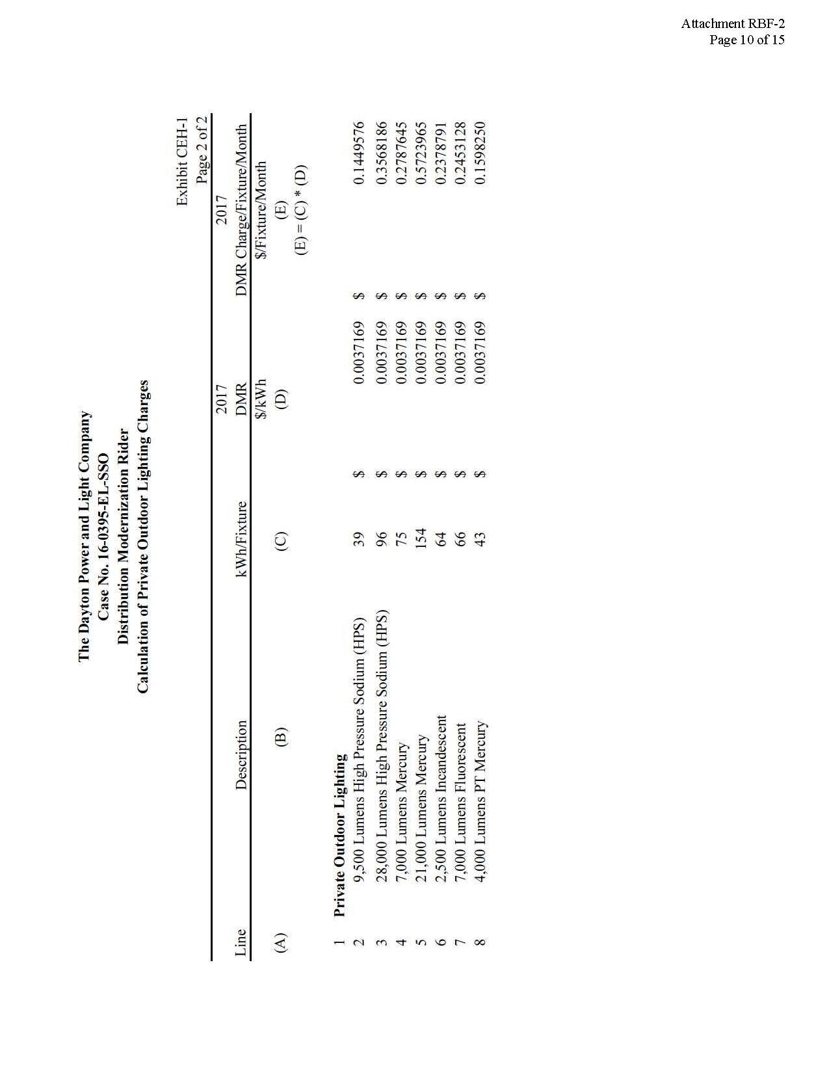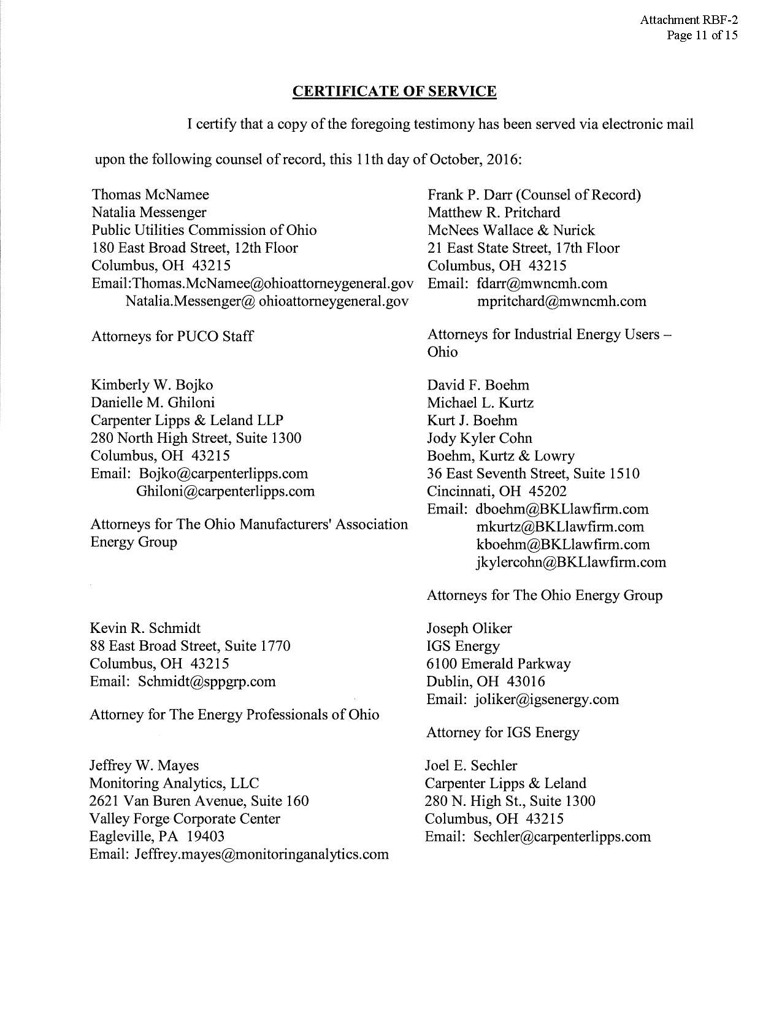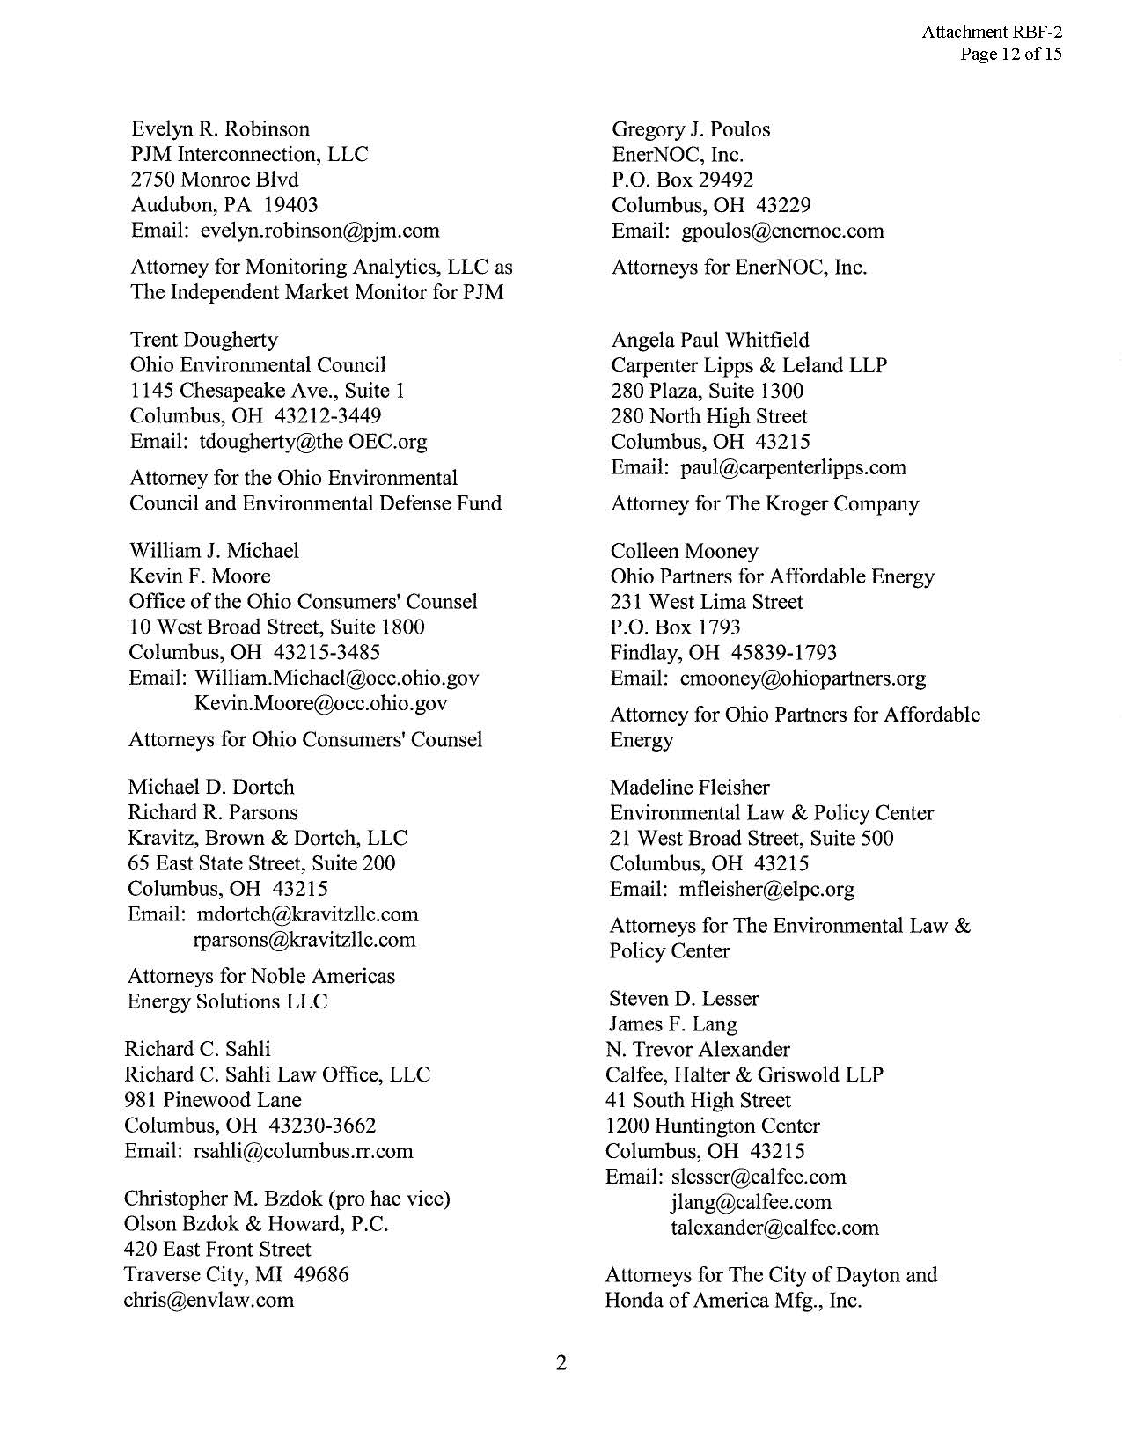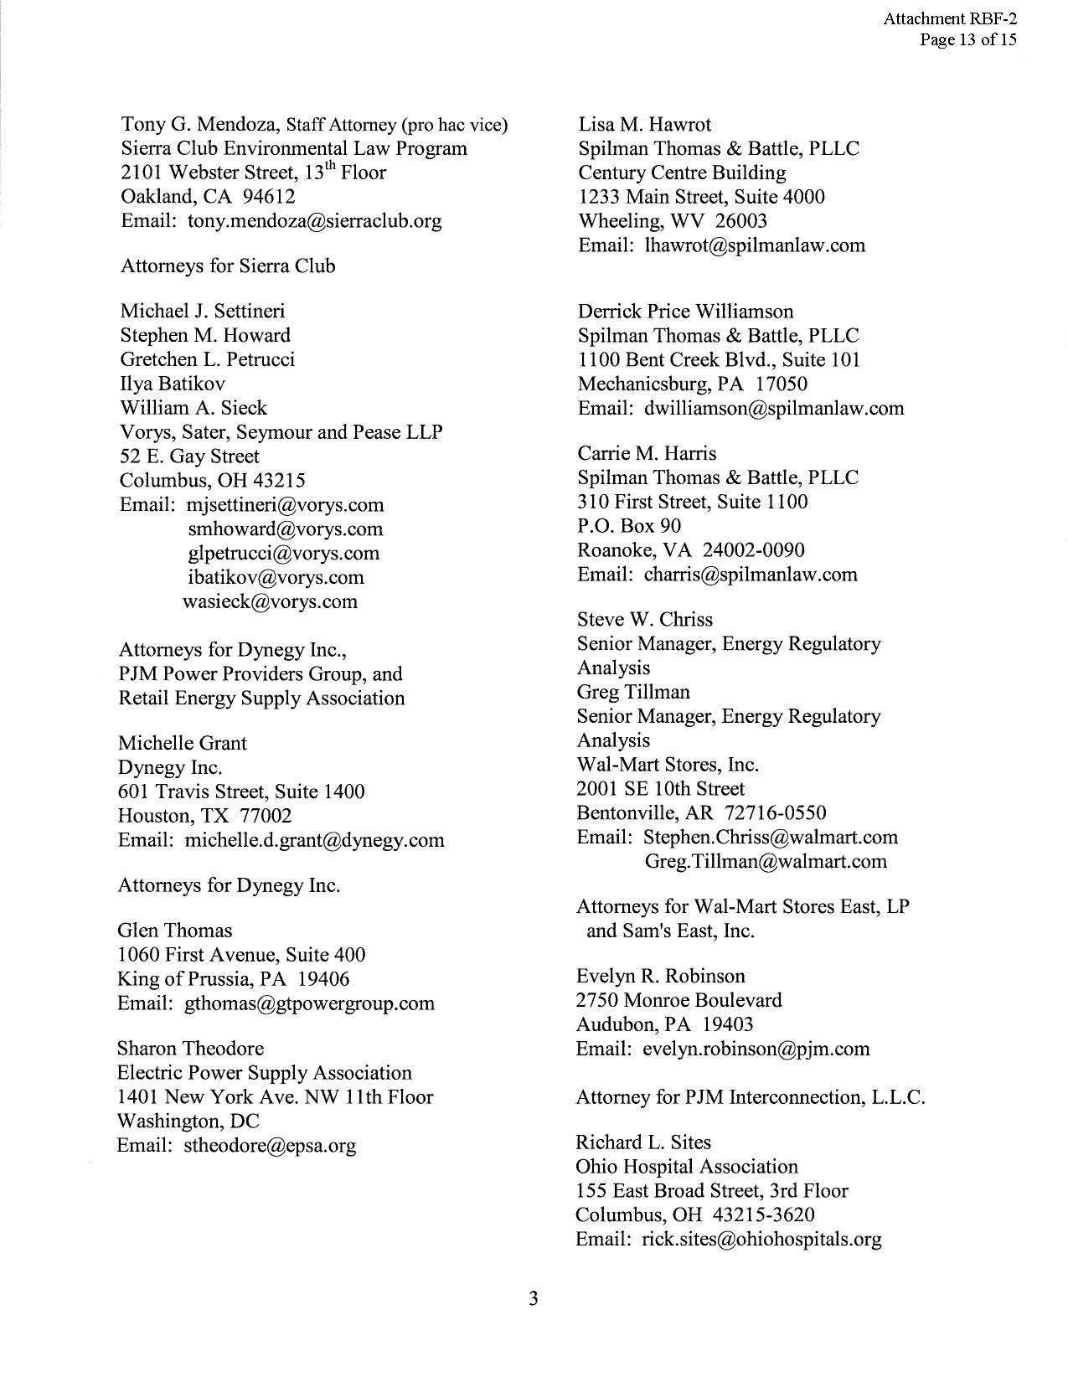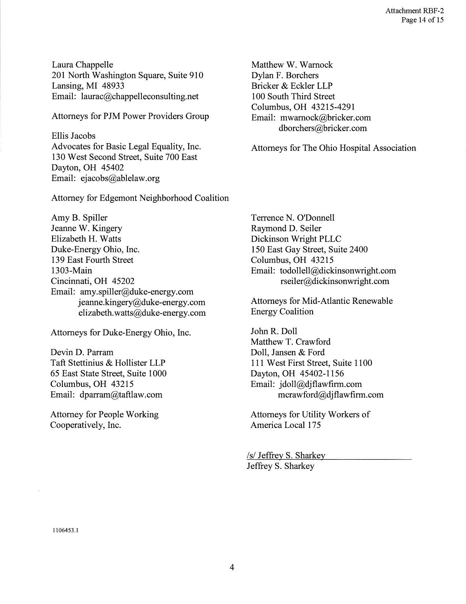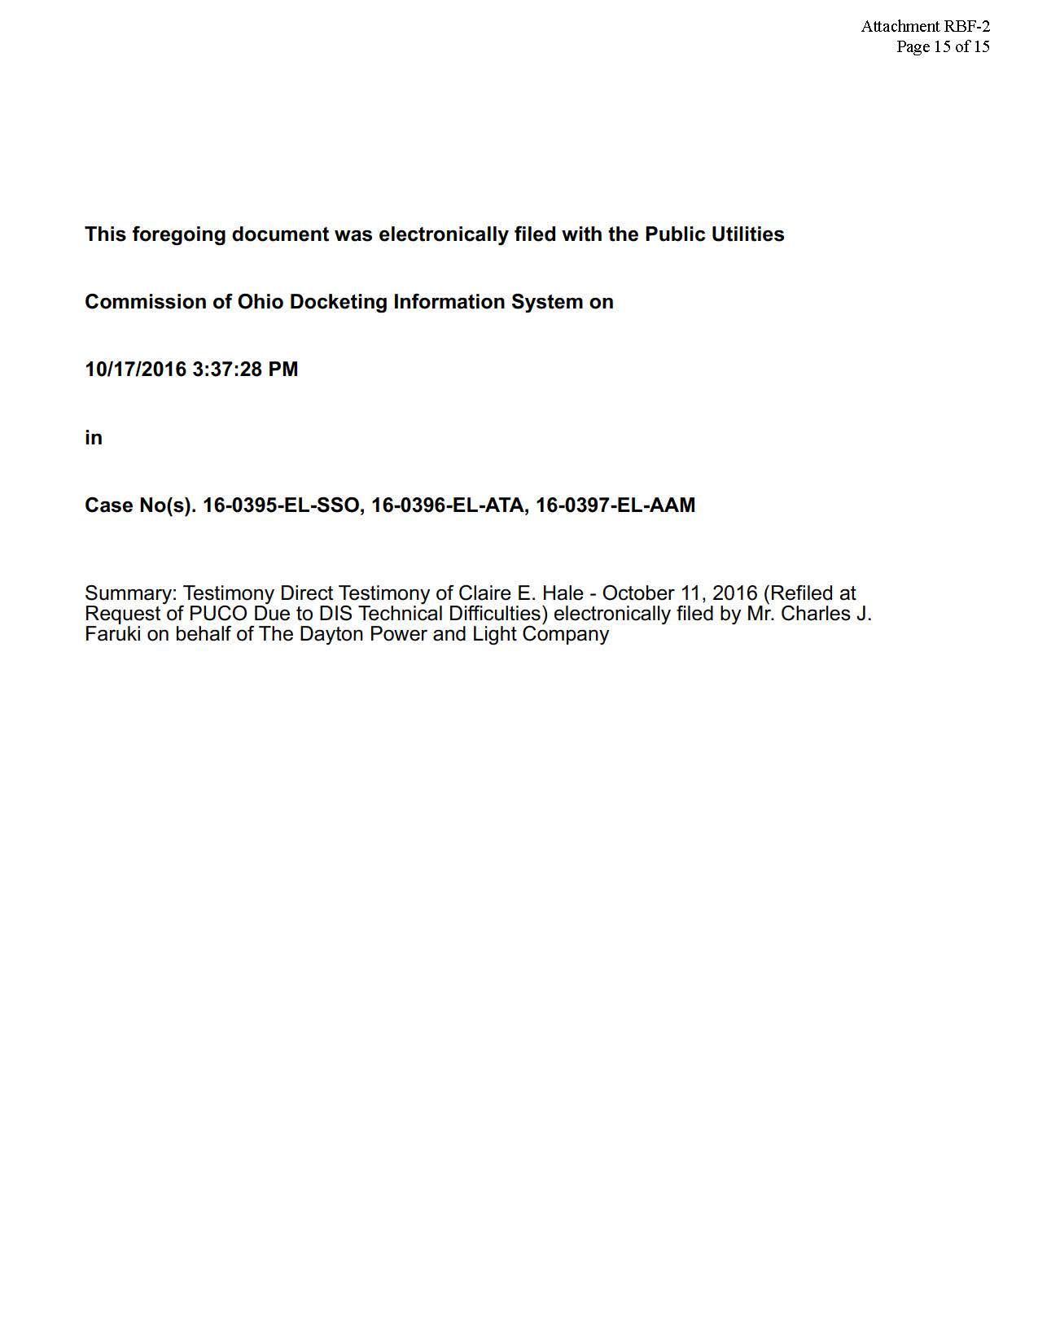

Stipulation at Section II.2.c.
Stipulation at Section II.2.c.
Amended Stipulation at page 5.

