BEFORE
THE PUBLIC UTILITIES COMMISSION OF OHIO

In the Matter of the Application of Ohio Power Company for Authority to Establish a Standard Service Offer Pursuant to Section 4928.143, Revised Code, in the Form of an Electric Security Plan.  In the Matter of the Application of Ohio Power Company for Approval of Certain Accounting Authority. | :  :  :  :  :  :  :  :  : | Case No. 13-2385-EL-SSO  Case No. 13-2386-EL-AAM

PREFILED TESTIMONY
OF
TIMOTHY W. BENEDICT
Energy & Environment Department
Market Analysis & Planning Division
Public Utilities Commission of Ohio

Staff Exhibit _____

May 20, 2014

1. Q. Please state your name and your business address.
A. My name is Timothy W. Benedict, and my business address is 180 East Broad Street, Columbus OH 43215.

2. Q. By whom are you employed and what is your position?
A. I am employed by the Public Utilities Commission of Ohio as a Utility Specialist in the Division of Planning and Market Analysis, Department of Energy and Environment. My responsibilities include demand forecasting and economic analysis of wholesale and competitive markets.

3. Q. Please summarize your educational background and work experience.
A. I received a B.A. in Economics from the University of Vermont and a M.A. in Economics from Cleveland State University, where I was a graduate teaching and research assistant in the Department of Economics. I have been employed by the Staff of the Public Utilities Commission of Ohio since December 2009.

4. Q. Have you testified in prior proceedings before the Commission?
A. Yes. I have testified before the Commission in Case No. 08-917-EL-SSO (on remand) and in Dayton Power & Light’s most recent ESP proceeding, Case No. 12-0426-EL-SSO.

5. Q. What is the purpose of your testimony in this proceeding?
A. The purpose of my testimony is to recommend a specific adjustment to the competitive bid process as proposed by the Company.

6. Q. What change to the competitive bid process do you propose?
A. AEP’s proposed procurement auctions will require winning bidders to deliver electricity to the AEP Load Zone, as defined by PJM. The Company in its application recognizes that “at a time in the future it may be appropriate” to define a new pricing point to settle AEP Ohio load. Staff believes that the creation of a new pricing point that better reflects the auction product would be an improvement to the auction procurement process and encourages AEP to petition PJM to establish an AEP Ohio settlement zone for this purpose as soon as is practicable.

7. Q. Why does Staff believe that this modification should be made?
A. The AEP Load Zone is an aggregation of load buses that are located across all of AEP’s east operating companies including, but not limited to, AEP Ohio, the entity for which generation service is being procured. For illustrative purposes, refer to Attachment 1, which depicts the buses comprising the AEP Load Zone. This inconsistency can be resolved through the creation of an AEP Ohio Load Zone. Additionally, Staff hypothesized that it would be less expensive to deliver energy to an AEP Ohio zonal price point as compared to the AEP Load Zone. To test this proposition, Staff utilized Ventyx’s PROMOD IV (“PROMOD”) production cost modeling software, which simulates the commitment and dispatch process of wholesale electricity markets, including MISO and PJM. Staff ran the model for calendar year 2014, producing average wholesale clearing prices for both an AEP Ohio Load Zone as well as the AEP Load Zone. The AEP Ohio Load Zone produced prices that were approximately 2% lower than the price of energy delivered to the AEP Load Zone, confirming our expectations.

8. Q. Does Staff have concerns that this change may adversely affect the competitive bid process in any way?
A. As long as potential bidders are provided sufficient notification of the change, we do not anticipate any adverse consequences of the proposed modification. National Economic Research Associates (“NERA”) has established an extensive bidder information process and Staff has confidence that this recommendation can be implemented with minimal disruption to the auction process.

9. Q. Does this conclude your testimony?
A. Yes, it does. However, I reserve the right to submit supplemental testimony as described herein, as new information subsequently becomes available or in response to positions taken by other parties.

PROOF OF SERVICE
I hereby certify that a true copy of the foregoing Prefiled Testimony of Timothy W. Benedict submitted on behalf of the Staff of the Public Utilities Commission of Ohio, was served by regular U.S. mail, postage prepaid, hand-delivered, and/or delivered via electronic mail, upon the following parties of record, this 20th day of May, 2014.

/s/ Devin D. Parram
Devin D. Parram
Assistant Attorney General

Parties of Record:

campbell@whitt-sturtevant.com  barthroyer@aol.com  cloucas@ohiopartners.org  cmooney@ohiopartners.org  dconway@porterwright.com  dboehm@bkllawfirm.com  dborchers@bricker.com  edmund.berger@occ.ohio.gov  fdarr@mwncmh.com  gary.a.jeffries@dom.com  gpoulos@enernoc.com  williams@whitt-sturtevant.com  glpetrucci@vorys.com  mhpetricoff@vorys.com  tsiwo@bricker.com  jmcdermott@firstenergycorp.com  jfinnigan@edf.org  jkylercohn@bkllawfirm.com  jfinnigan@edf.org  joseph.clark@directenergy.com  joliker@mwncmh.com  joseph.serio@occ.ohio.gov  judi.sobecki@aes.com  bojko@carpenterlipps.com  lfriedeman@igsenergy.com  lhawrot@spilmanlaw.com  mohler@carpenterlipps.com  haydenm@firstenergycorp.com | mjsatterwhite@aep.com  mswhite@igsenergy.com  maureen.grady@occ.ohio.gov  mkurtz@bkllawfirm.com  msmalz@ohiopovertylaw.org  nmcdaniel@elpc.org  plee@oslsa.org  philip.sineneng@thompsonhine.com  ricks@ohanet.org  rocco.dascenzo@duke-energy.com  sam@mwncmh.com  swilliams@nrdc.org  casto@firstenergycorp.com  sasloan@aep.com  stephanie.chmiel@thompsonhine.com  stephen.chriss@walmart.com  stnourse@aep.com  tammy.turkenton@puc.state.oh.us  tshadick@spilmanlaw.com  tobrien@bricker.com  tdougherty@theOEC.org  vparisi@igsenergy.com  zkravitz@taftlaw.com  whitt@whitt-sturtevant.com  myurick@taftlaw.com  mpritchard@mwncmh.com  schmidt@sppgrp.com

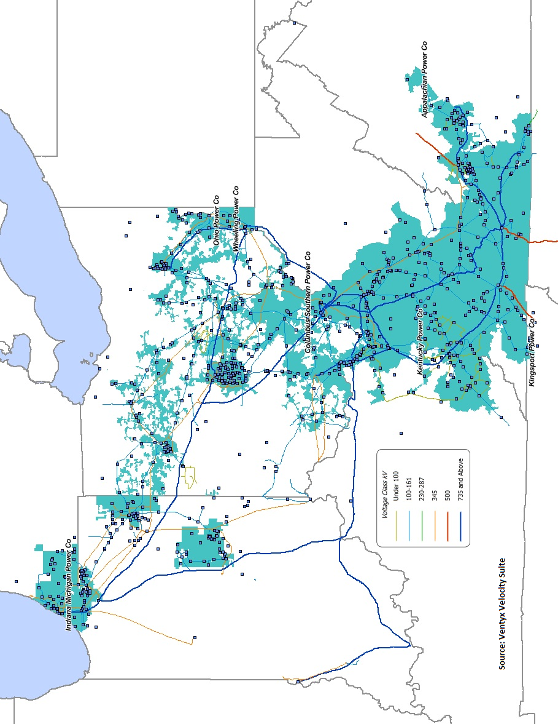

Application at 7.

