BEFORE
THE PUBLIC UTILITIES COMMISSION OF OHIO

In the Matter of the Application of Ohio Power Company for Authority to Establish a Standard Service Offer Pursuant to Section 4928.143, Revised Code, in the Form of an Electric Security Plan.  In the Matter of the Application of Ohio Power Company for Approval of Certain Accounting Authority. | :  :  :  :  :  :  :  :  : | Case No. 13-2385-EL-SSO  Case No. 13-2386-EL-AAM

PREFILED TESTIMONY
OF
RAYMOND W. STROM
Energy & Environment Department
Efficiency & Renewables Division
Public Utilities Commission of Ohio

Staff Exhibit _____

May 20, 2014

1. Q. Please state your name and your business address.
A. My name is Raymond W. Strom. My business address is 180 East Broad Street, Columbus, Ohio 43215.

2. Q. By whom are you employed and what is your position?
A. I am employed by the Public Utilities Commission of Ohio as a Public Utilities Administrator 3, in the Efficiency and Renewables Division of the Energy and Environment Department.

3. Q. Please summarize your educational background.
A. I have earned B.S. and M.S. degrees from Ohio University, both in the biological/environmental sciences. I have also earned a Master of Business Administration degree from Capital University.

4. Q. Please summarize your work experience.
A. Prior to my employment with the PUCO, I was employed as a chemist, a laboratory technician, a graduate teaching assistant, a research technician and a quality control coordinator for various organizations. In 1987, I joined the staff of the Public Utilities Commission of Ohio as Supervisor of the Electric Fuel Component Section. In 1992, I was promoted to Public Utility Administrator 1. Starting in 1999, I served as a Public Utility Administrator 2 in the Facilities, Siting and Environmental Analysis Division. In October of 2009 I was promoted to Chief of the Efficiency and Renewables Division.

5. Q. Have you testified in prior proceedings before the Commission?
A. Yes.

6. Q. What is the purpose of your testimony?
A. The purpose of my testimony is to present Staff’s recommended revisions to the Company’s competitive bidding process proposals. My testimony also deals with Staff’s recommended revisions to the ESP period.

7. Q. What are Staff’s concerns about the Company’s proposed competitive bidding process?
A. In general, the procedures that the Company is recommending appear to be appropriate and consistent with other competitive bidding processes that are conducted by Ohio’s other EDUs. However, Staff is concerned about the Company’s proposal to restrict its initial auctions to products that terminate at or before May 31, 2017. This is then followed with procurements of one year products with delivery ending May 31, 2018. The impact of this mix of products that the Company is proposing is that the Company’s ratepayers that are served under its standard service offer are subjected to uncertainty and potential rate volatility in both 2017 and 2018 as a result of this ESP.

It is my understanding that the driving force behind the May 31, 2017 termination is the Company’s desire to have the unilateral ability to terminate the ESP at that time. The May 31, 2018 termination is a result of the alternate ending date of the ESP, should the Company choose not to use its unilateral ESP termination provision.

8. Q. What does Staff recommend to address these concerns?
A. Staff recommends that the mix of products be revised so that there would not be a 100% termination at June 1, 2017. Further, in order to reduce the uncertainty and frequency of potential rate volatility occurrences over the long term, Staff recommends that the ESP should be extended for a longer period of 5 years. Extending the ESP to a period of 5 years would, over a series of several such ESPs, provide for only three potential rate volatility occurrences over a fifteen year period. This compares to five occurrences for three year ESPs, or ten occurrences for the type of ESP being proposed by the Company. A proposed auction schedule that would accommodate a 5 year ESP is attached as Exhibit RWS-1.

9. Q. How should the Company’s unilateral option to terminate the ESP at the end of the second year be treated under your proposed auction schedule?
A. Ideally, this option should be rejected by the Commission. However, if the Commission were inclined to allow the Company to retain the option of unilateral termination, it should only do so with the concomitant requirements that any subsequent ESP would include the same competitive bidding process for procurement of its SSO supply, and that the auction blending process would continue unabated.

10. Q. What about the termination, and potential rate volatility, at the end of May 2020 in your proposed ESP auction schedule?
A. As I stated earlier, my proposed 5 year ESP auction schedule has fewer potential rate volatility occurrences than the Company’s proposal. However, it should be possible to lessen the potential for rate volatility in my proposed schedule if the Commission were to further require, as part of this ESP, that the Company propose its next SSO, whether ESP or MRO, sufficiently far in advance that the last procurements of this ESP could be blended with the initial procurements of the subsequent SSO.

11. Q. Does Staff have other concerns with the Company’s CBP proposal?
A. Yes. One concern is about the list of criteria presented in the testimony of Company witness LaCasse, on page 29, lines 8 through 13, which has only three reasons that the Commission may use for rejection of the auction results. When making its decision regarding accepting the auction results, the Commission will have access to more information than the several items listed by the Company. The Commission will also receive information from Staff about how each auction progresses, as well as reports on the auctions from the auction manager and the Commission’s consultant. Limiting the Commission’s decision to solely the three criteria listed would essentially render this other information that the Commission receives meaningless, and would severely limit the Commission’s role in oversight of the auction process. Further, pursuant to the bidding rules, all three of the listed criteria will essentially be known prior to the commencement of each auction, so if these three rejection criteria are not met, the auction probably should not even take place. This limitation should not be placed on the Commission. I believe that it would be more appropriate for the competitive bidding process plan to indicate that the inputs from Staff, the Commission’s consultant and the Auction Manager should be used by the Commission in making its decision on whether or not to accept the auction results, but that the decision ultimately should rest with the Commission based on the criteria that it determines are appropriate to use.

Another concern is that the CBP does not appear to provide for a process to revise it, if necessary, during the term of the ESP. As the Commission noted in its decision in the most recent DP&L ESP case, it retains the right to modify and alter the load cap or any other feature of the CBP process for future auctions as the Commission deems necessary based upon its continuing review of the CBP process, including its review of the reports on the auction provided to the Commission by the independent auction manager, the Commission's consultant, the Company, and Staff. The Company’s CBP should similarly include the potential for modification during the ESP period as the Commission deems necessary.

12. Q. Does this conclude your testimony?
A. Yes, it does. However, I reserve the right to submit supplemental testimony as described herein, as new information subsequently becomes available or in response to positions taken by other parties.

PROOF OF SERVICE
I hereby certify that a true copy of the foregoing Prefiled Testimony of Raymond W. Strom submitted on behalf of the Staff of the Public Utilities Commission of Ohio, was served by regular U.S. mail, postage prepaid, hand-delivered, and/or delivered via electronic mail, upon the following parties of record, this 20th day of May, 2014.

/s/ Devin D. Parram
Devin D. Parram
Assistant Attorney General

Parties of Record:

campbell@whitt-sturtevant.com  barthroyer@aol.com  cloucas@ohiopartners.org  cmooney@ohiopartners.org  dconway@porterwright.com  dboehm@bkllawfirm.com  dborchers@bricker.com  edmund.berger@occ.ohio.gov  fdarr@mwncmh.com  gary.a.jeffries@dom.com  gpoulos@enernoc.com  williams@whitt-sturtevant.com  glpetrucci@vorys.com  mhpetricoff@vorys.com  tsiwo@bricker.com  jmcdermott@firstenergycorp.com  jfinnigan@edf.org  jkylercohn@bkllawfirm.com  jfinnigan@edf.org  joseph.clark@directenergy.com  joliker@mwncmh.com  joseph.serio@occ.ohio.gov  judi.sobecki@aes.com  bojko@carpenterlipps.com  lfriedeman@igsenergy.com  lhawrot@spilmanlaw.com  mohler@carpenterlipps.com  haydenm@firstenergycorp.com  Exhibit RWS-1 | mjsatterwhite@aep.com  mswhite@igsenergy.com  maureen.grady@occ.ohio.gov  mkurtz@bkllawfirm.com  msmalz@ohiopovertylaw.org  nmcdaniel@elpc.org  plee@oslsa.org  philip.sineneng@thompsonhine.com  ricks@ohanet.org  rocco.dascenzo@duke-energy.com  sam@mwncmh.com  swilliams@nrdc.org  casto@firstenergycorp.com  sasloan@aep.com  stephanie.chmiel@thompsonhine.com  stephen.chriss@walmart.com  stnourse@aep.com  tammy.turkenton@puc.state.oh.us  tshadick@spilmanlaw.com  tobrien@bricker.com  tdougherty@theOEC.org  vparisi@igsenergy.com  zkravitz@taftlaw.com  whitt@whitt-sturtevant.com  myurick@taftlaw.com  mpritchard@mwncmh.com  schmidt@sppgrp.com
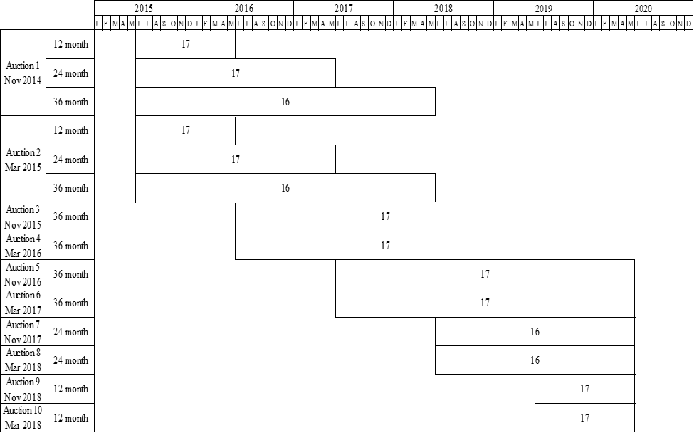

In the Matter of the Application of The Dayton Power and Light for Approval of its Electric Security Plan, Case No. 12-426-EL-SSO (Opinion and Order at 16-17) (Sep. 4, 2013).

