OCC EXHIBIT_______

BEFORE
THE PUBLIC UTILITIES COMMISSION OF OHIO

In the Matter of the Application of Aqua Ohio, Inc. To Increase Its Rates and Charges for Its Waterworks Service. | )  )  ) | Case No. 16-0907-WW-AIR

DIRECT TESTIMONY
OF
JAMES D. WILLIAMS

On Behalf of
The Office of the Ohio Consumers' Counsel
10 West Broad Street, Suite 1800
Columbus, Ohio 43215-3485

December 19, 2016
TABLE OF CONTENTS

Page

I. INTRODUCTION 1
II. PURPOSE OF MY TESTIMONY 3
III. OBJECTIONS TO STAFF REPORT 5
A. UNACCOUNTED FOR WATER 5
B. EXTERNAL AUDITOR 7
C. BILL PAYMENT ASSISTANCE PROGRAM 11
iv. CONCLUSION 17

ATTACHMENTS
JDW-1 List of Previous Testimony Filed at the PUCO by James Williams
JDW-2 Aqua Ohio response to OCC INT-90
JDW-3 Aqua Ohio response to OCC INT-85
JDW-4 Aqua Ohio response to OCC INT-86
JDW-5 Aqua Ohio response to OCC INT-87
JDW-6 Aqua Ohio response to OCC INT-92
JDW-7 Aqua Ohio response to OCC INT-94
JDW-8 Aqua Ohio response to OCC INT-89
JDW-9 Map the Meal Gap 2016
JDW-10 Aqua Ohio response to OCC INT-91

I. INTRODUCTION

Q1. PLEASE STATE YOUR NAME, BUSINESS ADDRESS, AND POSITION.
A1. My name is James D. Williams. My business address is 10 West Broad Street, 18th Floor, Columbus, Ohio 43215-3485. I am employed by the Office of the Ohio Consumers’ Counsel (“OCC”) as a Senior Utility Consumer Policy Analyst.

Q2. PLEASE BRIEFLY SUMMARIZE YOUR EDUCATION AND PROFESSIONAL EXPERIENCE.
A2. I am a 1994 graduate of Webster University, in St. Louis, Missouri, with a Master’s in Business Administration, and a 1978 graduate of Franklin University, in Columbus, Ohio, with a Bachelor of Science, Engineering Technology. My professional experience includes a career in the United States Air Force and over 20 years of utility regulatory experience with the OCC.

Initially, I served as a compliance specialist with the OCC and my duties included the development of compliance programs for electric, natural gas, and water industries. Later, I was designated to manage all of the agency’s specialists who were developing compliance programs in each of the utility industries. My role evolved into the management of OCC’s consumer hotline, the direct service provided to consumers to resolve complaints and inquiries that involved Ohio utilities. More recently, following a stint as a Consumer Protection Research Analyst, I was promoted to a Senior Utility Consumer Policy Analyst. In this role, I am responsible for developing and recommending policy positions on utility issues that affect residential consumers.

I have been directly involved in the development of comments in various rulemaking proceedings at the Public Utilities Commission of Ohio (“PUCO”) and the Ohio Development Services Agency. Those comments included advocacy for consumer protections, affordability of utility rates, service quality and the provision of reasonable access to essential utility services for residential consumers. I have assisted in the development of OCC policies and positions in a number of proceedings involving the service standards for Waterworks Companies and Sewage Disposal System Companies, and the provision of utility services and consumer protections for residential consumers, including low-income Ohioans.

Q3. HAVE YOU PREVIOUSLY SUBMITTED TESTIMONY OR TESTIFIED BEFORE THE PUCO?
A3. Yes. The cases that I have submitted testimony and/or have testified before the PUCO can be found in Attachment JDW-1.

II. PURPOSE OF MY TESTIMONY

Q4. WHAT IS THE PURPOSE OF YOUR TESTIMONY IN THIS PROCEEDING?
A4. The purpose of my testimony is to address and support preliminary objections 20, 21, 22, and 23 that were filed by the OCC concerning the PUCO Staff Report. More specifically, the purpose of my testimony is to address the PUCO Staff recommendations concerning the level of unaccounted for water (“UFW”) in several communities served by Aqua Ohio, Inc. (“Aqua” or “Utility”) and the need for an external auditor to examine program management processes used by Aqua in implementing Information Technology (“IT”) programs. Furthermore, my testimony addresses poverty levels in many of the communities served by Aqua and the relatively high number of families who are being disconnected for non-payment.

Q5. Please summarize your conclusions.
A5. I recommend that the PUCO require the PUCO Staff to evaluate possible adjustments that should be made in chemical and energy expenses incurred by Aqua Ohio in serving communities where the UFW level continues to exceed fifteen percent. This evaluation should be conducted as part of the PUCO Staff review and investigation that will be undertaken in Aqua’s next base rate case. In addition, I recommend that the PUCO accept the PUCO Staff recommendation to require Aqua to retain, at its own expense, an external auditor to examine control processes used by Aqua in managing IT programs. However, because this is an on-going issue that Aqua should have already addressed, I recommend that the PUCO protect consumers from potential further harm by requiring the external auditor’s findings and recommendations to be publicly filed within six months of the date the PUCO issues an Opinion and Order in this case. Finally, the PUCO should direct Aqua to initiate programs to help customers avoid disconnection of water service. These programs include more consumer friendly payment plans and a shareholder funded bill payment assistance program within sixty days of issuance of the Opinion and Order in this case. The bill payment assistance program would help payment troubled low-income customers avoid disconnection for non-payment.

III. OBJECTIONS TO STAFF REPORT

A. UNACCOUNTED FOR WATER

Q6. PLEASE SUMMARIZE THE STAFF RECOMMENDATIONS CONCERNING UNACCOUNTED FOR WATER.
A6. The PUCO Staff recommended that Aqua Ohio continue filing Infrastructure Leak Index (“ILI”) reports annually for the five Aqua Ohio systems where more than 3,000 customers are served. These five systems include Ashtabula, Lawrence County, Marion, Mentor (Lake Shore West), and Tiffin. Staff recommended no chemical and power costs adjustments in the case because the actual ILI for these five systems was under the target ILI prescribed by PUCO rules.

Q7. CAN YOU BRIEFLY EXPLAIN THE PUCO RULES CONCERNING UNACCOUNTED FOR WATER?
A7. Yes. Ohio Adm. Code 4901:1-15-20(C)(5) requires each waterworks company to determine the percentage of unaccounted for water on a rolling twelve-month average. The percentage is based on total metered usage and the total amount of water production. Utilities must provide reports to the PUCO Staff if the UFW level exceeds fifteen percent. These reports must also assess the costs and benefits of a leak survey. In addition, if the utility’s system has more than 3,000 service connections or more than sixteen connections per mile of distribution main, the remedial report must provide a calculation for the infrastructure leak index.

Q8. DID THE PUCO STAFF PROVIDE ANY SPECIFIC RECOMMENDATION CONCERNING THE UNACCOUNTED FOR WATER LEVEL IN OTHER AQUA OHIO SYSTEMS?
A8. No. The PUCO Staff mentioned that five of Aqua Ohio’s systems have fewer than 3,000 customers and calculated UFW levels exceeding 15 percent. These include Blacklick Estates, Huber Ridge, Imperial Bryonaire, Sites Lake, and Mohawk. The PUCO Staff mentions that remedial action plans were submitted for these systems.

Q9. SHOULD THE PUCO STAFF HAVE CONSIDERED OTHER RECOMMENDATIONS CONCERNING THE UNACCOUNTED FOR WATER LEVEL AT THE BLACKLICK ESTATES AND HUBER RIDGE SYSTEMS?
A9. Yes. Table 1 provides the rolling 12-month average UFW for Blacklick Estates and Huber Ridge over each of the past five years. The Huber Ridge UFW has exceeded 15 percent for each of the past five years. The Blacklick Estates has exceeded the 15 percent UFW for each of the past four years. Staff should have performed an analysis about the UFW in the the Blacklick and Huber Ridge systems to determine if adjustments for power and chemical expenses were appropriate. The PUCO should require this analysis to be performed by the PUCO Staff as part of the next rate case if the UFW for the Huber Ridge and/or Blacklick systems continue to trend above 15 percent.
Table 1: 12-month Average Unaccounted for Water Blacklick and Huber Ridge (2011 – 2015)

System | # Customers | 2015 | 2014 | 2013 | 2012 | 2011
Blacklick | 2,875 | 18.02 | 17.65 | 27.2 | 21.8 | 14.3
Huber Ridge | 2,233 | 17.68 | 21.19 | 19.0 | 20.1 | 19.9

B. EXTERNAL AUDITOR

Q10. CAN YOU BRIEFLY DESCRIBE THE PUCO STAFF RECOMMENDATION REGARDING AQUA BEING DIRECTED TO RETAIN AN EXTERNAL AUDITOR TO EXAMINE MANAGEMENT OF INFORMATION TECHNOLOGY PROGRAMS.
A10. Yes. The PUCO Staff reviewed documentation provided by Aqua for several different IT initiatives to examine if the Utility is providing adequate controls in the management of the programs. The PUCO Staff concluded that the documentation was lacking for several projects and there was not a uniform process in place for tracking programs from initiation to completion. In addition, the PUCO Staff noted that there was no substantive post-completion analysis conducted for any of the programs. The PUCO Staff also noted that several high budget initiatives experienced cost overruns and there was a lack of documentation explaining and/or authorizing the cost increases.

For the sake of background in understanding the importance of this issue, the PUCO Staff identified similar issues associated with the management of IT programs in the last Aqua rate case. According to the Stipulation in that case, Aqua agreed to include, as part of the instant case, information demonstrating that the Utility “engages in rigorous, regular, Project Management Institute (PMI) driven budget development and oversight of IT projects.” However, Aqua did not satisfy this previous commitment. Therefore, the PUCO Staff is now recommending that Aqua be directed to engage an external auditor, paid for by Aqua America from non-regulated funds, to examine the control processes used by Aqua in managing IT programs and to make appropriate recommendations. The PUCO Staff further recommends that the audit be conducted within one year of the PUCO Opinion and Order in this case.

Q11. IS THE PUCO STAFF RECOMMENDATION REASONABLE?
A11. No. My recommendation is that the PUCO require Aqua to engage an external auditor, using shareholder funds, and to publicly file the results of the audit with all findings and recommendations within six months of the Opinion and Order in this case. The PUCO should act more expediently towards ensuring that Aqua has systems and processes in place to prevent any potential further harm to consumers. Inadequately managed IT programs can ultimately result in imprudently incurred expenses that drive up the cost of service paid by consumers. And inadequately managed IT programs can negatively impact the utility service provided to consumers. Aqua has had sufficient time since the last base rate case to implement the additional controls that it promised to demonstrate adequacy of the program management, and it has failed to do so.

In fact, concerns about the way in which Aqua manages IT programs pre-date the last base rate case. Aqua Ohio customers experienced serious billing issues in 2008 and 2009 because of inadequately managed IT
programs. The billing issues resulted in Aqua Ohio customers either not receiving a bill for service or receiving a bill for an unusually long period of service.

The examination of Aqua’s implementation of IT programs by an external auditor is a reasonable next step towards bringing final resolution to a long standing issue that can significantly impact customers. But the external auditor’s findings and recommendations need to be publicly filed within six months of the Opinion and Order in this case. A more aggressive schedule for conducting the external audit is appropriate because Aqua is not prioritizing fixing this long-standing issue. Aqua spends millions of dollars annually on IT systems and programs that are ultimately paid for by customers in the form of higher rates. The review of the adequacy and sufficiency of program documentation is crucial for the PUCO to determine the just and reasonableness of proposed base rates. Aqua Ohio should face significant financial consequences if it is unable to demonstrate that all of the external auditor recommendations are implemented prior to the next base rate case.

C. BILL PAYMENT ASSISTANCE PROGRAM

Q12. DID THE STAFF REPORT PROVIDE RECOMMENDATIONS CONCERNING AQUA PAYMENT ASSISTANCE?
A12. No.

Q13. DOES AQUA OFFER RESIDENTIAL CUSTOMERS WHO ARE HAVING TROUBLE PAYING THEIR WATER BILL ANY TYPE OF BILL PAYMENT ASSISTANCE?
A13. No. In the Aqua response to OCC INT-90 (attached herein as JDW-2), the Utility confirmed that it does not offer any company-sponsored bill payment assistance program. Aqua offers customers who are experiencing financial difficulty with a single very limited payment plan that I will discuss later in my testimony.

Q14. CAN YOU DESCRIBE HOW RESIDENTIAL CUSTOMERS ARE IMPACTED WHEN THEY ARE UNABLE TO PAY THEIR AQUA WATER BILL?
A14. Yes. One of the ways in which residential customers are impacted is through disconnection of their water service. Table 2 provides a summary of the total number of residential customers who have been disconnected for non-payment in each Aqua Ohio district between 2013 and now.
Table 2: Aqua Ohio Disconnections (2013 – October 2016)

Operating Division | Customers | 2013 | 2014 | 2015 | 2016
Lake/Ashtabula | 40,743 | 1,669 | 1,453 | 1,562 | 1,470
Franklin/ Lawrence | 11,406 | 865 | 663 | 705 | 605
Mansfield/ Portage/ Masury | 3,585 | 130 | 136 | 125 | 145
Marion/ Tiffin | 22,817 | 1,690 | 1,432 | 1,335 | 1,292
Mohawk/ Tomahawk | 1,253 | 0 | 0 | 12 | 1
Total | 79,904 | 4,354 | 3,685 | 3,739 | 3,513

Between 2013 and October 2016, Aqua has disconnected 15,291 residential customers for non-payment. This represents a disconnection rate of 19.1 percent. This means that almost one in five Aqua customers have been disconnected for non-payment at some period of time between 2013 and October 2016. This is compelling information demonstrating the struggle residential customers are having paying their water bill.

Q15. ARE THERE ADDITIONAL FINANCIAL IMPACTS ON RESIDENTIAL CUSTOMERS WHEN THEY ARE UNABLE TO PAY THEIR AQUA WATER BILL?
A15. Yes. Customers pay hefty late payment charges when they are unable to timely pay their Aqua Ohio water bill. In fact as shown in Table 3, residential customers have paid Aqua Ohio over $1.9 million in late payment charges between 2013 and October 2016. The Aqua Ohio tariff’s generally support a five percent late payment charge on unpaid current monthly charges.
Table 3: Aqua Ohio Customer Late Payment Charges (2013 – October 2016)
Operating Division | 2013 | 2014 | 2015 | 2016
Lake/ Ashtabula | $194,591 | $190,409 | $200,726 | $167,945
Franklin/ Lawrence | 90,131 | 88,389 | 90,518 | 77,701
Mansfield/ Portage/Masury | 27,473 | 26,042 | 25,787 | 22,187
Marion/ Tiffin | 197,650 | 178,173 | 182,489 | 159,540
Mohawk/ Tomahawk | 0 | 0 | 3,610 | 3,741
Total | $509,845 | $483,013 | $503,130 | $431,114

Q16. ARE THERE ANY OTHER FINANCIAL IMPACTS THAT RESIDENTIAL CUSTOMERS INCUR WHEN THEY ARE UNABLE TO PAY THEIR WATER BILL?
A16. Yes. Customers who are disconnected for non-payment are required to pay hefty reconnection charges in order to get the water service restored. Reconnection charges during normal business hours cost $55.95. Reconnection charges during other than normal business hours cost $155.86. As shown in Table 4, Aqua Ohio customers paid over $600,000 between 2013 and October 2016 in reconnection charges.
Table 4: Aqua Ohio Customer Reconnection Charges (2013 – October 2016)
Operating Division | 2013 | 2014 | 2015 | 2016
Lake/ Ashtabula | $77,434 | $60,672 | $67,882 | $61,043
Franklin/ Lawrence | 40,134 | 22,988 | 22,892 | 20,648
Mansfield/ Portage/Masury | 3,092 | 3,087 | 3,247 | 3,566
Marion/ Tiffin | 65,530 | 56,378 | 45,396 | 44,933
Mohawk/ Tomahawk | 0 | 0 | 191 | 58
Total | $189,190 | $143,125 | $139,608 | $130,248

Q17. will the INCREASE in aqua rates result in even more IMPACT on CUSTOMER’S abilitY to pay their WATER BILL?
A17. There can be no doubt. Aqua has proposed an overall rate increase of 9.2 percent over rates that were established in 2014. Aqua Ohio claims that slightly higher operating and maintenance expenses and other costs since 2014 have contributed to the proposed increase. But the proposed Aqua Ohio 9.2 percent increase can far exceed the increases many Aqua customers have seen in their household incomes since 2014. The Consumer Price Index (CPI) helps measure changes in consumer buying power as adjusted for inflation over time. The CPI has increased about 2.2 percent since 2014; yet Aqua Ohio is proposing a 9.2 percent increase in rates. Therefore, customers who already struggle paying their water bill and who received only inflationary increases in household income since 2014 will be negatively impacted by the Aqua rate increase.
Q18. DOES POVERTY IN MANY OF THE COUNTIES SERVED BY AQUA EXCEED THE NATIONAL AND OHIO POVERTY LEVELS?
A18. Yes. Table 5 provides a summary of the poverty level in each of the counties served by Aqua. Ohio has a statewide poverty level of 15.9 percent that exceeds the national poverty level rate of 15.5 percent. As can be seen in Table 5, the poverty levels in ten of the fourteen counties served by Aqua Ohio exceed the statewide poverty level. High poverty levels also result in many Ohioans having inadequate access to food. Food insecurity means that people do not have sufficient access to a safe and reliable supply of food on a daily basis to maintain health and well-being. Ohio currently rates forty-fourth and well above the national average for persons who have insecure access to food. Table 5 includes the approximate percentage of persons in each of the counties served by Aqua that have insecure access to food.
Table 5
County | Poverty Level (%) | Food Insecurity (%)
Ashtabula | 19.0 | 15.7
Franklin | 18.0 | 17.9
Lake | 9.2 | 12.4
Lawrence | 17.4 | 15.1
Mahoning | 17.9 | 16.9
Marion | 19.1 | 15.9
Pike | 24.2 | 17.9
Portage | 16.0 | 14.8
Preble | 12.8 | 13.1
Richland | 16.3 | 16.2
Seneca | 17.1 | 14.2
Stark | 15.0 | 15.2
Trumbull | 17.3 | 16.3
Williams | 14.5 | 13.3

Q19. DO YOU HAVE SPECIFIC RECOMMENDATIONS FOR THE TYPE OF BILL PAYMENT ASSISTANCE PROGRAMS THAT AQUA SHOULD OFFER CUSTOMERS?
A19. Yes. I have two specific recommendations. The first recommendation involves Aqua offering additional payment plans. In the Aqua response to OCC INT-89 (attached herein as JDW-8), Aqua stated that it provides customers who are delinquent in payments with a payment plan that requires an upfront payment of 25 to 50 percent of the amount owed and the remaining balance is paid in equal installments over three months. Requiring large upfront payments with installments payments over a few months can be difficult for customers and can result in payment plan default. Aqua does not maintain data showing how many customers who were disconnected for non-payment were in default on a payment plan when service was disconnected. To help consumers avoid disconnection of service, I recommend that the PUCO require Aqua to offer customers a one-sixth payment plan similar to the plan that the PUCO requires gas and electric utilities to offer customers. A one-sixth plan requires payment of one-sixth of the delinquent account balance in six equal installments along with current charges.

My second recommendation is that the PUCO require Aqua to offer a shareholder funded bill payment assistance program for low-income customers throughout its service territory. The funding level should be at least $30,000 annually. Bill payment assistance should be made available for customers who have household levels at or below 200 percent of the poverty level and who have established an inability to pay their water bill. The PUCO should require Aqua, the PUCO Staff, and the OCC to work together to formulate an implementation plan for distributing the bill payment assistance funds in a cost-effective manner. Similar programs have been provided in the past to Aqua Ohio customers including customers formerly served by Ohio American Water Company. This plan should be filed within 90 days of the issuance of the Opinion and Order in this case.

iv. CONCLUSION

Q20. DOES THIS CONCLUDE YOUR TESTIMONY?
A20. Yes. However, I reserve the right to incorporate new information that may subsequently become available through outstanding discovery or otherwise.
CERTIFICATE OF SERVICE
It is hereby certified that a true copy of the foregoing Direct Testimony of James D. Williams on Behalf of the Office of the Ohio Consumers’ Counsel has been served via electronic transmission this 19th day of December 2016.

/s/ Kevin Moore
Kevin Moore
Assistant Consumers’ Counsel

SERVICE LIST

Steven.beeler@ohioattorneygeneral.gov  Robert.eubanks@ohioattorneygeneral.gov  Attorney Examiners:  Jeffrey.jones@puc.state.oh.us  Megan.addison@puc.state.oh.us | whitt@whitt-sturtevant.com  campbell@whitt-sturtevant.com  glover@whitt-sturtevant.com  law@marionohio.org

Attachment JDW-1
Page 1 of 3
Testimony of James D. Williams
Filed at the Public Utilities Commission of Ohio

1. In the Matter of the Application of the Cincinnati Gas and Electric Company for an Increase in Its Rates for Gas Service to All Jurisdictional Customers, Case No. 95-0656-GA-AIR (August 12, 1996).

2. In the Matter of the Application of the Cincinnati Gas and Electric Company for an Increase in Its Rates for Gas Service to All Jurisdictional Customers, Case No. 01-1228-GA-AIR (February 15, 2002).

3. In the Matter of the Commission’s Investigation into the Policies and Procedures of Ohio Power Company, Columbus Southern Power Company, The Cleveland Electric Illuminating Company, Ohio Edison Company, The Toledo Edison Company and Monongahela Power Company regarding installation of new line extensions, Case No. 01-2708-EL-COI (May 30, 2002).

4. In the Matter of the Application of The East Ohio Gas Company d/b/a Dominion East Ohio for an Increase in Its Rates for Gas Service to All Jurisdictional Customers, Case No. 07-0829-GA-AIR (June 23, 2008).

5. In the Matter of the Application of the Columbia Gas of Ohio, Inc. for Authority to Amend Filed Tariffs to Increase the Rates and Charges for Gas Distribution, Case No. 08-072-GA-AIR (September 25, 2008).

6. In the Matter of a Settlement Agreement Between the Staff of the Public Utilities Commission of Ohio, The Office of the Consumers’ Counsel and Aqua Ohio, Inc. Relating to Compliance with Customer Service Terms and Conditions Outlined in the Stipulation and Recommendation in Case No. 07-564-WW-AIR and the Standards for Waterworks Companies and Disposal System Companies, Case No. 08-1125-WW-UNC (February 17, 2009).

7. In the Matter of the Application of the Ohio American Water Company to Increase its Rates for water and Sewer Services Provided to its Entire Service Area, Case No. 09-391-WS-AIR (January 4, 2010).

8. In the Matter of the Application of Aqua Ohio, Inc. for Authority to Increase its Rates and Charges in its Masury Division, Case No. 09-560-WW-AIR (February 22, 2010).

Attachment JDW-1
Page 2 of 3

9. In the Matter of the Application of Aqua Ohio, Inc. for Authority to Increase its Rates and Charges in Its Lake Erie Division, Case No. 09-1044-WW-AIR (June 21, 2010).

10. In the Matter of the Application of The Ohio American Water Company to Increase its Rates for Water Service and Sewer Service, Case No. 11-4161-WS-AIR (March 1, 2012).

11. In the Matter of Columbus Southern Power Company and Ohio Power Company for Authority to Establish a Standard Service Offer Pursuant to Section 4928.143, Ohio Rev. Code, in the Form of an Electric Security Plan, Case No. 11-346-EL-SSO, et al (May 4, 2012).

12. In the Matter of the Application of The Dayton Power and Light Company for
Approval of its Market Rate Offer, Case No. 12-426-EL-SSO (June 13, 2012).

13. In the Matter of the Application of Ohio Power Company to Establish Initial Storm Damage Recovery Rider Rates, Case No. 12-3255-EL-RDR (December 27, 2013).

14. In the Matter of the Application of Ohio Power Company for Authority to Establish a Standard Service Offer Pursuant to Section 4928.143, Ohio Rev. Code, in the Form of an Electric Security Plan, Case No. 13-2385-EL-SSO (May 6, 2014).

15. In the Matter of the Application of Duke Energy Ohio for Authority to Establish a Standard Service Offer Pursuant to Section 4928.143, Revised Code, in the Form of an Electric Security Plan, Accounting Modifications and Tariffs for Generation Service, Case 14-841-EL-SS0 (May 29, 2014).

16. In the Matter of the Application of Ohio Edison Company, The Cleveland Electric Illuminating Company and The Toledo Edison Company for Authority to Provide for a Standard Service Offer Pursuant to R.C. 4928.143 in the Form of an Electric Security Plan, Case No. 14-1297-EL-SSO (December 22, 2014).

17. In the Matter of the Application of Duke Energy Ohio, Inc., to Adjust Rider DR-IM and Rider AU for 2013 Grid Modernization Costs, Case No. 14-1051-EL-RDR (December 31, 2014) and (February 6, 2015).

Attachment JDW-1
Page 3 of 3

18. In the Matter of the Application Not for an Increase in Rates Pursuant to Section 4901:18, Revised Code, of Ohio Power Company to Establish Meter Opt Out Tariff, Case No. 14-1158-EL-ATA (April 24, 2015).

19. In the Matter of the Application of Duke Energy of Ohio, Inc., for Approval of a Grid Modernization Opt-out Tariff and for a Change in Accounting Procedures Including a Cost Recovery Mechanism., Case 14-1160-EL-UNC and 14-1161-EL-AAM (September 18, 2015).

20. In the Matter of the Application of Duke Energy Ohio, Inc., for Approval of an Alternative Rate Plan Pursuant to Section 4929.05, Revised Code, for an Accelerated Service Line Replacement Programs, Case No. 14-1622-GA-ALT (November 6, 2015).

21. In the Matter of the Complaint of Jeffrey Pitzer, Complainant, v. Duke Energy Ohio, Inc. Respondent., Case No. 15-298-GE-CSS (December 30, 2015).

22. In the Matter of the Application of Ohio Power Company to Initiate Phase 2 of Its gridSMART Project and to Establish the gridSMART Phase 2 Rider., Case No. 13-1939-EL-RDR (July 22, 2016).

23. In the Matter of the Application of Columbia Gas of Ohio, Inc. for Approval of
Demand Side Management Program for its Residential and Commercial Customers., Case No. 16-1309-GA-UNC (September 13, 2016).

24. In the Matter of the Application of the Dayton Power and Light Company for Approval of Its Electric Security Plan, Case No. 16-0395-EL-SSO (November 21, 2016).

25. In the Matter of the Application of Aqua Ohio, Inc. to Increase Its Rates and Charges for Its Waterworks Service., Case No. 16-0907-WW-AIR (December 19, 2016).
Attachment JDW-2

INT-90. Please describe any bill payment assistance programs (and the amount) that Aqua Ohio makes available to residential customers to help avoid disconnection for non-payment.

RESPONSE: Aqua objects that this interrogatory is vague, overbroad, and unduly burdensome
to answer and seeks information that is neither relevant to the subject matter of this proceeding
nor reasonably calculated to lead to the discovery of admissible evidence. Subject to and without
waiving this objection, Aqua answers as follows:
Aqua does not offer any company-sponsored bill-payment assistance programs.

Attachment JDW-3

INT-85. Referring to the Direct Testimony of Mr. Kolodziej at page 2, what is the total number of residential customers in each of the principal operating divisions including the Lake/Ashtabula Division, the Franklin County/Lawrence Division, the Struthers Division, the Stark/Mansfield/ Portage Division and the Marion/ Tiffin Division?

RESPONSE: Aqua objects that this interrogatory seeks information that is neither relevant to
the subject matter of this proceeding nor reasonably calculated to lead to the discovery of
admissible evidence. Subject to and without waiving these objections, Aqua answers as follows:
As of the date of the testimony, the jurisdictional total of residential customers are listed
below:
- Lake/Ashtabula 40,743
- Franklin/Lawrence 11,406
- Mansfield/Portage/Masury 3,585
- Marion/Tiffin 22,817
- Mohawk/Tomahawk 1,253

Attachment JDW-4

INT-86. For each of the principal operating divisions identified in the Aqua Ohio response to INT-85, how many residential customers were disconnected for non-payment in each year 2013 through 2015?

RESPONSE: See objection and response to INT-85. Aqua further objects that this interrogatory
seeks information that is neither relevant to the subject matter of this proceeding nor reasonably
calculated to lead to the discovery of admissible evidence. Subject to and without waiving these
objections, Aqua answers as follows:
The jurisdictional residential disconnections by year are listed below.
2013
- Lake/Ashtabula 1,669
- Franklin/Lawrence 865
- Mansfield/Portage/Masury 130
- Marion/Tiffin 1,690
- Mohawk/Tomahawk 0

2014
- Lake/Ashtabula 1,453
- Franklin/Lawrence 663
- Mansfield/Portage/Masury 136
- Marion/Tiffin 1,432
- Mohawk/Tomahawk 0

2015
- Lake/Ashtabula 1,562
- Franklin/Lawrence 705
- Mansfield/Portage/Masury 125
- Marion/Tiffin 1,335
- Mohawk/Tomahawk 12

Attachment JDW-5

INT-87. For 2016 year to date, how many residential customers were disconnected for non-payment in each of the Aqua Ohio principal operating divisions?

RESPONSE: See objection and response to INT-85. Aqua further objects that this interrogatory
seeks information that is neither relevant to the subject matter of this proceeding nor reasonably
calculated to lead to the discovery of admissible evidence. Subject to and without waiving these
objections, Aqua answers as follows:
Jurisdictional residential disconnections through October 2016 are listed below.

- Lake/Ashtabula 1,470
- Franklin/Lawrence 605
- Mansfield/Portage/Masury 145
- Marion/Tiffin 1,292
- Mohawk/Tomahawk 1

Attachment JDW-6
Page 1 of 2

INT-92. For each principal operating division and year 2013 through year to date 2016, what is the total amount of late payment charges that were billed to residential customers?

RESPONSE: Aqua objects that this interrogatory seeks information that is neither relevant to
the subject matter of this proceeding nor reasonably calculated to lead to the discovery of
admissible evidence. Subject to and without waiving this objection, Aqua answers as follows:
The total jurisdictional late payment charges by year are listed below.
2013
- Lake/Ashtabula $194,591
- Franklin/Lawrence $90,131
- Mansfield/Portage/Masury $27,473
- Marion/Tiffin $197,650
- Mohawk/Tomahawk $0
2014
- Lake/Ashtabula $190,409
- Franklin/Lawrence $88,389
- Mansfield/Portage/Masury $26,042
- Marion/Tiffin $178,173
- Mohawk/Tomahawk $ 0
2015
- Lake/Ashtabula $200,726
- Franklin/Lawrence $90,518
- Mansfield/Portage/Masury $25,787
- Marion/Tiffin $182,489
- Mohawk/Tomahawk $ 3,610

Attachment JDW-6
Page 2 of 2

Through October 2016
- Lake/Ashtabula $167,945
- Franklin/Lawrence $77,701
- Mansfield/Portage/Masury $22,187
- Marion/Tiffin $159,540
- Mohawk/Tomahawk $ 3,741

Attachment JDW-7
Page 1 of 2

INT-94. Referring to the Aqua Ohio response to INT-93, for each year 2013 through year to date 2016, what is the total amount of reconnection charges that were paid by residential customers?

RESPONSE: See objection and response to INT-93. Subject to and without waiving this
objection, Aqua answers as follows:
The total jurisdictional reconnection charges by year are listed below.
2013
- Lake/Ashtabula $77,434
- Franklin/Lawrence $40,134
- Mansfield/Portage/Masury $3,092
- Marion/Tiffin $68,530
- Mohawk/Tomahawk $ 0
2014
- Lake/Ashtabula $60,672
- Franklin/Lawrence $22,988
- Mansfield/Portage/Masury $3,087
- Marion/Tiffin $56,378
- Mohawk/Tomahawk $ 0
2015
- Lake/Ashtabula $67,882
- Franklin/Lawrence $22,892
- Mansfield/Portage/Masury $3,247
- Marion/Tiffin $45,396
- Mohawk/Tomahawk $ 191
Through October 2016
- Lake/Ashtabula $61,043
- Franklin/Lawrence $20,648
Attachment JDW-7
Page 2 of 2

- Mansfield/Portage/Masury $3,566
- Marion/Tiffin $44,933
- Mohawk/Tomahawk $ 58

Attachment JDW-8

INT-89. Please describe each payment plan that Aqua Ohio makes available to residential customers to avoid credit and collection activities including disconnection for non-payment.

RESPONSE: Aqua objects that this interrogatory is overbroad and unduly burdensome to
answer and seeks information that is neither relevant to the subject matter of this proceeding nor
reasonably calculated to lead to the discovery of admissible evidence. Subject to and without
waiving this objection, Aqua answers as follows:
Aqua offers residential customers who are in delinquent status a payment arrangement.
The payment arrangement generally requires an initial minimum installment payment from 25%
to 50% percent of the account balance, with the remaining balance divided into three equal
monthly installments. The monthly installments are in addition to future billed charges which
become due after the creation date of the arrangement.

Attachment JDW-9

INT-91. Referring to the Aqua Ohio response to INT-86 and INT-87, for each principal operating division and year 2013 through year to date 2016, how many of the customers who were disconnected for non-payment were delinquent on a payment plan at the time service was disconnected?

RESPONSE: See objections and responses to INT-86, INT-87, and INT-88. Subject to and
without waiving this objection, Aqua answers as follows:
This information is not maintained in the ordinary course of business and is not readily
available.

Attachment JDW-10
Page 1 of 3

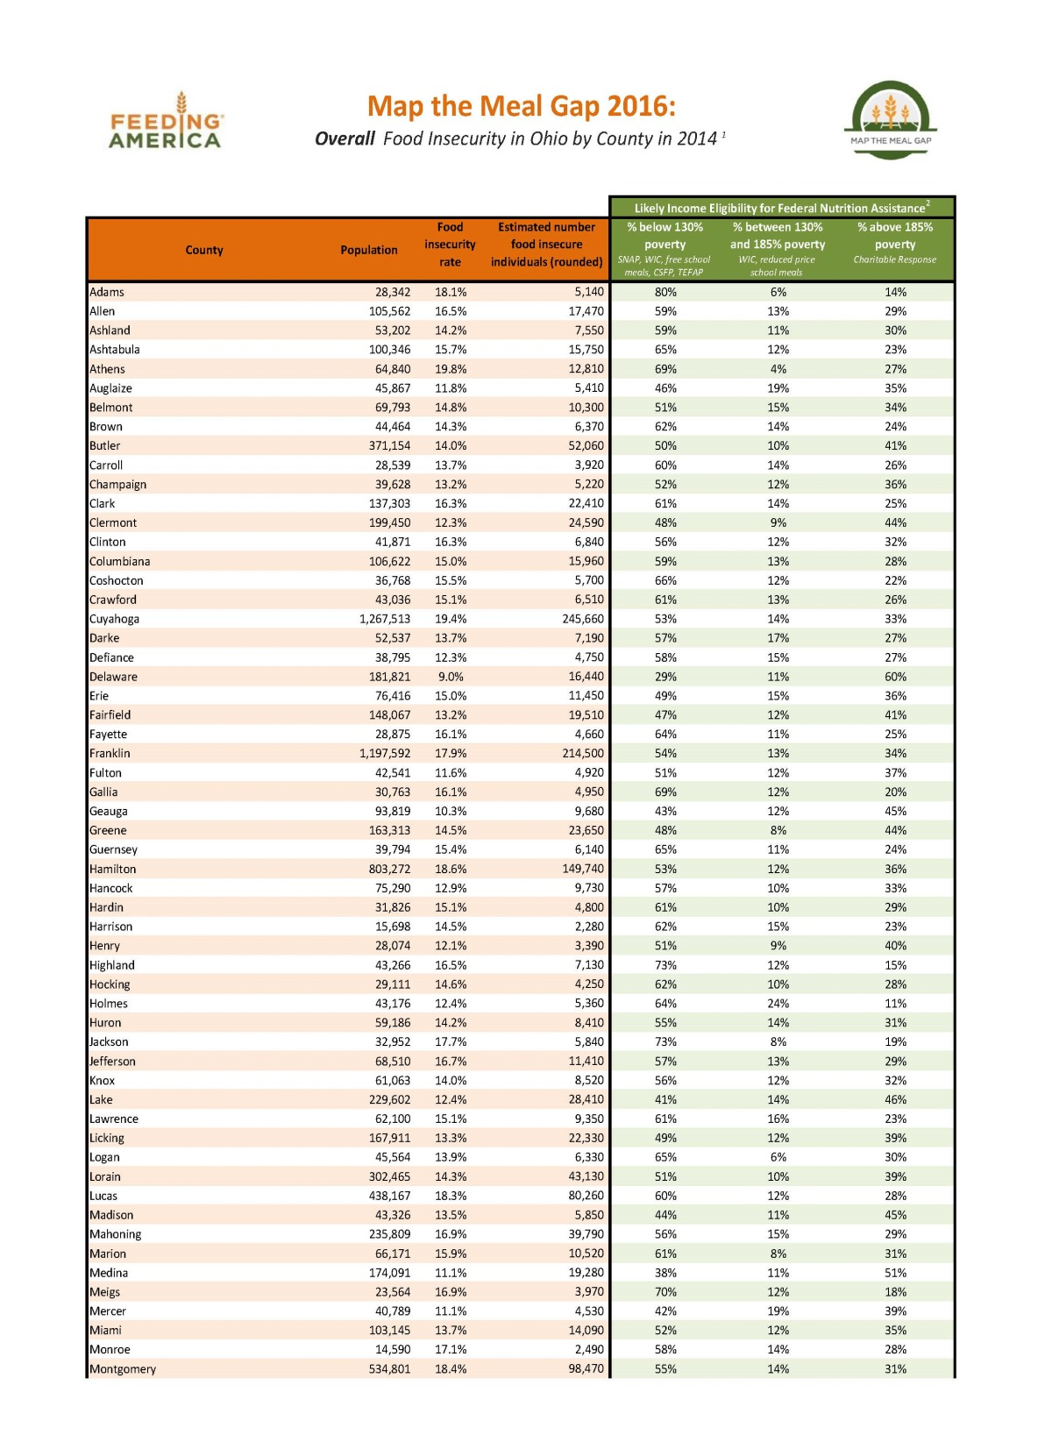

Attachment JDW-10
Page 2 of 3
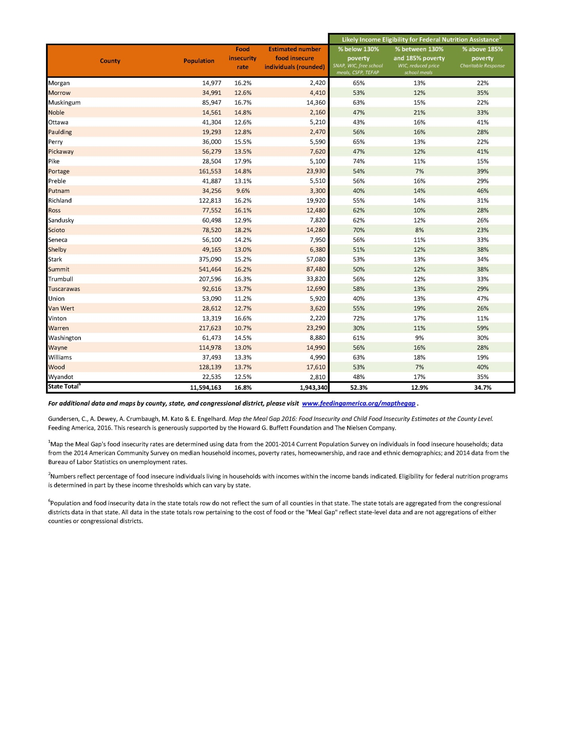

Attachment JDW-10
Page 3 of 3

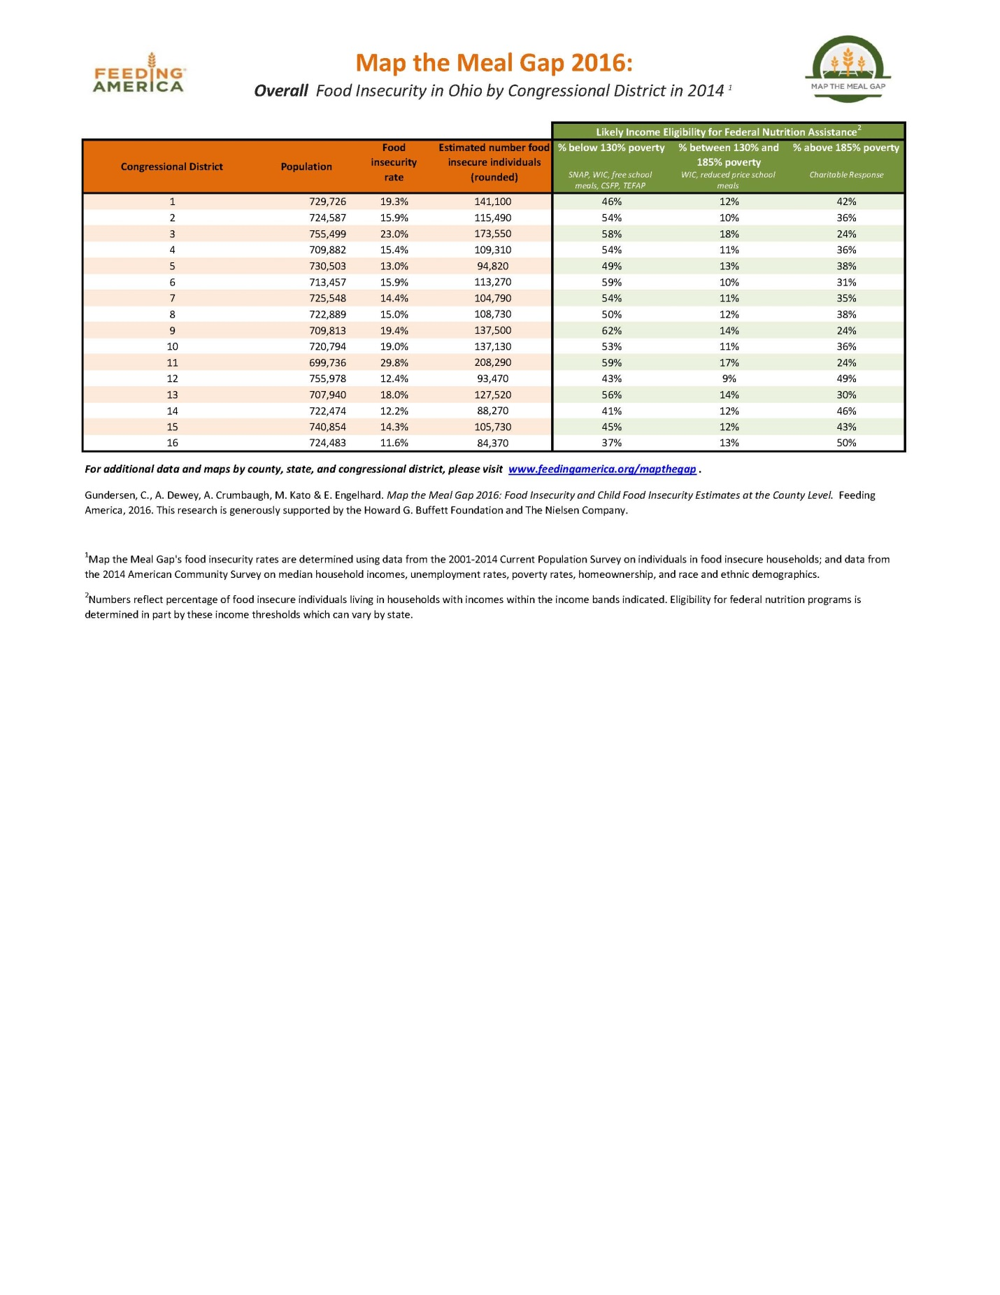

In the Matter of the Commission’s Review of Chapter 4901:1-15, Ohio Administrative Code, Standards for Waterworks Companies and Sewage Disposal Companies, Case No. 11-5605-WS-ORD.
In the Matter of the Application of Aqua, Ohio, Inc., for Authority to Increase its Rates and Charges for its Waterworks Service, Case No. 16-0907-WW-AIR, A Report by the Staff of the Public Utilities Commission of Ohio, November 17, 2016 (“Staff Report”).
Staff Report at 30.
Id.
Staff Report at 29.
Id.
Staff Report at 43.
Id at 44.
Id.
Id.
In the Matter of the Application of Aqua Ohio, Inc. to Increase Its Rates and Charges for Its Waterworks Service., Case No. 13-2124-WW-AIR, A Report by the Staff of the Public Utilities Commission of Ohio, May 20, 2014 at 48-49.
Stipulating parties included Aqua Ohio, the PUCO Staff, City of Tiffin, and City of Marion.
Case No. 13-2124-WW-AIR, Stipulation and Recommendation, July 21, 2014 at 3.
Staff Report at 44.
In the Matter of a Settlement Agreement Between the Staff of the Public Utilities Commission of Ohio, the Office of the Ohio Consumers’ Counsel, and Aqua Ohio, Inc. Relating to Compliance with Customer Service Terms and Conditions Outlined in the Stipulation and Recommendation in Case No. 07-564-WW-AIR and the Standards for Waterworks Companies and Sewage Disposal System Companies, Case No, 08-1125-WW-UNC.
Case No 08-1125-WW-UNC, Staff Report (December 29, 2008).
Aqua Ohio response to OCC INT-85 (attached herein as JDW-3).
Id.
Aqua Ohio response to OCC INT-86 (attached herein as JDW-4).
Id.
Id.
Aqua Ohio response to OCC INT-87 (attached herein as JDW-5).
Disconnection rate is the Total number of disconnections (15,291)/ Number of customers (79,904) = 19.13 percent.
Aqua Ohio Tariff, Section 4, Original Sheet No. 4.
Aqua Ohio response to OCC INT-92 (attached herein as JDW-6).
Aqua Ohio Tariff, P.U.C.O Tariff No. 2, Section 4.
Aqua Ohio response to OCC INT-94 (attached herein as JDW-7).
Application, Important Notice to Public Officials, April 28, 2016.
Id.
Ohio Poverty Report 2016. https://www.development.ohio.gov/files/research/p7005.pdf.
https://www.ers.usda.gov/topics/food-nutrition-assistance/food-security-in-the-us/key-statistics-graphics.aspx.
Map the Meal Gap 2016 (attached herein as JDW-9).
Aqua Ohio response to OCC INT-91 (attached herein as JDW-10).
Ohio Adm. Code 4901:1-18-05(B)(1).

