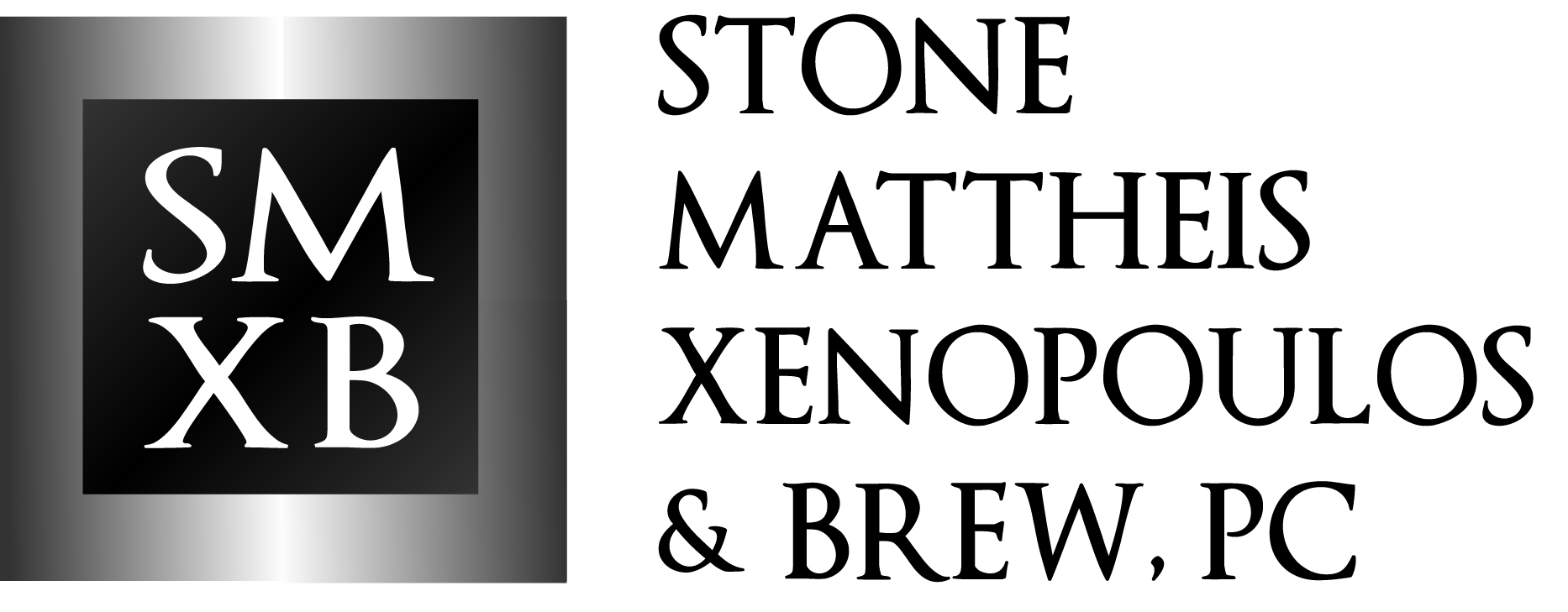

November 20, 2015

Public Utilities Commission of Ohio
Docketing Division
180 East Broad Street, 11th Floor
Columbus, OH 43215
RE: Notice of Withdrawal as Counsel of Owen J. Kopon
Dear Sir/Madam:
Please be advised that Nucor Steel Marion, Inc. hereby provides notice of the withdrawal of Owen J. Kopon as counsel in Case Nos. 14-1297-EL-SSO and 11-0126-EL-EEC. All other counsel for Nucor Steel Marion, Inc. should remain unchanged. Please revise the service and distribution lists accordingly.
By copy of this letter I am advising the parties of record of this change. If you have any questions, please do not hesitate to contact me.
Sincerely,

/s/ Michael K. Lavanga
Michael K. Lavanga

