**Case No.: 09-0897-EL-REN**

**Addendum #1 – Items G and N only.**

**G. Certification Criteria 2: Qualified Resource or Technology**

*You should provide information for only one resource or technology on this application; please check and/or fill out only one of the sections below. If you are applying for more than one resource or technology, you will need to complete a separate application for each resource or technology.*

G.1. For the resource or technology you identify in Sections G.4 – G.13 below, please provide a written description of the system.

The Cincinnati Park Board has a fully functioning 10 kW solar photovoltaic (PV) system on the ground next to their Eden Park Administration headquarters in Cincinnati, Ohio. The system consists of 90 Evergreen Solar EC-115 solar modules.

G.2. Please include a detailed description of how the output of the facility is going to be measured and verified, including the configuration of the meter(s) and the meter type(s).

The solar array at the Cincinnati Park Board is measured using an ASEA Brown Boveri As (Alpha) Polyphase Solid State Meter. The meter will solely measure the amount of electricity that is generated with the solar array.

G.3. Please attach digital photographs that depict an accurate characterization of the renewable generating facility. Please indicate the date(s) the photographs were taken. For existing facilities, these photographs must be submitted for your application to be reviewed. For proposed facilities or those under construction, photographs will be required to be filed within 30 days of the on-line date of the facility.

**INSERT PHOTOGRAPH(S)**

Photo taken – 04/13/09

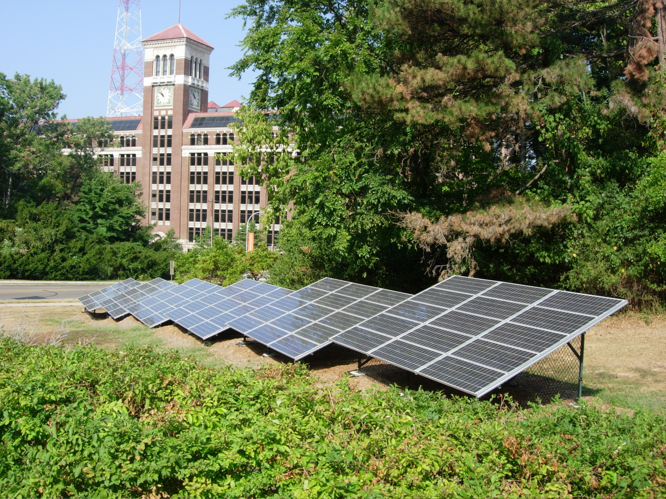

**The Applicant is applying for certification in Ohio based on the following qualified resource or technology (Sec. 4928.01 O.R.C.):**

**G.1** _x_ **SOLAR PHOTOVOLTAIC**

Total PV Capacity (DC): 10,350 watts

Total PV Capacity (AC): 7,969 watts

Expected Capacity Factor: 13%

Anticipated Annual output in kWh/yr: 12,121 kWh

Location of the PV array: __ Roof _x_ Ground __ Other

# of Modules and/or size of the array: 90 modules

**G.1a PV Modules**

For each PV module, provide the following information:

Manufacturer: Evergreen Solar  
Model and Rating:  EC-115

**N. Meter Specifications**

***All facilities are required to measure output with a utility grade meter. Please provide this information for each meter used in your system.***

Manufacturer: ASEA Brown Boveri

Serial Number: 01 562 692

Type: A1 (Alpha) Polyphase Solid State Meter

Date of Last Certification: 1/11/2010 - installed

Attach a photograph of the meter with date image taken. The meter reading must be clearly visible in the photograph.

Report the total meter reading number at the time of the photograph and specify the appropriate unit of generation (e.g., kWh): 0 kWh

**INSERT PHOTOGRAPH(S)**

Photo taken – 01/11/2010

