# Appendix A

# Customer Annual Energy Use

The customer uses over 20 million kWh per year. The monthly energy use for the previous three financial years is presented in tables below.



The 3-year average baseline is thus:

(20,234,070 kWh/year + 20,634,323 kWh/year + 21,126,973 kWh/year) / 3

= 20,665,122 kWh/year

# Project Implementation

1. The compressed air projected was completely implemented and operational by the start of May 2014
2. The LED project upgrade was completed by the end of October 2013.

Note: Complete project details, along with energy savings calculations and methodologies are available in the *Energy Savings Analysis for General Mills* document provided with the application.

# Project Life

The savings from both the projects will be realized for the entire useful life of the equipment. The project life for each project is explained below.

1. The useful project life for an air compressor is 15 years based on the OHIO TRM[1].
2. The useful project life for LED lighting is about 6 years, based on current runtime and studies conducted by Dept. of Energy[2].

# Exemption Period

The savings from both the lighting and compressed air projects is 4% of the average annual energy use for the facility:

Total savings = 508,033 kWh/year (compressed air) + 327,624 kWh/year (lighting)

= 835,657 kWh/year

Percent savings = 835,657 kWh/year savings / 20,665,122 kWh/year baseline = 4.04%

Hence the ongoing exemption period for the facility can be extended beyond the standard 24 months to 48 months. This should be acceptable based on the requirement of 1% savings per year. Furthermore the project life for both projects is well beyond 4 years.

# Total Resource Cost Test

“The TRC value of the program is calculated by dividing the value of our avoided supply costs (generation capacity, energy, and any transmission or distribution) by the sum of our program overhead and installation costs and any incremental measure costs paid by either the customer or the electric utility.” – PUCO application

The TRC for the lighting and compressed air projects are presented in the table below.



Table : TRC Calculations

The energy savings for the projects are presented in Appendix B followed by the invoices for the projects costs in Appendix C.

# Appendix - B

Energy Savings Analysis

for

General Mills

By



|  |  |
| --- | --- |
|  |  |

June 2014

Table of Contents

Appendix - B iii

1 Executive Summary 5

2 Compressed Air System Upgrade 6

2.1 Equipment Information and Project Description 6

2.2 Description of Calculation Methodology 6

2.3 Energy and Demand Savings Calculations 7

2.3.1 Compressed Air Flow Profile 7

2.3.2 Pre and Post- upgrade Power Profile 8

2.3.3 Normalized Compressed Air System Energy and Demand Savings 10

3 Lighting Upgrade 13

3.1 Equipment Information and Project Description 13

3.2 Description of Calculation Methodology 13

3.3 Energy and Demand Savings Calculations 13

Appendix – C 15

# Executive Summary

*Go Sustainable Energy* was contracted by General Mills to perform energy savings analysis for the different energy efficiency projects implemented at the facility. The projects are briefly described below,

1. Compressed Air System Upgrade: This upgrade consisted of installing a new 125-hp variable frequency drive (VFD) compressor along with changes in the control system. General Mills anticipates that installing a smaller VFD compressor along with the changes in the control system would improve system efficiency resulting in energy and cost savings.
2. Lighting Upgrade: The majority of the facility’s lighting fixtures were 150-watt high pressure sodium (HPS) lamps. The upgrade consisted of replacing 275 of these HPS lamps and ballasts with 54-watt LED lamps and integral drivers. The reduced lamp wattage results in energy and demand savings for the facility.

Table 1 below summarizes the energy and demand savings from both projects. Details about the analysis and calculation methodologies are presented in the following sections.



Table : Summary of Energy and Demand Savings

# Compressed Air System Upgrade

## Equipment Information and Project Description

The facility currently has a total of four oil-free rotary-screw Atlas Copco compressors. Table 2 below lists the basic information about each compressor.



Table : Equipment Summary

We obtained trended data from the facility’s ManageAir control system. The trended data ranges from November 2013 through mid-June 2014. This includes time periods before and after the upgrade.

The pre-upgrade scenario consisted of compressors C-1, C-2 and C-4. A typical VFD compressor can effectively vary its capacity, by reducing speed, to as low as 30%. However, below 30% fraction capacity a VFD compressor needs to turn on and off. This is not energy efficient and also increases wear on the compressor reducing its useful life. In the pre-upgrade scenario, the VFD compressor (C-1) was too large to trim effectively during production transition periods, and would have cycled on and off as we’ve described. To prevent excessive cycling of the VFD compressor, the control system was setup such that a load/unload compressor (C-2 or C-4) would run in the unload mode, during the low flow transition times as a standby compressor. A load/unload compressor produces no airflow in the unload mode. This control strategy was not efficient because an extra compressor would remain in the unload mode drawing power but not providing any air-flow.

The post-upgrade scenario consists of a new smaller VFD compressor (C-3). This compressor was sized such that it could be used as the trim compressor in the transition ranges where the larger VFD could not trim. The control sequences were modified to benefit from the addition of the smaller VFD. In addition to improved system performance, this also eliminated the need for having a large constant speed compressor in the unload mode. This results in a more efficient system than the baseline scenario.

## Description of Calculation Methodology

The energy savings calculated here are based on the International Performance Measurement and Verification Protocol (IPMVP). The methodology uses the *Retrofit isolation – Option B (all parameter measurement)* path to quantify energy savings. The detailed methodology and calculations are outlined in the following sections.

## Energy and Demand Savings Calculations

When performing measurement and verification on compressed air power draw, it is important to account for overall compressed air flow. Normalizing for flow is particularly important when analyzing a manufacturing facility’s compressed air system, which will likely vary based on production over time. Flow normalization creates a flow profile for both the pre- and post-upgrade periods and then calculates a power draw based on the compressed air system’s power profile. This method allows for a true comparison of the overall power draw in pre- and post-upgrade periods.

### Compressed Air Flow Profile

The compressed air flow profile is a representation of the compressed air needs of a facility, which is mainly dependent on production. Hence the flow profile is independent of the air compressors and the control system. To generate a representative profile it is better to have a larger data set of typical production operation. We generated the flow profile using hourly flow data from the facility’s compressed air control system for the time period January 5, 2014 through June 8, 2014, a total of about 22 weeks. This time period was selected after discussions with plant personnel to eliminate any erroneous and non-typical data points. Figure 1 below presents the flow data that was used to generate the flow profile. It includes both the pre- and post-upgrade scenarios as C-3 was fully operational by the start of May 2014.

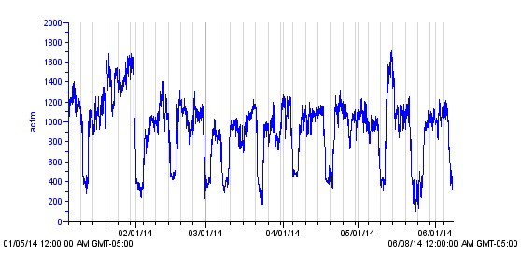

Figure : Pre- and Post-Upgrade Compressed Air Consumption

It can be observed that compressed air flow is fairly consistent with some periods of high compressed air use. The flow profile is then generated by creating bins of the flow data and calculating the percentage time and average air flow in each bin. Table 4 and Figure 2 below, present the compressed air flow profile data.

|  |  |
| --- | --- |
| Table : Flow Profile | Figure : Flow Profile |

### Pre and Post- upgrade Power Profile

A power profile characterizes the system’s power draw relative to the compressed air flow. It accounts for variables that cannot be accounted for in a theoretical approach, such as compressed air storage, unloaded time of a compressor etc. A power profile can be generated from the system power and air-flow for a representative period.

The system power and flow-data were obtained from the compressed air control system. Plant personnel stated that the power for C-2 was not being recorded due to a meter error. This was confirmed though the available data. Since only total system power was available, rather than power of each individual compressor, we chose January 2014 to create the pre-upgrade power profile, as C-2 was not operated in this month.

The new compressor C-3 was on site by the end of March 2014. However plant personnel stated that the compressor was offline due to a failed motor and a damaged compressor seal. This was also observed through the available data. C-3 was fully operational by mid May 2014. Eliminating the time periods when C-2 was operated, we used four weeks of data from May 11, 2014 through June 7, 2014 to create the post-upgrade power profile.

Figure 3 and Figure 4 below present the power and flow data used to generate the power profiles for the pre- and post-upgrade scenarios.

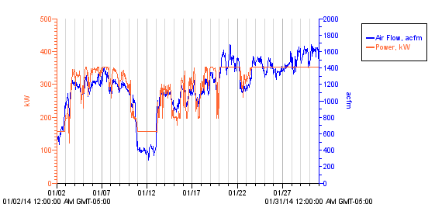

Figure : Pre-upgrade Flow and Power Data

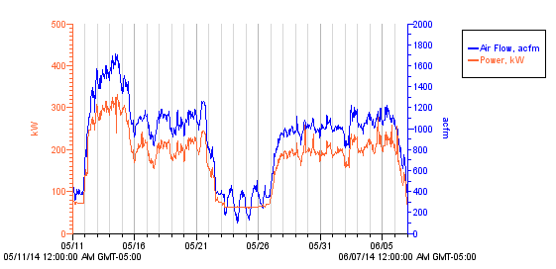

Figure : Post-upgrade Flow and Power Data

Similar to the flow-profile, the average compressed air flow and the corresponding average power draw for the pre- and post-scenarios were calculated over a range of bins. Figure 5 below graphically presents the power profiles for both cases. The actual data for the pre- and post-scenarios are presented in Table 5 and Table 6 respectively

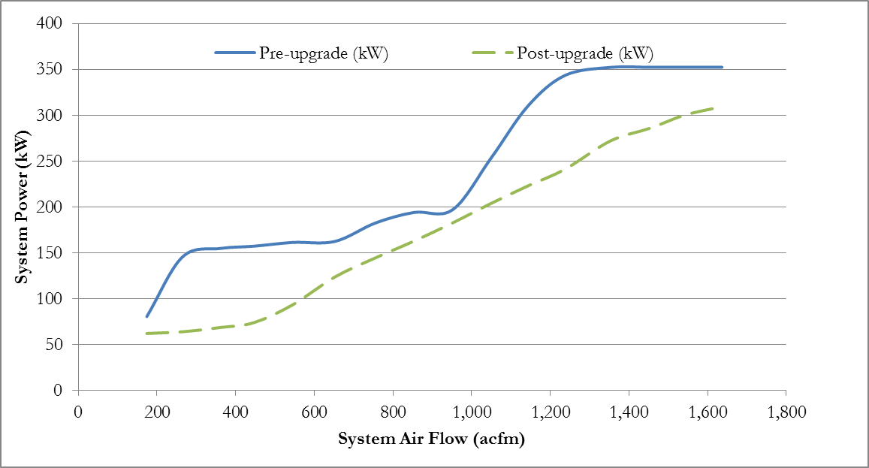

Figure : Pre- and Post-upgrade System Power Profiles

|  |  |
| --- | --- |
| Table : Pre-Upgrade Power Profile | Table : Post-Upgrade Power Profile |

### Normalized Compressed Air System Energy and Demand Savings

The normalized system energy and peak demands are found by applying the system power profiles to the compressed air flow profile. The total system power for both scenarios is found for each average flow bin in Table 4 by linearly interpolating the flow and power data in Table 5 and Table 6. Figure 6 below, presents the data from the flow profile along with the pre- and post-upgrade power profiles.

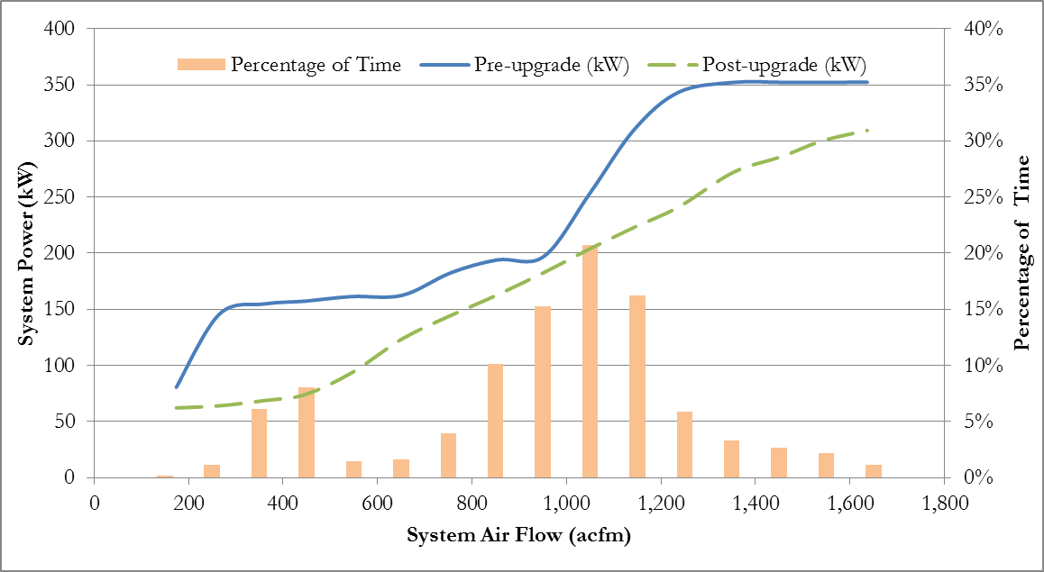

Figure : Flow Profile along with Pre and Post-upgrade Power Profiles

Energy consumption for each bin is calculated by multiplying the power draw by the number of hours per year. The following example shows the calculation of power draw and energy consumption for the 200 cfm pre-upgrade scenario bin.

*Power–pre (200 cfm) = 54.8 kW + (154.7 kW – 54.8 kW) x (174 cfm – 138 cfm) / (278 cfm – 138 cfm)*

*= 80.6 kW,*

*Energy–pre (200 cfm) = 80.6 kW x 15 hours/year = 1,209 kWh/year.*

Similar calculations are performed to calculate the post-upgrade power and energy use. The energy savings is then the difference between the pre- and post- upgrade scenarios. Table 7 presents the annual energy analysis along with the savings.



Table : Annual System Energy Analysis

The normalized annual energy savings is equal to the difference between the pre- and post-installation energy consumption, and is about,

***Annual energy savings = 2,118,545 kWh/year – 1,610,512 kWh/year***

***= 508,033 kWh/year.***

Since the flow profile is based on hourly flow data, the electrical demand will correspond with the peak flow. Hence, the demand savings is the difference in power draw for the bin with the highest air flow. In this case it is the difference in power for the 1,700 cfm bin.

***Demand Savings = 352.3 kW – 309.3 kW = 43.0 kW***

# Lighting Upgrade

## Equipment Information and Project Description

In the pre-upgrade scenario, the majority of the facility’s lighting requirement was met by 275 150-watt high pressure sodium (HPS) lamps.

The upgrade consisted of replacing the HPS lamps with 54-watt LED lamps. The upgrade was completed by the end of October 2013. First, the HPS lamps were removed and the ballasts were disconnected. Then, direct replacement LED lamps with integral drivers were installed in the existing fixture. The reduced lamp wattage results in energy and demand savings for the facility. Figure 7 below shows an installed LED fixture.

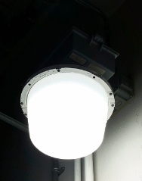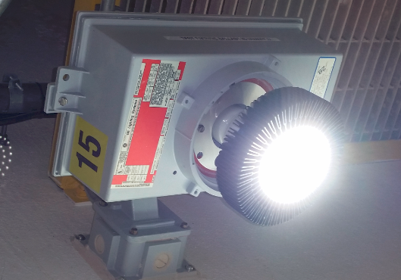

Figure : Installed LED Fixtures

## Description of Calculation Methodology

The energy savings calculated here are based on the International Performance Measurement and Verification Protocol (IPMVP). The methodology uses the *Retrofit isolation – Option A (key parameter measurement)* path to quantify energy savings. The detailed calculations are outlined in the following sections.

## Energy and Demand Savings Calculations

Table 8 below presents the pre- and post-upgrade lighting fixtures.



Table : Pre and Post Lighting fixtures[3]

The demand reduction from the lighting upgrade can be calculated as,

*Demand reduction (kW) = [Current Power (kW/fixture) –Proposed Power (kW/fixture)] x Quantity of Fixtures*

To determine the yearly electric energy reduction we multiply the power reduction by the number of annual operating hours of the fixtures. According to facility personnel these lights operate year round. Hence we use an operating time of 8,760 hours per year.

*Energy reduction (kWh/year) = Demand reduction (kW) x Annual operating hours (hours/year)*

The equations presented above were used to calculate the demand savings and electrical energy savings. The results are presented in Table 9 below.



Table : Energy and Demand Savings

# Appendix – C

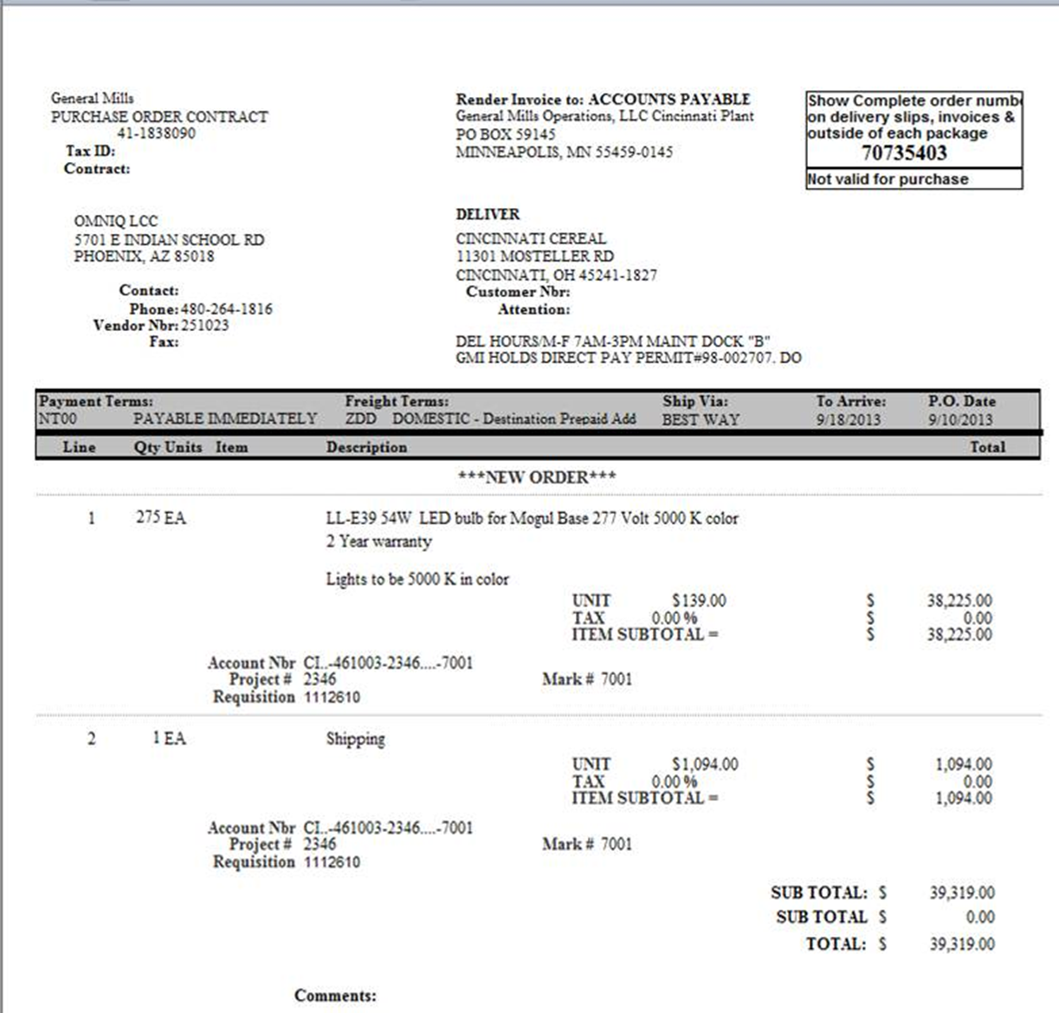

Figure 8: Implementation Cost for LED Lights

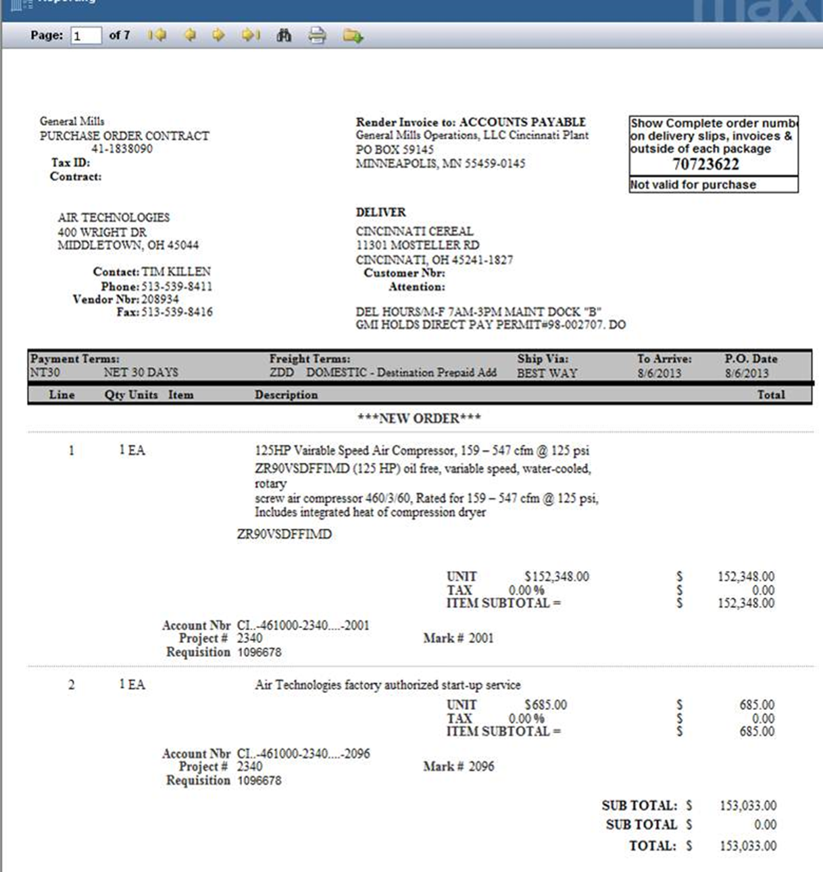

Figure : Implementation Cost for Compressed Air Project

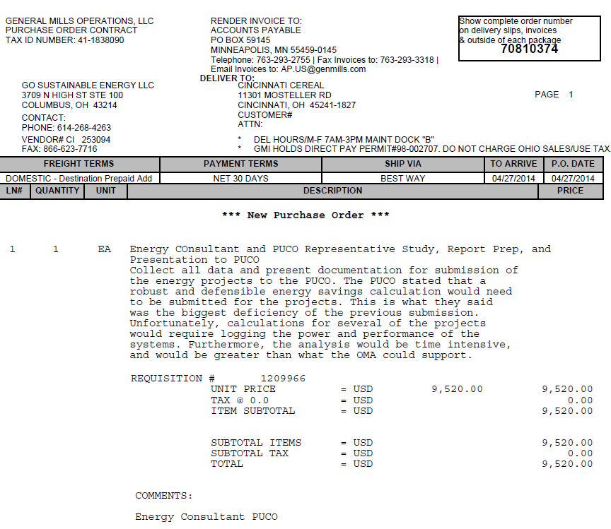

Figure 10: Other Administrative Costs for the Project

1. <http://amppartners.org/pdf/TRM_Appendix_E_2011.pdf>
2. <http://apps1.eere.energy.gov/buildings/publications/pdfs/ssl/lifetime_white_leds.pdf>
3. Fixture draw includes ballast for HPS lamps and drivers for LED lamps based on manufacturer’s data